Nicole Forke

30 May 2020

Assignment 5.2 - Unit Test 01

Web 420

HTTP GET Request:

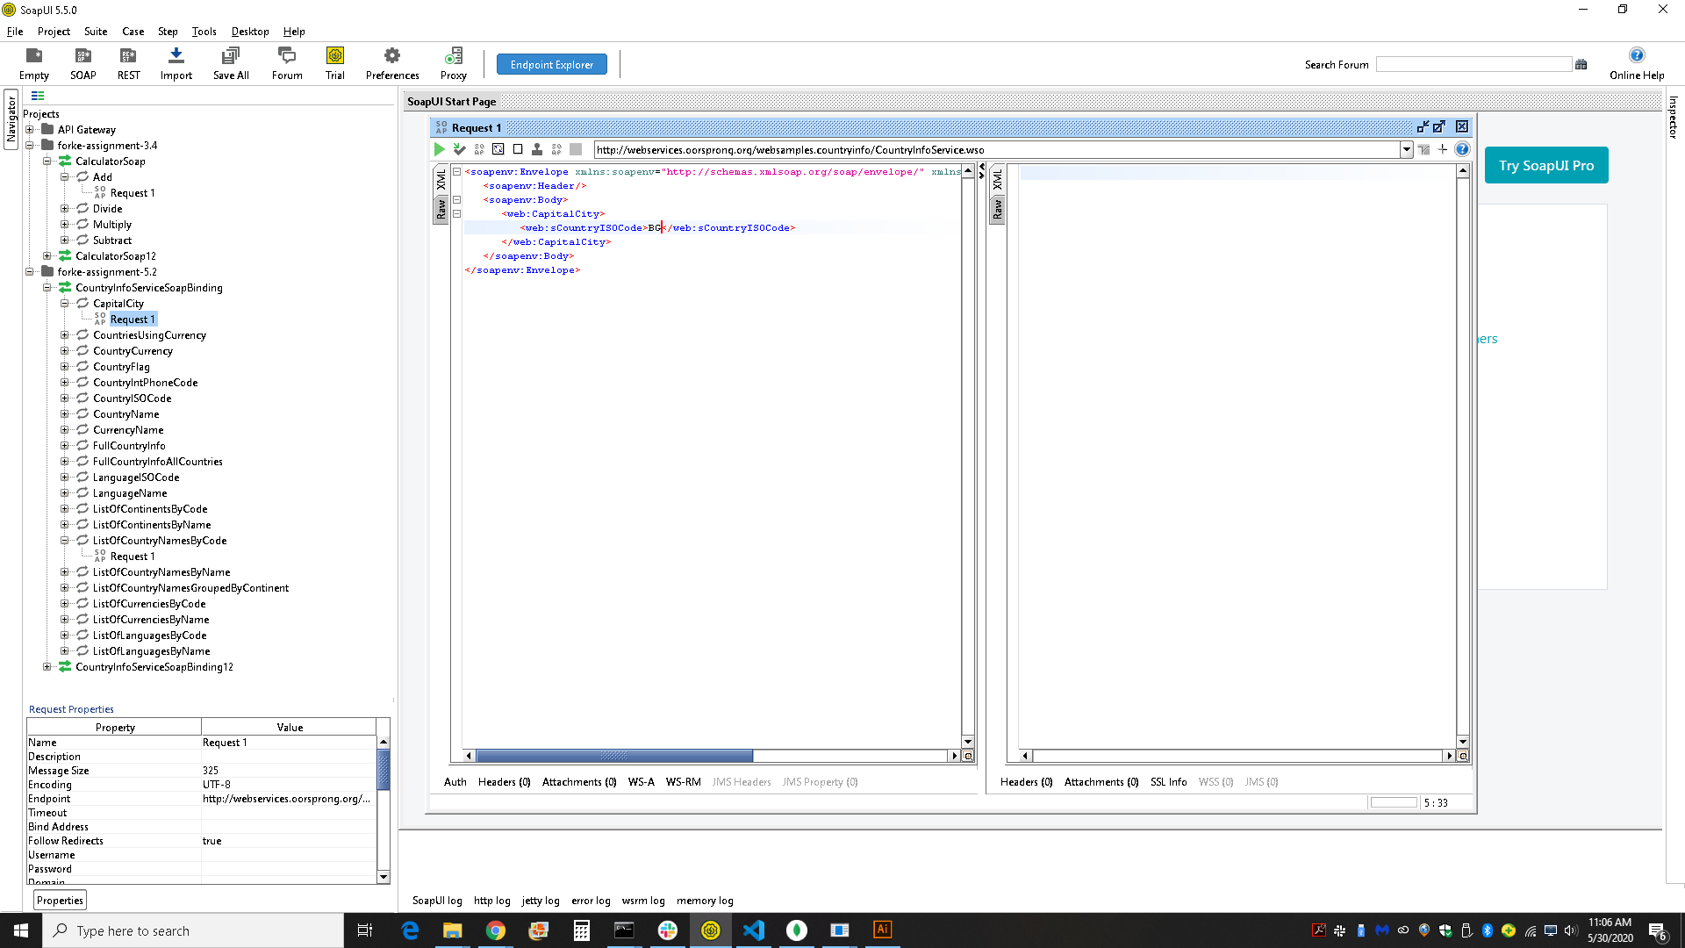

HTTP GET Response:

