Nicole Forke

30 May 2020

Assignment 5.3 - Unit Test 02

Web 420

JSON Request

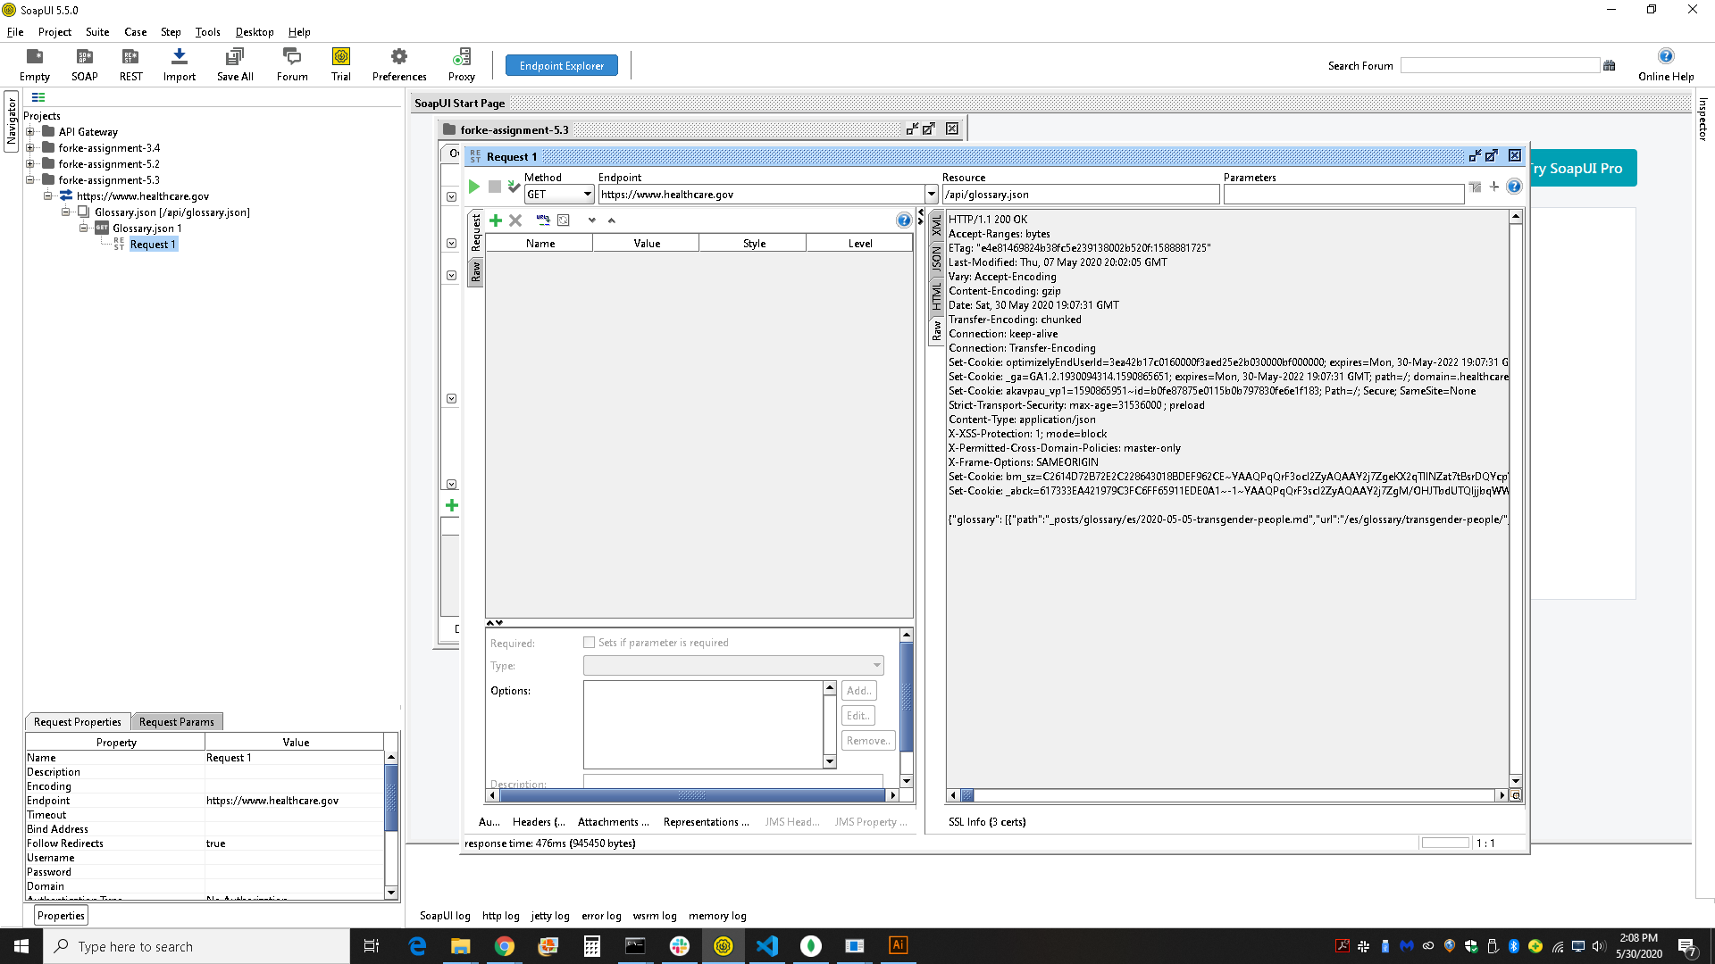

JSON Response

