Nicole Forke

30 May 2020

Assignment 5.4 - API Gateway Unit Test 02

Web 420

CLI Log Messages

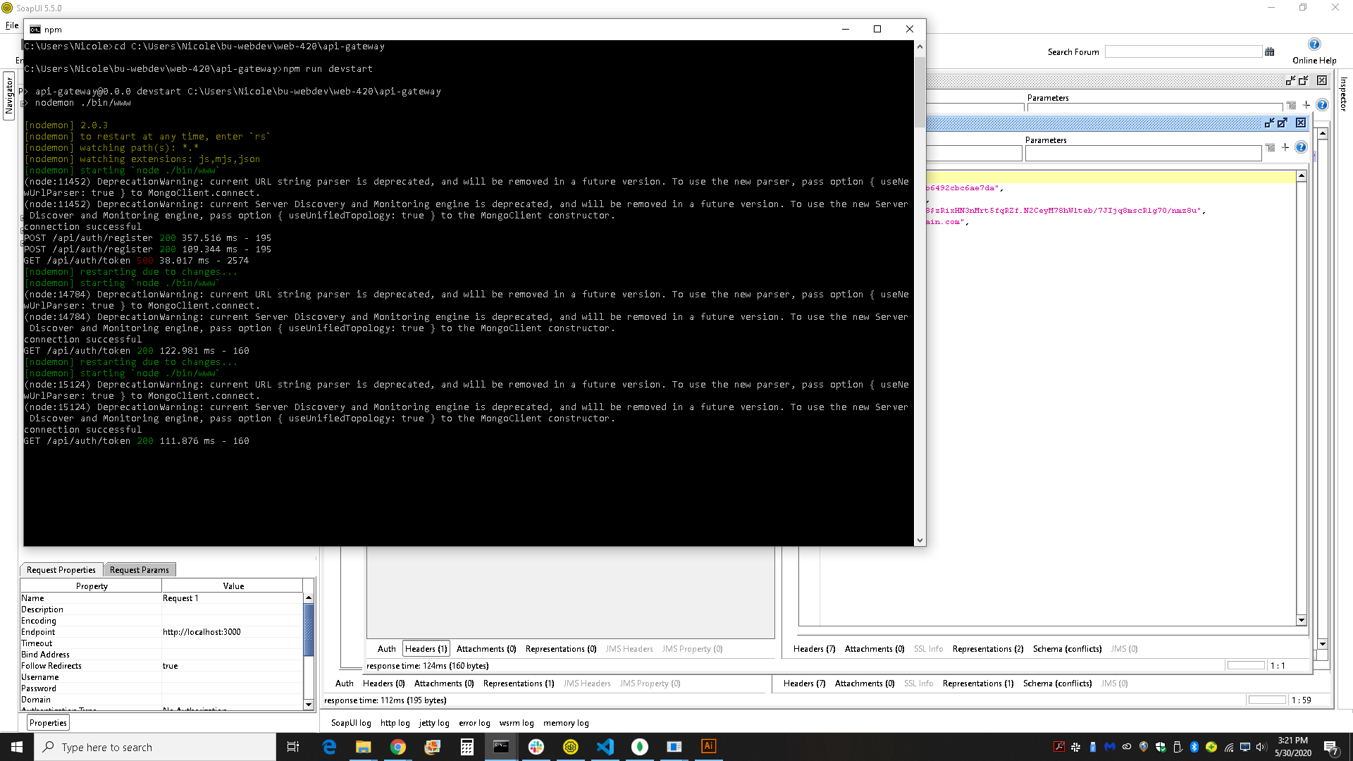

SoapUI Response

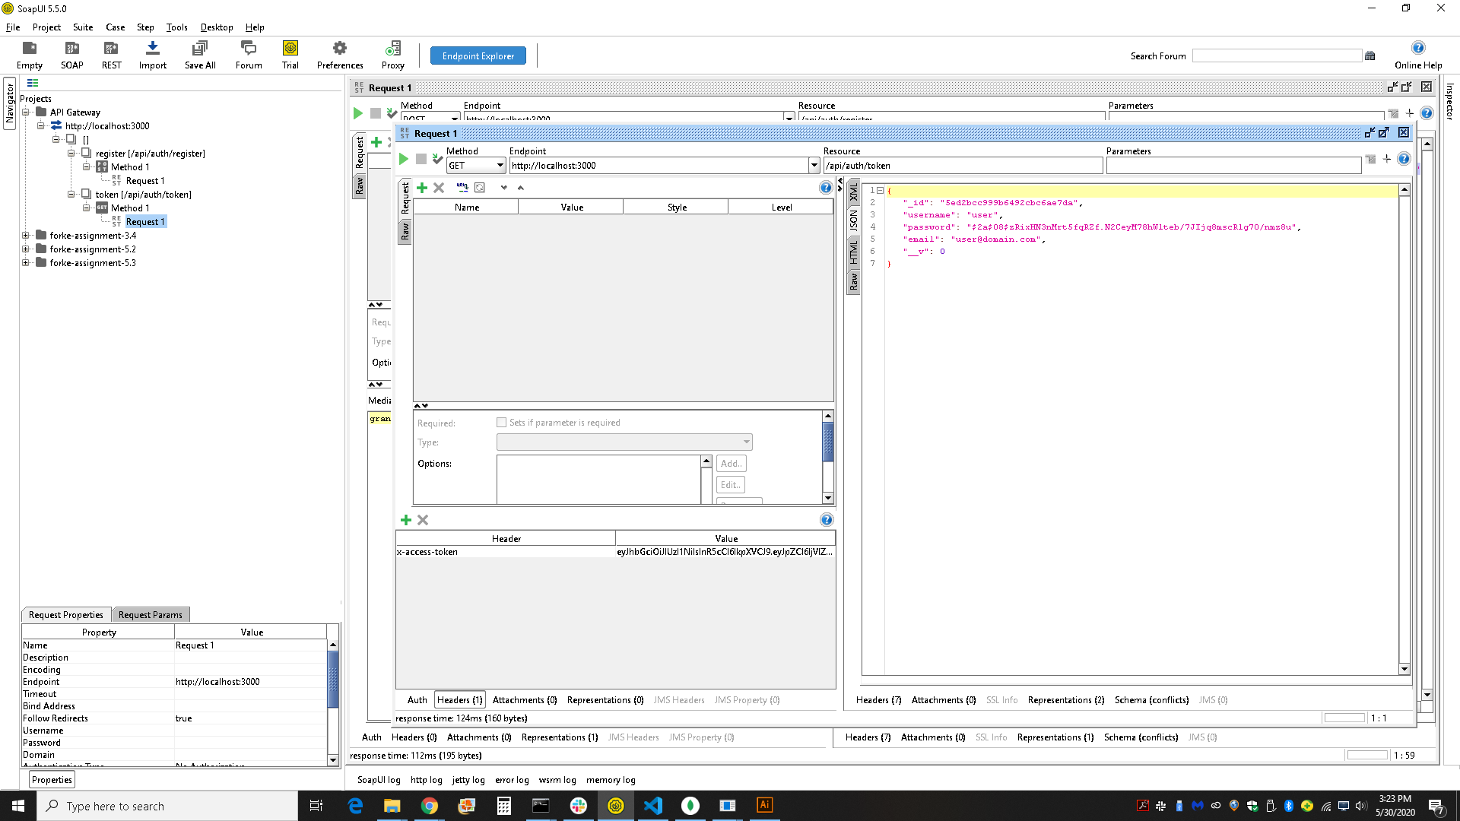

mLab Record

