To: Professor Krasso

From: Nicole Forke

Date: 14 June 2020

Subject: From Legacy to SOA

Research has shown that many corporations continue to use legacy systems. Unfortunately, these systems do not use any updated protocols in order to make production easy and efficient. Instead they cause loss of time due to the ancient nature of having to rewrite code in order to update the legacy system. Migrating the legacy system over to a service-oriented architecture (SOA) will benefit your company in many ways.

A service-oriented architecture makes use of services in the network. This allows the numerous services to communicate with each other. For example, this chart shows how SOA services communicate and what SOA can offer:

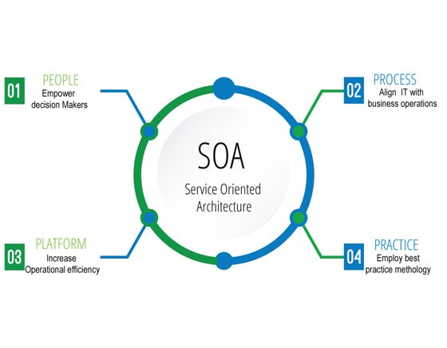 [(medium.com)](https://medium.com/@SoftwareDevelopmentCommunity/what-is-service-oriented-architecture-fa894d11a7ec)

With a SOA you'll be able to reuse functionality and scaling will be made easier. See the chart below for more benefits to migrating to SOA.

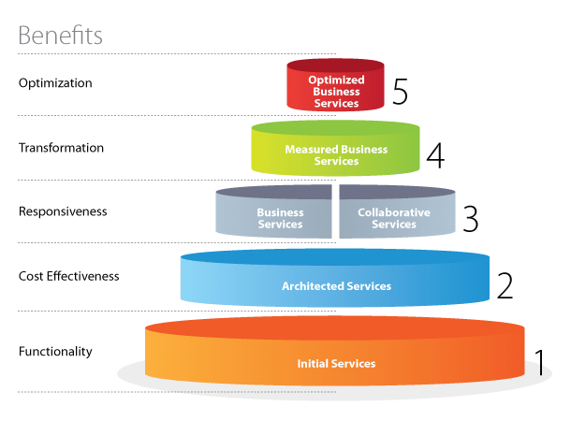 [(tridenstechnology.com](https://tridenstechnology.com/soa-development-for-small-companies/))

We have drawn a proposed SOA diagram for your review and to show how the legacy system could be more efficient after migrating to SOA. The process, will be kept as simple as possible in order to keep costs down. The first step, will be to integrate the data from the legacy system onto the database for the SOA. This process could take some time, so having the information transfer over a weekend would be beneficial. While the data is transferring the IT infrastructure will be created to manage the systems on the network. IT will maintain the GitLab System and the Active Directory System, keeping these systems from being transferred through the Enterprise Service Bus (ESB). The reason for this is to keep employees from accessing this information.

The next steps will be to create a Human Resource and Corporate system. Each will have separate systems below them. This creates a hierarchy for the network. Only the assigned systems can be reached through each main system. This avoids duplication of data on multiple servers due to multiple employees having access to the systems.

The Human Resource system will contain the Employee system, which holds the Training system, Payroll system and Recruiting system. While these systems are being transferred over and updated as necessary they won't be accessible by the employee or HR. Of course, the highest impact will be the employee system, so it needs to be transferred right after the human resource system. The best time to update and transfer these is after work hours to prevent business downtime. Since the training system is only utilized when there are new employees or yearly training sessions, this system would have the least impact on business production. The recruiting system also has low impact on business. Finally, the payroll system, has a high impact since this system calculates employee paychecks, vacation, 401k, etc.

The Corporate system, will need to be transferred and updated from the legacy system first to keep production in process. The systems located beneath the Corporate system are the Budget system, Service Desk system and Procurement system. These are vital systems for production. To keep the business running smoothly each system should be broken down into sections and updated or transferred after work hours. The system with the least impact on business would be the budget system, next would be the contract system, and procurement will have the highest impact since this is where materials are purchased. Again, the best time to transfer and update these systems is after business hours to have the least impact on production.

Once the SOA is put in place, the business will find the communication between computers, systems, etc. all work and communicate more efficiently. IT will also find that versioning and managing is also made easier allowing them more time to be productive in creating new applications or updating the current versions.

References

Smith, Dennis and Lewis, Grace. (2007). Migrating Legacy Assets to Service Oriented Architecture (SOA): a DoD Example*.pdf*

Software Development Community. (2019). *What Is Service-Oriented Architecture?.*

[https://medium.com/@SoftwareDevelopmentCommunity/what-is-service-oriented-architecturefa894d11a7ec](https://medium.com/@SoftwareDevelopmentCommunity/what-is-service-oriented-architecture-fa894d11a7ec)

Software Development Community. (2019). *What Is Service-Oriented Architecture?.*

[https://medium.com/@SoftwareDevelopmentCommunity/what-is-service-oriented-architecturefa894d11a7ec](https://medium.com/@SoftwareDevelopmentCommunity/what-is-service-oriented-architecture-fa894d11a7ec)

Tridens Technology. SOA Development for Small Companies.

<https://tridenstechnology.com/soa-development-for-small-companies/>

Crest Payroll. *Why Legacy Payroll Systems are Harmful To Your Business.*

<https://www.crestpayroll.com/Why-legacy-payroll-systems-are-harmful-to-your-business.html>