Nicole Forke

11 July 2020

Web 425 - Assignment 1.5 - Angular Artifacts

Professor Krasso

Chrome

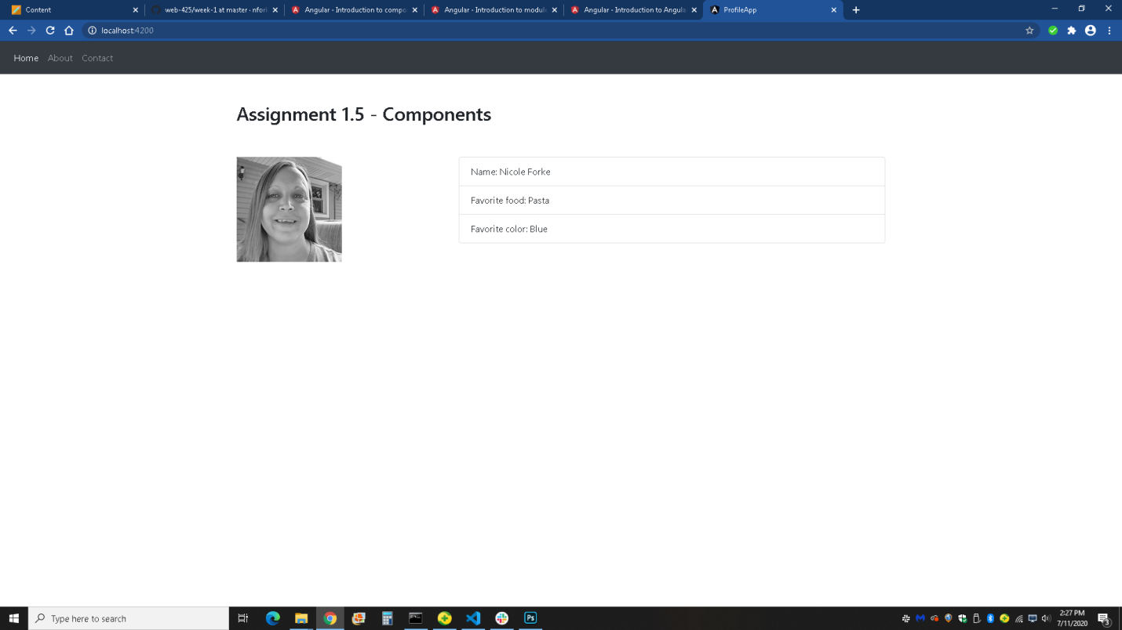

Firefox

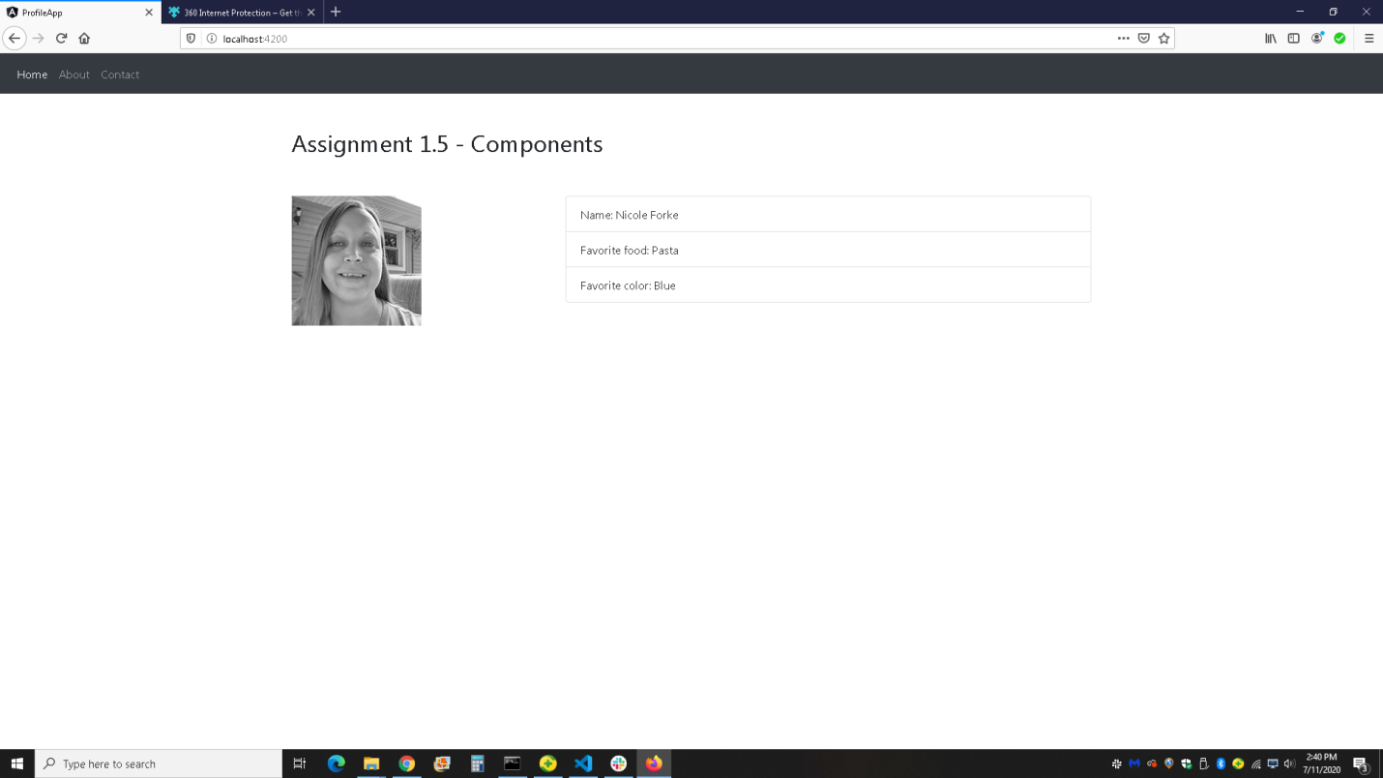

Edge

