|  |  |
| --- | --- |
| Test Tour | Guidebook Tour |
| Object to be tested / Rough Guidance | In accordance with the definition of Guidebook Tour concept, the goal of this session is to verify that the functions execute as defined in the API docs |
| Tester | Whole Team |
| Further Testing Opportunities? | Could also be tested using invalid inputs |

**Protocol**

1. Test: Verify that the .set() function changes the date to the input parameter and a clone is returned
   1. Status: ✓
   2. Documentation/Comments: Passed  
      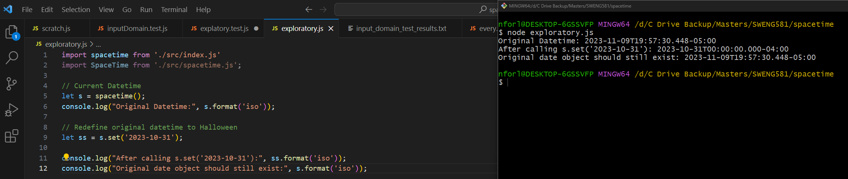
2. Test: Verify that the .isValid() function confirms a valid date and time according to the rules of the Gregorian calendar and the JavaScript Date object – Return clone
   1. Status: ✓
   2. Documentation/Comments: Passed – However, the docs say the return type is a clone. The correct return type should be Boolean  
      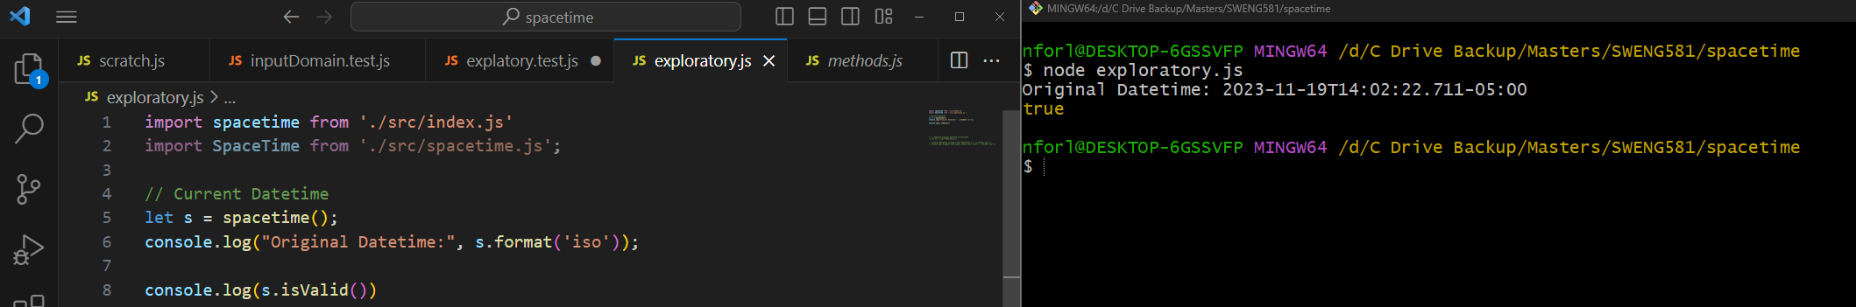
3. Test: Verify that the .log() function will pretty-print the date to the console, for nicer debugging – Return clone
   1. Status: ✓
   2. Documentation/Comments: Passed  
      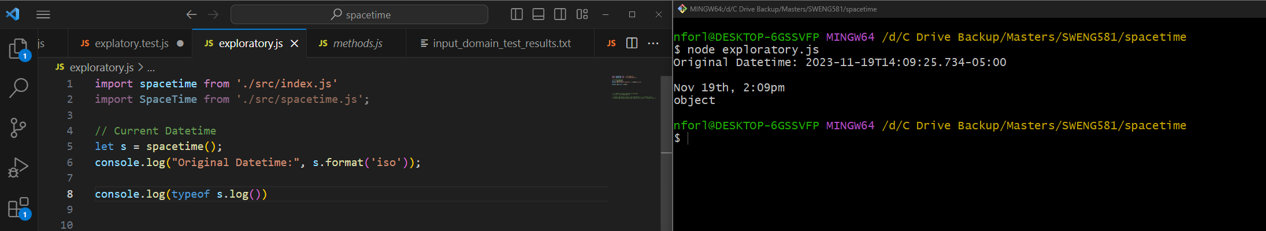
4. Test: Verify that the .progress() function correctly calculates the progress of a given moment within a specific time frame, such as a day, week, month, or year. The function takes a moment in time and returns a value between 0 and 1, indicating how far that moment is in relation to the start and end of the specified time frame – Return Object
   1. Status: ✓
   2. Documentation/Comments: Passed  
      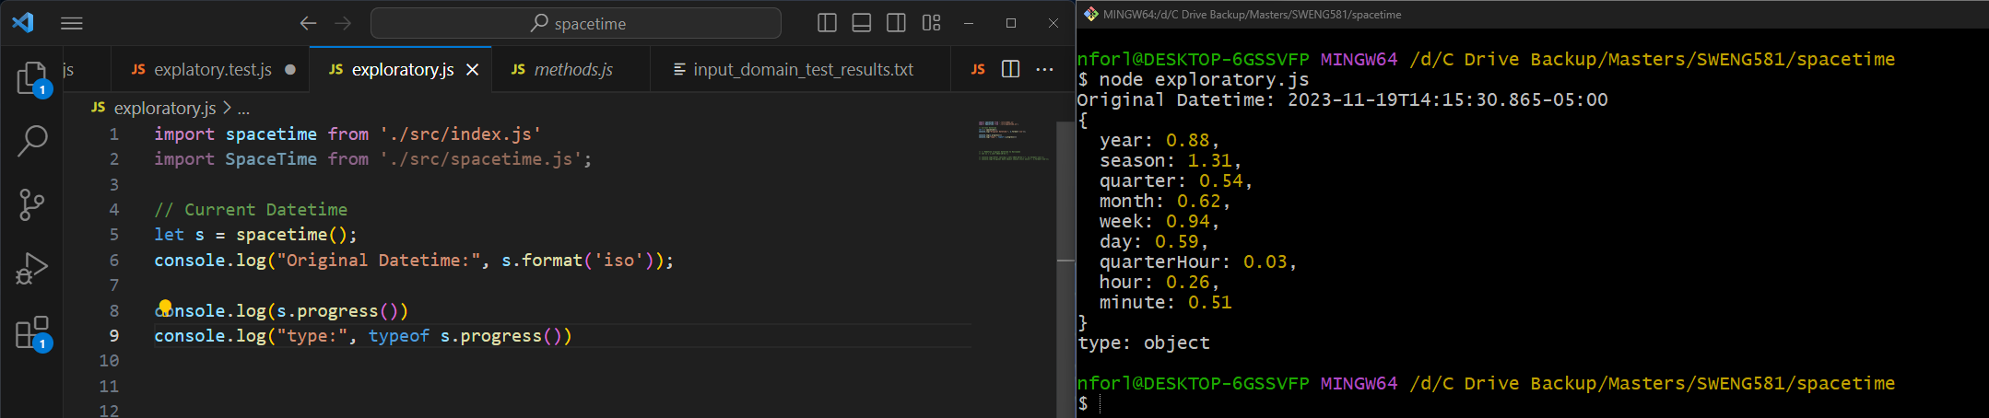
5. Test: Verify that the .leapYear() function correctly returns if the current year is a leap year or not – Returns Boolean
   1. Status: ✓
   2. Documentation/Comments:  
      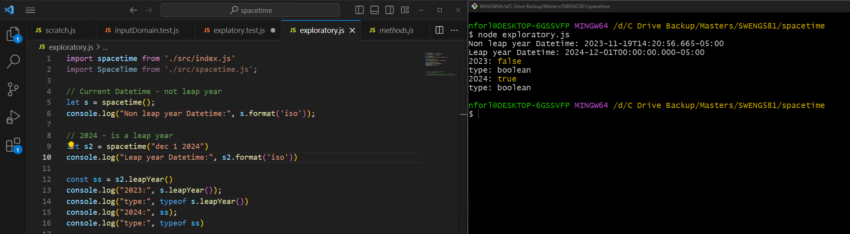
6. Test: Verify that the .inDST() function correctly returns if the current selected time zone is in daylight savings time – Returns Boolean
   1. Status: ✓
   2. Documentation/Comments:  
      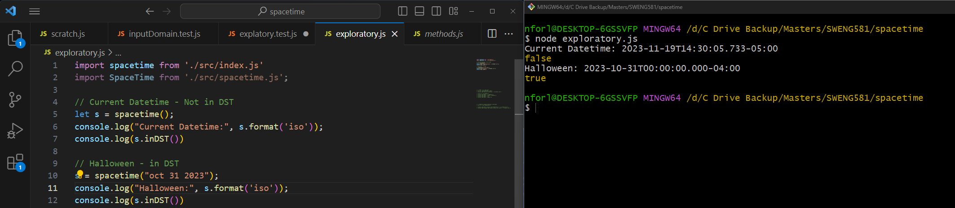
7. Test: Verify that the .hasDST() function validated if the timezone ever uses daylight-savings and return boolean
   1. Status: ✓
   2. Documentation/Comments: Passed
   3. 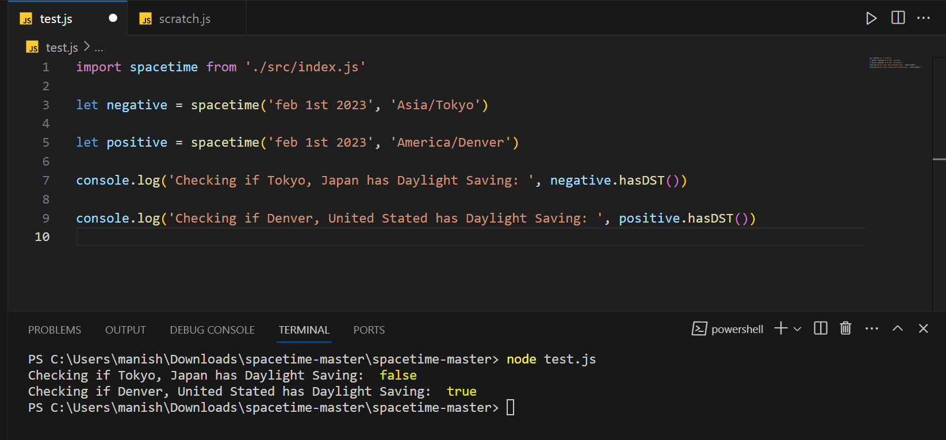
8. Test: Verify that the .offset() function correctly calculates the current time difference from Coordinated Universal Time (UTC) while accounting for Daylight Saving Time (DST) - Returns number.
   1. Status: ✓
   2. Documentation/Comments: Passed
   3. 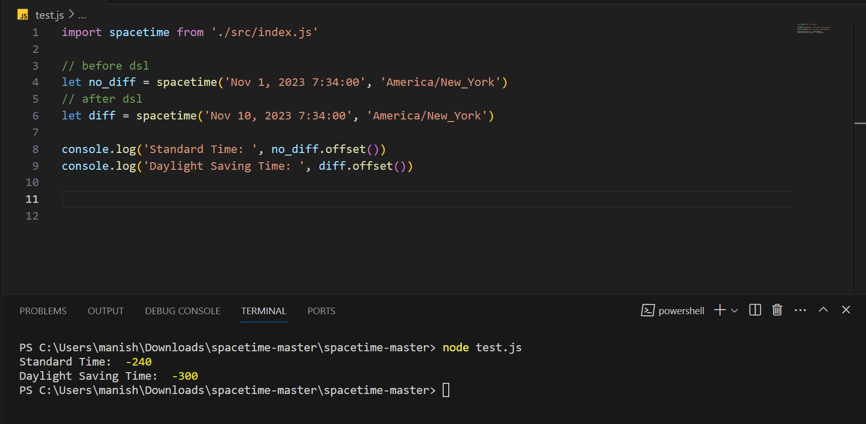
9. Test: Verify that .isAsleep() correctly states if a user is asleep, or in this case, the time is between 10pm and 8am – Returns boolean.
   1. Status: ✓
   2. Documentation/Comments: Passed
   3. 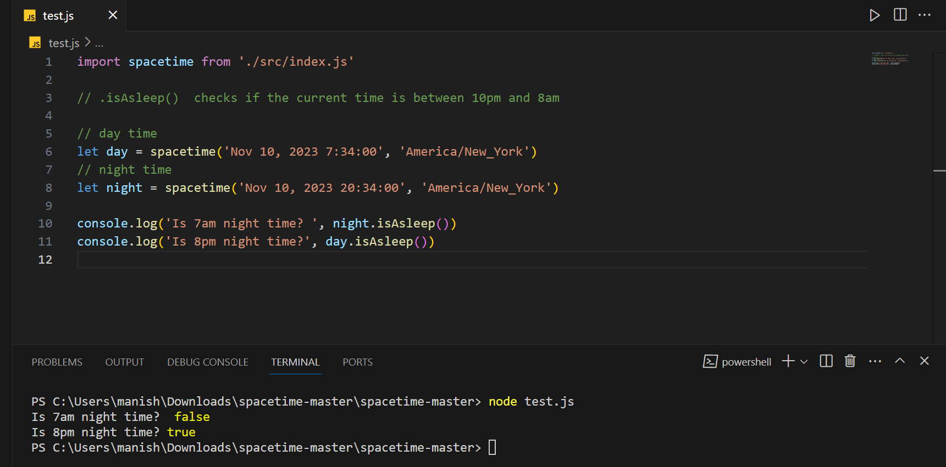
10. Test: Verify that the .i18n() internalization function correctly allows a user to switch between different sets of names based on the desired language or regional conventions. Example: In English, ‘November’ and ‘December’ are ‘Novembre’ and ‘Vendredi’ in French. - Returns clone
    1. Status: ✓
    2. Documentation/Comments: Passed
    3. 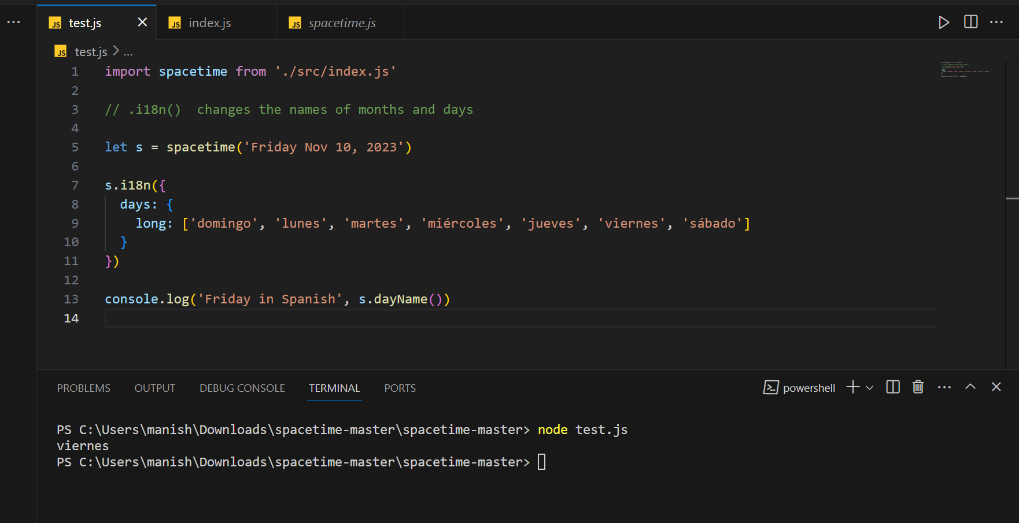
11. Test: Verify that the .weekStart() function can be changed to whichever day is desired. The default starting day of the week for this application is Monday – Return clone
    1. Status: ✓
    2. Documentation/Comments: Passed
    3. 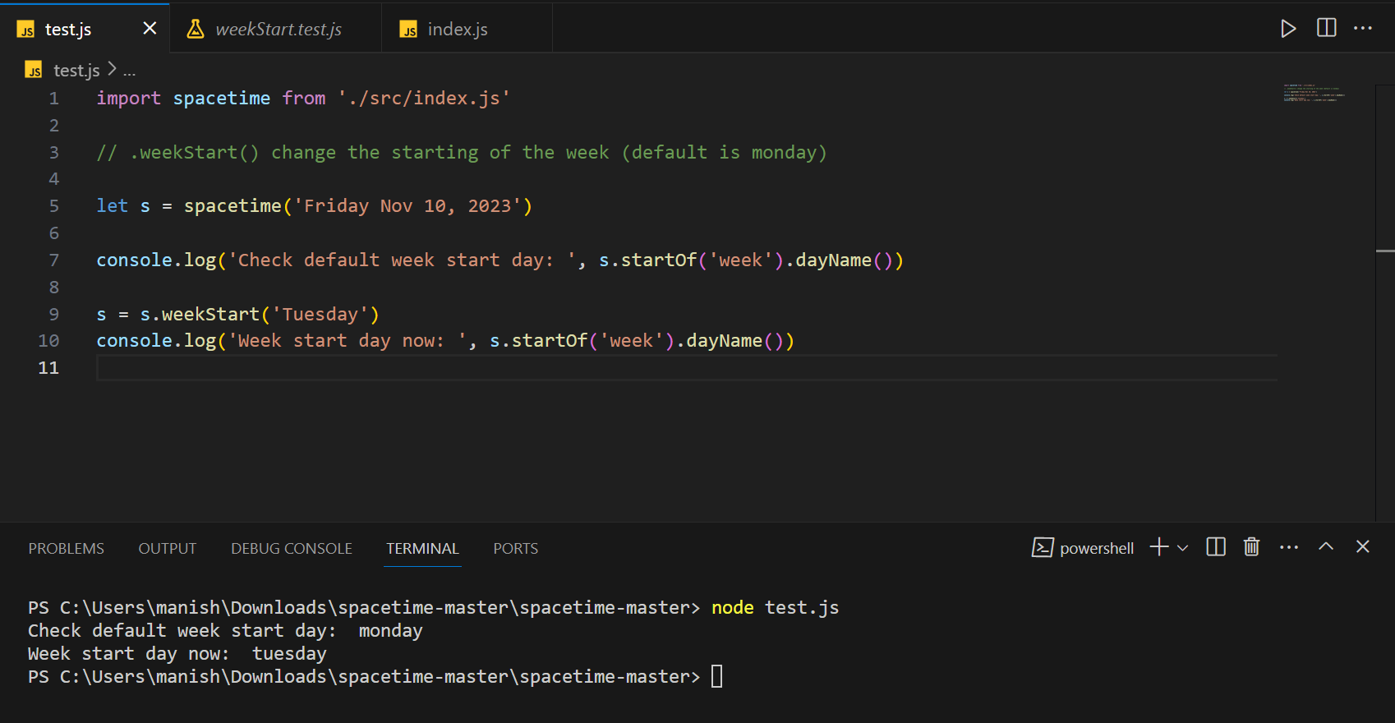
12. Test: Verify that the .daysInMonth() function correctly returns the number of days witin the current month (December has 31 days; June has 30, etc.) - Returns number
    1. Status: ✓
    2. Documentation/Comments: Passed
    3. 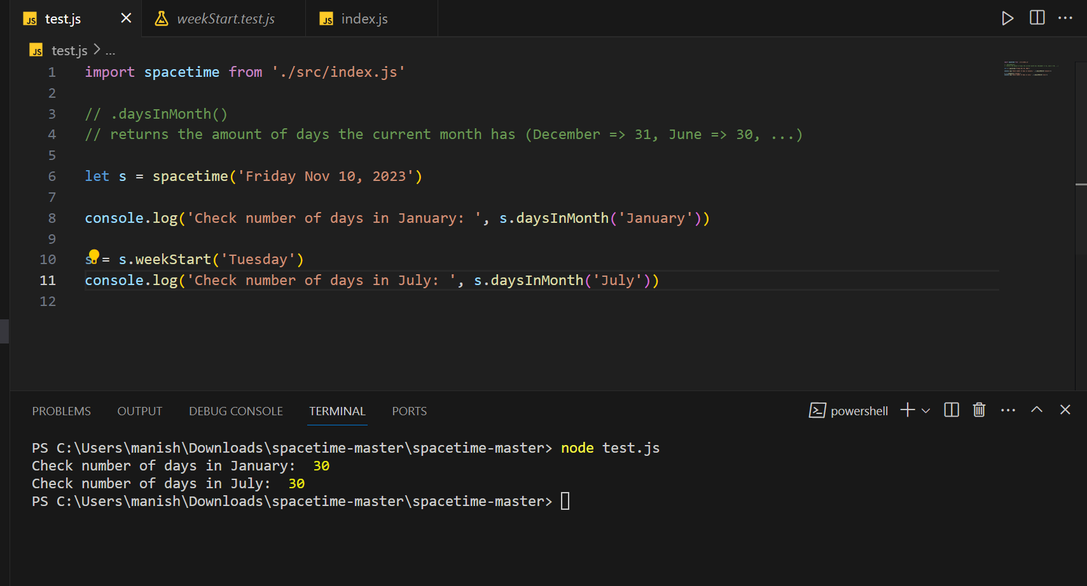
13. Test: Verify that .clone() will make a copy of the object and does not reference the original – Returns clone
    1. Status: ✓
    2. Documentation/Comments: Passed
    3. 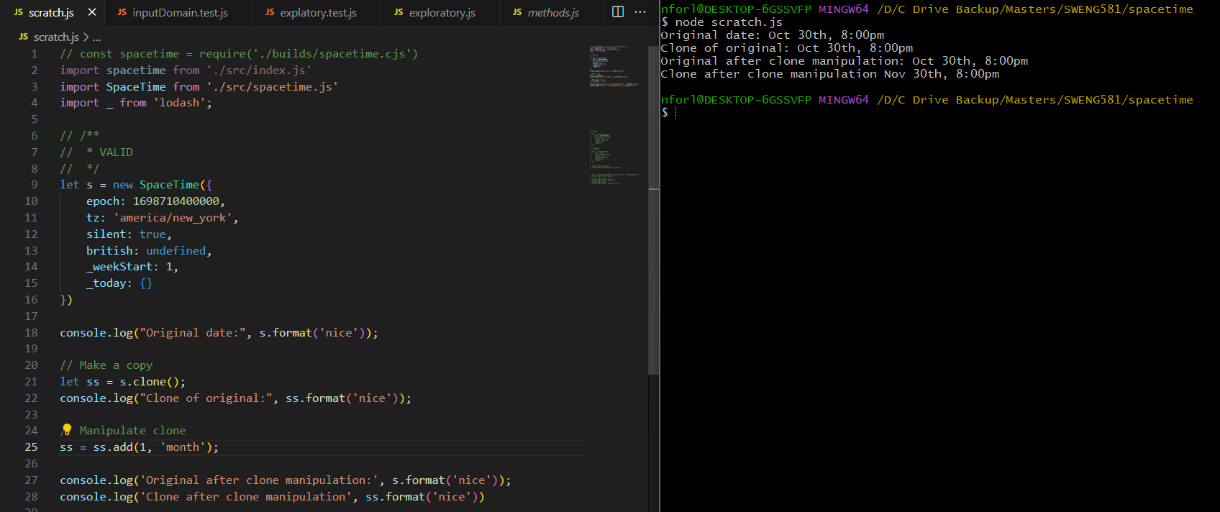
14. Test: Verify that .millisecond() will set or return the current number of milliseconds (0-999) - Returns a clone if setting and number if getting
    1. Status: ✓
    2. Documentation/Comments: Passed
    3. 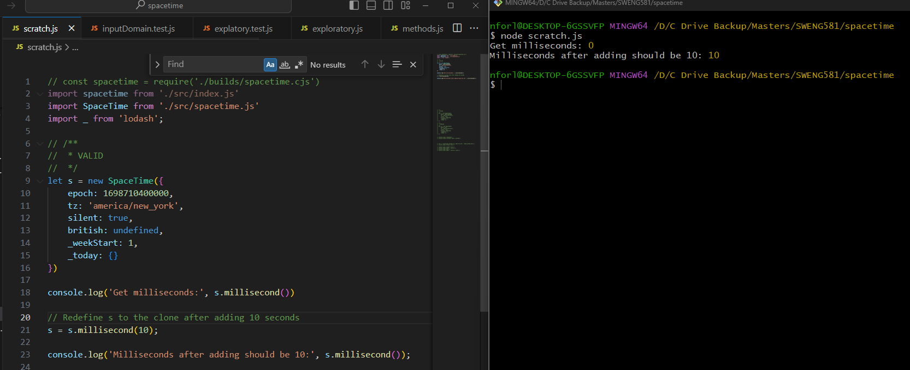
15. Test: Verify that .second() will set or return the current number of second (0-59) - Returns a clone if setting and number if getting
    1. Status: ✓
    2. Documentation/Comments: Passed
    3. 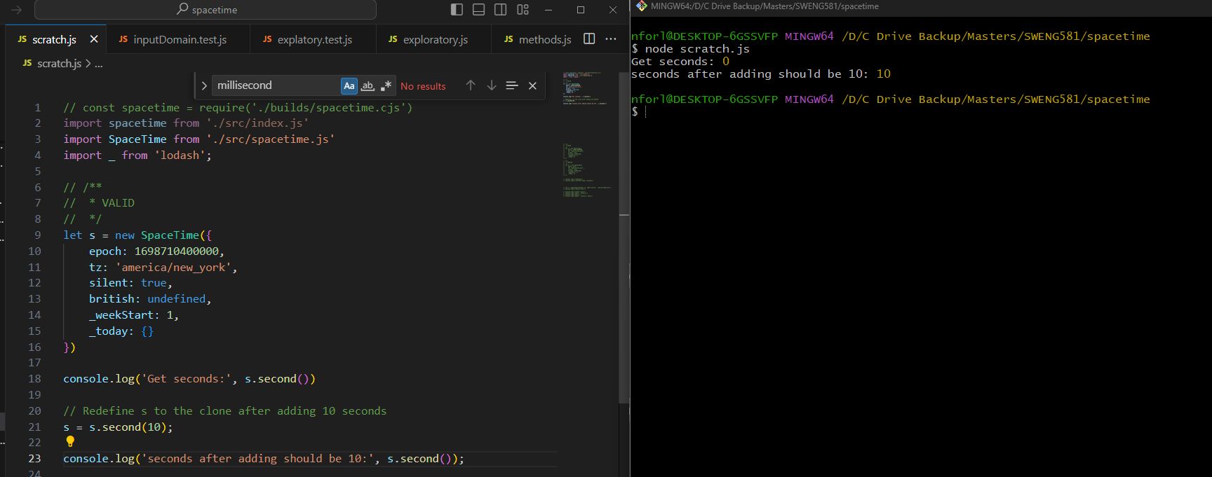
16. Test: Verify that .hour() will set or return the current number of hour(0-23) - Returns a clone if setting and number if getting
    1. Status: ✓
    2. Documentation/Comments: Passed
    3. 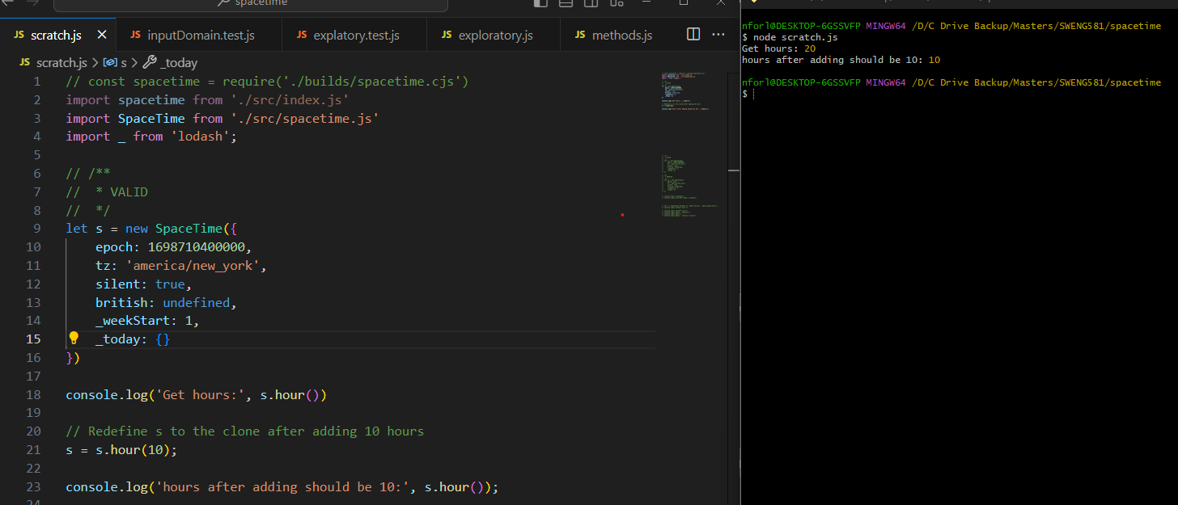
17. Test: Verify that .date() will set or return the current date (1-31) - Returns clone if setting and number if getting
    1. Status: ✓
    2. Documentation/Comments: Passed
    3. 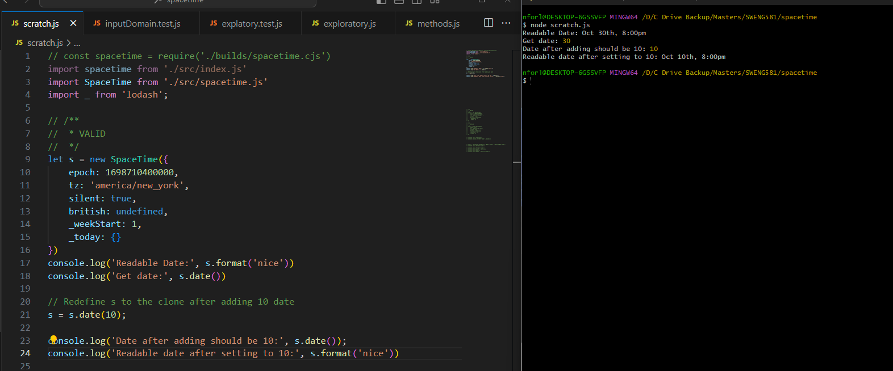
18. Test: Verify that .month() will set or return the zero-based month-number(0-11) - Returns clone if getting and number if getting
    1. Status: ✓
    2. Documentation/Comments: Passed
    3. 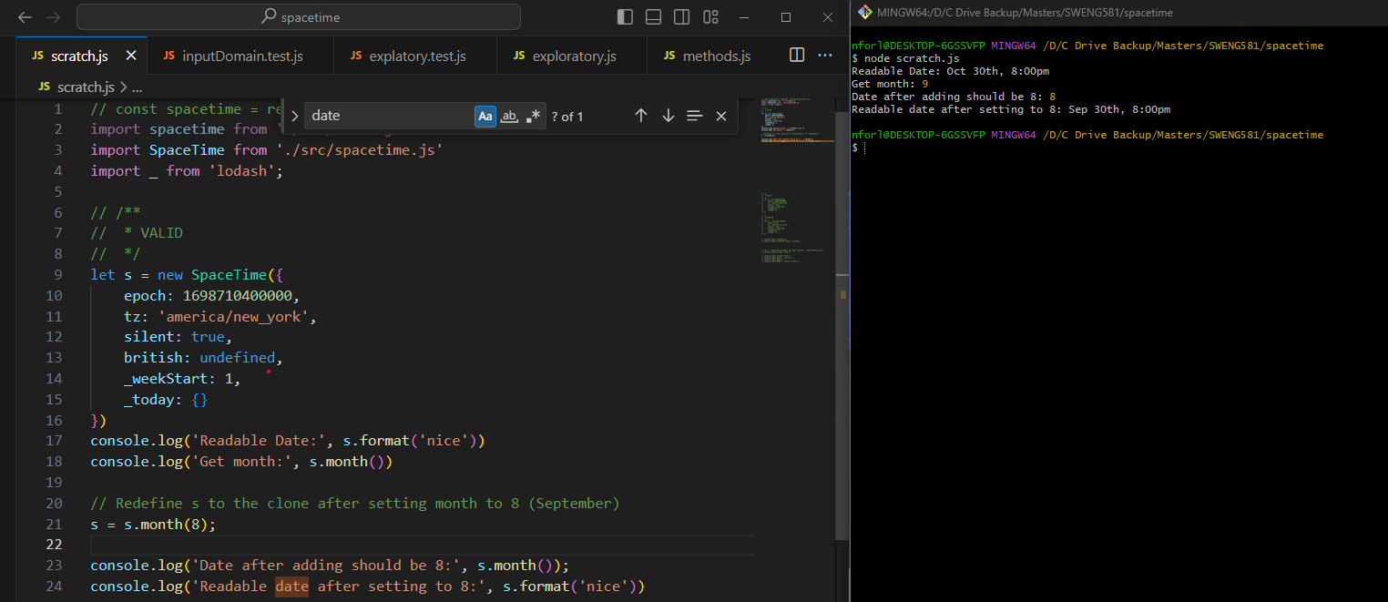
19. Test: Verify that .year() will set or return the 4-digit year as an integer – Returns clone if setting and return number if getting
    1. Status: ✓
    2. Documentation/Comments: Passed
    3. 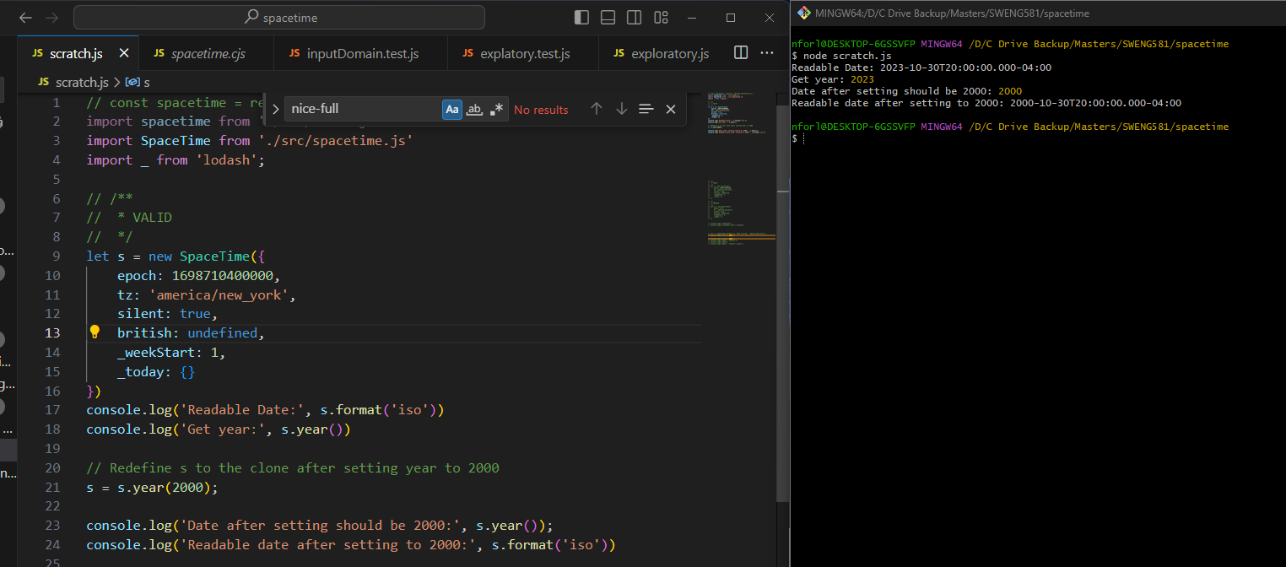
20. Test: Verify that .dayOfYear() will set or return the day of the year (1-366) - Return clone if setting and number if getting
    1. Status:
    2. Documentation/Comments: Passed
    3. 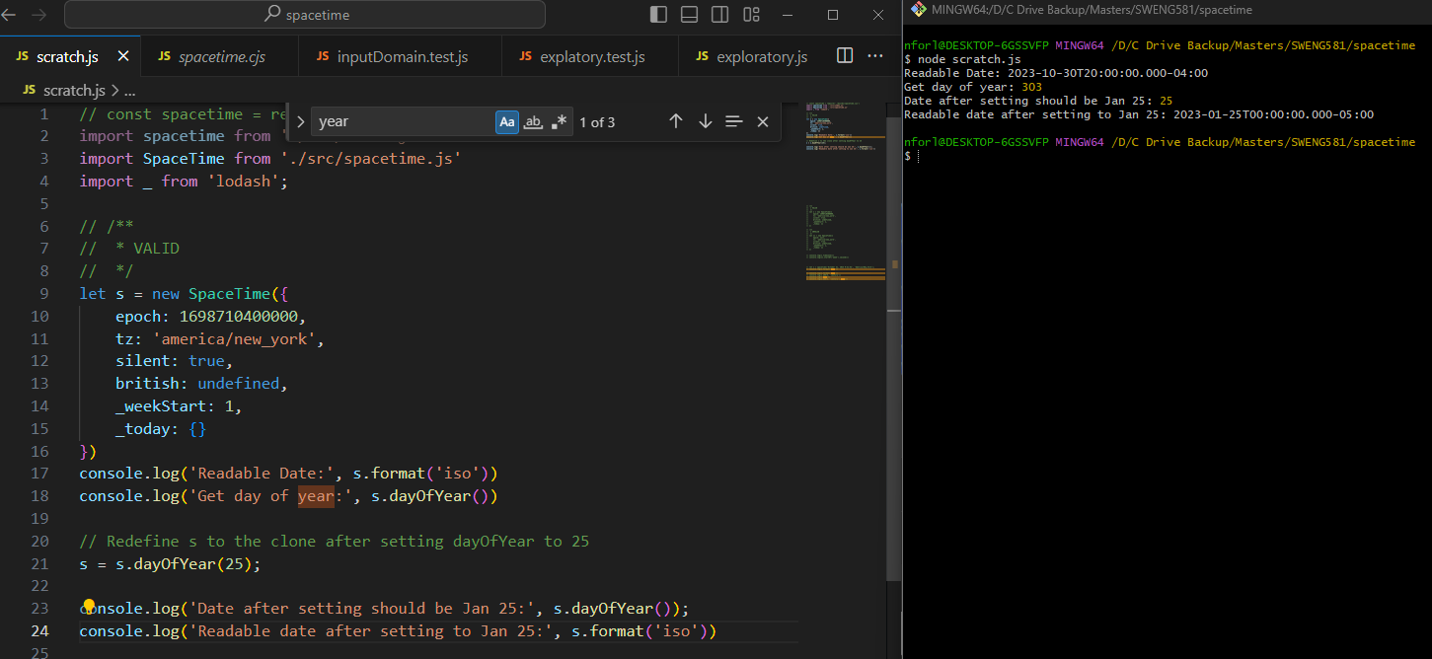
21. Test: Verify that .time() will set or return the time – Return clone if setting and number if getting
    1. Status: ✓
    2. Documentation/Comments: Passed* - The documentation says it should return a number but it should be returning a string. The function is working correctly, but the documentation needs to be updated.
    3. 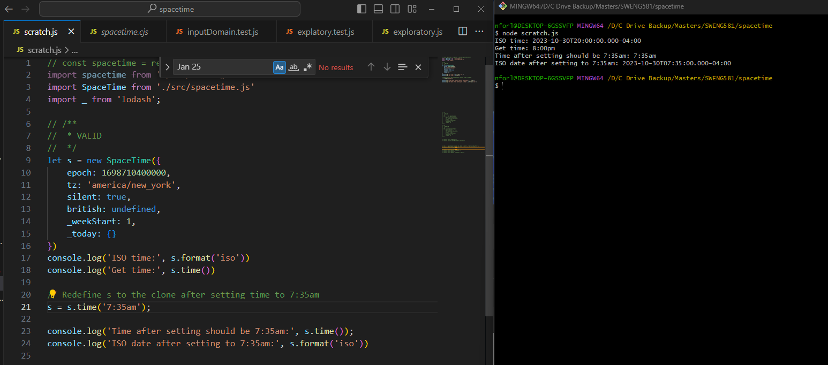
22. Test: Verify that .hourFloat() will set or return the hour + minute in decimal form – Returns clone if setting and number if getting
    1. Status: ✓
    2. Documentation/Comments: Passed
    3. 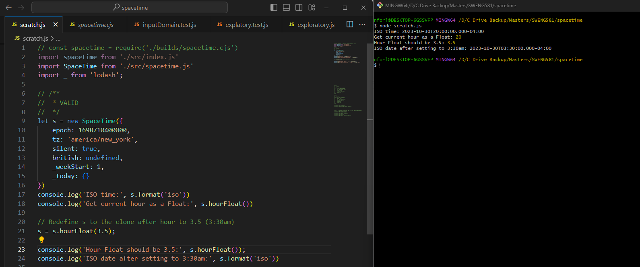
23. Test: Verify that .day() will set or return the day of the week as an integer, starting on Sunday (day-0) - Will return a clone if setting or a number if getting
    1. Status: ✓
    2. Documentation/Comments: Passed
    3. 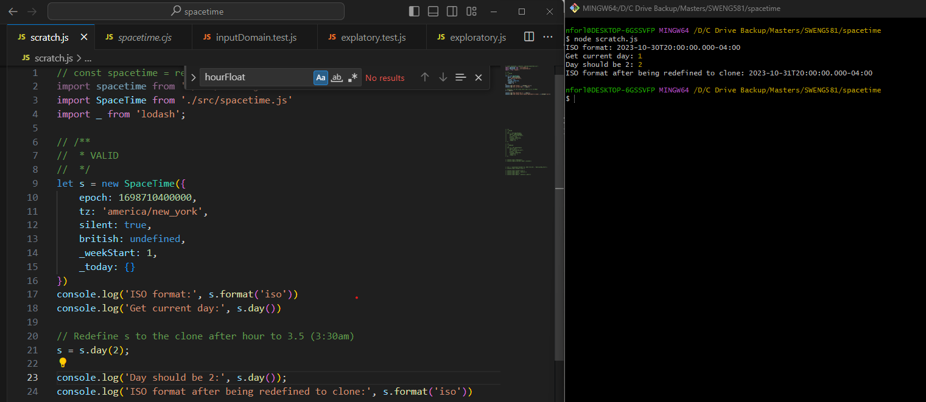
24. Test: Verify that .ampm() will set or return whether the time is am or pm – Returns clone if setting and string if getting.
    1. Status: ✓
    2. Documentation/Comments: Passed
    3. 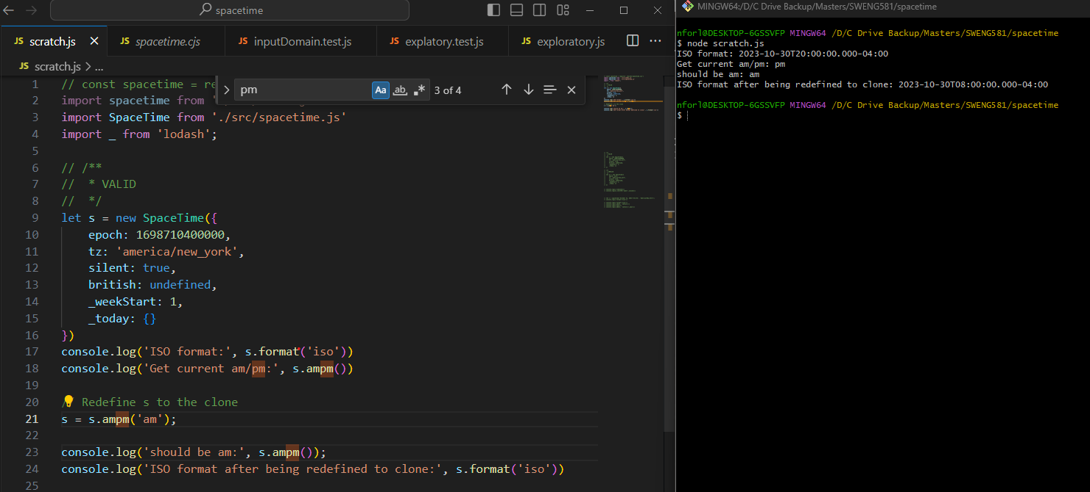
25. Test: Verify that .dayTime() will return or set the general time-of-day – Returns clone if setting and string if getting
    1. Status: ✓
    2. Documentation/Comments: Passed
    3. 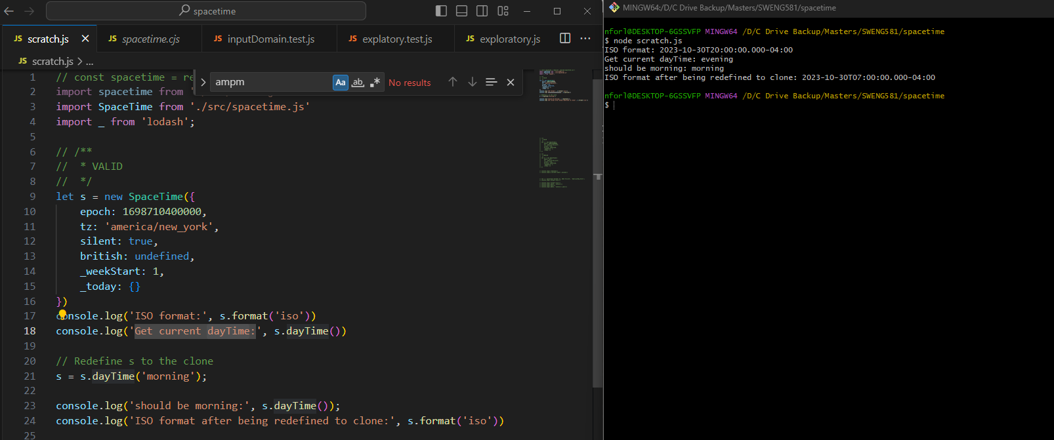

|  |  |  |  |
| --- | --- | --- | --- |
| Nr | What done? | Status | Comment |
| 1 | Verify that the .set() function changes the date to the input parameter and a clone is returned |  |  |
| 2 | Verify that the .isValid() function confirms a valid date and time according to the rules of the Gregorian calendar and the JavaScript Date object – Return clone |  | The docs say the return type is a clone. The correct return type should be Boolean |
| 3 | Verify that the .log() function will pretty-print the date to the console, for nicer debugging – Return clone |  |  |
| 4 | Verify that the .progress() function correctly calculates the progress of a given moment within a specific time frame, such as a day, week, month, or year. The function takes a moment in time and returns a value between 0 and 1, indicating how far that moment is in relation to the start and end of the specified time frame – Return Object |  |  |
| 5 | Verify that the .leapYear() function correctly returns if the current year is a leap year or not – Returns Boolean |  |  |
| 6 | Verify that the .inDST() function corectly returns if the current selected time zone is in daylight savings time – Returns Boolean |  |  |
| 7 | Verify that the .hasDST() function validated if the timezone ever uses daylight-savings and return boolean |  |  |
| 8 | Verify that the .offset() function correctly calculates the current time difference from Coordinated Universal Time (UTC) while accounting for Daylight Saving Time (DST) - Returns number. |  |  |
| 9 | Verify that .isAsleep() correctly states if a user is asleep, or in this case, the time is between 10pm and 8am – Returns boolean. |  |  |
| 10 | Verify that the .i18n() internalization function correctly allows a user to switch between different sets of names based on the desired language or regional conventions. Returns clone |  |  |
| 11 | Verify that the .weekStart() function can be changed to whichever day is desired. The default starting day of the week for this application is Monday – Return clone |  |  |
| 12 | Verify that the .daysInMonth() function correctly returns the number of days witin the current month (December has 31 days; June has 30, etc.) - Returns number |  |  |
| 13 | Verify that .clone() will make a copy of the object and does not reference the original – Returns clone |  |  |
| 14 | Verify that .millisecond() will set or return the current number of milliseconds (0-999) - Returns a clone if setting and number if getting |  |  |
| 15 | Verify that .second() will set or return the current number of second (0-59) - Returns a clone if setting and number if getting |  |  |
| 16 | Verify that .hour() will set or return the current number of hour(0-23) - Returns a clone if setting and number if getting |  |  |
| 17 | Verify that .date() will set or return the current date (1-31) - Returns clone if setting and number if getting |  |  |
|  |  |  |  |
| 18 | Verify that .month() will set or return the zero-based month-number(0-11) - Returns clone if getting and number if getting |  |  |
| 19 | Verify that .year() will set or return the 4-digit year as an integer – Returns clone if setting and return number if getting |  |  |
| 20 | Verify that .dayOfYear() will set or return the day of the year (1-366) - Return clone if setting and number if getting |  |  |
| 21 | Verify that .time() will set or return the time – Return clone if setting and number if getting |  | The documentation says it should return a number but it should be returning a string. The function is working correctly, but the documentation needs to be updated |
| 22 | Verify that .hourFloat() will set or return the hour + minute in decimal form – Returns clone if setting and number if getting |  |  |
| 23 | Verify that .day() will set or return the day of the week as an integer, starting on Sunday (day-0) - Will return a clone if setting or a number if getting |  |  |
| 24 | Verify that .ampm() will set or return whether the time is am or pm – Returns clone if setting and string if getting |  |  |
| 25 | Verify that .dayTime() will return or set the general time-of-day – Returns clone if setting and string if getting |  |  |