Nick Forleo

Figure 1: Small End

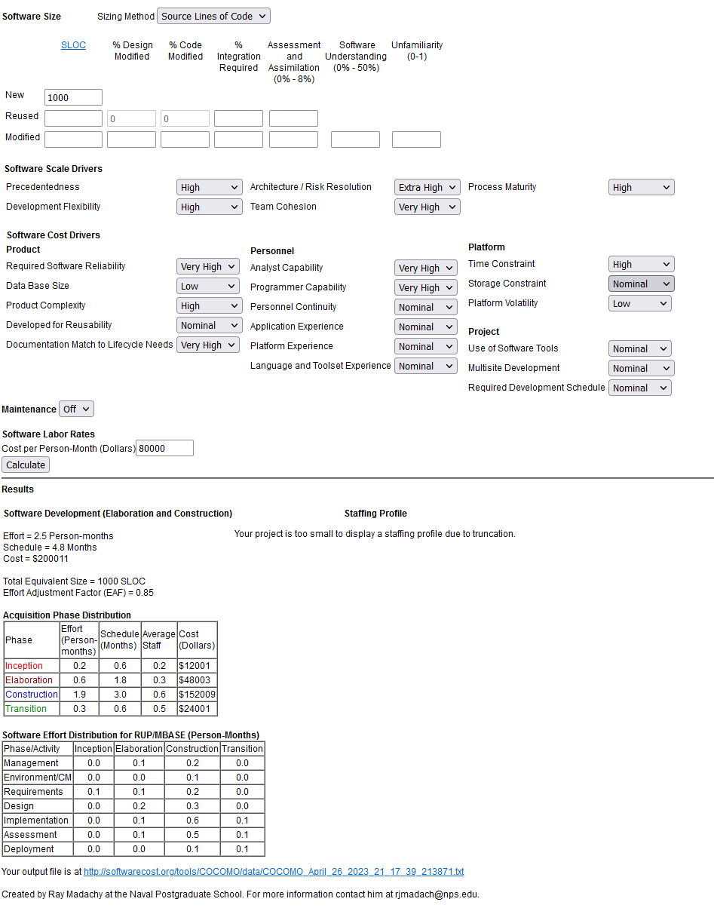

Figure 2: High End

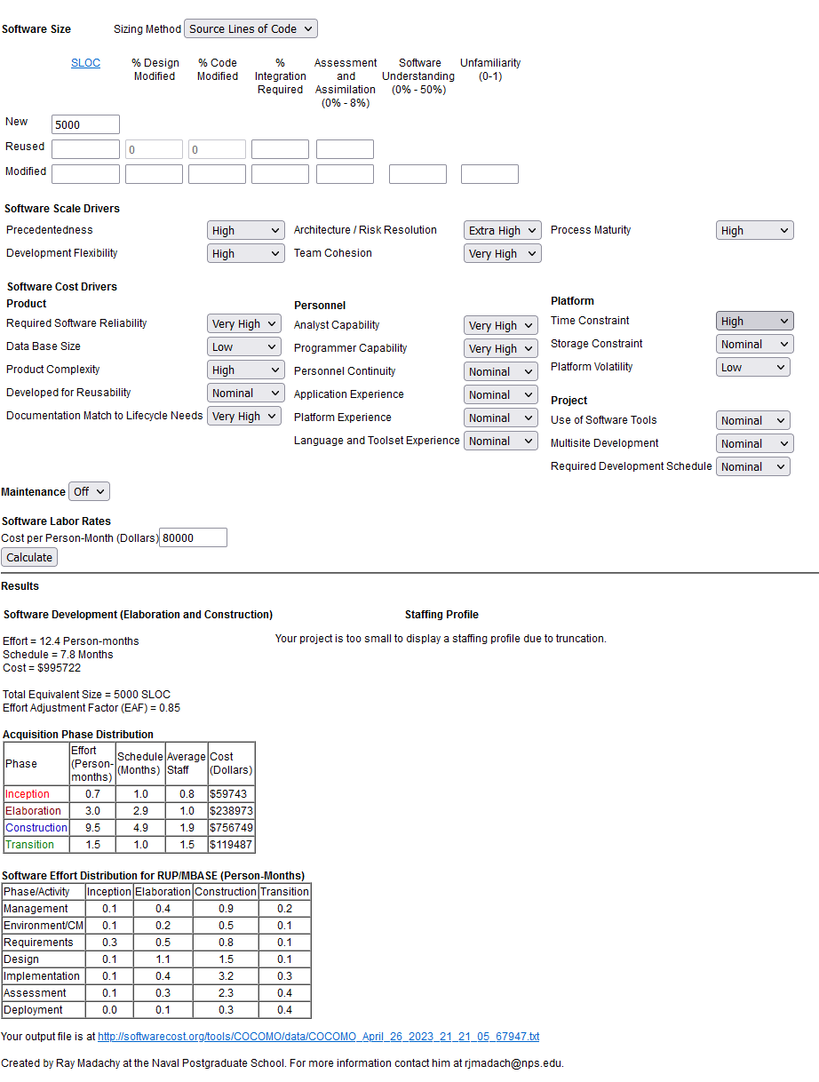

I ran the model based on the software aspect of the system, since that’s what the model is best for. Therefore, the model doesn’t entirely represent the cost of development for the whole system, but rather just the software portion. I also ran it twice, once with a smaller estimated codebase and once with a bigger estimated codebase. This way, if the system was actually being developed, we could provide the customer with a range of expected cost, rather than a single number that the customer might believe to be accurate. I also made some assumptions about the personnel working on the project, like potential salary and how many of us there are (IN this case, four). Although not pictured, I also adjusted the personnel skills to see how that would impact the cost. It was interesting to see how having less capable works caused such an increase in cost.

The cost breakdown was also pretty interesting and I think it is fairly accurate. The inception of the project would cost the least because at this point you would just be determining if such a product needs to be built. Then the elaboration would follow since gathering requirements is in this step and those should be done as complete and accurate as possible. The construction phase would be the most expensive because this is where a lot of the labor cost is going to be. Finally, transition cost being in between inception and elaboration also makes sense because you will have to support the customer as they take ownership of the system. The costs for this phase would start a bit higher but taper off as the customer becomes more comfortable with it.