CSE241 Final Lab Documentation
Nathan Fox
Spring 2023
Table of Contents
1 System Description 1
2 System Specifications 1
2.1 System 1 : Decoder 2
2.2 System 2: Function Implementation 2
3 System-Verilog Implementation
4 Analysis 5
5 Recommendations 6

System Description
For the final lab, the task was to design a security system using a finite state machine setup, as well as define the surrounding environment to the security system. As such, a keypad for a safe on a desk was created and is what will be discussed in this document. The combination to this safe is going to be 0b1000. The keypad has four inputs: OBUT, ZBUT, ENBL, and SECI. The keypad has two buttons: a button that enters a 0 (zbut), and a button that enters a one (obut). ENBL or enable (E) would be physically represented with plugging the system into the wall, and unplugging it would turn the system off. Security violation (seci) would be something such as moving the safe while it is active, or setting it down on a slant, since it needs to be perfectly perpendicular. For output, the system also has four LEDS: LOCK, ULCK, RSTO and SECV. SECV only triggers during a security violation. The system reads in the passcode one bit at a time, and whenever it reads in a wrong bit, it triggers the RSTO LED. ULCK and LOCK represent whether the safe is unlocked or locked, respectively.

System Specifications
As touched on in section 1, there are four inputs and four outputs. These inputs and outputs are controlled via a Moore-style state machine. The following is the state diagram the system was design using:
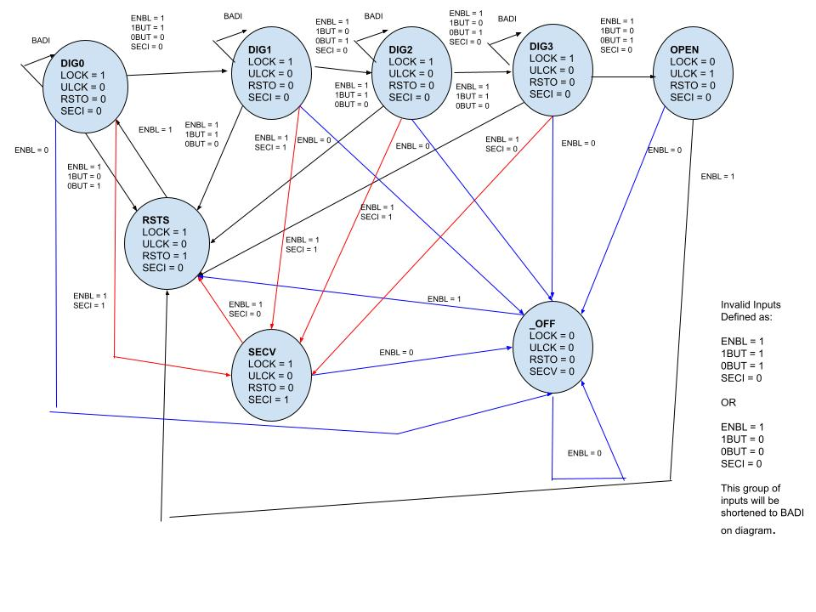
As shown, there are a total of 8 states. Four states for each bit of the passcode and four special states. These special states are the following:
Reset-State (RSTS): The state when a incorrect digit of the passcode has been passed in, triggering Reset-Out (RSTO). On clock update, assuming the system is enabled, it will transition back to Digit 0.
Security Violation: The emergency state when a security violation has been detected, using the Security Input (SECI). This could be anything from an attempted break in to setting the safe down at a slant. Regardless, the SECV state will trigger the eponymous output, SECV. Only when SECI is turned off will the system transfer into RSTS and resume normal reading. This will not occur when the safe is OPEN, because it is pointless to try to lock the system further if it is already open.
_OFF: The state that represents when everything is off. Since the system needs electricity to work, and enable (ENBL) has been defined to be plugging the system into the wall, any time ENBL is off the system immediately shuts down.
OPEN: The state which represents an open safe. The safe is open, and locking it is done mechanically after a clock update.

Transitioning through these states was found and implemented using kmaps to find transition equations, and output equations. These kmaps were derived from the state table and transition table. A total of 7 Kmaps were used. They will be shown below:
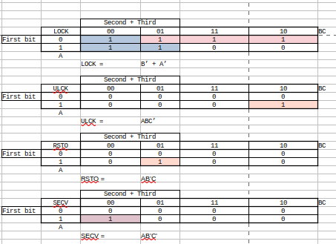
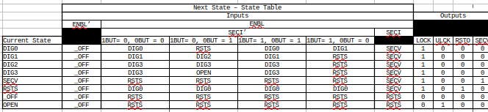
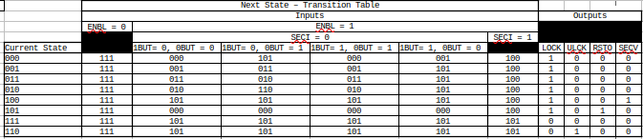
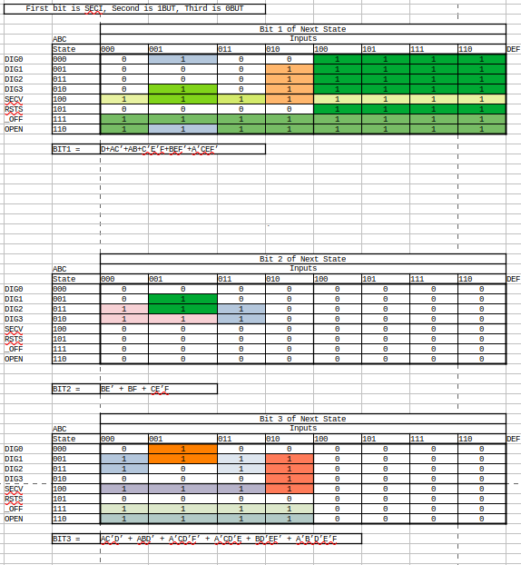

System-Verilog Implementation
The system was partially implemented in system verilog using a d-flip-flop module, and assign statements. Partially because it is incomplete, due to time constraints. Originally the implementation was using a large case statement to manually set each output LED depending on the state, but upon compiler error after compiler error the decision was made to switch to assigns, as a case statement in verilog turned out to the extraordinarily unpleasant. Regardless, there are some quirks of this implementation, the biggest one being vcd was not able to be used to create a timing diagram. It is unknown why, possibly because of all of the continuous assignment statements instead of gate-level implementation or decoders, but a truth table was all the information that could be extracted from this implementation. Arrays were used to conveniently store the 3-bit state into one data structure, so all manipulation of state was done on this array.

As for testing the system, it is again incomplete. The goal was to go through most possible inputs and transitions, to validate that resetting worked, _OFF worked, and so on. Only validation of it reading in the correct sequence of bits and unlocking was gotten to. The following is a truth table of the last compiled example, and it is not correct. All inputs are shown as well as all outputs. The final two columns are displayed for debugging purposes and would not be visible to a normal user, as they represent the state of the system.
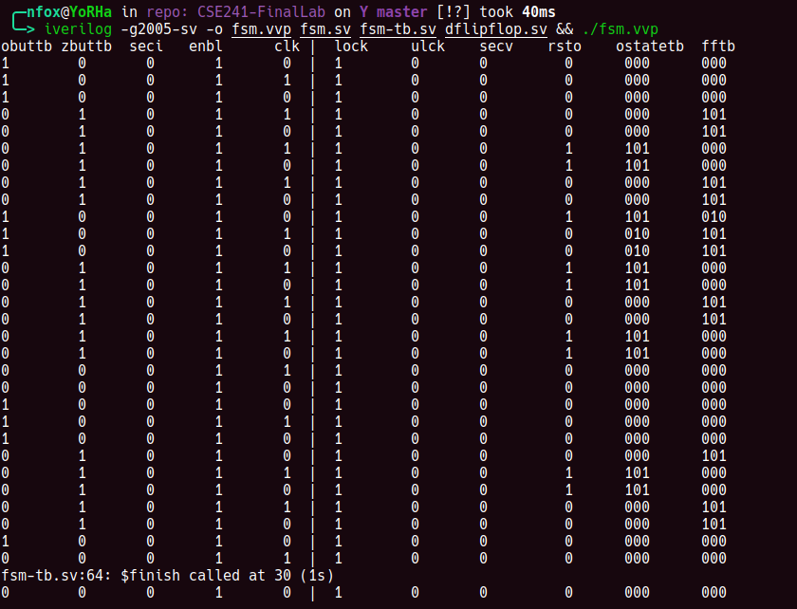

Analysis
The results from the little testing that was implemented suggest that the transition equations are implemented incorrectly and need to be reviewed. Since the transition equations require review, the output equations cannot be trusted. Overall, a disaster of a project. This safe is not going to protect anything. Little other useful information can be extracted, since the veracity of any information is in doubt considering the probable incorrect calculation and implementation of the transition and output equations.

Recommendations
It needs to work, quite simply. Before any other recommendations can be suggested it needs to work correctly first.

