**Directions:** This project will be a guided semi-replication of Stevenson and Wolfers (2006) “Bargaining in the Shadow of the Law: Divorce Laws and Family Distress”. *Quarterly Journal of Economics*, February. It’ll be uploaded along with this assignment to Canvas. Your job is to run *comparable* analysis as to what we have done in class, and which appears in their paper. This is due two weeks from Tuesday April 7th (or April 21st).

**Discussion of paper**

1. Write a two paragraph summary of this paper that answers the following questions:
   1. What is their main theoretical question?
   2. What is their research design?
   3. What data do they use?
   4. What is the key figure they present to illustrate their main findings in your opinion?
   5. Briefly summarize what they found in 1-2 sentences.
   6. Did you find the analysis convincing? If so, what specific evidence was compelling? If not, what was missing that had they done it would’ve potentially been more convincing?
2. What is no fault divorce and why do Stevenson and Wolfers think it’s relevant to suicide and homicide? Briefly explain their theory and what it has to do with the Coase theorem.
3. Write down and explain their estimation equation. Explain what each variable means, what each coefficient means, what each summation sign means, what each subscript means, what the epsilon means. What is the main parameter of interest?

**Pre-Analysis**

1. Create the directory and subdirectory system described in class for a new project entitled /Nofault_Divorce
2. Download the Stata data sw_nofault_divorce.dta and store it in the /Nofault_Divorce/data subdirectory
3. Create either a .do or .R program file and store it in either your /Do subdirectory of an equivalently named R program subdirectory
4. Create a table of states and treatment dates.
   1. Which states are the treatment groups, and when did they pass no fault divorce legislation?
   2. Which states never pass no fault laws?

**Empirical work**

Our analysis will only focus on two outcomes: homicide rates for females and suicide rates for females.

1. First estimate a simple diff-in-diff model with a static post-treatment dummy variable for the ATT. To do this, regress homicide rates (asmrh) and suicide rates (asmrs) against a treatment dummy (post), state fixed effects, and year fixed effects.
   1. Adjust your standard errors for serial correlation using the clustering correction.
   2. Create a new variable called “trend” which is equal to one in 1964, 2 in 1965, etc. Now estimate a new model that includes the prior controls but interacts the trend variable with each state fixed effect.
   3. Report your results in a beautiful table which explains exactly what you did and what you found.
2. What is the identifying assumption needed to estimate the variance weighted ATT when there is differential timing and using OLS? Test for the plausibility of this assumption in the pre-treatment period by estimating pre-treatment leads. Create an event study like the one we reviewed in Cheng and Hoekstra “castle doctrine” paper (which I’ve attached below). Examples of code that can do this are in the castle_x.do and castle_x.R files uploaded to Canvas.
3. Interpret the coefficients on the leads and lags. How convincing is it that the treatment units were not statistically different from the control units in the pre-treatment period?
4. Decompose the treatment effect into individual 2x2 diff-in-diff numbers.[1] Plot the figure scattering the weights against their respective 2x2 numbers. Show that the DD coefficient you estimated using your regression is equal to the weighted average of all DD comparison groups.
5. Name two situations under which the static DD parameter is a biased estimate of the true ATT? Which one is testable and which one is not testable? How concerned should we be, and why?

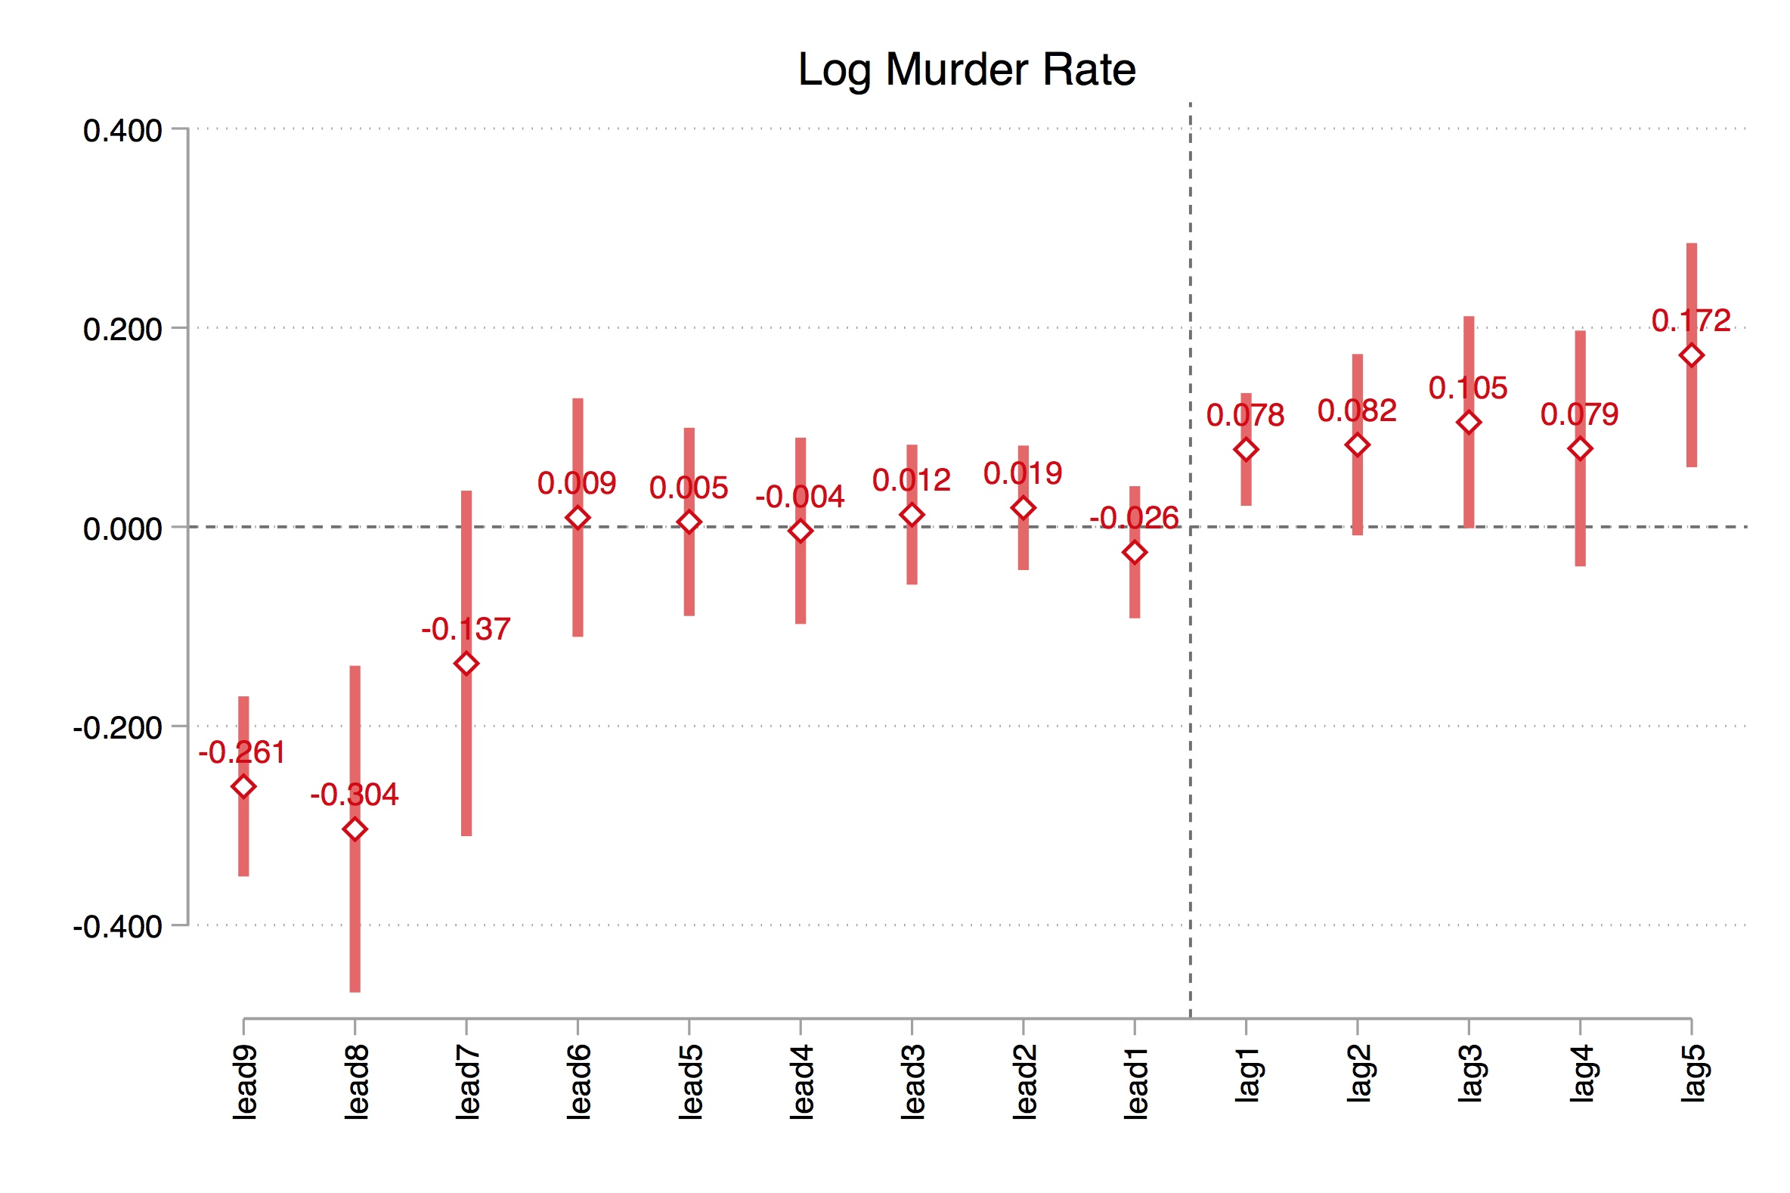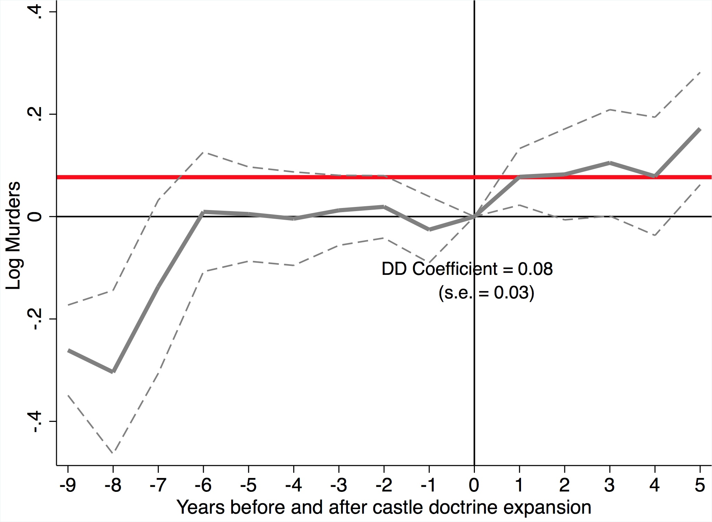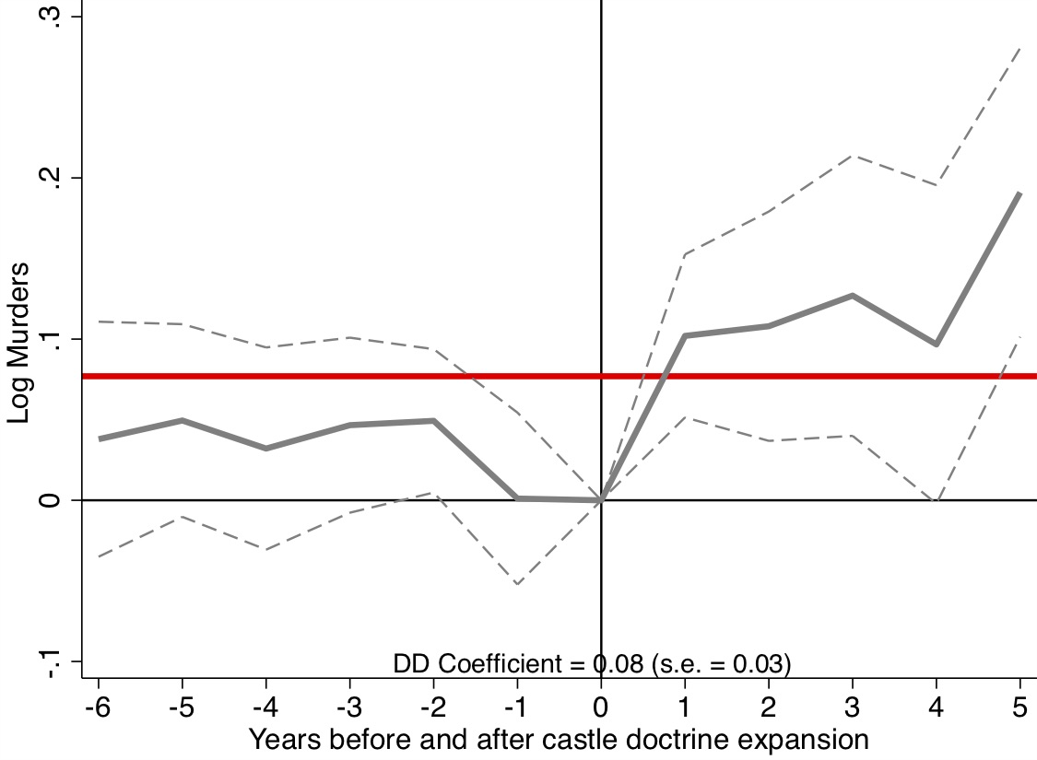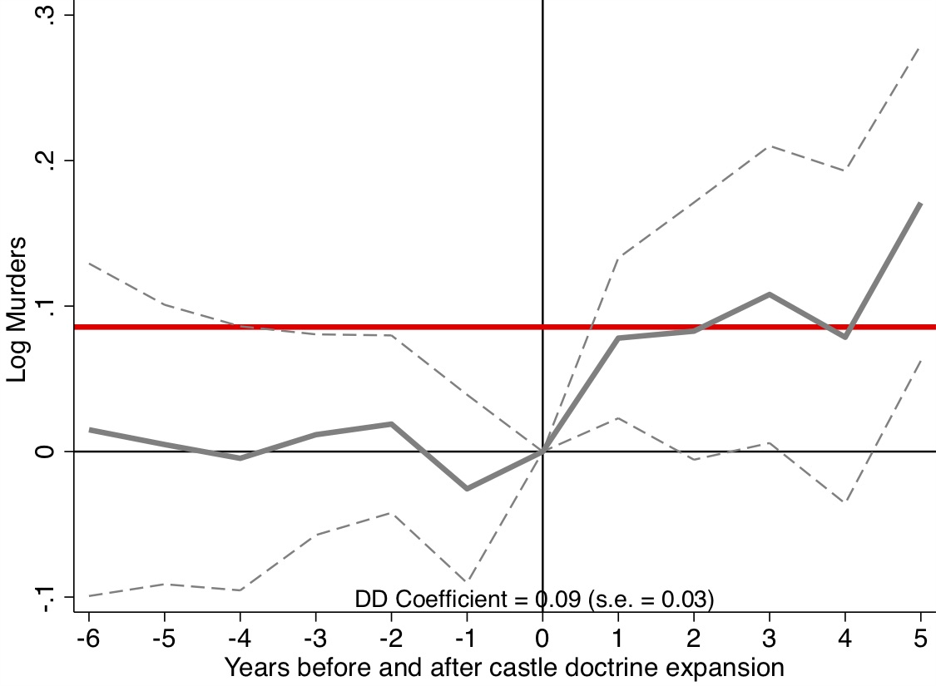

1. Because there were a group of states that passed legislation prior to the start of the panel, these are controls called the “Already treated”. There’s a second group of states who never received the treatment called “Never treated”, and these are distinct groups.