Research Project Proposal – Nathan Franz

*Causal Question*

How does exposure to lithium in drinking water affect labor market participation?

*Importance*

Lithium is used as a treatment for manic-depression and some other disorders. There is some evidence that, at concentrations somewhere around a hundredth or thousandth the psychiatrically used dose, lithium naturally found in drinking water is correlated with decreased suicide rates. Whatever the mechanism of action, lithium may regulate mood in a way that prevents the extremely drastic action of killing oneself. If so, it also seems likely to prevent less drastic symptoms of mood disorders, such as behavior that might lead to reduced labor market participation among those suffering. A cheap additive to drinking water that may have such a large positive effect on mental health is absolutely worth investigating.

*Randomized Experiment*

In order to investigate this question with a randomized experiment with an unlimited budget, I would randomly assign treatment or control roles to a few dozen counties with low-lithium drinking water. I would then increase the lithium levels in their municipal water for the treatment group to the high end of those that occur naturally (say, 100 μg).

*Natural Experiment*

In order to *actually* investigate this question, I will use the variation in groundwater lithium levels that occurs as a result of geological variation. These concentrations vary substantially between areas the size of counties or PUMAs. I have data detailing when people moved into their current residence and where they moved from, which, if combined with average lithium level in the PUMA of residence, gives an estimate of lithium exposure.

*Data*

I will use IPUMS ACS data with geographic, demographic, migratory, and labor-related variables. I will also use US Geological Survey Water Quality Data to estimate the average lithium levels of each PUMA.

*Tentative DAG*

*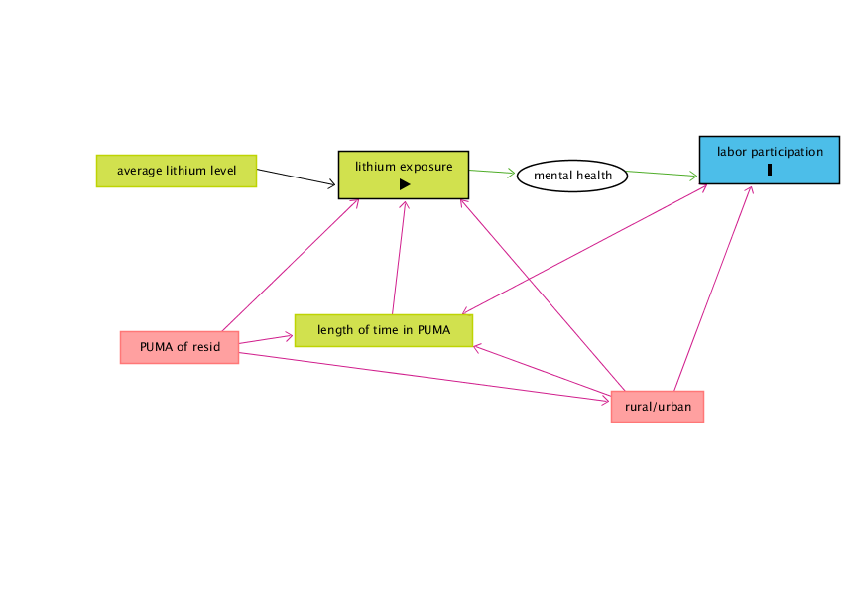*

*Sources*

<https://www.gwern.net/Lithium>

<https://www.waterqualitydata.us/>

<https://usa.ipums.org/usa/>

<https://usa.ipums.org/usa/volii/boundaries.shtml> (shapefiles)