**Ankit Thakur**

**Professional Summary**

As an automation engineer with over 8 years of experience, I have delivered RPA solutions for using Ui-path, Selenium and Katalon Studio. I have improved efficiency, accuracy and customer satisfaction by automating manual tasks. I have strong analytical, problem-solving and communication skills, and I am keen to learn new technologies and skills.

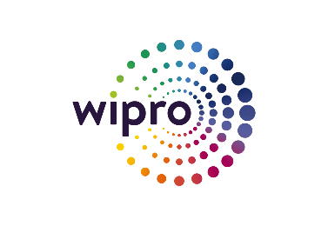**Professional Experience (8 Years)**

Sept 2019 – Present **Wipro Technologies - Developer Analyst- II**

**Project: Prototype YSA Rule Engine**

* Working with C# programming language and .NET framework, including .NET Core,

MVC, Entity Framework, etc.

* Familiarity with web development using C# and web technologies such as HTML, CSS, JavaScript, Angular, etc.
* Ability to use SQL and database management systems such as SQL Server, Oracle, MySQL, etc.
* Proficiency in software engineering principles and best practices such as object-oriented design, design patterns, SOLID principles, unit testing, code review, etc.

**Project: CRAFT**

* Designing, developing workflows using UiPath Studio.
* Ability to use Uipath REFramework, a robust and scalable framework for building complex and reliable automation projects.
* Deploying components of automation such as robots and packages on Orchestrator.
* Working with C# .net. and developing API using C#.net.
* Good knowledge of the RPA lifecycle and how to produce automation.
* Analyzing business requirement in order to determine the best automation strategy.

**Project: CBA**

* working with Katalon Studio, a test automation tool that supports web, API, mobile, and desktop testing.
* Proficiency in OOPS concepts and scripting languages such as Java, Groovy.
* Experience with database systems such as SQL Server, Oracle, MySQL, etc. and data manipulation techniques such as SQL queries, Excel formulas, etc.

July 2017 – Sept 2018 **HCL Technologies – Software Engineer**

* Executing Automation Test scripts using Selenium web driver.
* Creating Test Plans, Test Set and Executing Test Cases and reporting on TFS.
* Updating and Maintaining Automation framework, adding new scripts.

July 2014 – May 2017**Tech Mahindra - Jr. Software Engineer**

* Planning functional scenarios for testing based on Business requirements.
* Performing smoke test at the beginning of a test cycle.
* Maintaining automation framework and creating new scripts using Selenium web driver.
* Carrying out regression testing through Automation at the end of a release.

**Educational Qualification**

2019 **Masters of Computer Applications** School of Computer and Information Sciences

Indira Gandhi National Open University

2014 **Bachelor of Computer Applications**

**Vivekananda Institute of Professional**

Guru Gobind Singh Indraprastha University

**Technical Skills**

RPA Tools Ui-Path Studio/Orchestrator

Automation Tools: Selenium

Lifecycle Management tools: JIRA, and Team Foundation Server

Programming Skills: Core Java, C#,

Database Tools: MS SQL Server, Oracle SQL Developer

Operating Systems: Windows, Linux and Mac OS

Applications: Eclipse, Visual Studio, VS Code, Net Beans, MS Office