dbt Learning Program
Week 3 Recap & Week 4 Guide
A Reusable Macro

This guide walks through everything covered in Week 3 and introduces the new concepts for Week 4, with diagrams for each major idea. The goal is not just to finish the tasks and get a passing grade — it's to actually understand why each step matters, because that understanding is what carries over into every future project you touch, long after these specific tables are forgotten.

What's Inside
- Part 1 — Week 3 Recap: generic tests, custom tests, and test severity — what you built and why it matters
- Part 2 — Week 4 Guide: Jinja macros and the “don't repeat yourself” principle, explained with diagrams
- Part 3 — Walkthrough of all three Week 4 tasks with code
- Part 4 — Mistakes to Avoid, Word List, and Quick Quiz

Part 1 — Week 3 Recap: Test the Warehouse
Week 3 was about proving your warehouse is trustworthy, not just that it runs without errors. Before you touch Week 4, make sure the ideas below feel solid — the macro you're about to write will live inside fct_order_items, the same model you spent all of last week testing.

What You Actually Built in Week 3

1. Generic Tests in schema.yml
You declared reusable checks — unique, not_null, and relationships — against columns in models/schema.yml: primary keys on the three dimensions and stg_orders, and foreign keys on fct_order_items pointing back to dim_products and dim_customers.

2. A Custom Singular Test
You wrote tests/test_net_amount_non_negative.sql — a plain SELECT that returns any row where net_amount is negative. It found real bad data (a 150% discount), so you set it to severity='warn' rather than deleting it.

3. Test Severity and store_failures
Every test has a severity: error (the default) stops the pipeline and skips anything downstream; warn logs the problem and keeps going. You used warn for known-dirty source data you weren't fixing, and turned on store_failures so the actual bad rows land in a queryable audit table instead of just a row count.
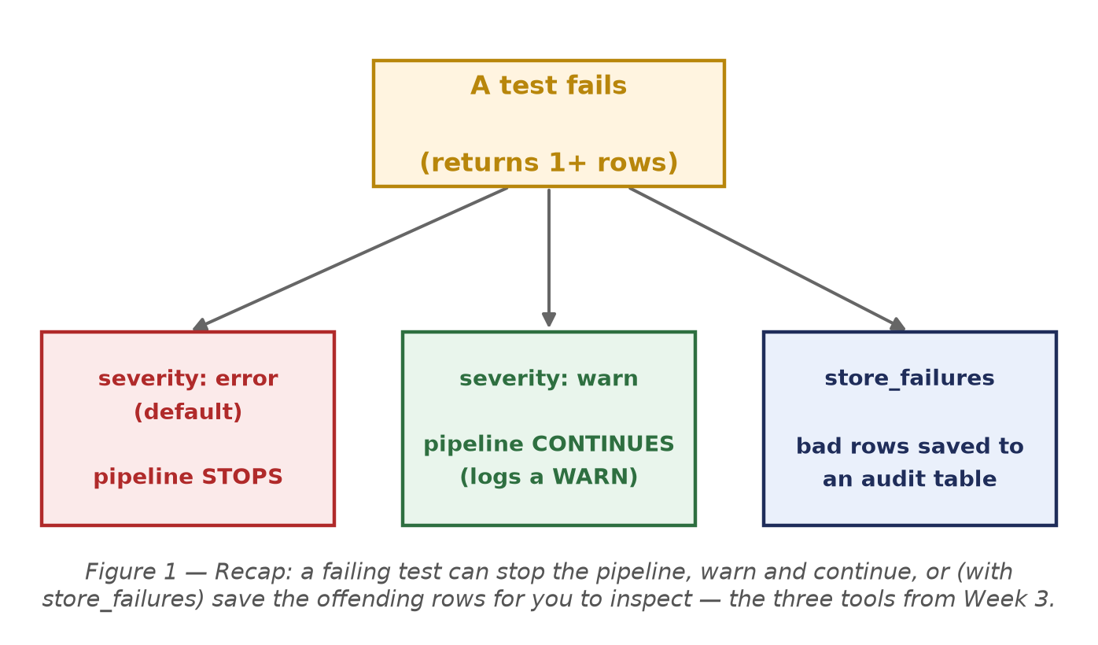
Figure 1 — Recap: a failing test can stop the pipeline, warn and continue, or (with
store_failures) save the offending rows for you to inspect — the three tools from Week 3.

4. Fixed the Duplicate Orders Bug
Your unique test on stg_orders.order_id caught a real duplicate in the raw feed. You fixed it by deduplicating in stg_orders with row_number() over (partition by order_id ...), which brought fct_order_items down to exactly 313 rows and fct_orders to 155.

Self-Check Before Moving On
If any of these feel shaky, it's worth revisiting the Week 3 material before starting Week 4:
- What's the difference between a generic test and a singular test?
- Why does severity='warn' matter for the Week 6 Airflow pipeline specifically?
- Where does fct_order_items compute net_amount — and how many times does that formula appear?

Part 2 — Week 4: A Reusable Macro
Budget: roughly 2 hours. This week is smaller in scope than Week 3, but the habit it builds — noticing repetition and pulling it into one reusable place — is one you'll use in every dbt project you ever touch. You'll write one macro, use it twice inside fct_order_items, and then reuse the same instinct to build a second fact table.

What's New This Week (In Plain Terms)

Jinja and Macros
You've already been using Jinja without necessarily calling it that — every {{ ref('model_name') }} you've written is a Jinja expression. A macro is the same idea taken one step further: instead of a built-in dbt function, it's a snippet of SQL you define yourself, give a name, and call with {{ your_macro(args) }} anywhere in the project.
Analogy: think of a macro like a spreadsheet formula you save and name once (=NET_AMOUNT(qty, price, disc)) instead of retyping the same arithmetic into every cell. Change the formula in one place, and every cell using it updates.

Why Bother? The DRY Principle
Open fct_order_items and look closely: the net_amount formula, quantity * unit_price * (1 - discount_pct / 100.0), appears twice — once for the net_amount column, and again inside the margin calculation. That's the exact situation macros exist for. This is called “Don't Repeat Yourself” (DRY): every time the same logic is written out more than once, you've created a second place a future bug fix has to remember to visit.
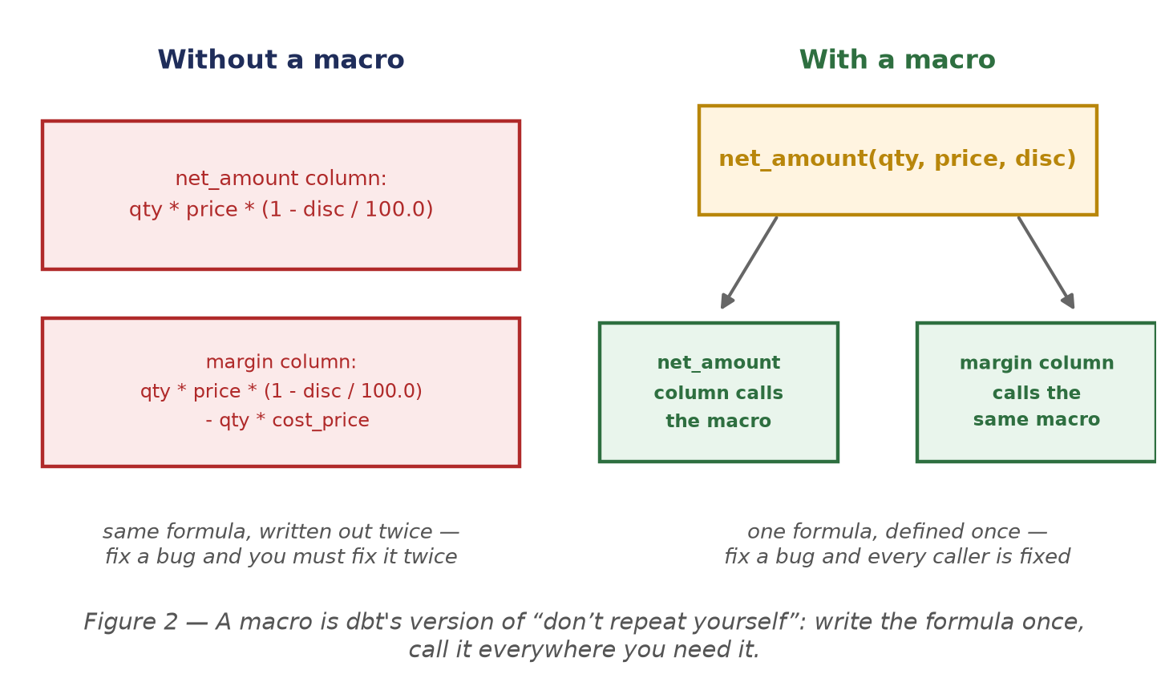
Figure 2 — A macro is dbt's version of “don't repeat yourself”: write the formula once,
call it everywhere you need it.

Reusing the Habit: fct_orders
The same instinct applies at a bigger scale than a single formula. You already have a line-item-grain fact table (fct_order_items); this week you'll build a second fact table at the order grain (fct_orders) by rolling the first one up, rather than re-deriving order totals from scratch with a fresh set of joins.
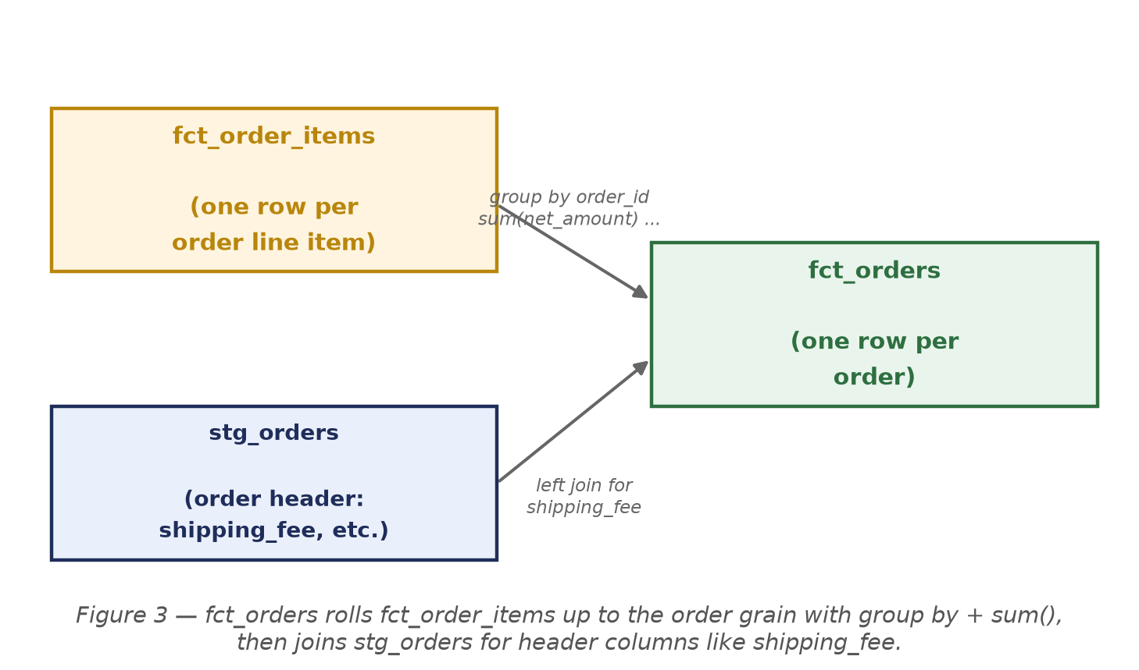
Figure 3 — fct_orders rolls fct_order_items up to the order grain with group by + sum(),
then joins stg_orders for header columns like shipping_fee.

How fct_orders Fits Into the Star Schema
Here's the complete picture once fct_orders exists: it doesn't replace fct_order_items, it sits alongside it at a coarser grain, and it can be joined to the same dimensions for the exact same reason — an order, like a line item, belongs to exactly one customer and one store.
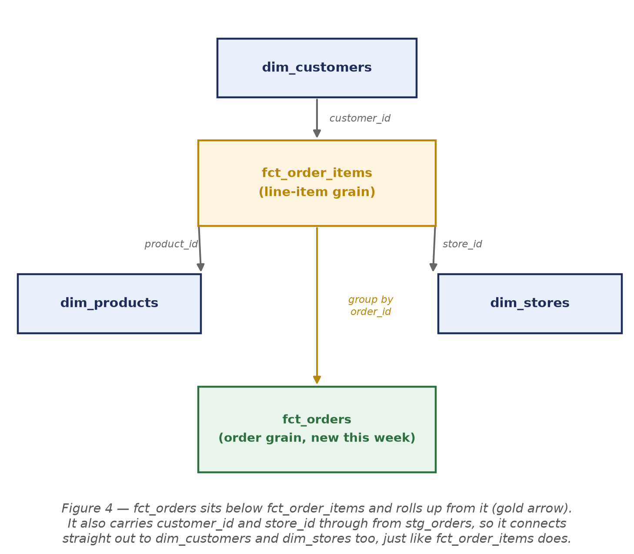
Figure 4 — fct_orders sits below fct_order_items and rolls up from it (gold arrow).
It also carries customer_id and store_id through from stg_orders, so it connects
straight out to dim_customers and dim_stores too, just like fct_order_items does.

Once this is in place, someone could ask “what's our average order value by region?” and answer it either from fct_orders directly, or by joining down to fct_order_items when they need line-item detail — that's the payoff of having both grains available.

Part 3 — Task Walkthrough

Task 4.1 — Write the Macro (45 pts)
Create macros/net_amount.sql:
-- Usage: {{ net_amount('quantity', 'unit_price', 'discount_pct') }}
-- Returns: quantity * unit_price * (1 - discount_pct / 100.0)
{% macro net_amount(quantity, unit_price, discount_pct) %}
({{ quantity }} * {{ unit_price }} * (1 - {{ discount_pct }} / 100.0))
{% endmacro %}

Why the quotes at the call site: the three arguments are column names passed in as strings, not values — the macro just stitches that text straight into the compiled SQL. That's why net_amount('oi.quantity', 'oi.unit_price', 'oi.discount_pct') has quotes around each argument, even though the compiled SQL underneath has none.

Check it compiles before moving on — a macro with a typo won't fail loudly until something tries to call it:
dbt compile --profiles-dir .

Deliverable: macros/net_amount.sql, taking quantity, unit_price, and discount_pct, and compiling cleanly.

Task 4.2 — Use It in the Fact (35 pts)
In fct_order_items, replace every hardcoded copy of the net_amount formula — both the net_amount column and the one buried inside the margin calculation — with a call to your new macro:
{{ net_amount('oi.quantity', 'oi.unit_price', 'oi.discount_pct') }}::numeric(12,2) as net_amount,
...
({{ net_amount('oi.quantity', 'oi.unit_price', 'oi.discount_pct') }}
- oi.quantity * p.cost_price)::numeric(12,2) as margin

Rebuild and confirm the numbers didn't move:
dbt run --select fct_order_items --profiles-dir .

Deliverable: fct_order_items calls {{ net_amount(...) }} instead of repeating the formula, and still builds — output is byte-for-byte unchanged from before.

Task 4.3 — Reuse It Once More: Build fct_orders (20 pts)
Create models/dev/fct_orders.sql — an order-grain fact (one row per order) that rolls up fct_order_items:
- Group the line items by order_id and sum() up num_line_items, total_quantity, and net_revenue.
- Bring in the order header's shipping_fee by joining back to stg_orders.
- Add order_total = net_revenue + shipping_fee.
Hint: left join your rollup onto stg_orders (not the other way around) so that orders with zero line items still show up as a row, with their measures defaulted to 0 via coalesce(...).

Build it and check the row count:
dbt run --select fct_orders --profiles-dir .

Deliverable: fct_orders.sql builds and returns 155 rows — one per order.

Grading Your Work
Once all three tasks are complete, run:
python scripts/grade_assignment.py --week 4

Fix any items marked with an X and re-run the grader until everything passes.

Part 4 — Mistakes to Avoid, Word List, and Quick Quiz

Mistakes to Avoid
- Forgetting the quotes at the call site — net_amount(oi.quantity, ...) without quotes will try to reference a Jinja variable named oi, not the column, and either errors out or compiles to nonsense.
- Only replacing one of the two call sites — the net_amount column is the obvious one, but the margin calculation repeats the exact same formula and is easy to miss.
- Changing the formula while you refactor it into a macro — Task 4.2 explicitly requires the output to stay byte-for-byte identical; this is a reuse exercise, not a chance to “fix” the math.
- Building fct_orders straight from stg_order_items instead of from fct_order_items — that would mean re-deriving revenue math a third time instead of reusing the fact table you already built.
- Using an inner join from stg_orders to the rollup — that silently drops any order with zero line items; use a left join so every order still shows up.

Word List
Term | Meaning
Jinja | The templating language dbt compiles before sending SQL to the warehouse — anything inside {{ }} or {% %}.
Macro | A named, reusable snippet of Jinja/SQL you define once and call with {{ macro_name(args) }}.
DRY | “Don't Repeat Yourself” — the principle that logic written more than once should be pulled into one reusable place.
Argument | A value passed into a macro when it's called; net_amount takes three: quantity, unit_price, discount_pct.
Grain | What one row of a table represents. fct_order_items is line-item grain; fct_orders is order grain.
Rollup | Aggregating a finer-grain table (more rows) up to a coarser grain (fewer rows) with group by + sum().
compile | The dbt command that renders Jinja/macros into plain SQL without running it — useful for catching macro errors early.

Quick Quiz
Answer these before moving on to Week 5 — if any answer doesn't come quickly, go back and re-read that section rather than guessing.
- Why do the arguments to net_amount() need to be passed in as quoted strings?
- Name both places in fct_order_items that call the net_amount() macro.
- What should stay exactly the same before and after Task 4.2, and how would you verify it?
- Why is fct_orders built from fct_order_items rather than from stg_order_items directly?
- What join type should connect the rollup to stg_orders in fct_orders, and why does it matter?
Questions or stuck on something? Reach out before spending too long on one blocker — the goal this week is understanding reuse, not just getting green checkmarks from the grader.

