dbt Learning Program
Week 2 Recap & Week 3 Guide
Testing the Warehouse with dbt

This guide walks through everything covered in Week 2 and introduces the new concepts for Week 3, with diagrams for each major idea. The goal is not just to finish the tasks and get a passing grade — it's to actually understand why each step matters, because that understanding is what carries over into every future project you touch, long after these specific tables are forgotten.

What's Inside
- Part 1 — Week 2 Recap: the line-level fact table, incremental models, and snapshots — what you built and why it matters
- Part 2 — Week 3 Guide: generic tests, custom tests, and test severity, explained with diagrams
- Part 3 — Walkthrough of all four Week 3 tasks with code
- Part 4 — Mistakes to Avoid, Word List, and Quick Quiz

Part 1 — Week 2 Recap: The Incremental Fact & Snapshots
Week 2 was about turning the dimensions from Week 1 into a real, growing warehouse — a fact table that connects to all of them, built in a way that scales. Before you touch Week 3, make sure the ideas below feel solid — testing only makes sense once you understand what you're testing, and every test you write this week points directly at a piece of what you built in Week 2.

What You Actually Built in Week 2

1. The Line-Level Fact — fct_order_items
You built models/dev/fct_order_items.sql with a grain of one row per order_item_id, no aggregation, just a clean joined row per line item. It joins stg_order_items to stg_orders (for customer_id, store_id, order_date, order_status) and to stg_products (for cost_price), always through the STAGE layer, never a seed directly.
- gross_amount = quantity × unit_price — the sticker-price total before any discount
- discount_amount = quantity × unit_price × discount_pct / 100 — how much was shaved off
- net_amount = quantity × unit_price × (1 − discount_pct / 100) — what the customer actually paid
- total_cost = quantity × cost_price — what it cost the business to fulfill that line
- margin = net_amount − total_cost — what's left over, the number the business cares about most

2. Incremental Materialization
By default, every model gets fully rebuilt every time you run dbt run; fine for small dimensions, wasteful for a fact table that can have millions of rows. You converted fct_order_items to build the full table on the first run, then only append new rows on every run after that.
{{ config(
materialized='incremental',
unique_key='order_item_id'
) }}

{% if is_incremental() %}
where order_item_id > (select coalesce(max(order_item_id), 0) from {{ this }})
{% endif %}

Why this matters: on the first run the table doesn't exist yet, so is_incremental() is false and the whole filter is skipped — dbt builds everything from scratch. On every run after that, the where clause only pulls in rows newer than the highest ID already in the table, so re-runs stay cheap no matter how large the table gets.

3. Snapshots — snap_products
An UPDATE normally overwrites a value forever — if a product's list_price changes, the old price is just gone. A snapshot takes a timestamped picture of a table every time it runs, using strategy='check' to watch specific columns for changes, so you can look back and answer “what was this product's price last month?” This is called tracking a slowly changing dimension.
{% snapshot snap_products %}
{{
config(
target_schema='RAW',
unique_key='product_id',
strategy='check',
check_cols=['list_price', 'is_active']
)
}}
select * from {{ ref('raw_products') }}
{% endsnapshot %}

The Complete Picture So Far
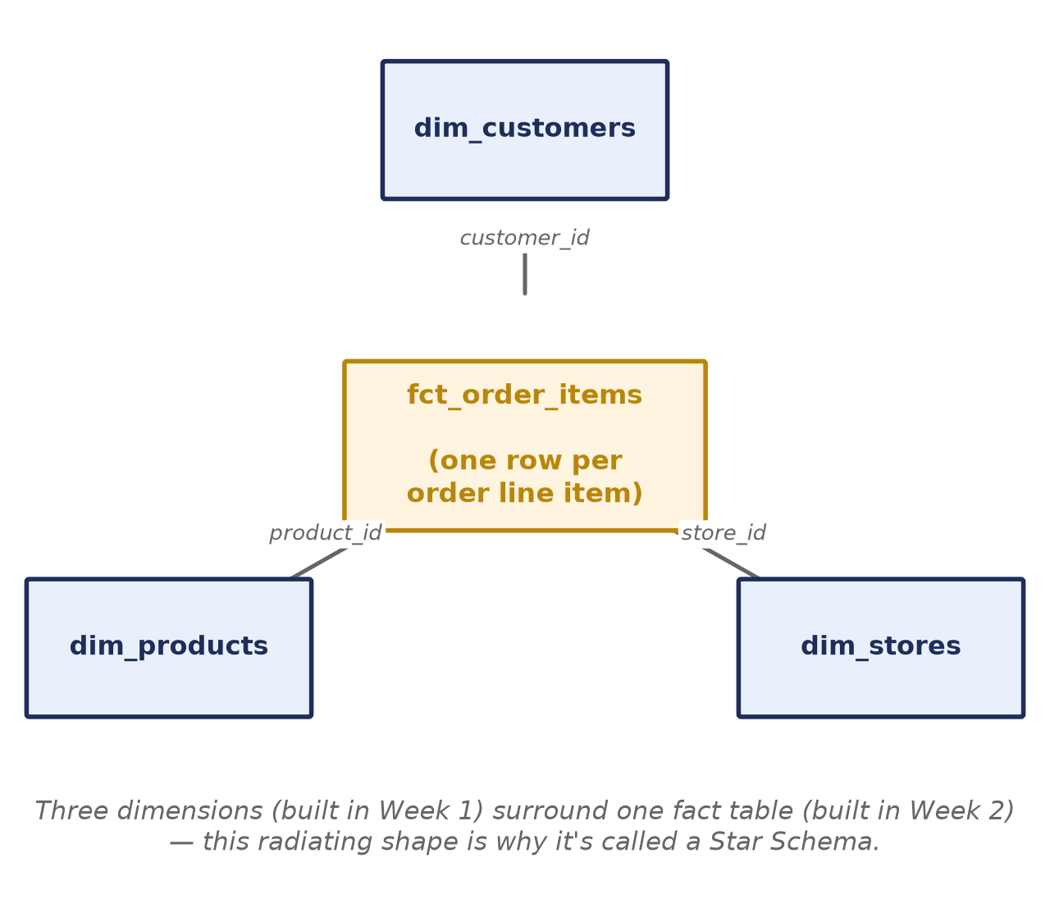
Figure 1 — fct_order_items in the center, connected to all three dimensions built in Week 1.
Once this is in place, someone could ask “what was total margin by region last quarter?” and answer it by joining fct_order_items to dim_stores. Week 3 doesn't add any new tables to this picture — it adds a layer of automated checks on top of every table and every join already here.

Self-Check Before Moving On
If any of these feel shaky, it's worth revisiting the Week 2 material before starting Week 3:
- Why is fct_order_items joined through the STAGE models and never straight from a seed?
- What does is_incremental() evaluate to on the very first run of a model, and why?
- What do the dbt_valid_from and dbt_valid_to columns in snap_products actually mean?

Part 2 — Week 3: Test the Warehouse
Budget: roughly 2 hours. This week you validate your data with dbt's testing framework — and you'll discover that the raw data isn't as clean as it looks. One of your tests is going to fail on real bad data, and your job is to diagnose it and fix the model, not to make the red text go away by deleting the test.
The raw data contains some intentional quality issues. Don't go hunting for them — let your tests surface them.

What's New This Week (In Plain Terms)

Generic Tests
A generic test is a reusable check you declare in YAML against a column: unique, not_null, and relationships (a foreign key actually exists in the table it points to) are the three you'll use this week. You never write SQL for these — dbt already knows how to check them.

Custom Singular Tests
Sometimes a rule is specific to your business logic and doesn't fit a generic test — “net_amount should never be negative” isn't something dbt could know to check on its own. A singular test is just a SELECT statement saved under tests/: if it returns zero rows, the test passes; every row it returns is counted as one failure.
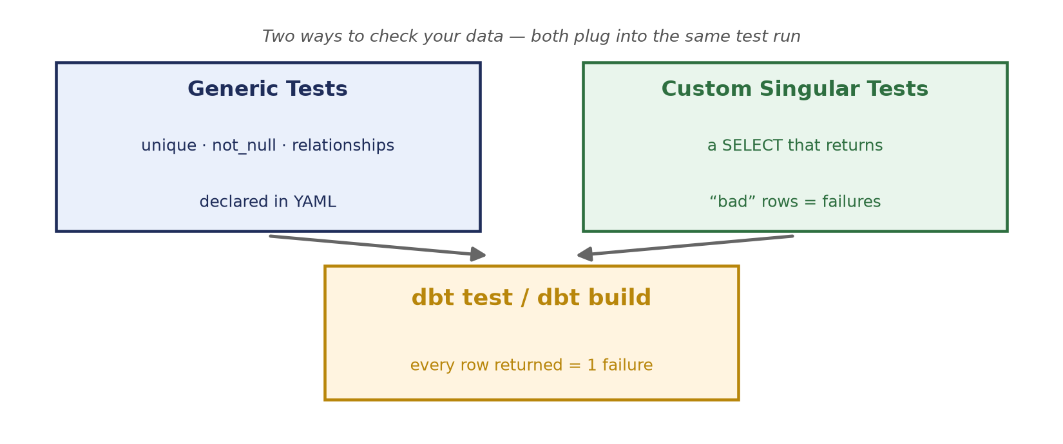
Figure 2 — Two ways to check your data, both plugging into the same dbt test run.

Test Severity: error vs warn
Every test has a severity. At the default, error, a failing test stops the pipeline and skips anything downstream of it — the right behavior for something that must never happen, like a duplicate primary key. At warn, a failing test prints a warning and keeps going with exit code 0 — the right behavior for known-dirty source data you're aware of but not fixing right now.
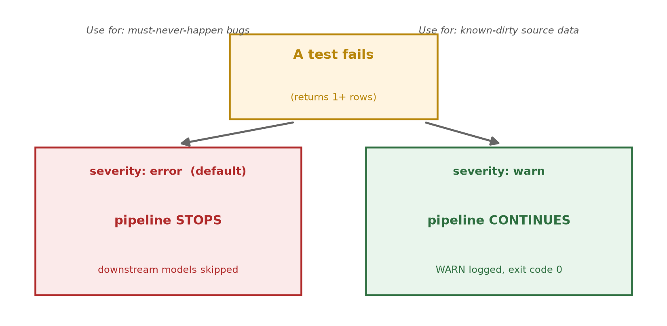
Figure 3 — The same failure, two different outcomes, depending on severity.
Why this matters: in Week 6 your Airflow DAG runs dbt build. If a test that catches unfixable dirty data is left at error severity, that task turns red and the whole DAG fails. Put those on warn so your pipeline stays green while still surfacing the issue in the logs.

The Duplicate Orders Bug
Your unique test on stg_orders.order_id is going to fail: one order_id appears twice in the raw feed. Because fct_order_items joins against stg_orders, that duplicate fans out into extra rows in the fact table — a single data quality issue upstream quietly inflates row counts everywhere downstream of it.
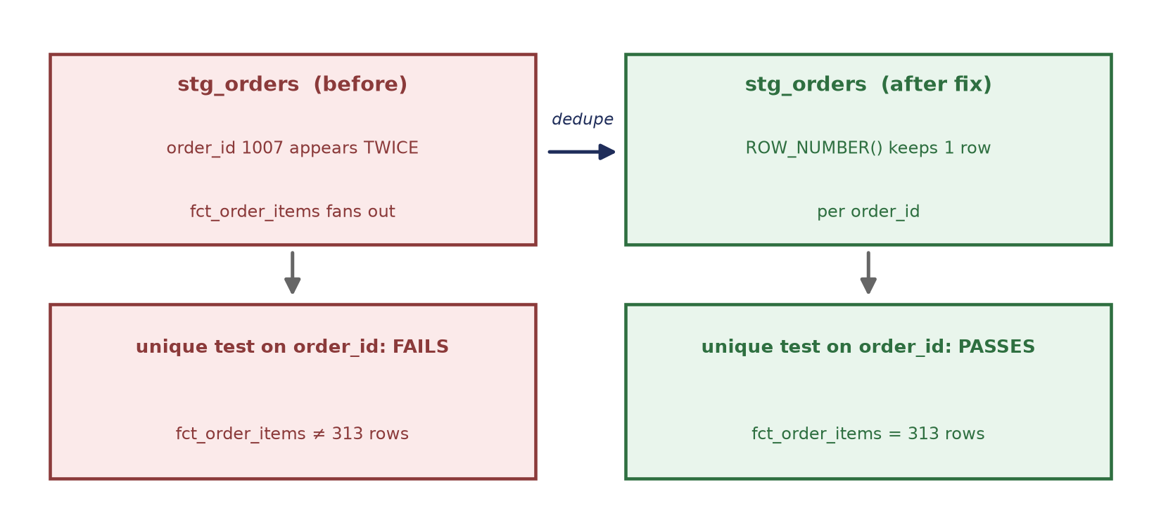
Figure 4 — One duplicated order_id is enough to break a unique test and inflate the fact table.

Storing Failures
A failing test tells you how many rows are bad, but not which ones. Turning on store_failures makes dbt save the actual failing rows into a queryable audit table, so you can inspect exactly what tripped the test instead of guessing.

Putting It All Together
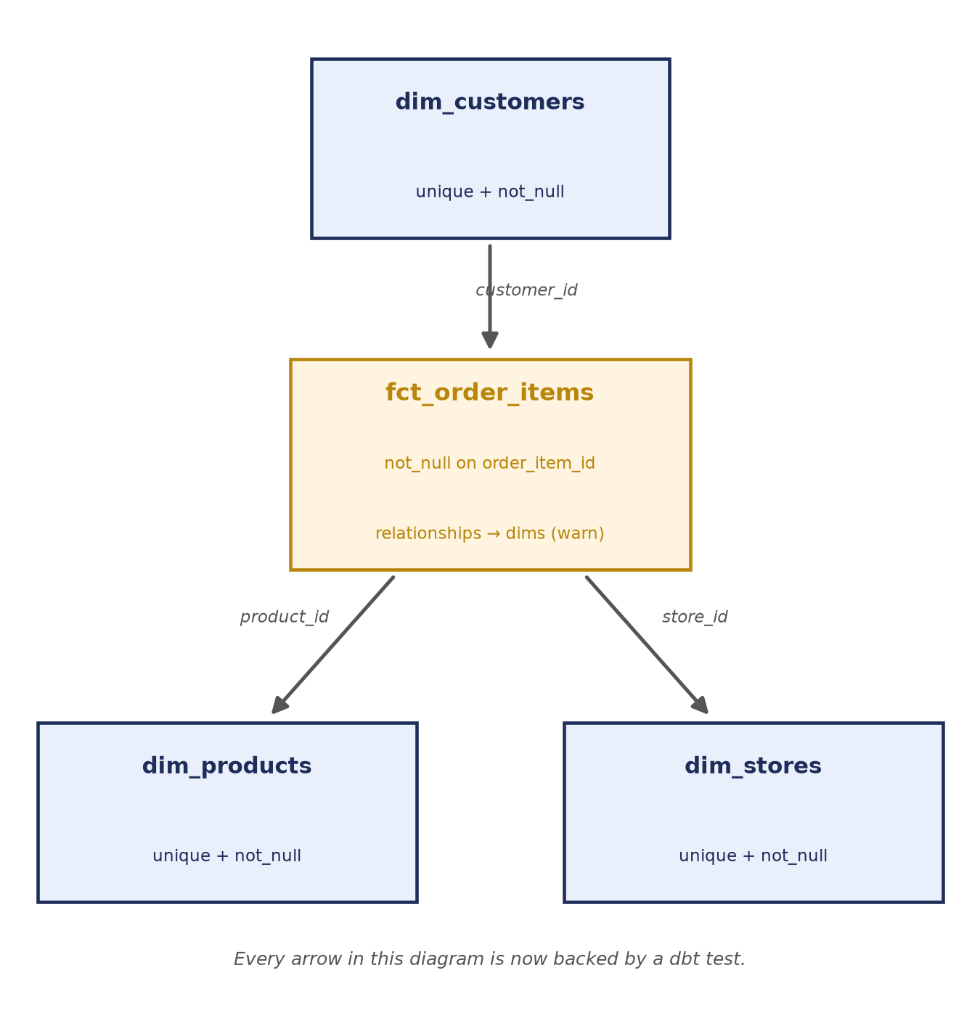
Figure 5 — By the end of this week, every join in the star schema is backed by a real test.
This is the point of the whole exercise: it's not enough for the pipeline to run without errors — you need proof that the data flowing through every one of those arrows is actually what it claims to be.

Part 3 — Task Walkthrough

Task 3.1 — Generic Tests in YAML (40 pts)
Create models/schema.yml and add these generic tests:
- dim_customers — unique + not_null on customer_id
- dim_products — unique + not_null on product_id
- dim_stores — unique + not_null on store_id
- stg_orders — unique + not_null on order_id
- fct_order_items — not_null on order_item_id; relationships to dim_products and dim_customers
version: 2

models:
- name: dim_customers
columns:
- name: customer_id
tests:
- unique
- not_null

dbt test --profiles-dir .

Deliverable: schema.yml plus a note of which tests fail and why. Some tests SHOULD fail — that's the point. The two relationships tests on fct_order_items will flag orphaned rows from the dirty source data — set those to severity: warn so they don't break your Week 6 pipeline.

Task 3.2 — One Custom Test (20 pts)
Write a singular test in tests/ that returns any rows where net_amount < 0 in fct_order_items.
-- tests/test_net_amount_non_negative.sql
{{ config(severity='warn') }}

select *
from {{ ref('fct_order_items') }}
where net_amount < 0

This test will find bad rows: a couple of records have a 150% discount, making net_amount negative. Since that's dirty source data you're not fixing here, give the test severity='warn' — it surfaces the problem in the logs but keeps dbt build green when Airflow runs it in Week 6.

Task 3.3 — Find & Fix the Duplicate Orders Bug (25 pts)
Your unique test on stg_orders.order_id fails — one order_id appears twice in the raw feed. Fix it by deduplicating in stg_orders so each order_id appears once. A common pattern:
deduped as (
select *
from (
select *,
row_number() over (partition by order_id order by order_date desc) as rn
from cleaned
) ranked
where rn = 1
)

Deliverable: a fixed stg_orders. After the fix, the unique test on order_id passes, fct_order_items = 313 rows and fct_orders = 155 rows.

Task 3.4 — Store the Failures (15 pts)
Turn on store_failures so dbt saves each failing test's rows into a table you can query. Configure it per-test in schema.yml:
- not_null:
config:
store_failures: true

…or project-wide in dbt_project.yml:
data_tests:
dbt_learning:
+store_failures: true

dbt test --store-failures --profiles-dir .

-- failures land in a *_dbt_test__audit style schema
select * from "DEV_dbt_test__audit".not_null_fct_order_items_order_item_id;

Deliverable: store_failures enabled, and you can point to a table holding the actual bad rows.

Grading Your Work
Once all four tasks are complete, run:
python scripts/grade_assignment.py --week 3

Fix any items marked with an X and re-run the grader until everything passes.

Part 4 — Mistakes to Avoid, Word List, and Quick Quiz

Mistakes to Avoid
- Leaving unfixable-data tests at severity: error — the relationships tests on fct_order_items and the net_amount test WILL fail on real dirty data. Set those to warn, or your Week 6 Airflow DAG turns red every single run.
- Deleting or loosening a test instead of fixing the model — the duplicate order_id bug is meant to be fixed in stg_orders, not worked around by removing the unique test that caught it.
- Forgetting that dbt build runs both models and tests — a red test in dbt build behaves like a red model: everything downstream of it gets skipped unless the severity is warn.
- Assuming a passing test means the data is fully correct — a test only checks the specific rule you wrote. unique + not_null on an ID says nothing about whether the dollar amounts in that row are right.
- Not re-running dbt test after a fix — always re-run the full suite after fixing stg_orders; a fix for one test can change row counts that other tests (and fct_order_items = 313 rows) depend on.

Word List
Term | Meaning
Generic test | A reusable test declared in YAML against a column — unique, not_null, relationships.
Singular test | A one-off test written as a SELECT under tests/; any row it returns is a failure.
Severity | Whether a failing test stops the pipeline (error) or just warns and continues (warn).
store_failures | A config that saves a failing test's actual bad rows into a queryable audit table.
Relationships test | A generic test that checks a foreign key value actually exists in the referenced table.
dbt build | Runs models, snapshots, seeds, and tests together in dependency order in one command.
Data quality issue | A problem in the source data itself (duplicates, bad values) rather than in your SQL.

Quick Quiz
Answer these before moving on to Week 4 — if any answer doesn't come quickly, go back and re-read that section rather than guessing.
- What's the difference between a generic test and a singular test?
- If a relationships test is set to severity: warn and it fails, does dbt build exit with a non-zero code?
- Why does the duplicate order_id bug need to be fixed in stg_orders rather than in fct_order_items?
- What does store_failures actually change about how a failing test behaves?
- Name one test in this project that SHOULD be left at severity: error, and explain why.

Questions or stuck on something? Reach out before spending too long on one blocker — the goal this week is understanding testing and data quality, not just getting green checkmarks from the grader.

