**CST-339 Programming in Java III**

**Project Status and Design Report**

|  |  |  |
| --- | --- | --- |
| **Topic:** | 1. *Introduction to Spring* Boot | |
| **Date:** | *This should be the date you completed the Report* | |
| **Revision:** | *1.0* | |
| **Team:** | 1. Arleth Martinez | |
| 1. Kevin Bloomquist | |
| 1. Michael Melichar | |
| 1. Noah Funderburgh | |
| **Weekly Team Status Summary:** | |  |  |  |  | | --- | --- | --- | --- | | **User Story** | **Team**  **Member** | **Hours**  **Worked** | **Hours Remaining** | | *Planning* | *All* |  |  | | *Setting user stories for the project* | *All* |  |  | | *Designing sitemap* | *All* |  |  | | *Creating a detailed project proposal* | *All* |  |  | |  |  |  |  | |  |  |  |  | | |
| **GIT URL:** | *https://github.com/ktbloomq/Milestone-CST-339* | |
| **Screencast URL:** | *The URL that can be used to access your screencast demonstration video for the respective assignment.* | |
| **Peer Review:** | *Y/N* | We acknowledge that our team has reviewed this Report and we agree to the approach we are all taking. |

**Planning Documentation**

**Initial Planning:**

*The team agreed on developing an e-commerce website within the Phone market. Created documentation, and delegated tasks to team members. Came up with the approach and sitemap diagram.*

*Weekly video Reports – Michael Melichar*

*(This can be any task lists or sprint planning you completed to complete this assignment. )*

**Retrospective Results:**

*The following table should be completed after each Retrospective on things that went well (keep doing).*

|  |
| --- |
| **What Went Well** |
| App Envisioning – Effective communication amongst the team in regard to planning the web app. |
|  |
|  |

*The following table should be completed after each Retrospective on things that didn’t go well (stop doing) and what would be done differently next time with an action plan to improve (try doing and continuous improvement).*

|  |  |  |
| --- | --- | --- |
| **What Did Not Go Well** | **Action Plan** | **Due Date** |
|  |  |  |
|  |  |  |
|  |  |  |

**Design Documentation**

**Install Instructions:**

*Step-by-step instructions for setting up your database, and configuring and deploying/installing your application. This section should also include detailed instructions for what configuration files are required by your application, what configuration settings need to be adjusted for various runtime (development or production) environments, and where the files need to be deployed to. This section should also contain detailed instructions for how to clone your application source code from GIT and deploy the application to an externally hosted site.*

**General Technical Approach:**

Our team is looking to develop a new e-commerce website to sell products online. The website will allow users to browse and purchase products, create new products, display details about a product, update an existing product and delete products. We want to create an easy-to-use, visually appealing website.

*You should, in words, describe your approach and design here. You should also summarize any meeting notes, brainstorming sessions, etc. that you want to retain through the design of your project.*

**Key Technical Design Decisions:**

*Any final technical design decisions, such as framework decisions, should be documented here. This should list the technology/framework, its purpose in the design, and why it was chosen.*

**Known Issues:**

*Any anomalies or known issues in the code or functionality should be documented here.*

**Risks:**

*The scope of this project could become too ambitious for the given timeframe. User payment and transaction information could be insecure*

**ER Diagram:**

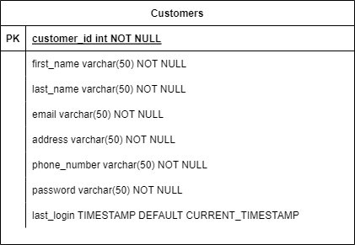

**DDL Scripts:**

*This should contain a link to Bitbucket wherefrom the DDL script can be downloaded.*

**Sitemap Diagram:**

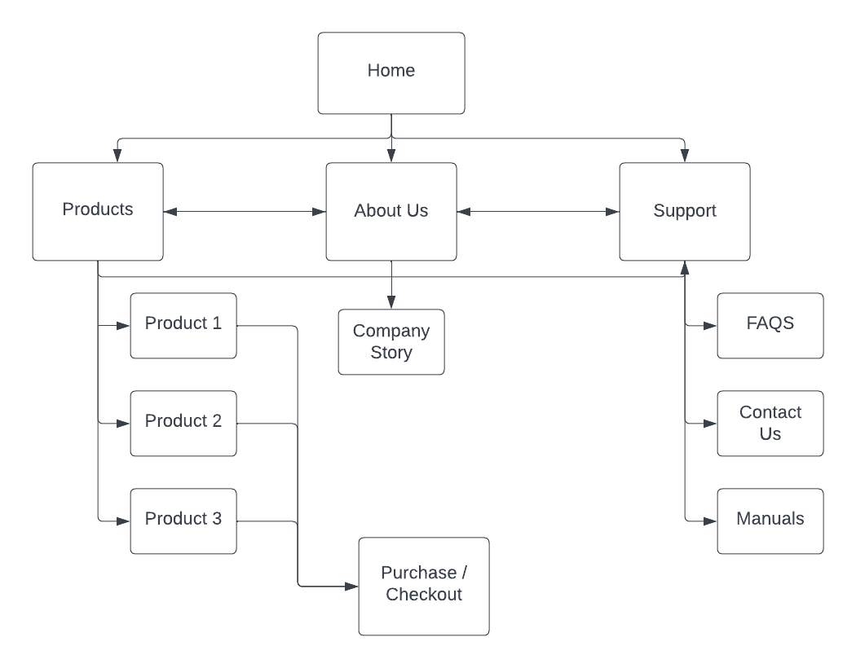

**User Interface Diagrams:**

*You should insert any wireframe drawings or whiteboard concepts that were developed to support your application. If you have no supporting documentation, please explain the rationale for why you are able to leave this section as N/A.*

**Class Diagrams:**

*You should insert any class diagrams here. Your class diagrams should be drawn correctly with the 3 appropriate class compartments, + and – minus to indicate accessibility, and also the data types for the state/properties as well as method arguments and return types. If you have no supporting documentation, please explain the rationale for why you are able to leave this section as N/A.*

**Service API Design:**

*This section should fully document any service API’s (like REST API’s) that are being published, how to access the service, what parameters are required by the API, and the detailed JSON data format specification that could be used by a third party developer to integrate with the service and API. The design can also be captured with tools such as Swagger.*

**Security Design:**

*This section should outline the design for how authentication and authorization was supported. This section should also contain all of the roles and privileges that are supported by the design.*

**Other Documentation:**