**Activity 2**

Noah Funderburgh

Grand Canyon University

Course Number: CST-323-O500

Jason Jazzar

11/19/2023

**Angular Version**

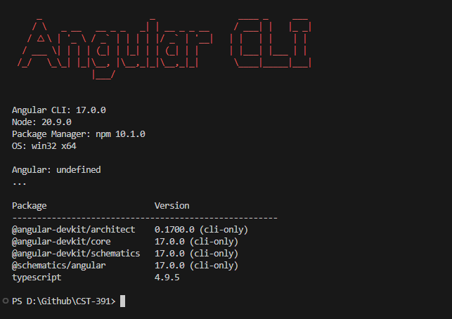

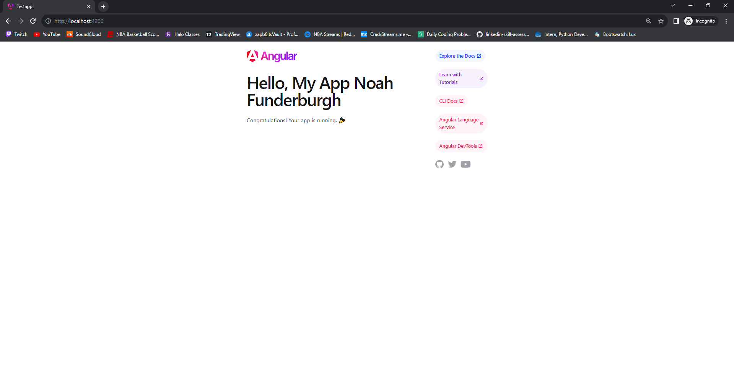**Changing the title within app.component.ts**

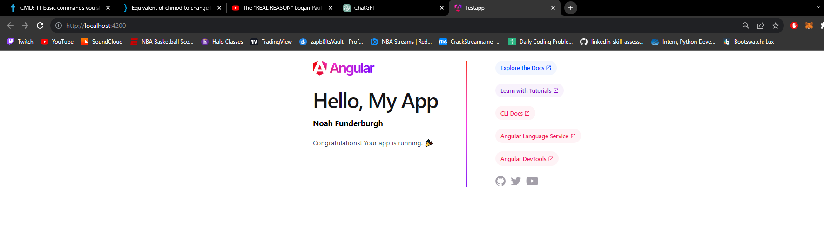**Adding a message variable and rendering it with h3 tag**

**Research Questions**

1. Inspect the default test project structure created in the Activity. Describe the purpose for each of the folders of the following in the project structure: node_modules, src, src/app, src/assets, and src/environments. Also, describe the purpose for each of the following files in the project: angular.json, package.json, and tsconfig.json,

* **node_modules:** contains all external libraries
* **src:** where the main development occurs
* **src/app:** main location for the applications code
* **src/assets:** stores any images fonts or stylesheets
* **src/enviornments:** hold configuration files
* **angular.json:** settings and configs specific to the build process and other settings for angular
* **package.json:** contains the metadata for the project
* **tsconfig.json:** configuration on how typescript should compile the project

1. Inspect the page source for the default page displayed when running the test project. Explain how the resultant page was generated by Angular by providing a brief overview and purpose for each of the following files: main.ts, app.component.css, app.component.html, app.component.ts, and app.module.ts.

* **Main.ts:** beginning point for an angular application
* **App.component.css:** loads a style sheet for app.component
* **App.component.html: template file which contains html markup that angular rends and binds with component logic**
* **App.component.ts:** defines the main logic for the root component
* **App.module.ts: imports and declars components services, and directives**