**Activity 4**

Noah Funderburgh

Grand Canyon University

Course Number: CST-323-O500

Jason Jazzar

12/03/2023

**Main Application Screen**

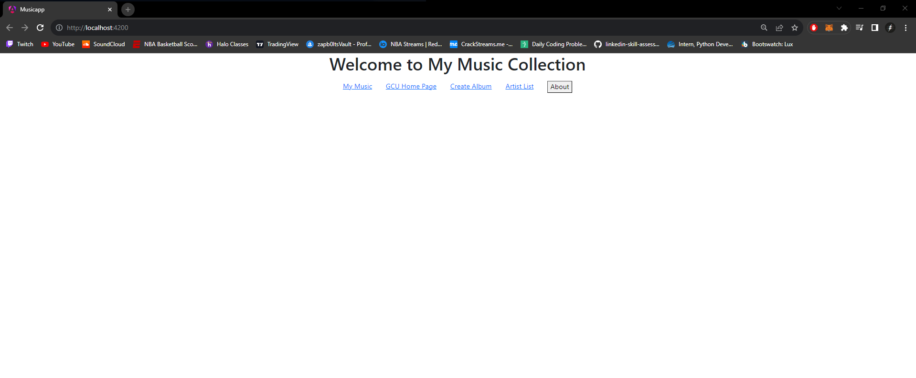

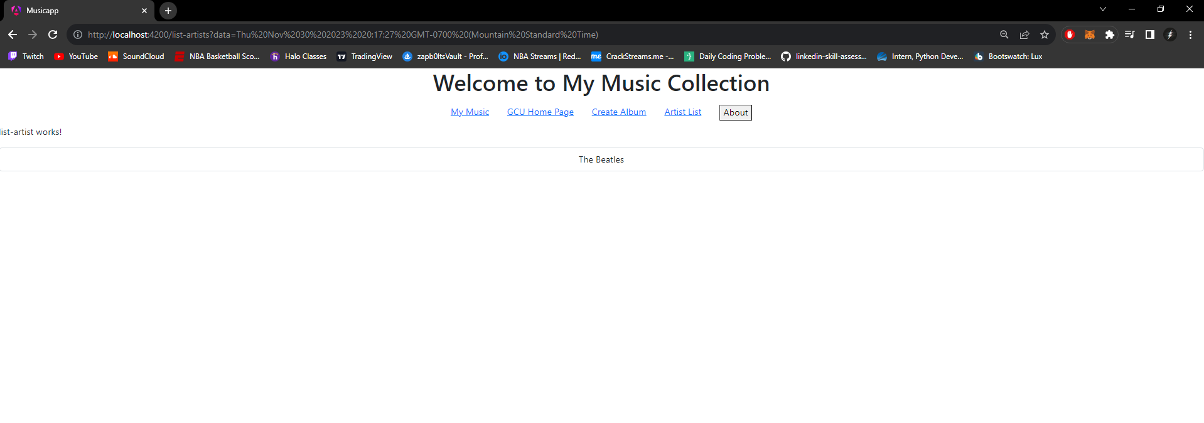**Artist List Screen**

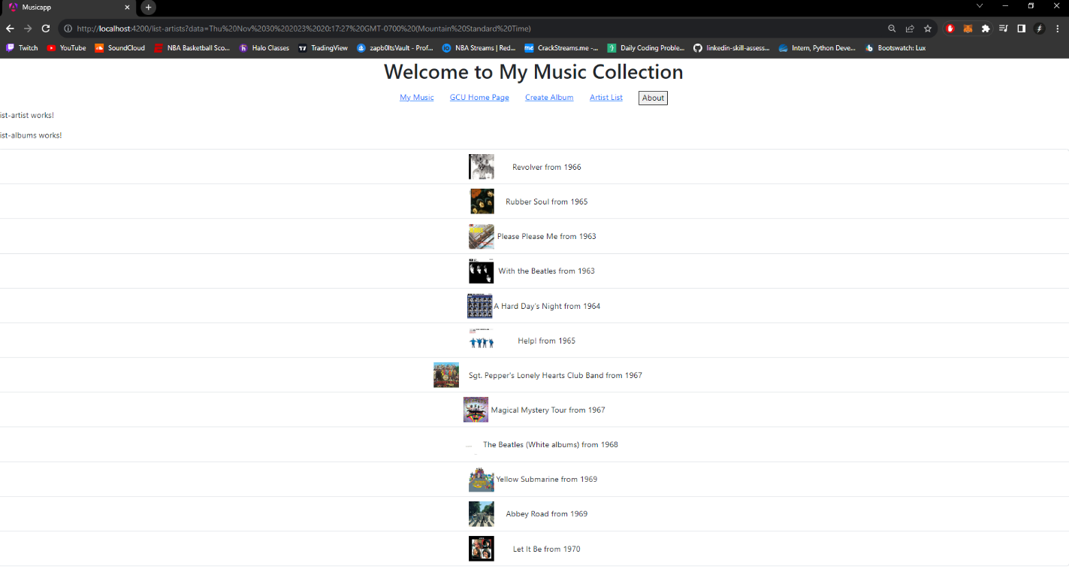**Album List Screen**

**Album Display with Tracks Screen**

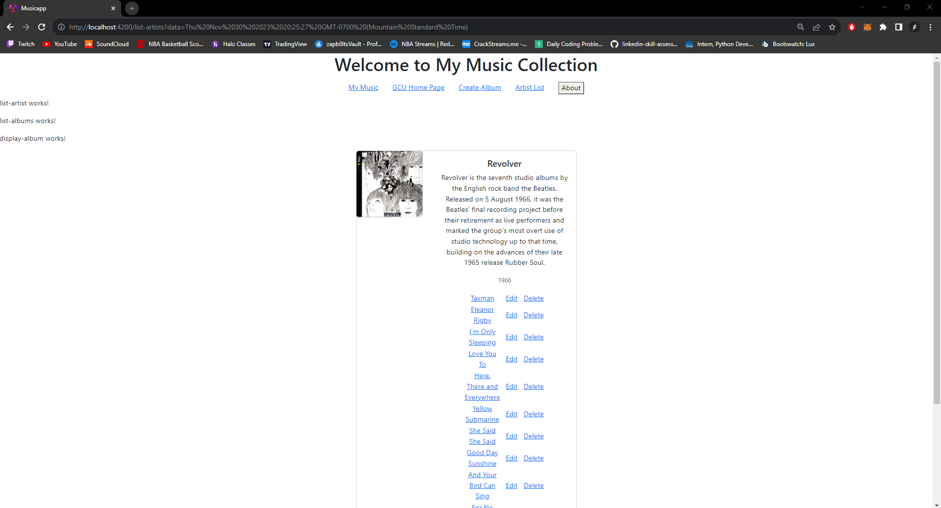

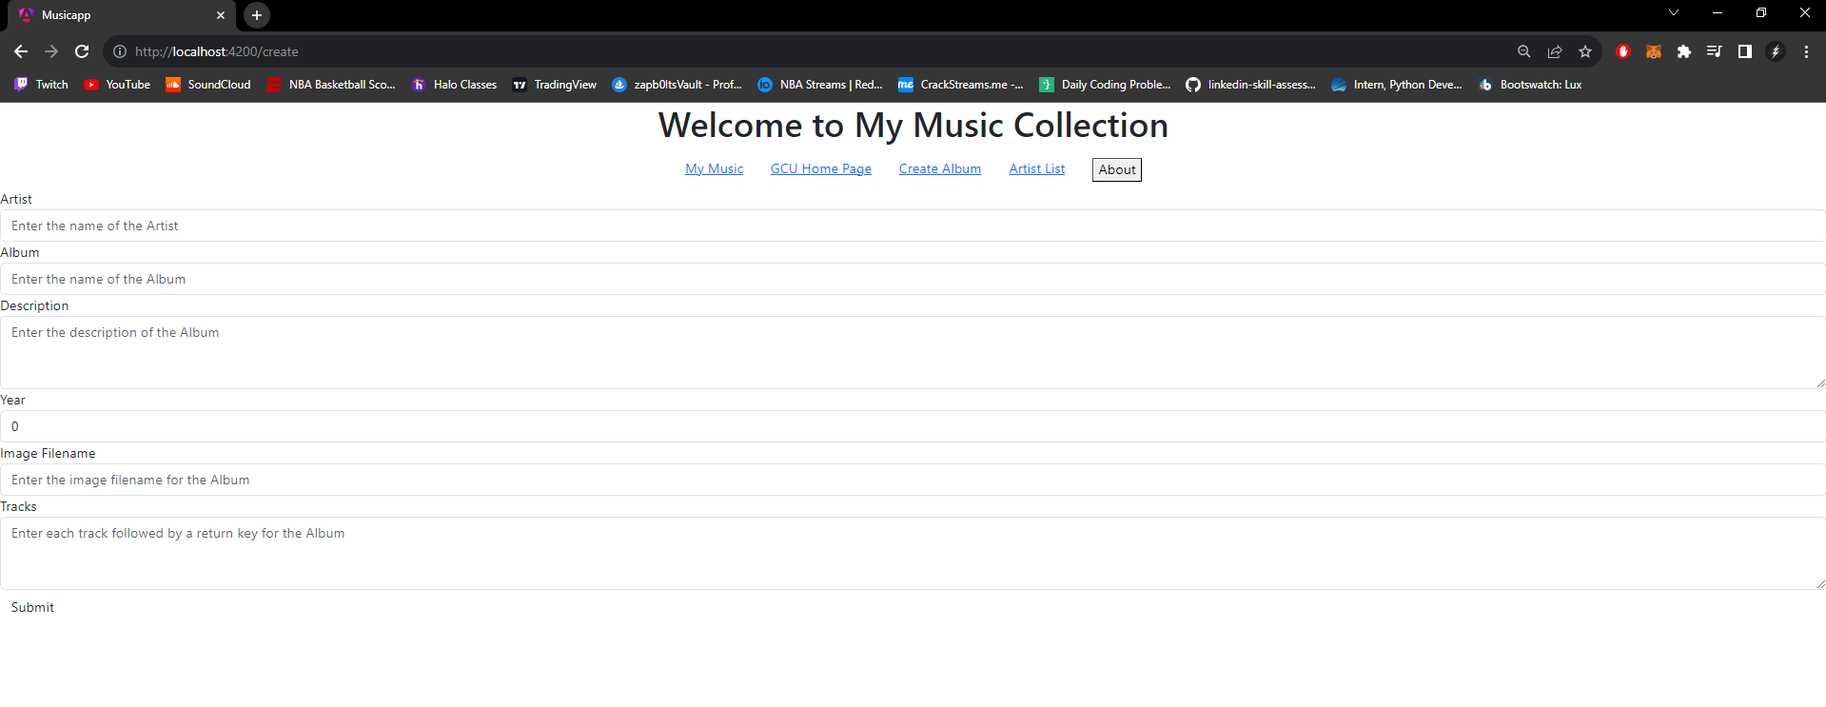**Add Album Screen**

**Research Questions**

1. Research how an Angular application maintains a logged in state. How does it communicate this state to the server?

One approach to maintain a logged in state within an angular application is to use a token-based authentication. When a user logs in it with a valid username/password it will send a http post to verify authentication. Once verified the server will generate a json web token which is used to verify authenticity. The angular application receives and stores it securely and process it accordingly as needed.