**Activity 5**

Noah Funderburgh

Grand Canyon University

Course Number: CST-323-O500

Jason Jazzar

12/10/2023

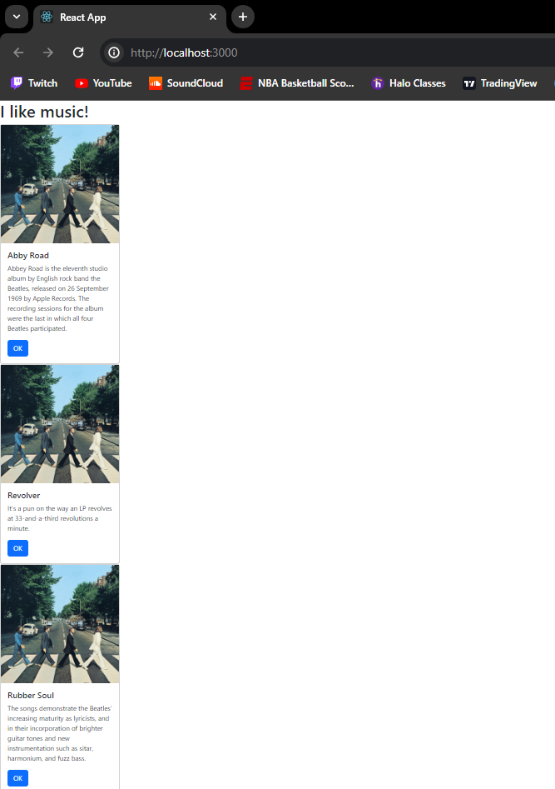**Stopping Point #1 – Custom Components**

**Custom Components:**

In this Activity, we created a React Application which displays Albums in a card view. We used a one parent element in JSX which is JS unique to React. To render the web page, we used React DOM Render at the end of App.js. Another feature that was added was bootstrap for styling purposes. To display the multiple cards I had to create a custom card component and then use component properties to pass along parameters for each card.

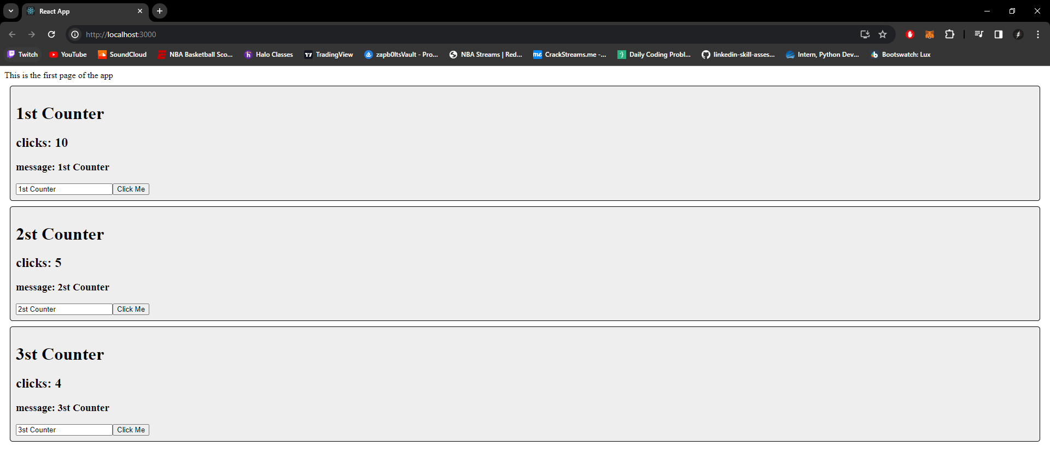**State Changer:**

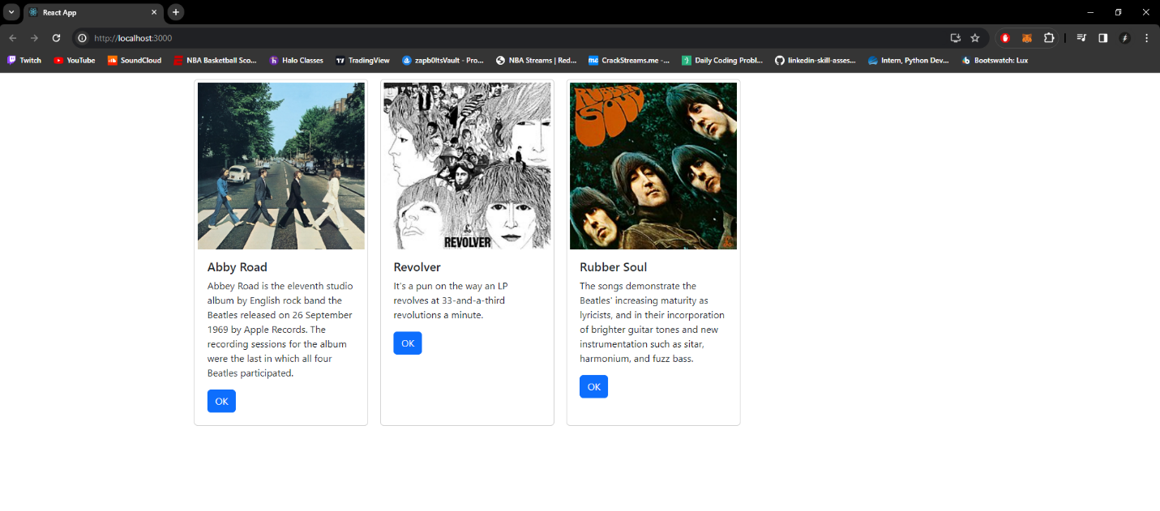**State and props:**

**Summary:**

In state and props we modified the original project music react app to use both state and properties. Properties are defined by the parent and can be used to affect the looks of a child. The properties were used in our rendered list function which generates the creates the JSX list via a map. The app also has a state albumList and handler setAlbumList which we set by using a hook. The state is usually changed by user action and updates our UI. The handler handles clicks or changes but for now, we have left it undefined.