**Activity 7**

Noah Funderburgh

Grand Canyon University

Course Number: CST-391-O500

Jason Jazzar

12/24/2023

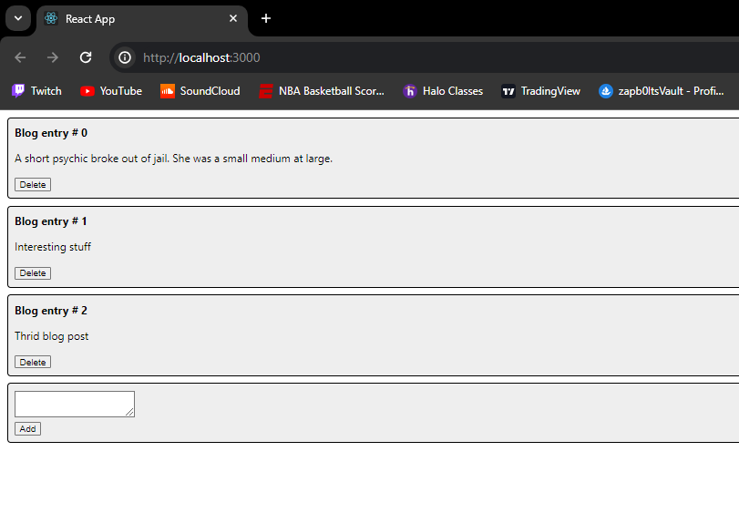**Mini App #3 – Dynamic Components Demo**

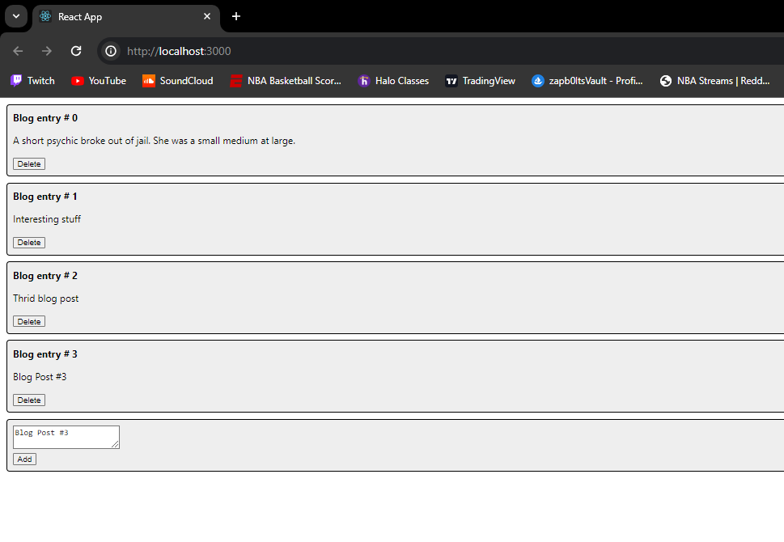**Inserting Post #3**

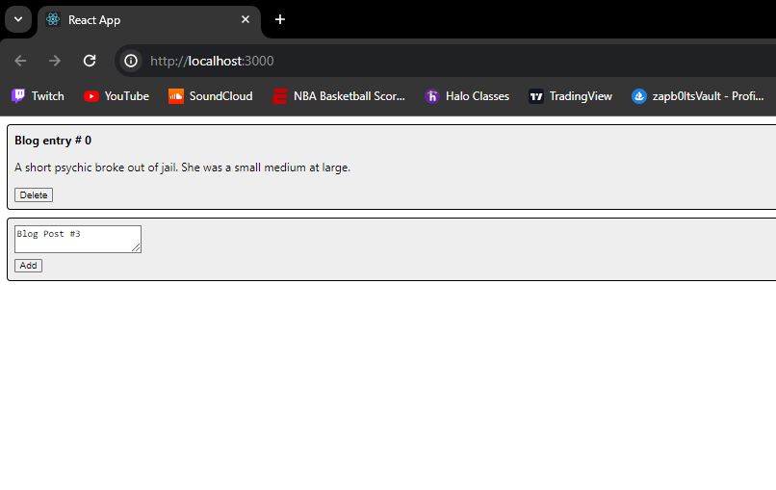**Deleting Posts**

**Part 5 Tracks, Lyrics and Video**

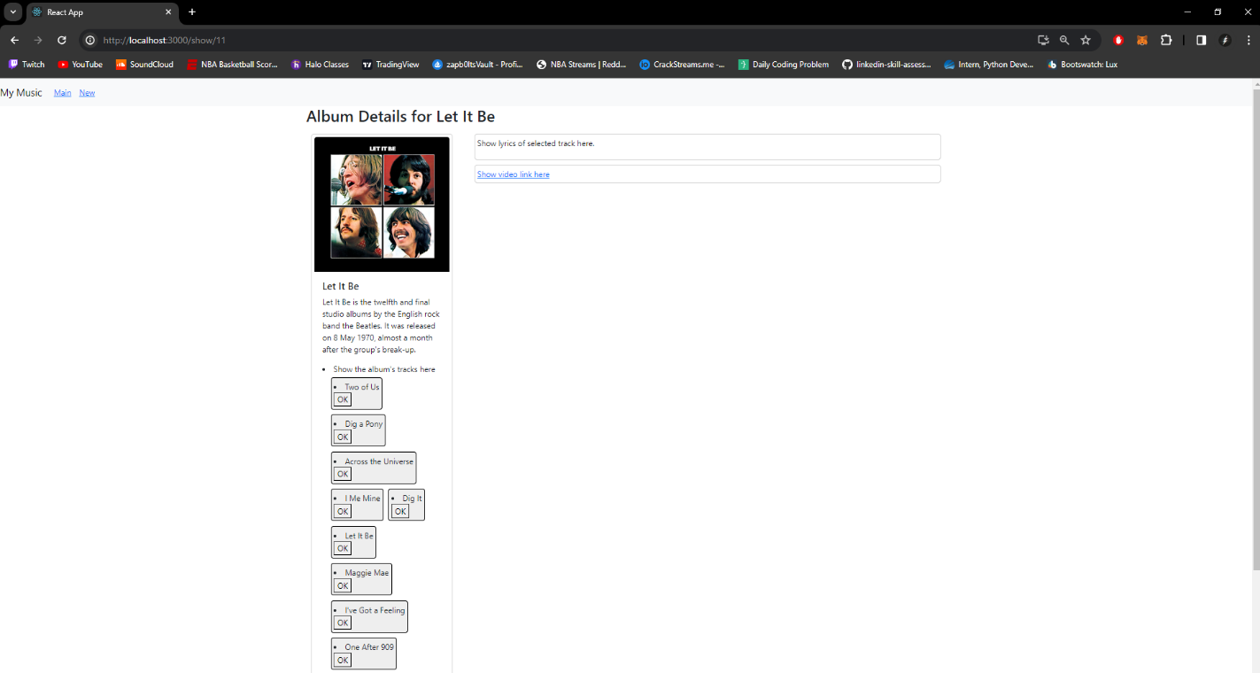

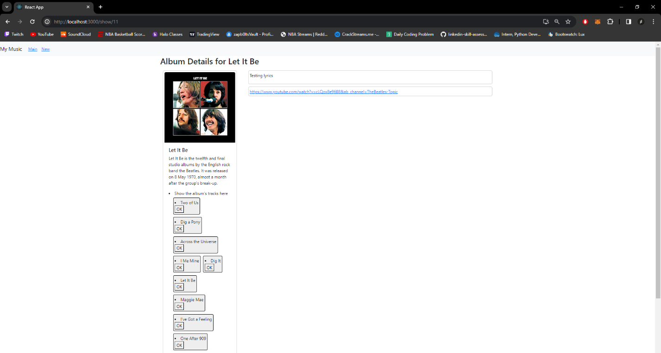

**Summary**

In Part 5 of the activity, I updated the Single Album View to show the tracks. Upon clicking a track, the lyrics and video link will be displayed as shown above. I did this by creating the new components TrackLyrics, TrackTitle, TrackList, TrackVideo, and Track and updating the onClick and handlers for these components.

**Part 6: Create new Album**

**Creating Album display**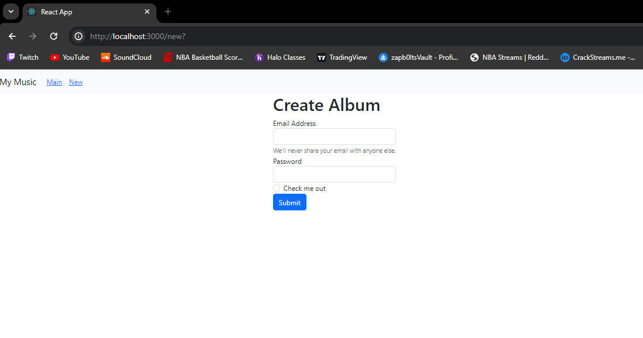

**Creating Album “For all the dogs”**

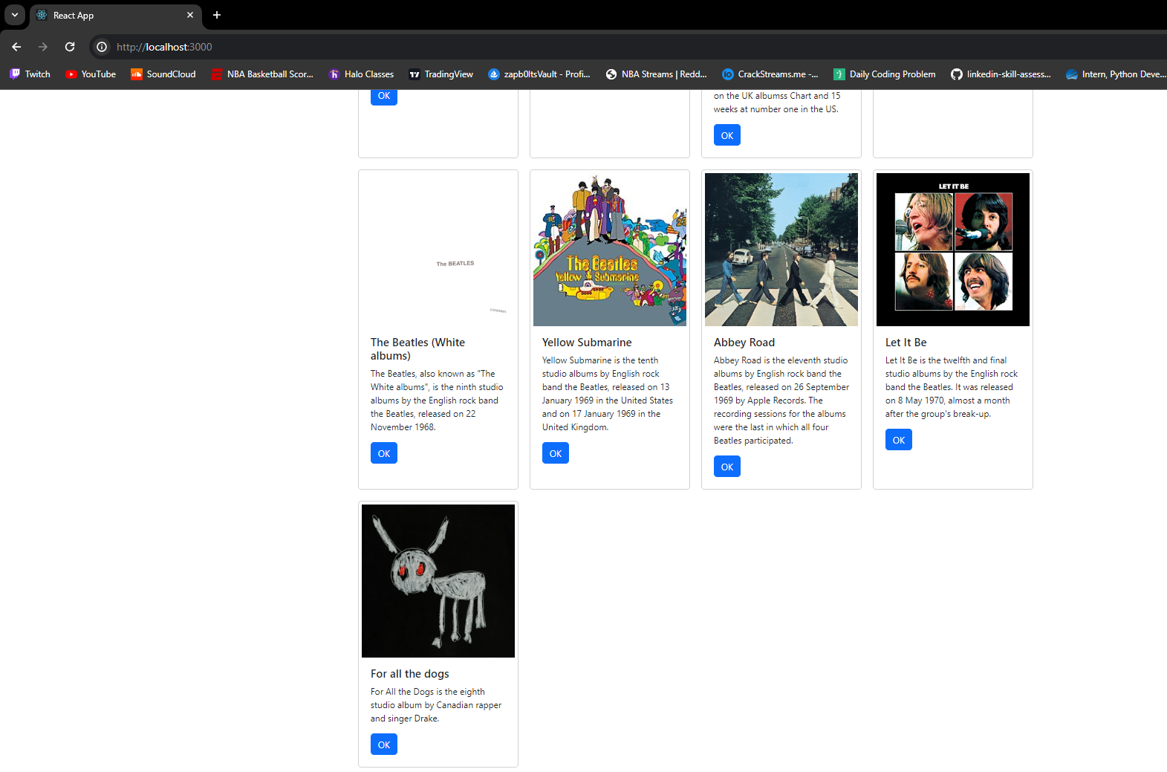**Inserted Album “For all the dog**

**Summary**

In Part 6 of the activity, we added the ability to create an Album. This then updates our album list and displays it on our homepage. To do this we created a NewAlbum component which made use of a Bootstrap form. After modifying, we added the functions handleFormSubmit and handleCancel. This allows the user to cancel or submit the new album. By using controlled components, the form was able to maintain its own state and update it based on user input.

**Part 7: Edit an Album**

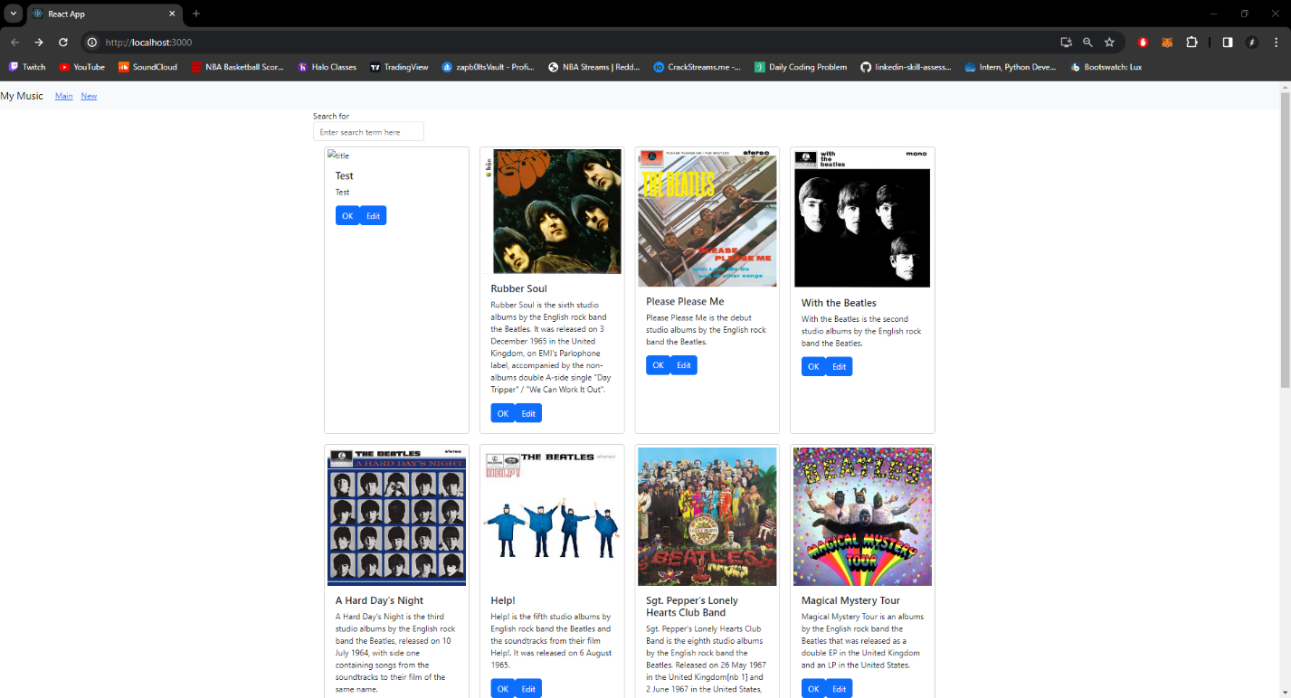**Edit Album**

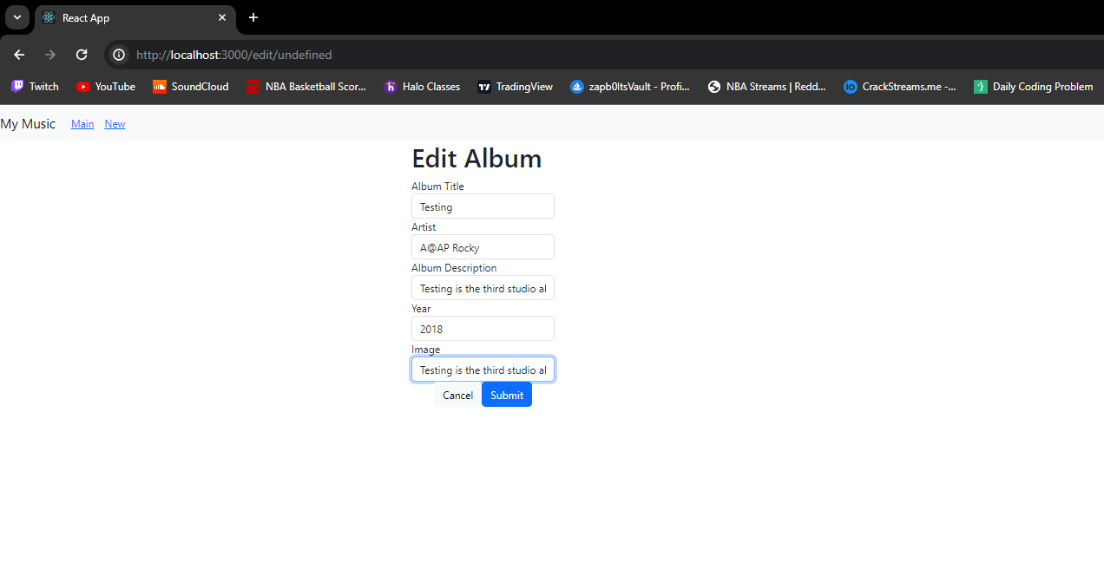**Editing Test Album**

**Summary**

In part 7 of the activity, we added the ability to edit albums within our application. Once you click the edit button, the id gets passed and is sent to the API as a put method. The approach used was to modify the NewAlbum to handle edits, this is to minimize maintenance efforts. We updated the component to check if the album exists already, if it does then a put method is sent if not a post method is sent to the API.