**Milestone 2: Project Requirements Template**

Noah Funderburgh

Grand Canyon University

Course Number: CST-451-O500

Michael Landreth

6/28/2024

**Project Requirements Template**

**Christian Crush**

**Use Cases**

Use Case 1: User Registration

1. User navigates to the Christian Crush homepage.
2. User selects "Sign Up" button.
3. User enters required information like name, email, password, date of birth, and gender.
4. User agrees to terms and conditions and submits the form.
5. User is redirected to the profile setup page.

Use Case 2: Profile Setup

1. Users log in with their registered email and password.
2. User navigates to the profile setup page.
3. User uploads a profile picture.
4. User fills in personal information (bio, interests, faith details).
5. User saves the profile.
6. System updates and displays the complete profile.

Use Case 3: Searching for matches

1. User logs in and navigates to the search page.
2. User sets search criteria (age range, location, faith compatibility).
3. User initiates the search.
4. System displays a list of matching profiles.
5. User views detailed profiles of potential matches.

Use Case 4: Messaging a match

1. User views a potential match's profile.
2. User selects the option to send a message.
3. User composes and sends a message.
4. System delivers the message to the recipient.
5. Recipient receives a notification about the new message.
6. Recipient logs in and reads the message.
7. Recipient responds to the message.

**System Design**

Image

**Technical Requirements**

* User Interface Requirements
  + Responsive Design: The application must be responsive and compatible with various devices (desktops, tablets, smartphones).
  + Browser Compatibility: Must support major browsers including Chrome, Firefox, Safari, and Edge.
  + Accessibility: Should adhere to WCAG 2.1 guidelines to ensure accessibility for all users.
* Profile Management Requirements
  + Profile Creation: Users should be able to create detailed profiles including personal information and a profile picture.
  + Profile Updates: Users should be able to update their profile information and pictures.
  + Profile Deletion: Users should be able to delete their profiles and all associated data
* Messaging System Requirements
  + Message Sending: Users should be able to send messages to other users.
  + Message Receiving: Users should be able to receive messages from other users.
* Data Storage Requirements
  + Database: Use a relational database like SQL Server for storing user data, profiles, matches, and messages.
  + Cloud Storage: Use cloud storage services (e.g., Azure Blob Storage) for storing user-uploaded images.
  + Data Backup: Implement regular data backup and recovery procedures.

**System Logical Model**

**Provide a diagram of the logical architecture of the system**

**Reports**

**Provide a listing of the reports that the system will provide, if applicable. If not, state that the system does not produce any reports and provide additional documentation as described in the handbook.**

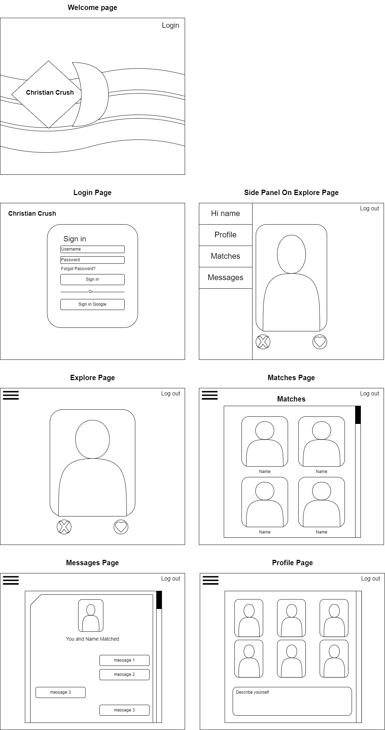**Screen Definitions and Layouts**

**Security**

**Other (as dictated by the context and scope of the project)**

## 