## **Final Plan**

Christian Crush

Prepared by Noah Funderburgh

|  |
| --- |
| Design Planning Summary |

1. Write an overview of this specific development project, a synopsis of the situation that led to the need (if applicable), and a short description of the issues that the development project is going to solve, as well as a general description of the proposed solution and the rationale for the solution.

The development of the Christian Crush dating application is driven by the growing demand for a faith-based dating platform where Christian singles can connect, interact, and build meaningful relationships based on shared values and beliefs. Many of the existing dating platforms are not suited specifically to the Christian community, resulting in a need for a dedicated solution that aligns with Christian principles and provides a safe, respectful, and engaging environment for its users.

**Issues to be Solved**

1. Lack of Faith-Based Dating Platforms: There are limited options for Christians seeking relationships on mainstream dating platforms. The Christian dating apps that do exist are bare bones and can be improved which I am to do.
2. Safety and Security Concerns: Dating platforms sometimes face issues with user safety and security, including data breaches and inappropriate behavior.
3. Community and Belonging: Christian singles often desire a sense of community and belonging that is centered around their faith, which is missing in many generic dating applications.

**Description of the Proposed Project**

The proposal is to create Christian Crush a dating application for web-based platform that is designed specifically for Christian singles. The notable features the application will feature are:

* User Registration and Profile Creation: Secure and straightforward user registration, and profile creation tailored to highlight users' faith and values.
* Messaging System: A secure and user-friendly messaging system that allows users to communicate safely.

**Reason for the project**

The rationale behind Christian Crush is to create a space where Christian singles can connect based on their faith, fostering relationships built on shared values. By addressing the specific needs and concerns of the Christian community, the application aims to provide a more meaningful and safe dating experience. The focus on security, through measures like hashed passwords and SQL injection prevention, ensures that users' data is protected, while the community-focused features help build a sense of belonging and support among users. This targeted approach not only fills a gap in the market but also promotes the development of genuine, faith-based relationships.

|  |
| --- |
| Overview of Design Concepts |

1. Provide the high-level design of the proposed solution or business case with supporting narrative text. This design should include mock-up screen shots for the proposed user interface, pseudocode, or flowcharts that show the logic for the program, as well as the anticipated process flow. The purpose of the solution/business case design is to allow the stakeholder to approve the concepts before committing resources to the technical design.

**Drawing of UI**

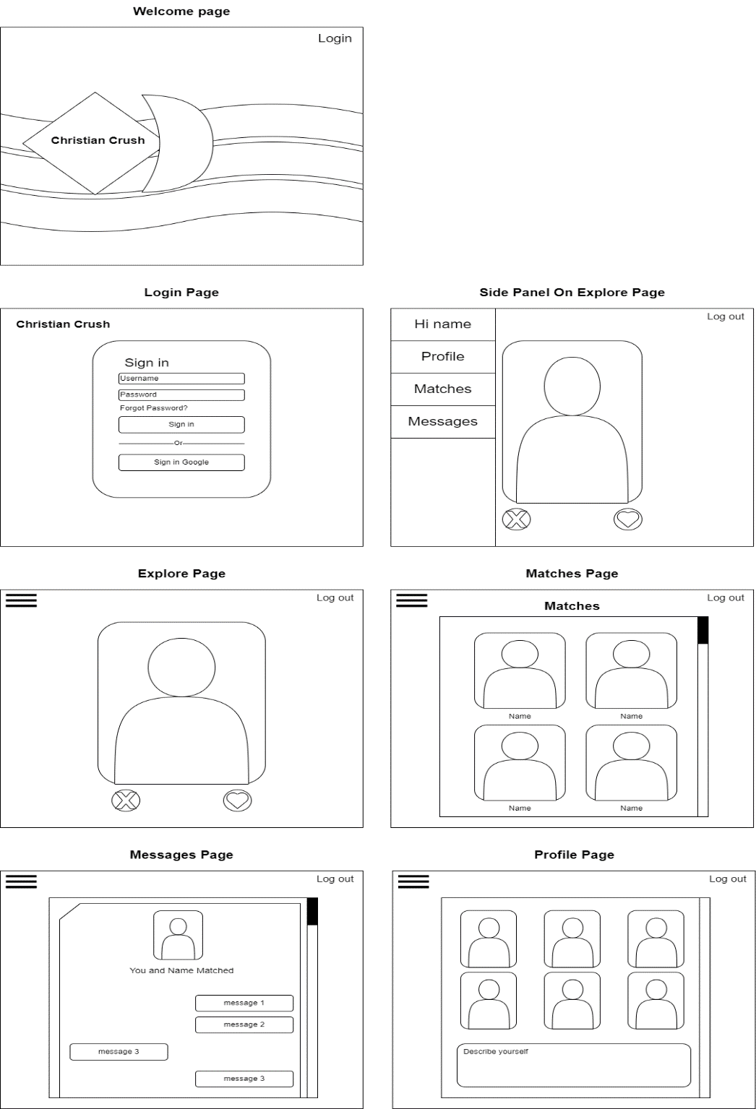

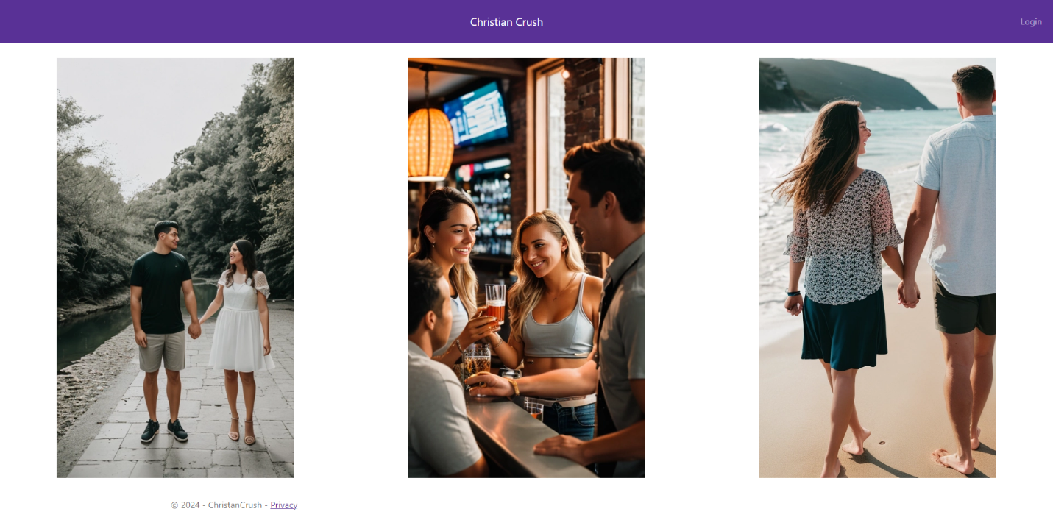**Welcome Page**

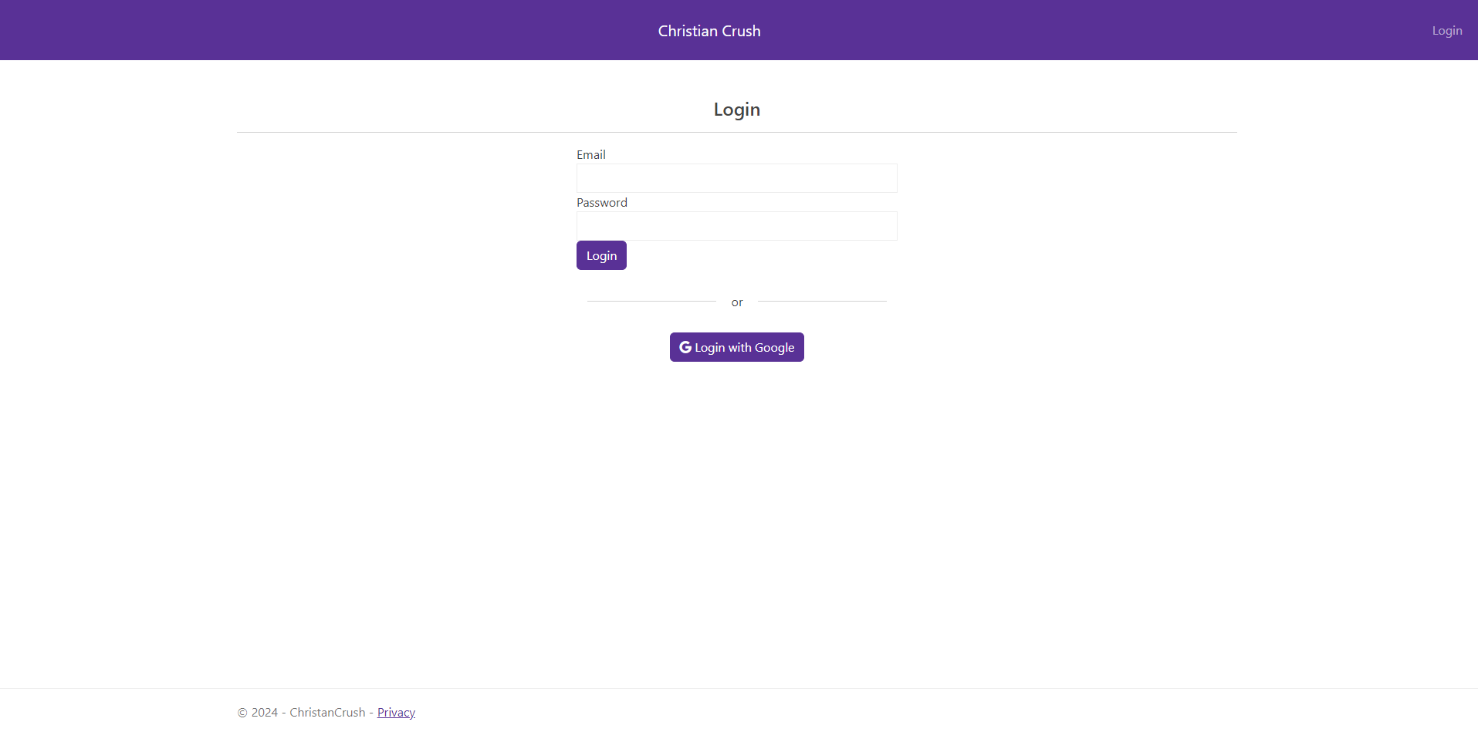**Login Page**

I designed the UI for Christian Crush with simplicity and user-friendliness in mind, ensuring that the interface is intuitive and easy to navigate. The color palette consists of calming and visually appealing colors like white, grey black, and purple. These colors are not only the colors of GCU, but I thought it would make be a great for standing out amongst competitors. The layout is clean and organized with straightforward navigation to provide users with a seamless experience. By focusing on these design principles, I aim to create an environment where users can comfortably connect and interact with one another.

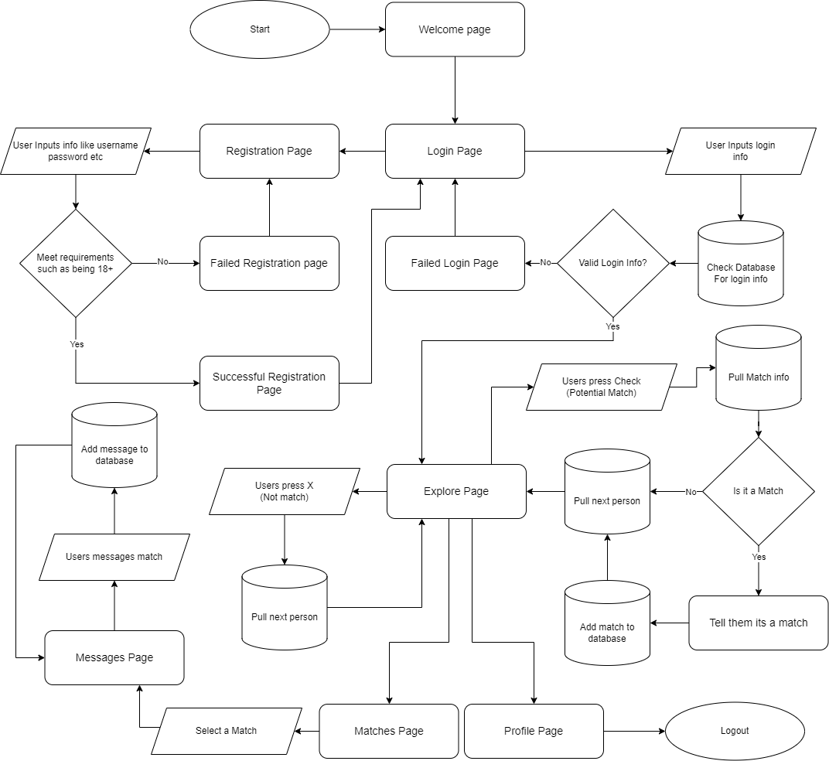**Website workflow**

The website workflow starts with user registration and login. Once logged in, users can complete their profiles and browse other profiles. The workflow also includes initiating contact through a secure messaging system. This detailed workflow ensures that user interactions are intuitive and secure, aligning with the overall goal of fostering meaningful connections.

1. Use the template to list the project deliverables.

|  |  |  |  |  |  |
| --- | --- | --- | --- | --- | --- |
| Deliverable Acceptance Log | | | | | |
| ID | Deliverable Description | Comments | Evaluator (internal or external as applicable) | Status | Date of Decision |
| 1 |  |  |  |  |  |
| 2 |  |  |  |  |  |
| 3 |  |  |  |  |  |
| 4 |  |  |  |  |  |
| 5 |  |  |  |  |  |

|  |
| --- |
| Detailed Solution Architecture |

1. Provide a detailed overview of how the proposed design fits into the overall solution/ business case structure. Create object model and use cases to depict the system. Use collaboration diagrams and/or sequence diagrams to show the workflows of components/packages/classes inside the component. Describe algorithms, if possible. Include detailed specifications for all screens, interfaces and integration points, processes, conversion, reports, and any required modification to existing systems. This section should also include any solution configuration changes that will be required to develop and implement the proposed solution. The purpose of the detail solution architecture is to provide sufficient information for a developer to produce the system.

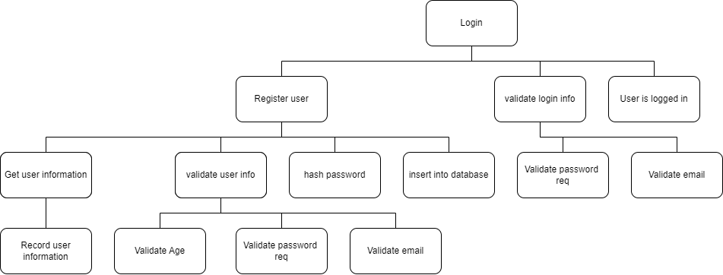**Login System Design**

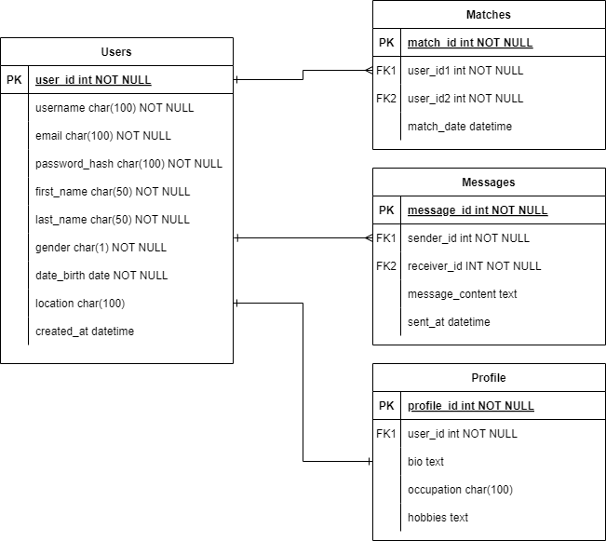**Database Design and Model Design**

**UML Classes**

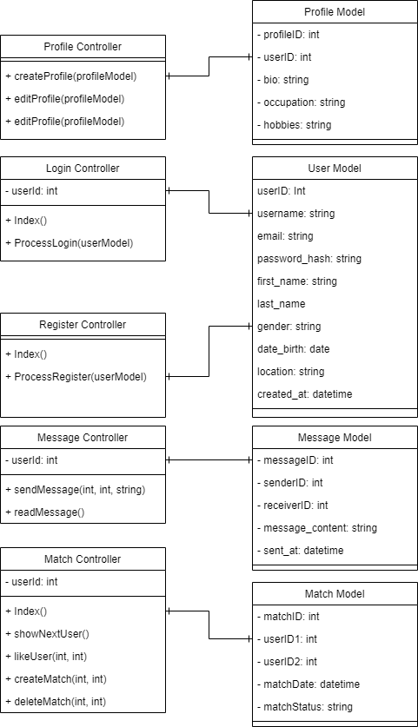

1. Describe the approach and resources required to assure system security, if applicable, otherwise explain why security is not relevant.

In order to ensure the security of the Christian Crush project, I will be implementing the option to log in through Google Auth0, providing a secure and reliable authentication method. Additionally, passwords will be hashed using salts to enhance their security and protect against brute-force attacks. To further safeguard the system, various tactics will be employed to prevent SQL injection, such as using parameterized queries and prepared statements. These measures will collectively fortify the application's defenses and protect user data.

1. Use the template to list the hardware and software technologies.

|  |
| --- |
| Hardware and Software Technologies |
| 1 - Visual Studio 2022 |
| 2 - ASP.NET Core Project built using .NET 6.0 |
| 3 - MySQL Community Server using Server version: 5.7.24 |
| 4 - Google AuthO |
| 5 - Herkou for database and hosting the website |
| 6 - Bootstrap |
| 7 - GitHub |

|  |
| --- |
| Revision and Signoff Sheet |

**Change Record**

|  |  |  |
| --- | --- | --- |
| **Date** | **Editor** | **Revision Notes** |
| 7/7/2024 | Noah F | Initial Final Plan |
|  |  |  |
|  |  |  |

|  |
| --- |
| **Overall Instructor Feedback/Comments** |