**Milestone 2: Project Requirements Template**

Noah Funderburgh

Grand Canyon University

Course Number: CST-451-O500

Michael Landreth

6/30/2024

**Project Requirements Template**

**Christian Crush**

**Use Cases**

Use Case 1: User Registration

1. User navigates to the Christian Crush homepage.
2. User selects "Sign Up" button.
3. User enters required information like name, email, password, date of birth, and gender.
4. User agrees to terms and conditions and submits the form.
5. User is redirected to the profile setup page.

Use Case 2: Profile Setup

1. Users log in with their registered email and password.
2. User navigates to the profile setup page.
3. User uploads a profile picture.
4. User fills in personal information (bio, interests, faith details).
5. User saves the profile.
6. System updates and displays the complete profile.

Use Case 3: Searching for matches

1. User logs in and navigates to the search page.
2. System displays a list of matching profiles.
3. User swipes left or right on potential match
4. If both users swipe right, they match, else they don’t

Use Case 4: Messaging a match

1. User logs in and navigates to their existing matches
2. User selects the match they wish to message
3. User composes and sends a message.
4. System delivers the message to the recipient.
5. Recipient logs in and reads the message.
6. Recipient responds to the message.

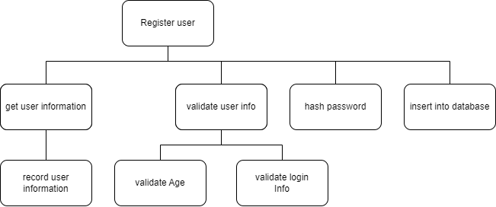**System Design**

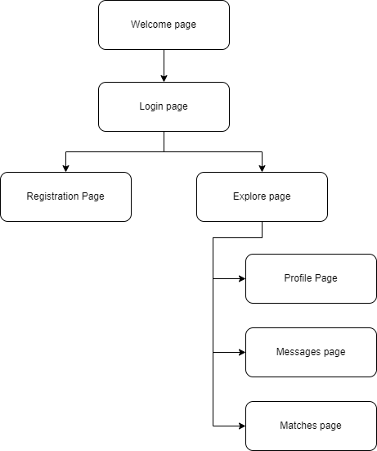

**Technical Requirements**

* User Interface Requirements
  + Responsive Design: The application must be responsive and compatible with various devices
  + Browser Compatibility: Must support major browsers including Chrome, Firefox, and Edge.
* Profile Management Requirements
  + Profile Creation: Users should be able to create profiles including personal information and a profile picture.
  + Profile Updates: Users should be able to update their profile information and pictures.
* Messaging System Requirements
  + Message Sending: Users should be able to send messages to other users.
  + Message Receiving: Users should be able to receive messages from other users.
* Data Storage Requirements
  + Database: Use a relational database like SQL Server for storing user data, profiles, matches, and messages.
  + Cloud Storage: Use cloud storage services (e.g., Azure Blob Storage) for storing user-uploaded images.

**System Logical Model**

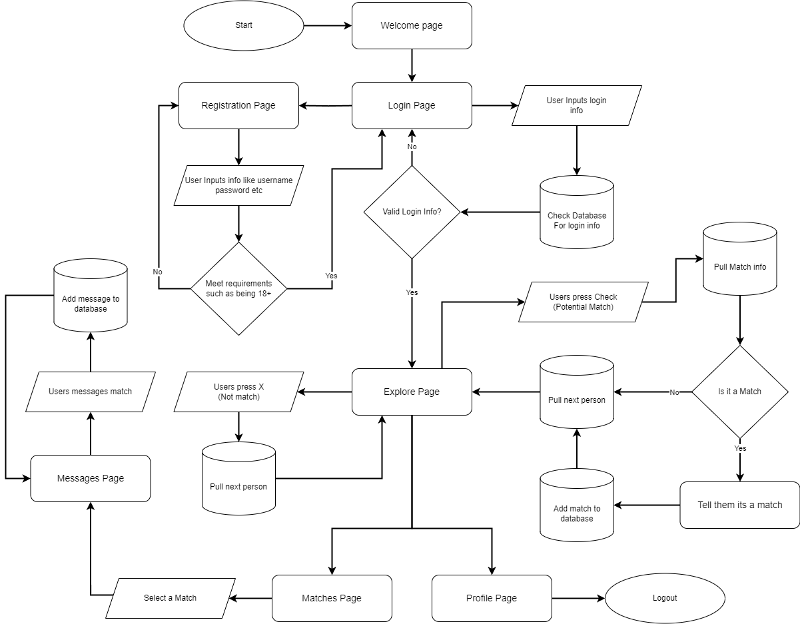

**Reports**

With this type of project I am building, there are many different types of reports that are essential for the system to run smoothly. A few I might implement are reports that provide critical information to the administrator, such as user registration reports to track new user sign-ups over time, user activity reports to monitor engagement and activity levels, and user feedback reports to summarize feedback and issues reported by users. Currently I don’t plan on implementing any reports as I don’t think they are needed for the project at the current time due to it being on a small scale but it is a feature that might get implemented later.

**Security**

In Christian Crush, security is important to protect user data and maintain the integrity of the platform. A key focus will be adding salts and then hashing the passwords using a robust algorithm like bcrypt, ensuring that even if the database is compromised, user passwords remain secure and unreadable. Additionally, measures will be implemented to prevent SQL injection attacks, a common vulnerability in web applications. This will involve using prepared statements and parameterized queries, which ensure that user inputs are treated as data rather than executable code, thereby mitigating the risk of malicious SQL code being executed. By prioritizing these security practices, Christian Crush aims to provide a safe and trustworthy environment for its users.

**Screen Definitions and Layouts**

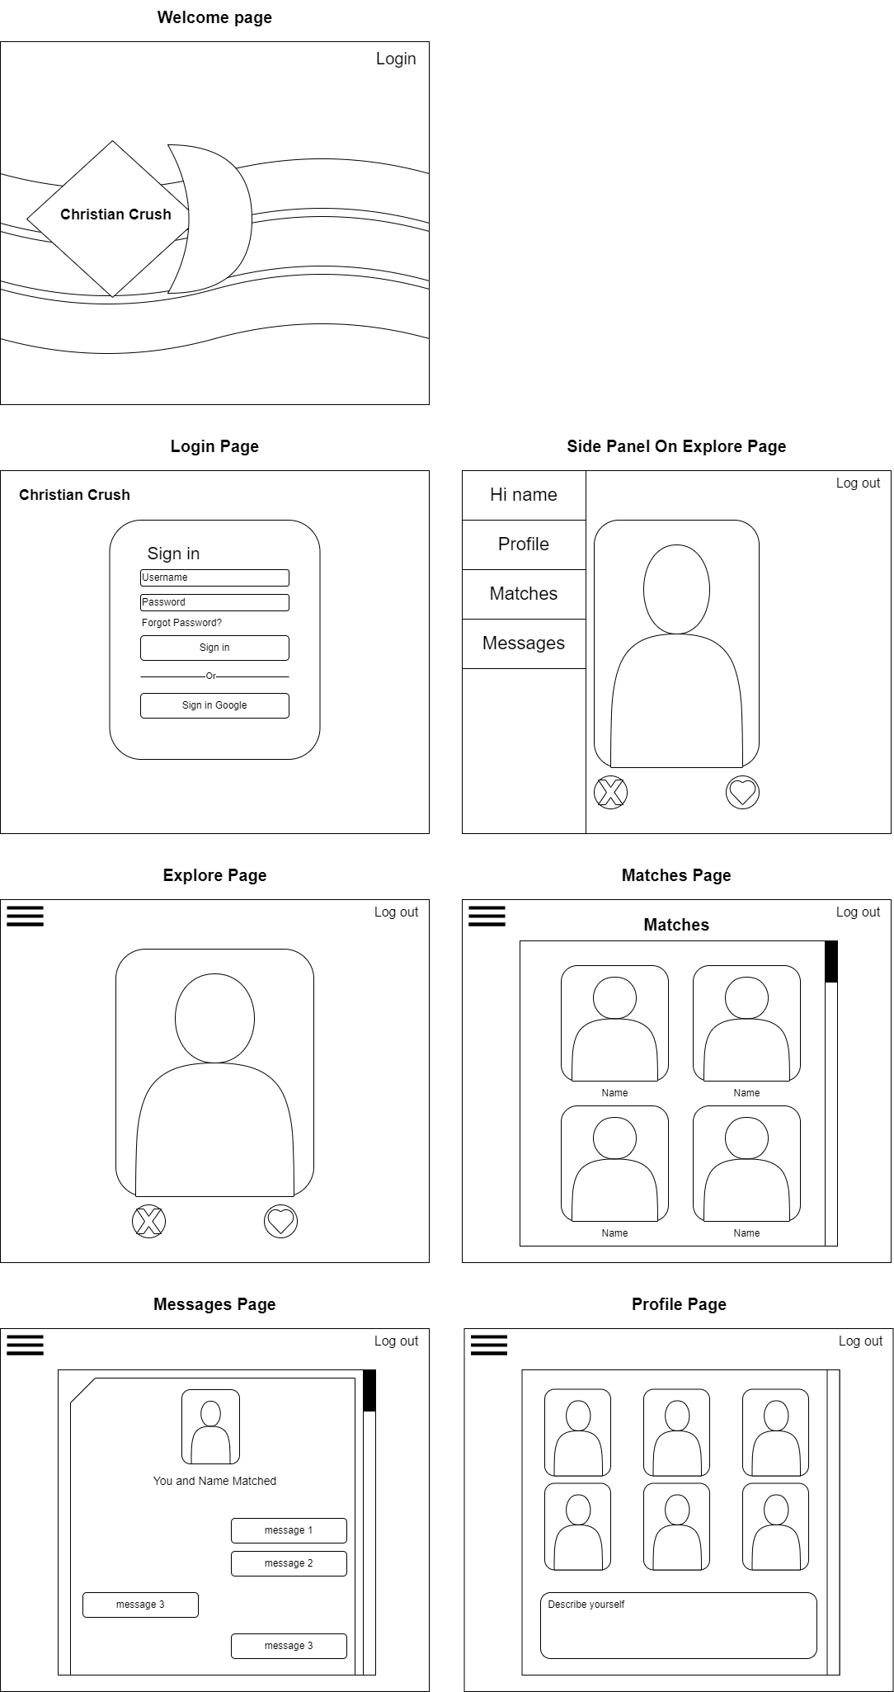All the screen layouts will be accessible for different devices. My focus will be for computers and phones.

## 

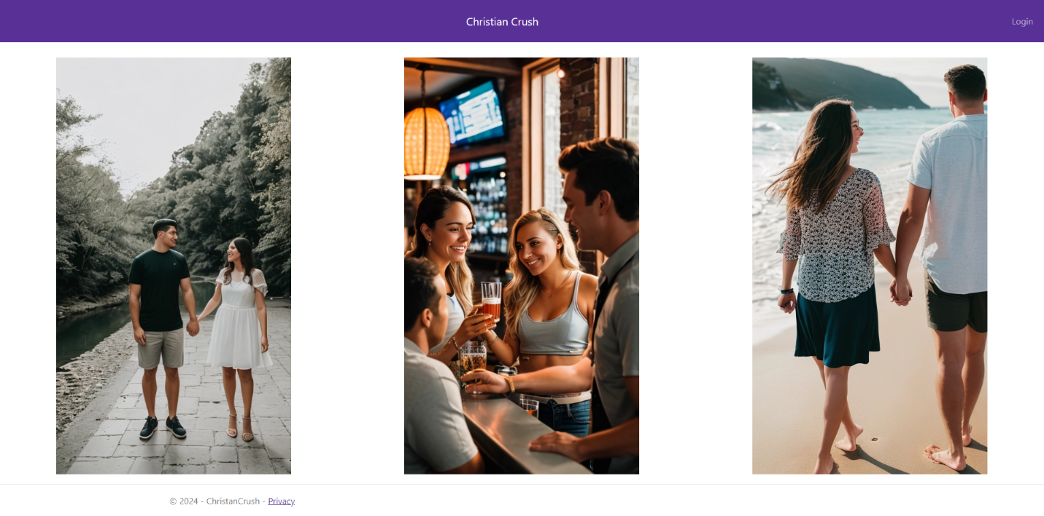

**Other**

