**Light Theme and Dark Theme: Case Study**

An online bookstore is looking to optimize its website design to improve user engagement and ultimately increase book purchases. The website currently offers two themes for its users: “Light Theme” and “Dark Theme.” The bookstore’s data science team wants to conduct an A/B testing experiment to determine which theme leads to better user engagement and higher conversion rates for book purchases.

The data collected by the bookstore contains user interactions and engagement metrics for both the Light Theme and Dark Theme. The dataset includes the following key features:

* Theme: dark or light
* Click Through Rate: The proportion of the users who click on links or buttons on the website.
* Conversion Rate: The percentage of users who signed up on the platform after visiting for the first time.
* Bounce Rate: The percentage of users who leave the website without further interaction after visiting a single page.
* Scroll Depth: The depth to which users scroll through the website pages.
* Age: The age of the user.
* Location: The location of the user.
* Session Duration: The duration of the user’s session on the website.
* Purchases: Whether the user purchased the book (Yes/No).
* Added_to_Cart: Whether the user added books to the cart (Yes/No).

Your task is to identify which theme, Light Theme or Dark Theme, yields better user engagement, purchases and conversion rates. You need to determine if there is a statistically significant difference in the key metrics between the two themes.

Many web platforms and applications perform A/B testing to run experiments to find the best design, layout, or themes for their platform. Instead of relying on assumptions or hunches, applications and websites can test different design variations on real-time users to measure their impact on user behaviour and metrics. By collecting and analyzing data, they can identify which design elements resonate most with users and optimize their offerings accordingly. So, if you want to know how to perform A/B testing to find the best theme on a website, this article is for you. In this article, I’ll take you through the task of A/B testing of Themes using Python.

## A/B Testing of Themes: Overview

A/B testing is a powerful and widely used [**Data Science**](https://thecleverprogrammer.com/2022/03/12/data-science-roadmap/) technique to compare and evaluate marketing strategies, designs, layouts, or themes. The primary purpose of A/B testing is to make data-driven decisions that lead to improved user experiences, enhanced performance metrics, and ultimately better business outcomes.

Let’s say we have two themes, dark mode and light mode. A company wants to understand which theme looks the best on its website.

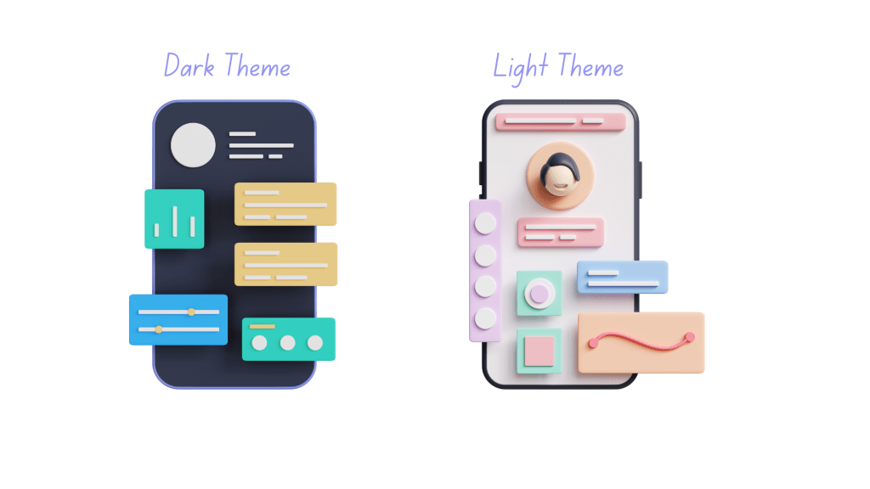

To understand which theme is better, the company can set a light theme as the default theme of the website for a certain period and collect data on how users interact with the website. Likewise, they can set a dark theme as the default theme for the same period and compare the user interaction data of both themes to find which theme resulted in better user interaction, purchases, signups, longer session duration, and more.

So for the task of A/B testing of themes, we need to have a dataset of user interaction data on two themes or design templates. I found an ideal dataset for this task. You can download the dataset from [**here**](https://statso.io/light-theme-and-dark-theme-case-study/).