Web Services Business Activity (WS-BA) sample for WebSphere Application Server – Installation and Execution Guide
Copyright© 2006 International Business Machines Corporation. All rights reserved.
US Government Users Restricted Rights – Use, duplication or disclosure restricted by GSA ADP Schedule Contract with IBM Corp.
Introduction
The Web Services Business Activity (WS-BA) technology for WebSphere provides support for the implementation of Web Services that follow the Web Services Business Activity specifications [WSBA]. It includes a sample application to demonstrate how this support should be used.
This document describes how to configure and install the support for WS-BA and a sample application that illustrates its use. The sample is provided both as a deployable binaries and source code. This document also describes how to deploy and run the sample application and how to rebuild the source code if desired. The accompanying document, [WSBA_Overview] gives an overview of the WS-BA standard and describes programming considerations for WAS applications that exploit WS-BA. It also contains a FAQ section.
System Requirements:
This sample requires an installation of WebSphere Application Server
version 7.0 or higher, though the WS-BA technology has been available since version 6.1. These instructions assume such an installation with a profile containing a single standalone application server. Instructions are given for Windows platforms only. To run on a UNIX platform substitute .sh for .bat and ‘/’ for ‘\’.
Installation Instructions:
Download the WSBASample.zip file and extract the contents to a suitable directory (eg c:\temp\WSBASample) hereafter referred to as the install_root directory. In the following text, the profile_root directory refers to the WebSphere AppServer profile directory (e.g.
c:\WebSphere\AppServer\profiles\AppSrv01).
The WS-BA Sample is unpacked into the following directories:

install_root\docs | Contains documentation for the WS-BA Sample.
install_root\src | Contains the source code for the WS-BA Sample.
install_root\installableApps | Contains the WSBASample.ear, WSBASampleWeb.war and WSBASampleEJB.jar, files for the WS-BA Sample.
Install_root\scripts | Contains scripts for rebuilding the sample, buildWSBASample.bat/ buildWSBASample.sh and setting up the WAS environment, setupWAS.jacl and install.jacl.

Configuring the WAS environment
This section describes how to setup the WAS environment for the sample application to run in.
This should only be run once per install.
Perform the following tasks:
- Stop the application server (for example, using the “stopserver” script).
- Make sure that your PATH includes profile_root\bin
- Change to the install_root\scripts
- To configure the WAS environment, type the following:

wsadmin.bat -conntype none -f setupWAS.jacl
- To install the sample application, type the following.

wsadmin.bat -conntype none -f install.jacl
- Start the application server (for example, using the “startserver” script)

setupWAS.jacl configures the following in WAS
:
- creates a JDBC XA Provider
- creates a data source on the provider
- enables the compensation service on the application server
- creates an Application Policy Set that supports WS-Transaction

install.jacl does the following

- installs the WSBASample application (WSBASample.ear).
- attaches the Policy Set created by setupWAS.jacl to the Web Service Providers and Service Clients of the WSBASample application.

Removing the WSBASample.ear file Remove the sample as follows:
- Stop the application server
- Make sure that your PATH includes profile_root\bin
- Type the following:

wsadmin.bat -conntype none -c "$AdminApp uninstall WSBASample”
- Start the application server (for example, using the “startserver” script).

Deploying the WSBASample.ear file
This section describes how to deploy the sample application.
Perform the following tasks::
- Stop the application server (for example, using the “stopserver” script).
- Make sure that your PATH includes profile_root\bin
- Change to the install_root\scripts directory
- To deploy the sample application, type the following:

wsadmin.bat -conntype none -f install.jacl
- Start the application server (for example, using the “startserver” script).

Rebuilding the WS-BA Sample Make a backup copy of the install_root\src directory before attempting to modify or rebuild the code.
To rebuild the WSBA Sample EAR files change to the install_root\src directory
Make sure that your PATH includes profile_root\bin

Type:
install_root\scripts\buildWSBASample.bat
at the command line.
The script sets the appropriate classpath information and executes the Ant build utility. The Ant utility reads the build.xml files, which describe how to build the Samples. Refer to the Jakarta Web site <http://jakarta.apache.org/ant/index.html> for additional documentation on the Ant utility.
Accessing the WS-BA Sample
The WS-BA Sample has a servlet interface and can be accessed by pointing a web browser to http://<your_server_hostname>:9080/WSBASampleWeb. The sample is split into two sets of scenarios, a simple example that shows the basic, core compensation for a zero phase piece of work such as e-mail, and a more complex example which involves mixing EJB’s and Web Services and still coordinating them to achieve a consistent outcome. The sample home page is shown in a screen shot below:
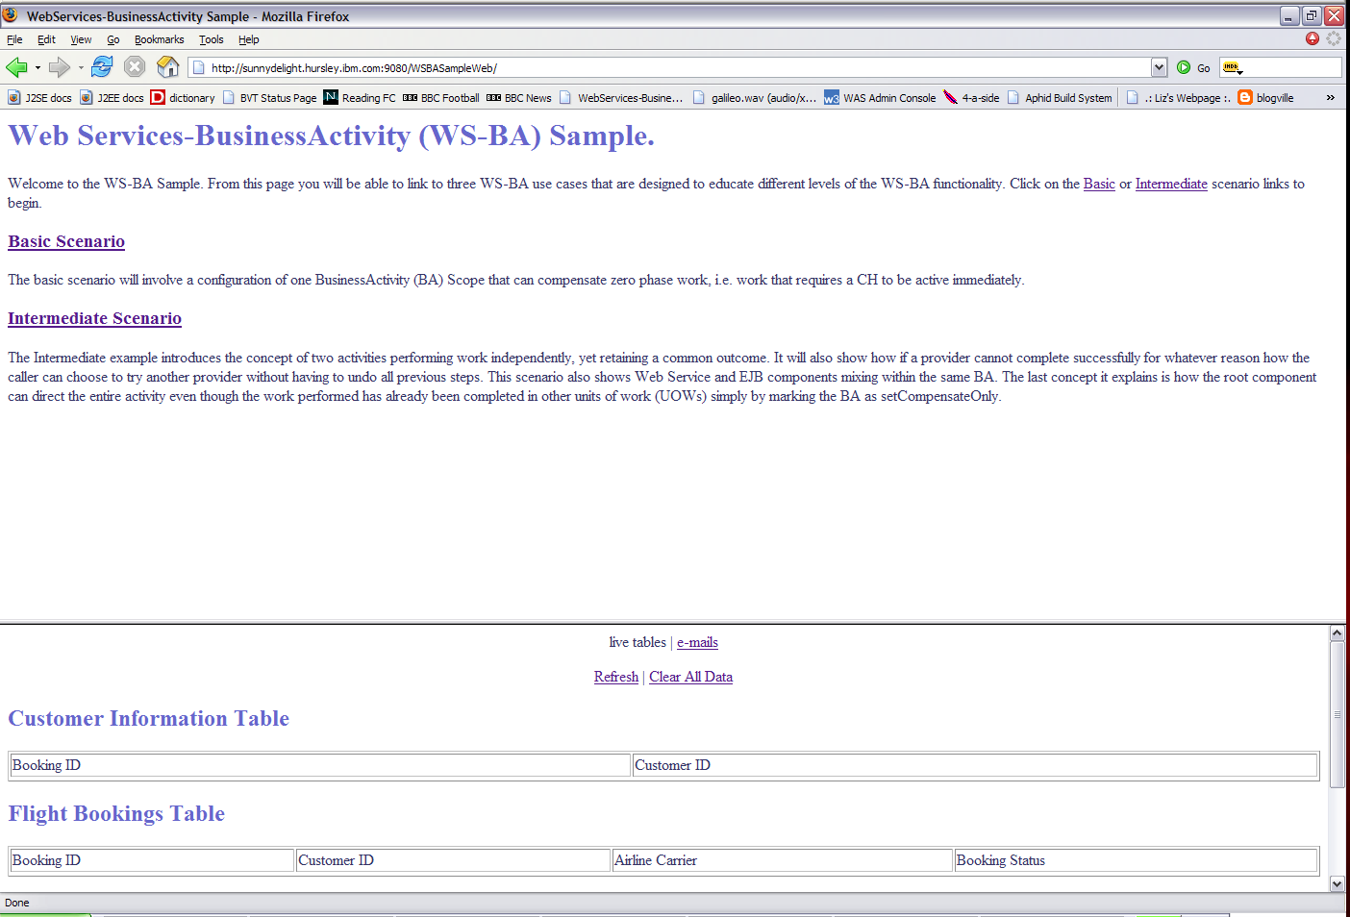

From the top part of this screen, you can navigate through the configuration of the samples, and choose which one to run. The bottom half of the sample provides you with a view of the database table data as well as any e-mails that have been received. When you click on either the basic or intermediate links from the WSBA sample home page above, you will be given a detailed description of the scenario with the topology of the component configuration with their interactions. This is shown below:
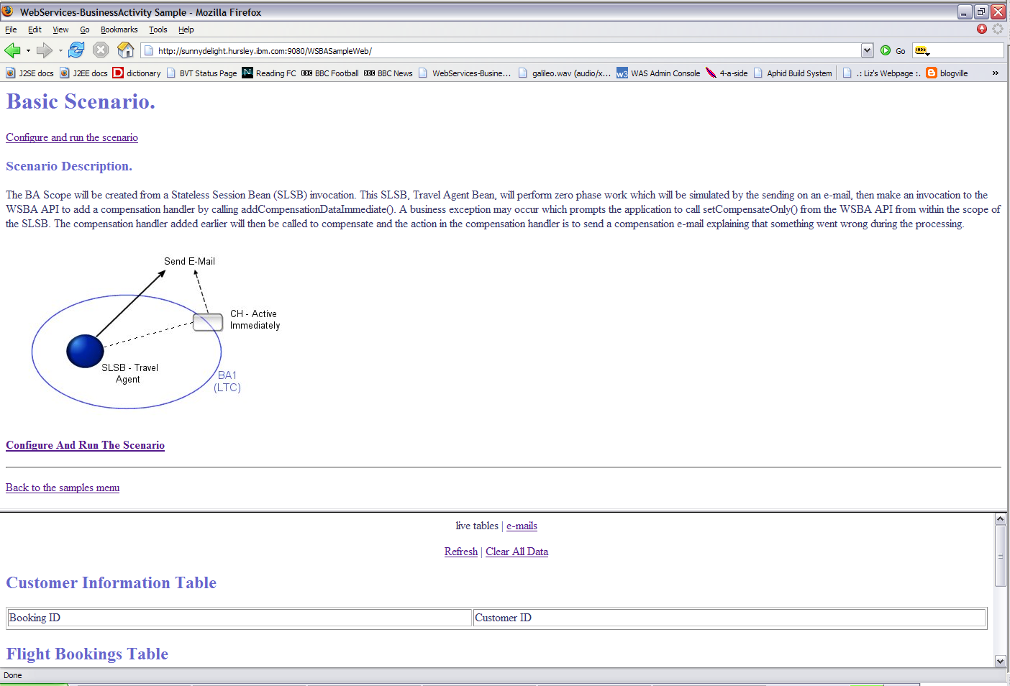
To configure the scenario, click the link labelled “Configure And Run The scenario”. This will take you to a page that allows you to enter information to change the outcome of the sample run. The basic scenario configuration step is shown below:
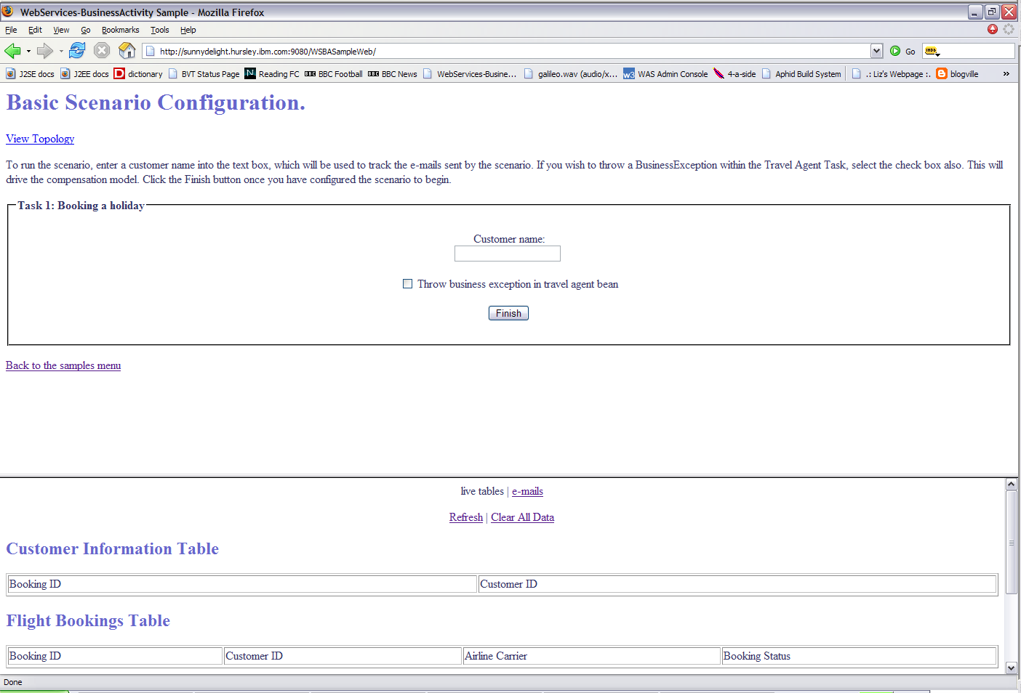
Once you run the sample, the configuration is likely to send e-mails and update tables. Everything the sample does will be logged and output to the user as the results for that run. You can also refresh the updated results in the tables and the inbox at the bottom of the screen as shown below:
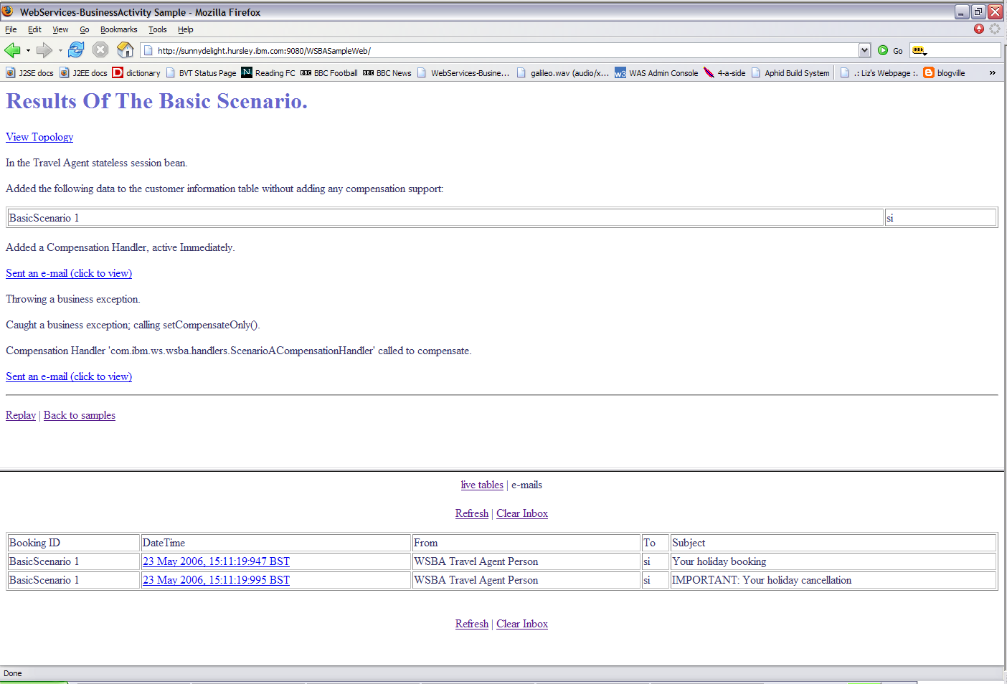
References:
[WSBA_Overview] Web Services Business Activity (WS-BA) sample for WebSphere Application Server – Overview and Programming Guide

[WSBA] Web Services Business Activity
http://download.boulder.ibm.com/ibmdl/pub/software/dw/specs/ws-tx/WS-BusinessActivity.pdf

[WSCOOR] Web Services Coordination
http://download.boulder.ibm.com/ibmdl/pub/software/dw/specs/ws-tx/WS-Coordination.pdf
Trademarks and service marks
The following terms are trademarks or registered trademarks of the IBM Corporation in the United States, other countries, or both:
IBM WebSphere
Java, J2EE and all Java-based trademarks and logos are trademarks or registered trademarks of Sun Microsystems, Inc. in the United States, other countries, or both.
Other company, product, and service names may be trademarks or service marks of others.

