USER MANUAL

WRITTEN BY

*RANU VIKRAM*

**USER'S MANUAL**

**TABLE OF CONTENTS**

Page #

1.0 GENERAL INFORMATION 1-1

1.1 Introduction 1-1

1.2 System Requirements 1-1

2.0 HOW TO PLAY 2-1

*3.0 POINTS OF CONTACT* 1-1

1. GENERAL INFORMATION
   1. INTRODUCTION

Bollywood Game is a simple pass time game. In this game, one is provided with a string which contains only vowels and dashes (for consonants). One has to guess the movie correctly.

* 1. SYSTEM REQUIREMENTS

System Requirements for this software are:

Windows Operating System 8 or later

.NET Framework 4.5

1. HOW TO PLAY

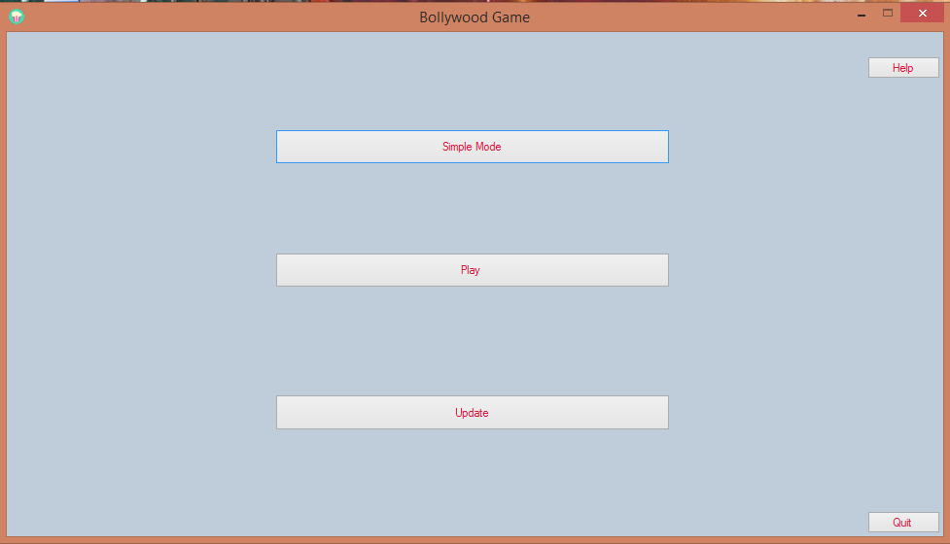

This game features 2 modes “Simple Mode” and “Play”. In Simple mode one has to guess movies from a pool of most popular movies, but score is not maintained in this mode, while in “Play” mode one has to guess movies from a pool of all Bollywood movies released till date and score is also maintained in this case.

User is also provided with the feature to update the databases of Bollywood movies. One can quit from this application at any time by clicking on the “Quit” button. One can also access help by clicking on “Help” button.

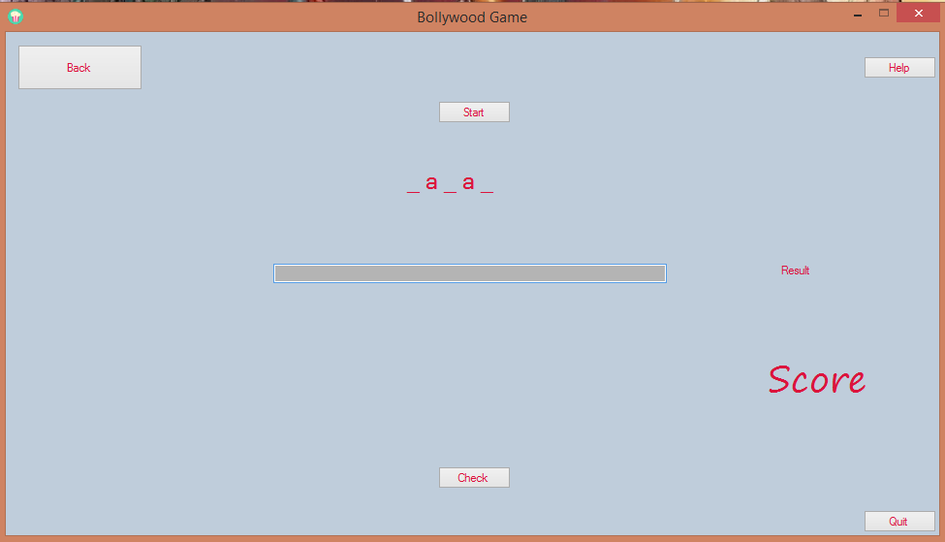

Click on “Start” button to start the game. Either clicks on “Check” button or press “enter” key to submit your input. If your answer is correct then score will be incremented by one. You will also be provided with correct answer along with result of your response.

One can click on “Back” button to return to main menu or hit “Quit” to close the application itself.

3.POINTS OF CONTACT

3.0 POINTS OF CONTACT

One can contact me by email at following address ([ranu010101@outlook.com](mailto:ranu010101@outlook.com)) for any software related query or can visit our website http://172.16.25.62:9094/bollywoodgame.html.