***Algorithm***

**Flow Chart**: A flow chart is a graphical or symbolic representation of a process. Each step in the process is represented by a different symbol and contains a short description of the process step. The flow chart symbols are linked together with arrows showing the process flow direction.

***Problem:*** Lamp doesn’t work!!!

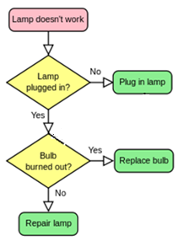

***Problem:*** Find N!

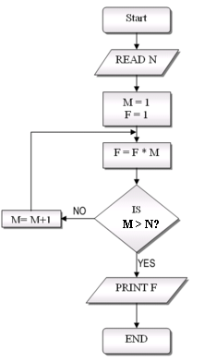

***Problem:*** Find the largest of three numbers A, B and C

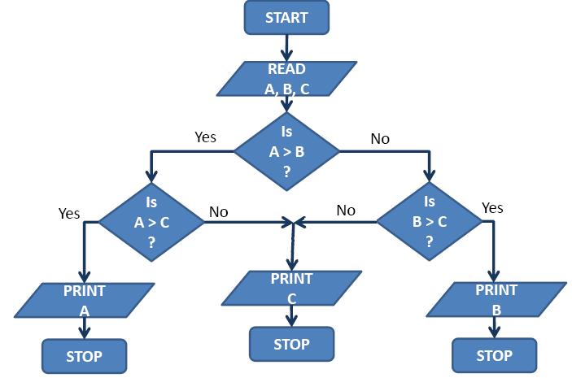

**Convention:**

1. Parallelograms are used to represent input/output.
2. Rectangles are used to indicate any processing operation such as storage and arithmetic.
3. Diamond shaped boxes are used to indicate questions asked or conditions tested.
4. Rectangles with rounded ends are used to indicate the beginning or end points.
5. Circle (labeled) is used to indicate jump in the process flow (it join different parts of a flow chart), called connector.
6. Arrows indicate the direction to be followed in a flow chart.

***Problem:*** Find the largest of a given set of numbers

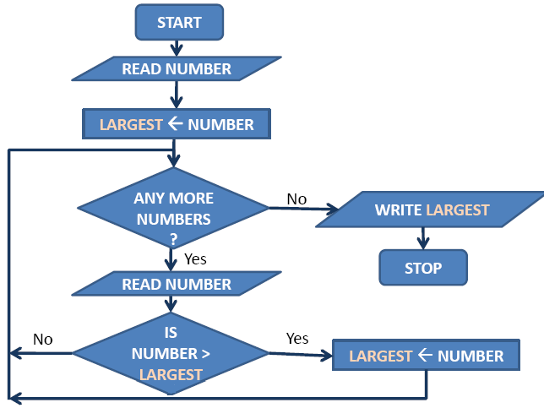

***Exercise:***

1. Celsius to Fahrenheit conversation.

2. The largest of a set of numbers.

3. Given integer is prime or composite.

4. LCM of two given integers.

5. GCD of two given integers.

6. Solve: ax2 + bx+ c = 0

7. The Fibonacci numbers:

Let a0= 1 and a1= 1, and an be given by the following recursive definition: an = an-1 + an-2

8. Write a program which takes a positive integer as input and prints all prime factors of it.

9. Write a program which takes a positive integer as input and print it in binary form.