Nikhil Gopal

Question 1:

The sample size calculation is 8.

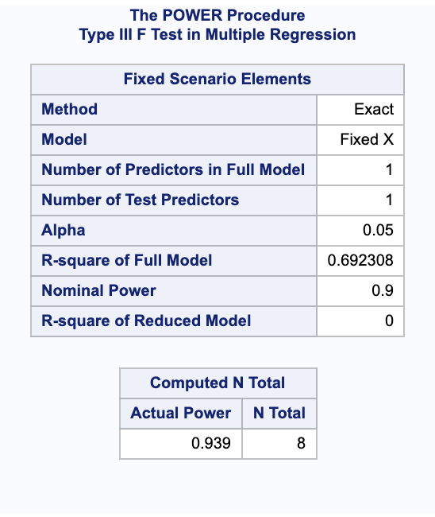

Question 2:

For this question, I am estimating that 80% of students who don’t have their basic needs will complete the degree within 4 years. I am estimating a very high proportion, because I think that having basic needs (shelter, food, water) are crucial to being able to focus on coursework, completing assignments on time and doing so consistently. Earning a degree takes 4 years, so a lack of consistency would lead lots of people to not earn the degree.

For this experiment, I would use logistic regression on the relationship between a report of true and failing to complete the degree within for years. My for the sample size calculation, my odds ratio would be log(0.8/0.2). I would want 90% power and an alpha of 0.05. 0.9 is a standard value for social science experiments, which is why I picked that value. The power calculation resulted in a sample size of 105:

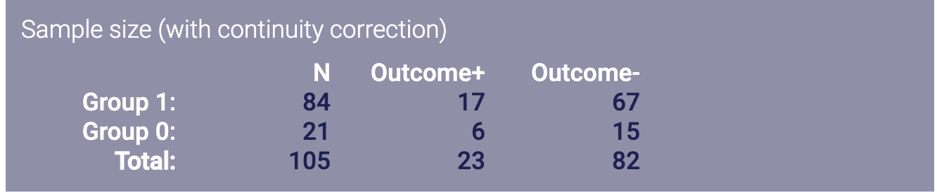

From:

<https://sample-size.net/sample-size-proportions/>

Question 3:

For this question, I would use survival analysis, since there is a possibility of data being censored. Some students might drop out of the study after being administered the drug cocktails. I would run a 2 sided test, with alpha of 0.05. Since we are trying to do a minimal effect size calculation for 80% of the students testing negative, I would use a hazard ratio of 4 (0.8/0.2). The probability would be 0.2, since the effect would be testing positive for covid, and we are estimating 80% of people will test negative. According to our calculations, the power would be 0.475, and the minimum effect size would be 0.475\*150=71.25.

