[Date]
UNIVERSITE DU LAC TANGANYIKA FACULTE D `INFORMATIQUETRAVAIL PRATIQUE Sujet. 10 procedure select-avec le where, and, or, 5 stockes insert, 5 delete 5 update Présente par NGARUKIYE ETIENNE et Ngabirano Evariste

drop procedure if exists liste_facture; delimiter // create procedure liste_facture() select idfacture, date_facture, montant from facture;

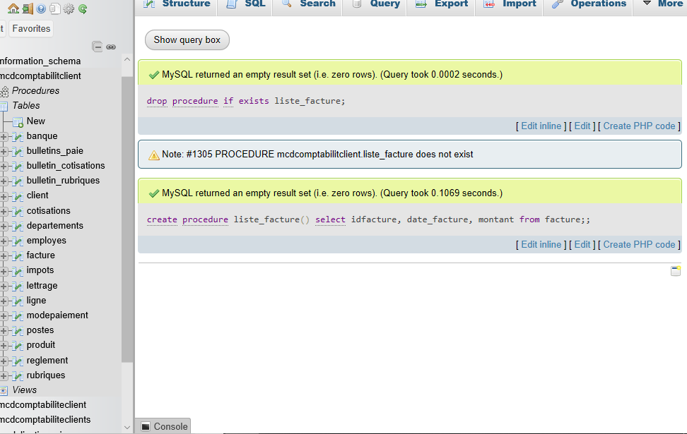

drop procedure if exists liste_client; create procedure liste_client() select idclient,nom,telephone from client;

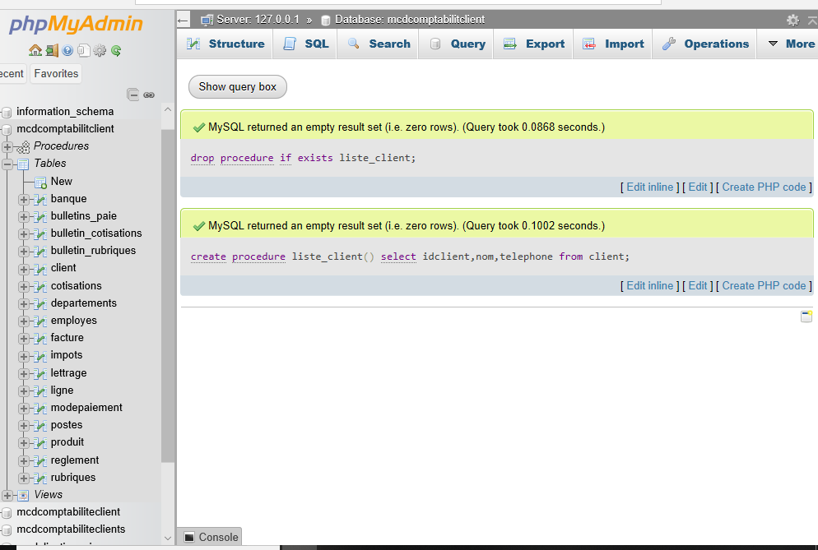

drop procedure if exists liste_reglement; create procedure liste_reglement() select idreglement,date_reglement,montant, mode_paiement from reglement;

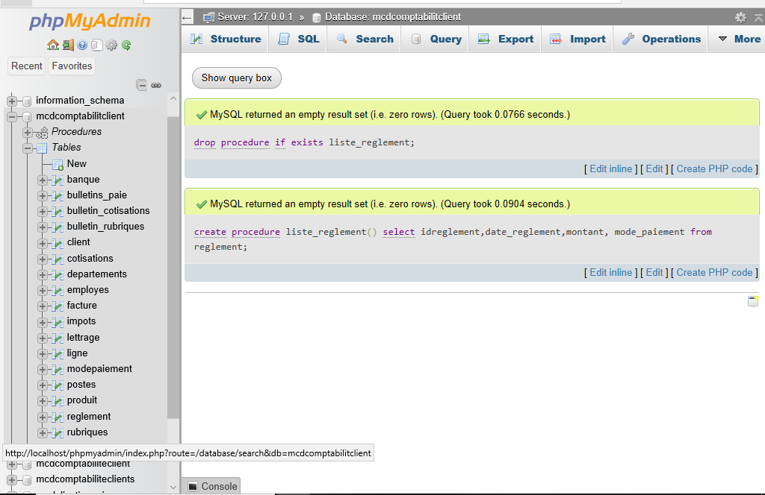

drop procedure if exists facture_client; create procedure facture_client(in p_idclient int) select idfacture,date_facture,montant from facture where idclient=p_idclient;

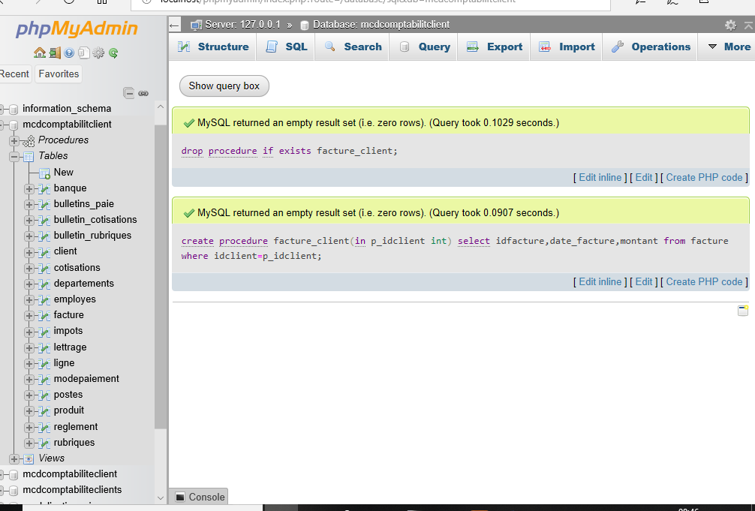
drop procedure if exists cherche_client; create procedure cherche_client(in p_nom varchar(50)) select * from client where nom like concat('%', p_nom, '%');

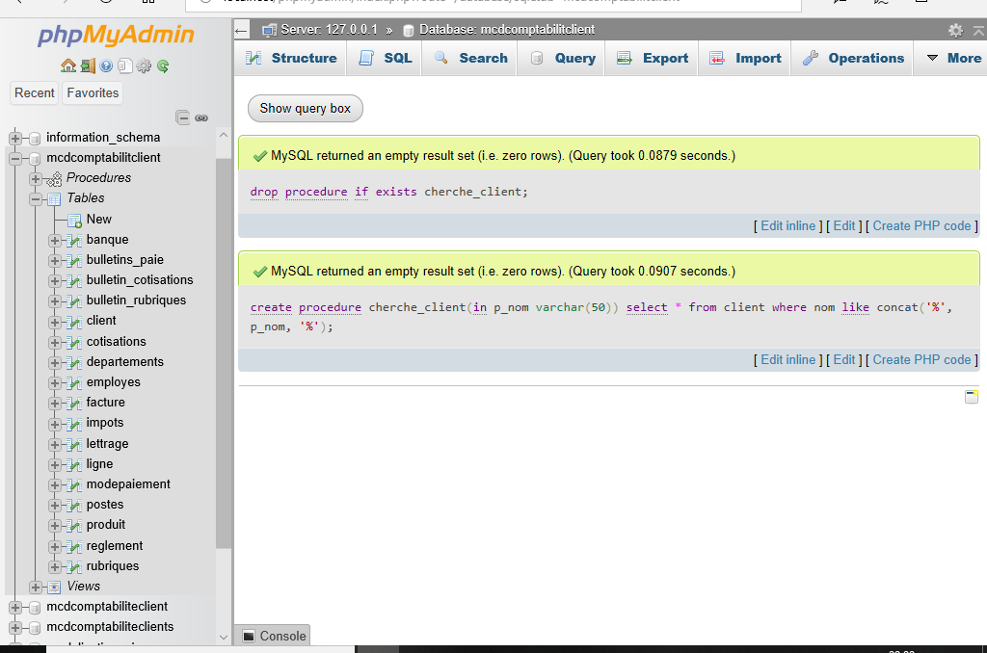

drop procedure if exists facture_nini; create procedure facture_nini(in p_montant decimal(10,2)) select idfacture,montant from facture where montant > p_montant;

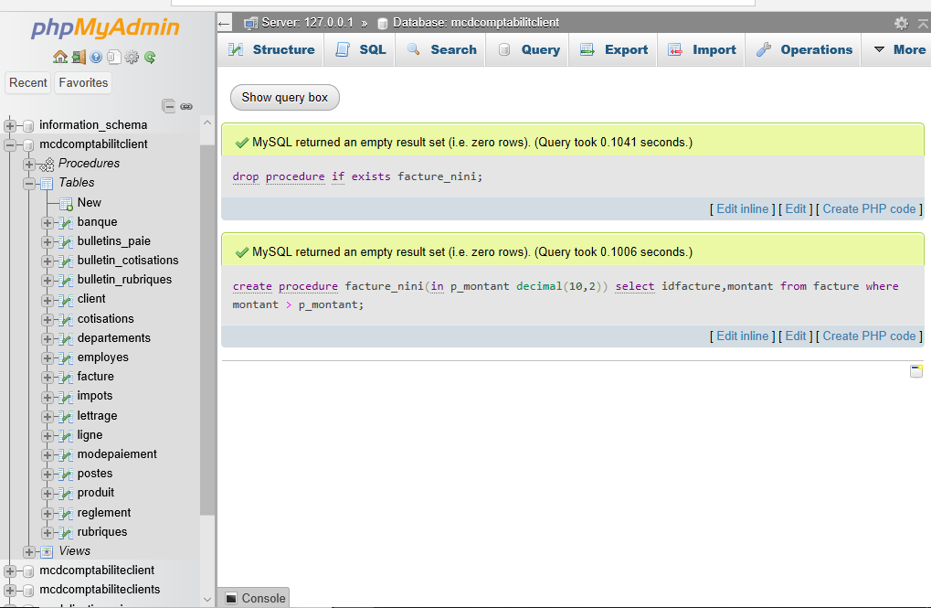

drop procedure if exists produit_ike; create procedure produit_ike(in p_stock int) select nom_produit,stock from produit where stock < p_stock;
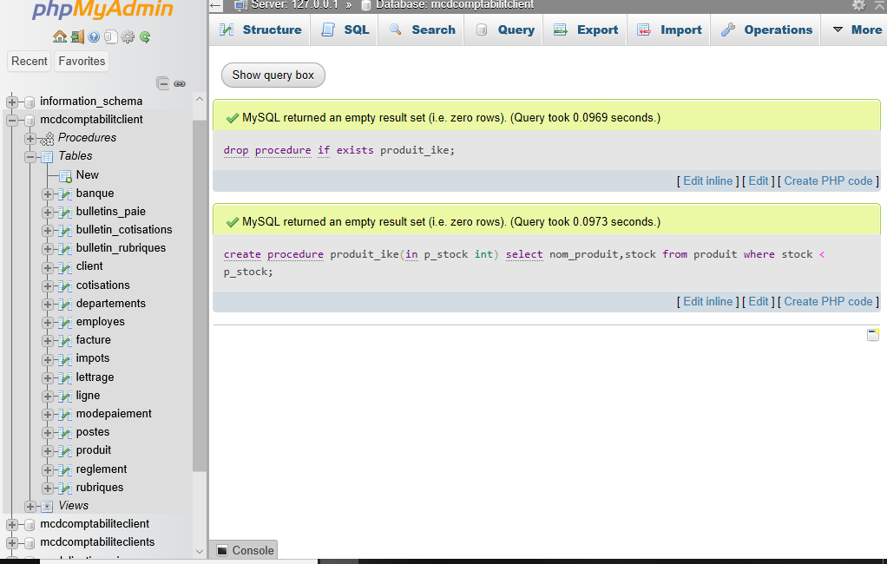

drop procedure if exists reglement_cash; create procedure reglement_cash() select idreglement,montant, date_reglement from reglement where mode_paiemant = 'cash';

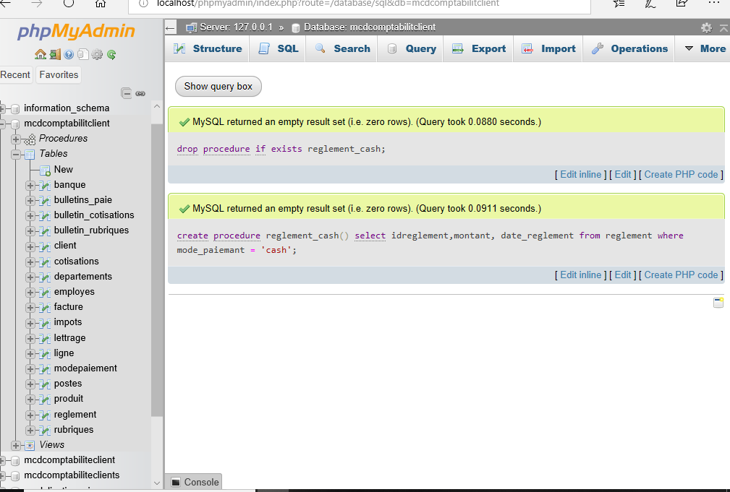

drop procedure if exists ligne_facture; create procedure ligne_facture(in p_idfacture int) select l.idligne, p.nom_produit, l.quantite, l.mntant from ligne l inner join produit p on l.idproduit = p.idproduit where l.idfacture = p_idfacture;

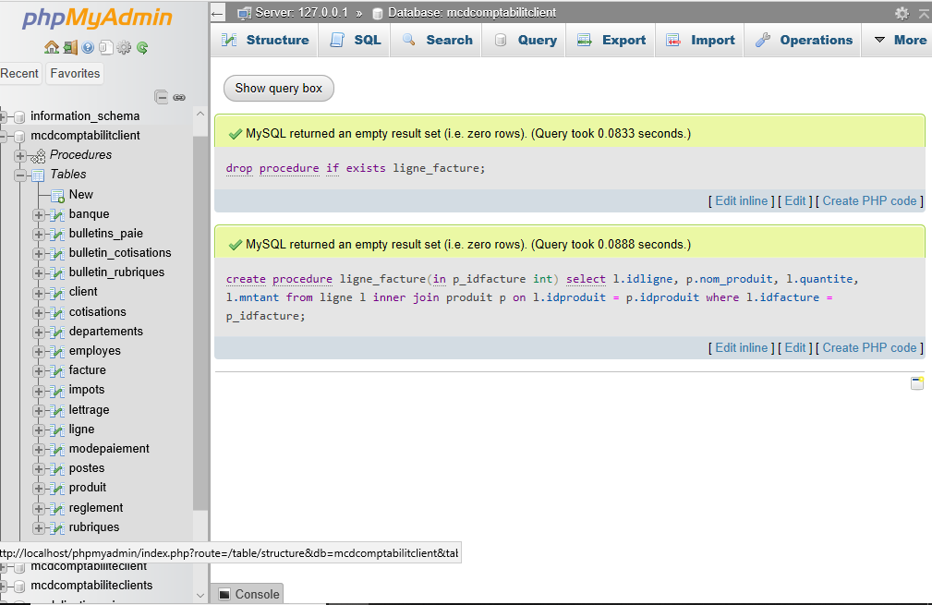

drop procedure if exists total_client; create procedure total_client() select count(*) as total from client;
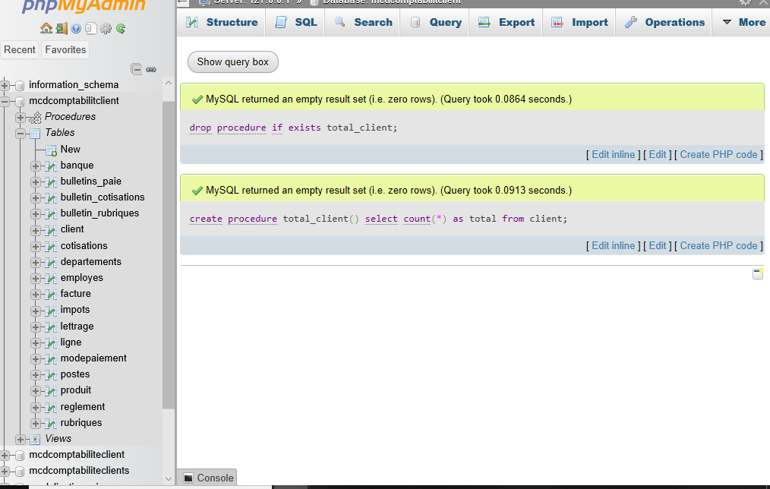

drop procedure if exists somme_facture; create procedure somme_facture() select sum(montant) as total_montant from facture ;



drop procedure if exists facture_leo; create procedure facture_leo() select idfacture, montant from facture where date(date_facture) = curdate();
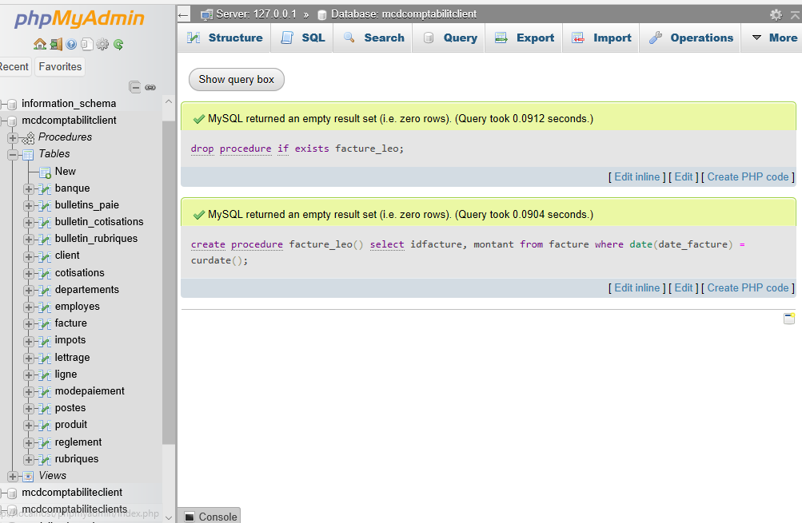

drop procedure if exists facture_ukwezi; create procedure facture_ukwezi() select idfacture, montant,date_facture from facture where month(date_facture) = month (curdate()) and year(date_facture) = year(curdate());
