**Contact Management System:**

**Contents**

1. Requirements ……………………………………………………………………………………….…. 2
2. Use-case Diagram ……………………………………………………………………………………. 3
3. Class Diagram ………………………………………………………………………………………….. 4
4. Sequence Diagram …………………………………………………………………………………… 5
5. User Guide ………………………………………………………………………………………………. 6
   1. Load ……………..……………………………………………………………………………………..6
   2. List All .…………………………………………………………………………………………………6
   3. Add ………………………………………………………………………………………………………7
   4. Edit ………………………………………………………………………………………………………7
   5. Delete………………………………………………………………………………………………..…7
   6. Search ……………………………………………………………………………………………….…7
   7. View ………………………………………………………………………………………………….…7
6. **Requirements:**

Design and implement the software for the following contact management system using OO principles:  
  
"The system allows the user to add new contacts, edit the existing ones, or delete contacts. Each contact has a name prefix, a first name, middle name, last name, and a name suffix. In addition, a contact can have email addresses, phone and fax numbers, an address, a date of birth.

The user of the system can enter additional information about the contact in a note.  The end user can list all the contacts in the system, or otherwise can search contacts; when searching, the system will return all the contacts that match the search keyword.

The system can print the number of contacts as well as the total number of contacts whose birthday is today or in the next seven days.

The system allows contacts to be loaded from an XML file or save all the contacts to an XML file."  
  
The interface for this contact management system is command line.  You will have to develop the commands that allow the user to use the calendar.  You'll also have to develop the XML format for loading and saving contacts.  
  
You may NOT use a database of any kind.  
  
All other rules for the project apply, in particular those related to languages you may use, test environment, automated unit testing and test coverage.

1. **Use-case diagram:**



1. **Class Diagram:**

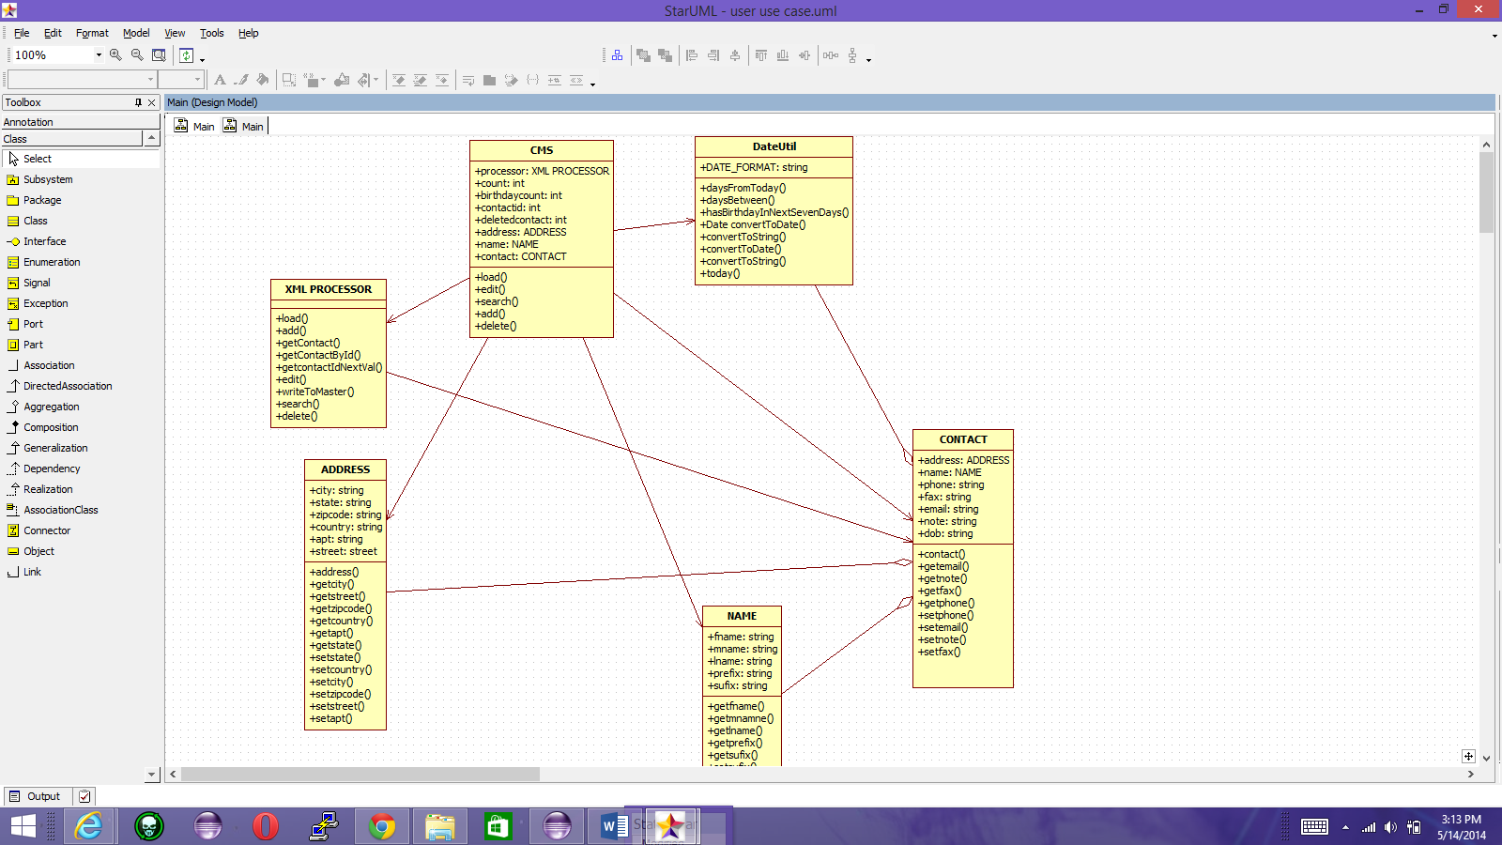

1. **Sequence Diagram:**

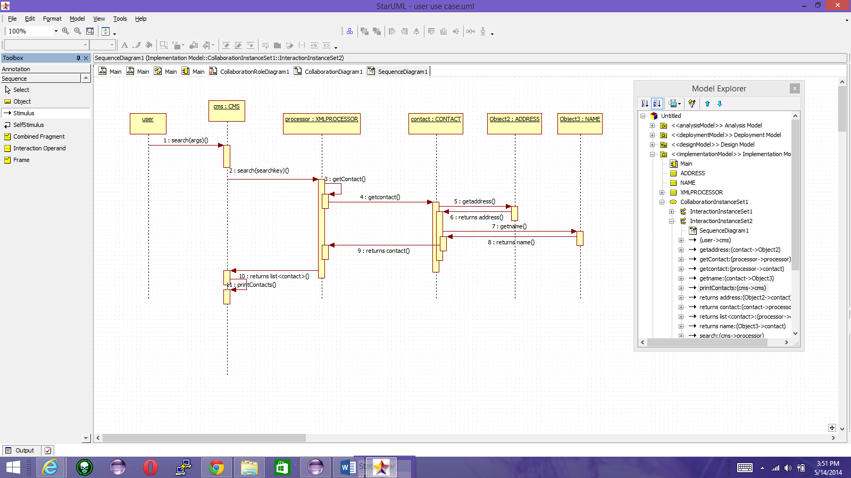

1. **User Guide:**

**5.1 Load**

Loads contact data from a xml file provided on the command line by the user in to the master XML file maintained by system to store & retrieve contact information.

CMS system maintains a master XML file to keep all contact information. This file will be used for loading, adding, listing and deleting contacts.

Command Usage: cms load –filename <xmlFileName>

Steps:

1. User enters the load command on the command line with arguments described above.
2. ContactManagementSystem parses the arguments and pass the filename to XMLProcessor to load contacts in to the master XML file.
3. Display appropriate message to the user after loading contacts.

**5.2 List All:**

Lists all the contacts present in the master XML file

**Command syntax:**

cms listall

**Steps:**

1) User enters the listall command on the command line with arguments described above.

2) ContactManagementSystem parses the arguments and pass it to XMLProcessor to list the contact from the master XML file.

3) Displays the list of all contacts ,the total number of contacts and the contacts whose birthday is within 7 days.

**5.3 Add:**

Adds a new contact into the master XML file.

**Command Syntax:**

cms add –prefix prefix --firstname <firstname> –middlename <middlename> –lastname <lastname> --suffix <suffix> --city <city> --state <state> --zip <zip> --country <country> --phone <phone> --fax <fax> --email <email> --dob <dob> --note <note> –pobox <pobox> --suffix <suffix> --street <street>

Steps:

1) User enters the add command on the command line with arguments described above.

2) ContactManagementSystem parses the arguments and pass it to XMLProcessor to add the contact to the master XML file.

3) The contact information is displayed back to user after successfully adding it to master XML file.

**5.4 Edit:**

Edits the contact already present in the XML file and updates it to the file.

**Command Syntax:**

Cms edit --contactid <contactid>

Steps:

1) User enters the edit command on the command line with arguments described above.

2) ContactManagementSystem parses the arguments and pass it to XMLProcessor to add the contact to the master XML file.

3) The contact information is displayed back to user after successfully editing else, displays “invalid contactid <contactid>” if we edit an invalid contactid .

**5.5 Delete:**

Deletes a contact with specific contactid specified by the user from the XML file.

**Command Syntax:**

Cms delete --contactid <contactid>

Steps:

1) User enters the delete command on the command line with arguments described above.

2) ContactManagementSystem parses the arguments and pass it to XMLProcessor to delete the contact to the master XML file.

3) displays the <contactid> that has been deleted successfully else,displays “contactid <contactid> not found” if we try to delete a contactid which is not present in the XML file.

**5.6 Search:**

The system will search all the contacts with the specified keyword and

displays all those contacts which matches that keywordand the total number of contacts from the search result ,whose birthday is in next seven days**.**

**Command Syntax:**

Cms search --searchkey <searchkey >

Steps:

1) User enters the search command on the command line with arguments described above.

2) ContactManagementSystem parses the arguments and pass it to XMLProcessor to search the contact to the master XML file.

3)Displays all the contacts which matches the keyword and also the total number of contacts whose birthday is in next seven days else displays contact doesn’t exist with the specified keyword.

**5.7 View**

View command displays the complete contact information of the specified contactid

**Command Syntax:**

Cms view --contactid <contactid>

Steps

1) User enters the view command on the command line with arguments described above.

2) ContactManagementSystem parses the arguments and pass it to XMLProcessor to view the contact .

3) Displays the contact information with matches the contactid specified by the user else, displays “contact not found”.