Date: 05/30/2014

To: Virgil Bistriceanu

From: Namrata Gaddameedi

Subject: Contact Management System

The purpose of this Memo is to summarize the progress on Project “Contact Management System”.

This memo describes the project, the number of hours I have spent to get the code working, the number of hours I have spent preparing my submission, and list of challenges I faced while working on this assignment, lines of code, coverage report, cyclomatic complexity .

**Project Description:** Contact Management System allows the user to listall , load , add , edit ,delete ,search and view contacts and also display contacts whose birthday is in next 7 days. Developed these command using the OO principles and the interface for this project is command line. The user enters the above commands in order to retrieve, update or remove contacts from the master Xml file maintained by the system.

**Time spent on project:**

* Number of hours spent on writing the code is 200 hours
* Number of hours spent on writing the submission is 16 hours

**Unit test coverage report:**

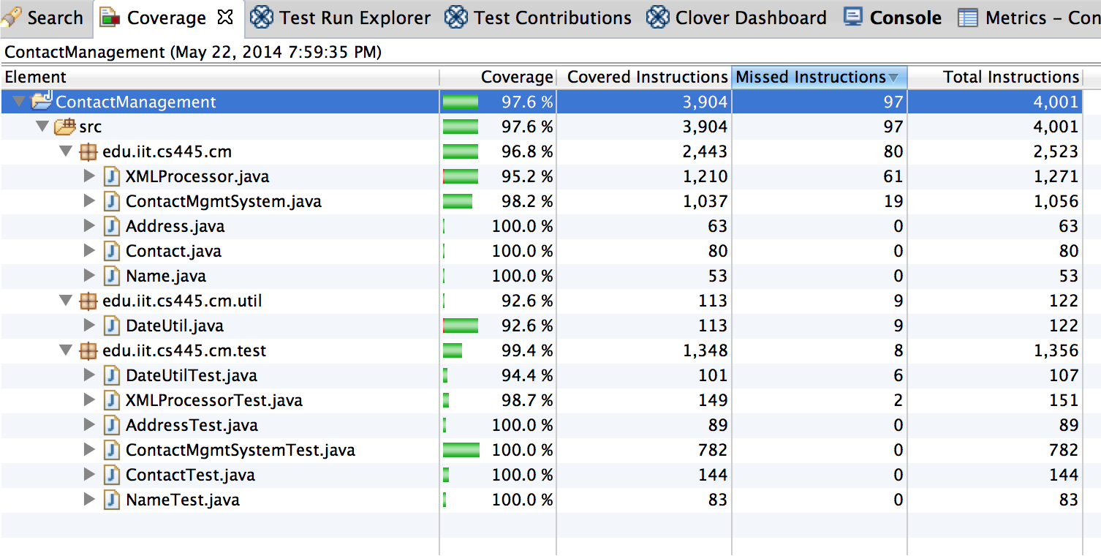

The overall coverage for contact management system is 97.6%**.** Please see the detailed report in the github under coverage_report directory.

The unit test coverage for all the unit test cases is above 90%

**Lines of code:**

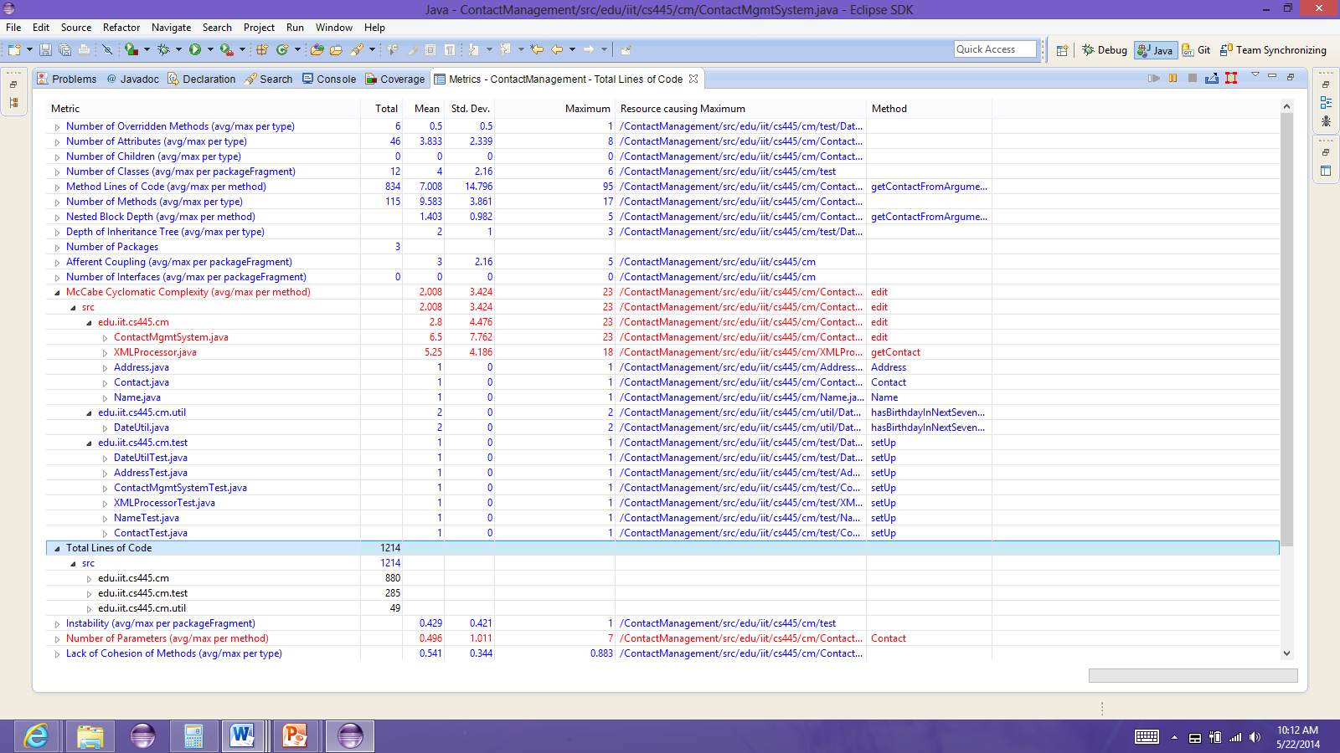

* Line of code in the application which includes DateUtil class 880+49=929
* Lines of code in unit test classes 295

**Cyclomatic complexity:**

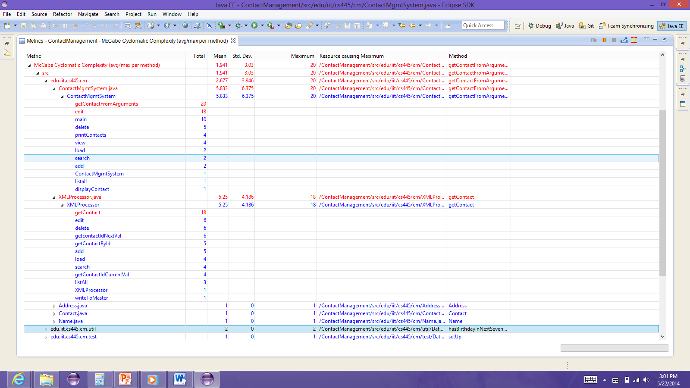

* The cyclomatic complexity for getcontactsfromarguments is 20 because to get a contact from xml file all the 17 fields used in the command has to be compared, hence used more number of if-loops as we need to check if correct argument are passed for the fields starting with “--“ else it may lead to improper output.
* In edit method, the cyclomatic complexity is 18 where the contact fields have been checked under all the possible conditions and avoid exceptions, which lead to more number of if statements.
* The cyclomatic complexity in getcontact method of Xmlprocessor class is 18 as we need to check if the contact is null else it gives a null pointer exception, and also in order to get the context from xml all the 17 fields have to be compared with the tagname. Hence by considering all the cases inorder to avoid exceptions and errors the number of if statements are more compared to others

**Challenges faced**: While working on this project the following are the difficulties I have faced:

* Reading & writing contacts from and to the XML file was completely new to me so I had to learn DOM using java and write this program.
* I used ant instead of make file for building and running contact management command line tool. Learning and implementing ANT was one of the big challenges I faced.
* Faced difficulty in Writing unit test case for the ContactMgmtSystemTest class as it needs to test the arguments entered by the user on the command line.

**Status:**

* The status of the project is COMPLETE
* The project is executed without any problems
* Did not miss any part from the requirements mentioned