Assignment_1 ( Linear Layout )

1. Make your app that consists of four text view using Linear Layout as show in figure-1.

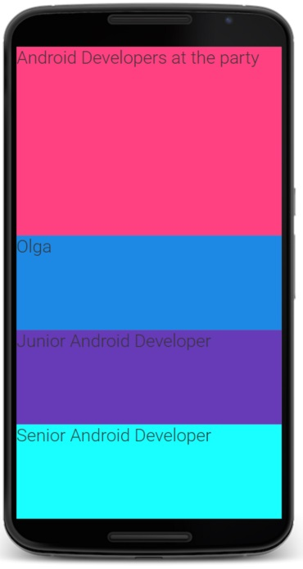

1. Make your app that consists of text view, edit text and button using Linear Layout as shown in figure-2.

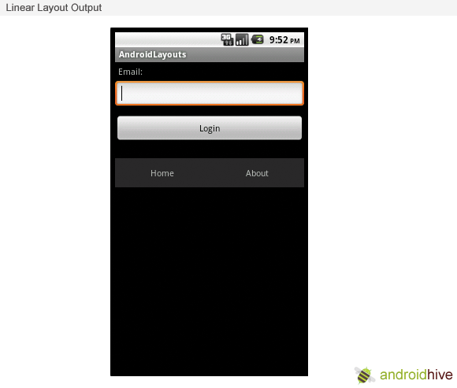

1. Test your app on the emulator.
2. If you have an Android phone or tablet, test your app on it.