**Assignment_2 (Relative Layout)**

1. Make your app that consists of TextView, EditText and three button (Login, Cancel and Register new Account) using Relative Layout as show in figure below.

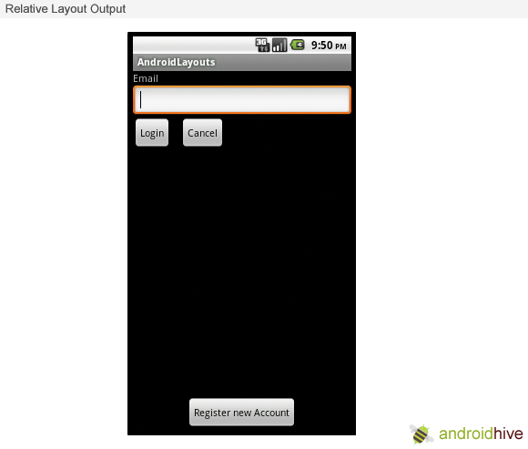

1. Make your app as shown in figure below.

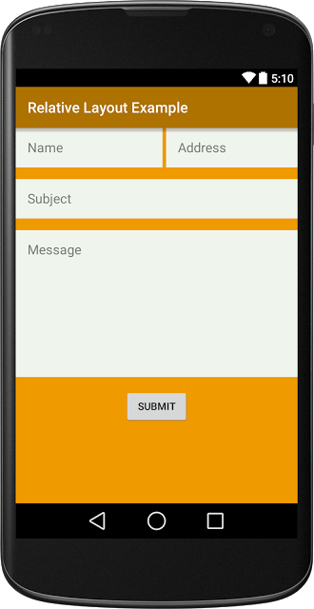

1. Test your app on the emulator.
2. If you have an Android phone or tablet, test your app on it.