**Supplement**

**Methods S1.** Search terms used in Web of Science and PubMed to source publications for screening.

(‘ecological niche modeling’ OR ‘species distribution modeling’ OR ‘ENM’ OR ‘SDM’ OR ‘MaxEnt’) AND (‘Bulinus’ OR ‘Biomphalaria’ OR ‘Oncomelania’ OR ‘Lymnaea’ OR ‘Parafossarulus’ OR ‘Bithynia’ OR ‘Melanoides’ OR ‘Neotricula’ OR ‘Galba’ OR ‘Fossaria’ OR ‘Pseudosuccinea’ OR ‘Radix’ OR ‘Segmentina’ OR ‘Hippeutis’ OR ‘Cerithidia’ OR ‘Pirenella’ OR ‘Thiara’ OR ‘Melania’ OR ‘Stenomelania’ OR ‘Bradybaena’)

**Methods S2.** Scoring criterion for best practice adherence regarding the response variable, sourced from Araujo et al., 2019.

We assessed response variable quality across five modelling issues: 1) the sampling of response variables, 2) the identification of taxa, 3) the spatial accuracy of response variables, 4) the environmental extent of the response variable’s sampling, and 5) the geographic extent of the response variable’s sampling. All proceeding classifications were adapted from Araujo et al. 2019’s *Standards for distribution models in biodiversity assessments,* wherein deficient, bronze, silver, and gold scores represent unacceptable, minimally acceptable, current best, and aspirational practices, respectively. The same classification scheme is applied in supplementary methods sections S3-5.

For the sampling of response variables, studies were labelled as gold if they were sampled using systematic schemes that 1) captured the major environmental and geographic gradients occupied by the taxon across the study’s range, 2) considered population demographic parameters, and 3) considered taxa detectability. Studies were labelled as silver if they failed to explicitly consider population demographic parameters or taxa detectability, but considered some information related to sampling intensity. Studies were labelled as bronze if they had not sampled according to systematic schemes but nonetheless considered some information related to sampling intensity. Studies were labelled as deficient if they both had not sampled according to systematic schemes and failed to consider information related to sampling intensity.

For the identification of taxa, studies were labelled as gold if taxa identification had been provided by experts and based on multiple lines of examinable evidence. Studies were labelled as silver if taxa identification had been provided by experts based on a single line of examinable evidence. Studies were labelled as bronze if taxa identification had been provided by heterogeneous sources, but with some ‘critical cleaning’ to exclude unreasonable records. Studies were labelled as deficient if taxa identification had been provided by heterogeneous sources and without any screening of unreasonable records.

For the spatial accuracy of response variables, studies were labelled as gold if the resolution of their records was sufficient to match that of their predictor variables, such that no location misalignment with any predictor variables would be possible. Studies were labelled as silver if the resolution of their records had been insufficient to match that of their predictor variables, but if potential location misalignment had been nonetheless addressed by formal uncertainty analyses. Studies were labelled as bronze if the resolution of their records had not been reported or was inconsistent, but if manual steps to remove unreasonable records had been reported nonetheless. Studies were labelled as deficient if the resolution of their records had not been reported or was inconsistent, and if no measures to remove unreasonable records had been reported.

For the environmental extent of the response variable’s sampling, studies were labelled as gold if the environmental extent presented had matched the taxon’s known span of environmental tolerance in the study area according to several lines of evidence. Studies were labelled as silver if the environmental extent presented had matched the taxon’s known span of environmental tolerance in the study area according to a single line of evidence. Studies were labelled as bronze if some degree of environmental extents had been extrapolated from geographic extents, but without explicit consideration of the taxon’s environmental tolerance. Studies were labelled as deficient if no evidence had been provided that records covered the taxon’s span of environmental tolerance in the study area.

For the geographic extent of the response variable’s sampling, studies were labelled as gold if the geographic extent presented was restricted to and included all regions of the study area in which the taxon could suitably establish populations according to several lines of evidence. Studies were labelled as silver if the geographic extent presented was restricted to and included the full current and historic ranges of the taxon. Studies were labelled as bronze if the geographic extent presented was derived from regions of the study area justified in some reasonable manner to contain the complete range of the taxon. Studies were labelled as deficient if they had offered no justification for the geographic extent presented.

**Methods S3.** Scoring criterion for best practice adherence regarding the predictor variables, sourced from Araujo et al., 2019.

We assessed predictor variable quality across three modelling issues: 1) the selection of candidate variables, 2) the spatiotemporal resolution of predictor variables, and 3) the handling of uncertainty in predictor variables.

For the selection of candidate variables, studies were labelled as gold if they had included as candidate variables the full suite of variables with measurable effects on the taxon’s distribution as supported by several lines of evidence, in addition to the occurrence data used for model training. Studies were labelled as silver if they had included as candidate variables those with measurable effects on the taxon’s distribution as supported by only a single line of evidence, in addition to the occurrence data used for model training. Studies were labelled as bronze if they had included as candidate variables those with some available theoretically justified effect on the taxon’s distribution. Studies were labelled as deficient if they had failed to provide any ecological justification for the inclusion for the suite of candidate variables selected.

For the spatiotemporal resolution of predictor variables, studies were labelled as gold if the direct measurement of predictor variables occurred at resolutions at which several lines of evidence suggested the taxon should respond. Studies were labelled as silver if predictor variables had been interpolated at resolutions at which a single line of evidence suggested the taxon should respond. Studies were labelled as bronze if predictor variables had been interpolated at some ecologically justified resolution for the taxon. Studies were labelled as deficient if predictor variables had interpolated at some resolution for which ecological justification was not provided.  
 For the handling of uncertainty in predictor variables, studies were labelled as gold if all predictor variable uncertainty was mapped, quantified, and interpreted. Studies were labelled as silver if the majority of predictor variable uncertainty was mapped and quantified. Studies were labelled as bronze if uncertainty due to variable choice was acknowledged, and an interpretation of its potential impacts provided. Studies were labelled as deficient if predictor variable uncertainty failed to be considered in any manner.

**Methods S4.** Scoring criterion for best practice adherence regarding model building, sourced from Araujo et al., 2019.

We assessed model construction quality across four modelling issues: 1) model complexity, 2) the treatment of response variable bias, 3) the treatment of collinearity, 4) the handling of model and parameter uncertainty.

For model complexity, studies were labelled as gold if they had optimized model complexity using the appropriate tools and multiple sources of independent data to consider the performances of multiple models with different levels of complexity. Studies were labelled as silver if they had optimized model complexity using the appropriate tools and a single source of independent data to consider the performances of multiple models with different levels of complexity. Studies were labelled as bronze if they optimized model complexity using commonplace rules-of-thumb or using appropriate methods, but without independent data. Studies were labelled as deficient if model complexity had altogether not been considered.

For the treatment of response variable bias, studies were labelled as gold if they had either demonstrated no environmental/geographic biases in response data, or corrected for biases in response data by performing comparisons using independent data. Studies were labelled as silver if they corrected for biases in response data, but only by internal cross-validation. Studies were labelled as bronze if some acknowledgement of bias and a discussion of its implications for the study’s results had been made. Studies were labelled as deficient if no acknowledgement of response data bias was made.

For the treatment of collinearity, studies were labelled as gold if they had either demonstrated that no collinearity was found in their data, or had constructed their models in a manner that accounted for collinearity such that they were insensitive to it. Studies were labelled as silver if they had either fitted their models in a manner known to not be sensitive to data collinearity, or had demonstrated that their results were robust to changes in data collinearity. Studies were labelled as bronze if they had either utilized approximate methods to handle collinearity, or acknowledged and described data collinearity, and its potential impacts on results. Studies were labelled as deficient if collinearity had not been addressed or acknowledged in any manner.

For the handling of model and parameter uncertainty, studies were labelled as gold if results had been obtained using several modelling techniques to account for modelling technique uncertainties, and if all uncertainty in response data and predictor variables was fully propagated through models, generating a thorough characterization of uncertainty. Studies were labelled as silver if results had been obtained using several modelling techniques to account for modelling technique uncertainties, and if the dominant uncertainties in response data and predictor variables had been propagated through models. Studies were labelled as bronze if results had been obtained using several modelling techniques to account for modelling technique uncertainties, and if uncertainty in response data and predictor variables had been acknowledged and discussed. Studies were labelled as deficient if modelling technique uncertainty had not been quantified, or if no acknowledgement had been made of uncertainty in response data and predictor variables.

**Methods S5.** Scoring criterion for best practice adherence regarding model evaluation, sourced from Araujo et al., 2019.

We assessed model evaluation quality across three modelling issues: 1) the evaluation of model assumptions, 2) the evaluation of model outputs, and 3) the measurement of model performance.

For the evaluation of model assumptions, studies were labelled as gold if they had demonstrated quantitatively robustness to the assumptions of the particular techniques used. Studies were labelled as silver if they had theoretically justified robustness to the assumptions of the particular techniques used. Studies were labelled as bronze if they had acknowledged and characterized one or more violations of assumptions of the particular techniques used, and discussed the relevant consequences. Studies were labelled as deficient if they had failed altogether to evaluate statistical assumptions.

For the evaluation of model outputs, studies were labelled as gold if they had evaluated model outputs against multiple different, independent evaluation datasets, or a statistically independent subset of the data used to train their models. Studies were labelled as silver if they had evaluated model outputs against a single independent evaluation dataset, or a geographically structured subset of the data used to train their models. Studies were labelled as bronze if they had evaluated model outputs using a single non-independent dataset. Studies were labelled as deficient if model outputs had not been evaluated or re-substituted at all.

For the measurement of model performance, studies were labelled as gold if they had summarized both discrimination and goodness of fit. Studies were labelled as silver if they had summarized calibration and goodness of fit. Studies were labelled as bronze if at least a single major aspect of model performance was summarized. Studies were labelled as deficient if no measures of model performance were at all described.

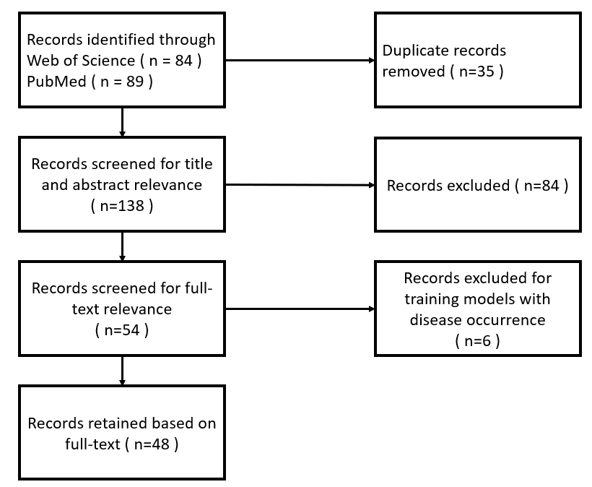

**Figure S1. PRISMA flow diagram outlining the literature search and screening process.**

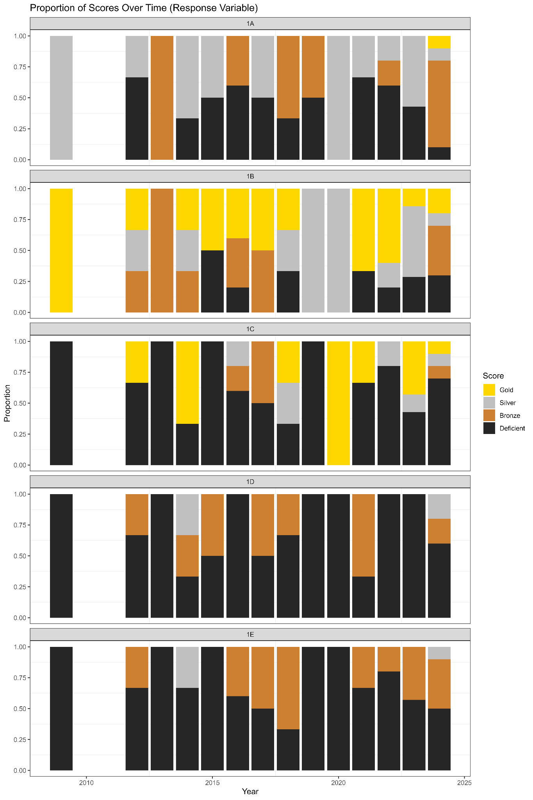

**Fig. S2.** Change in the proportion of response variable best quality adherence scores over time. Model issue abbreviations: 1A=Sampling of response variable, 1B=Identification of taxa, 1C=Spatial accuracy of response variable, 1D=Environmental extent across which response variable was sampled, 1E=Geographic extent across which response variable was sampled. The x-axis is binned by year; the y-axis is the proportion of scores for all studies within a year.

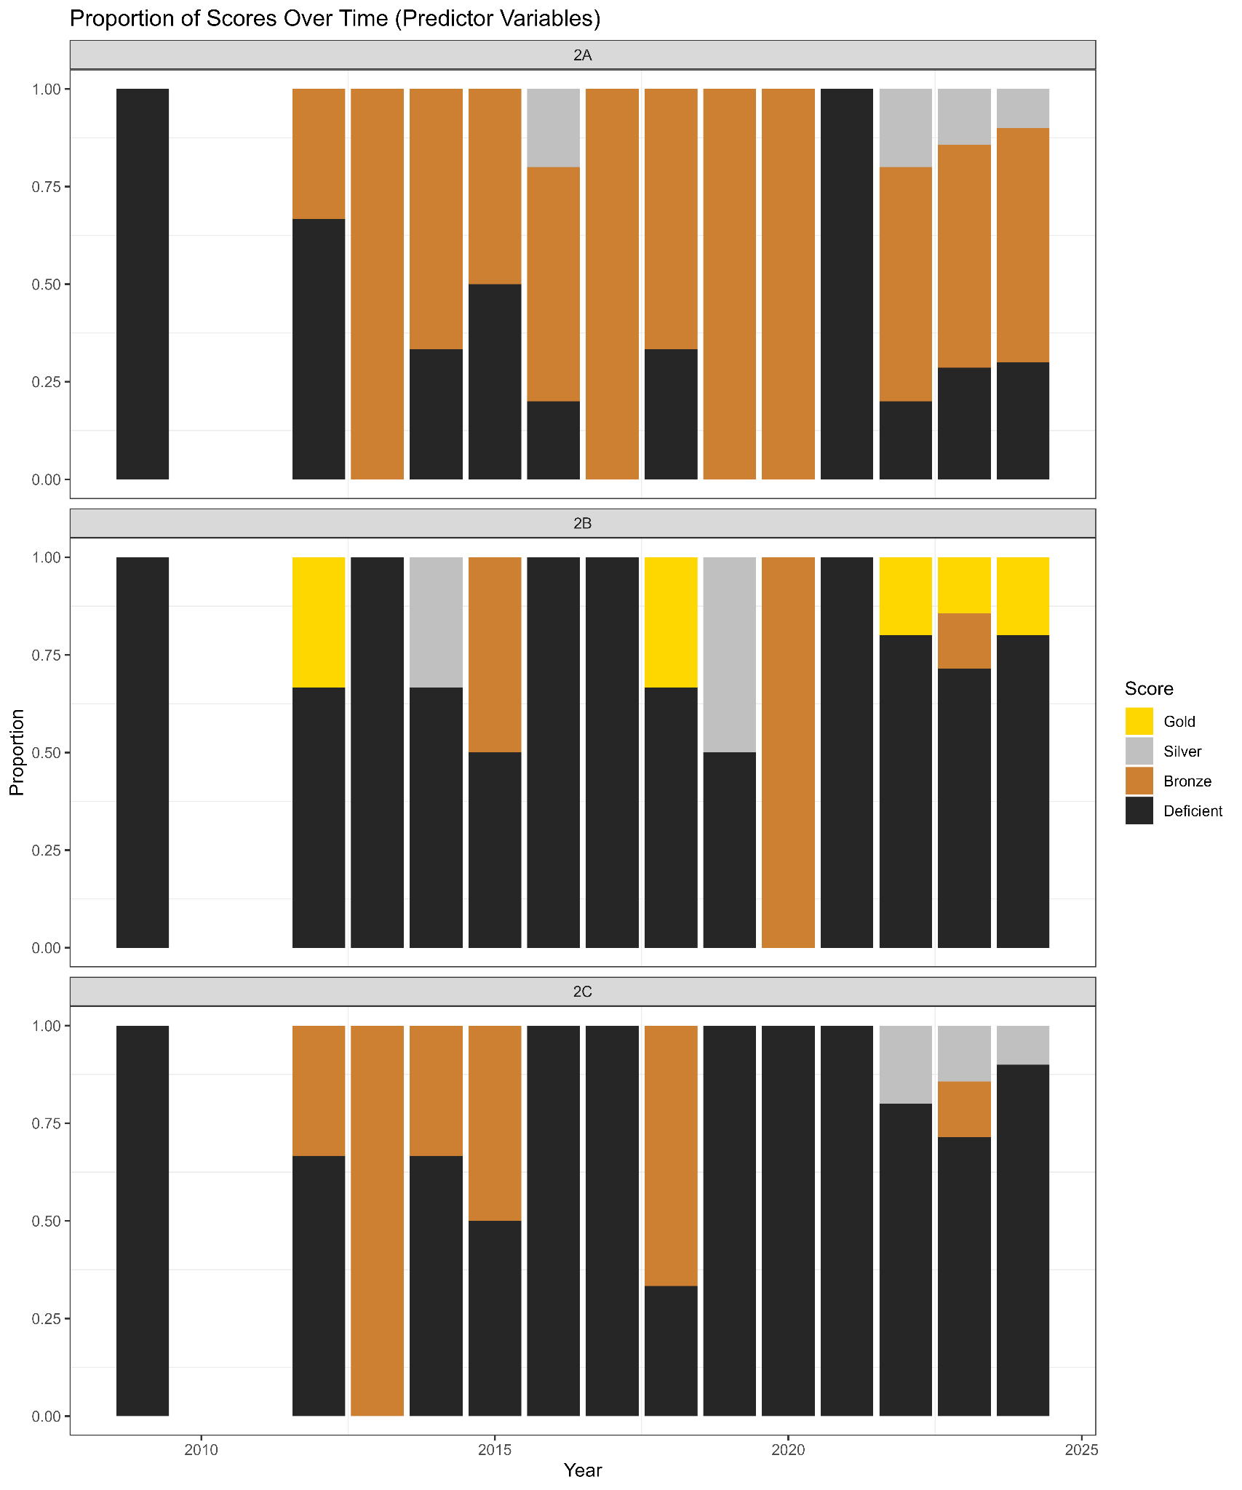

**Fig. S3.** Change in the proportion of predictor variable best quality adherence scores over time. Model issue abbreviations: 2A=Selection of candidate variables, 2B=Spatial and temporal resolution of predictor variables, 2C=Uncertainty in predictor variables. The x-axis is binned by year; the y-axis is the proportion of scores for all studies within a year.

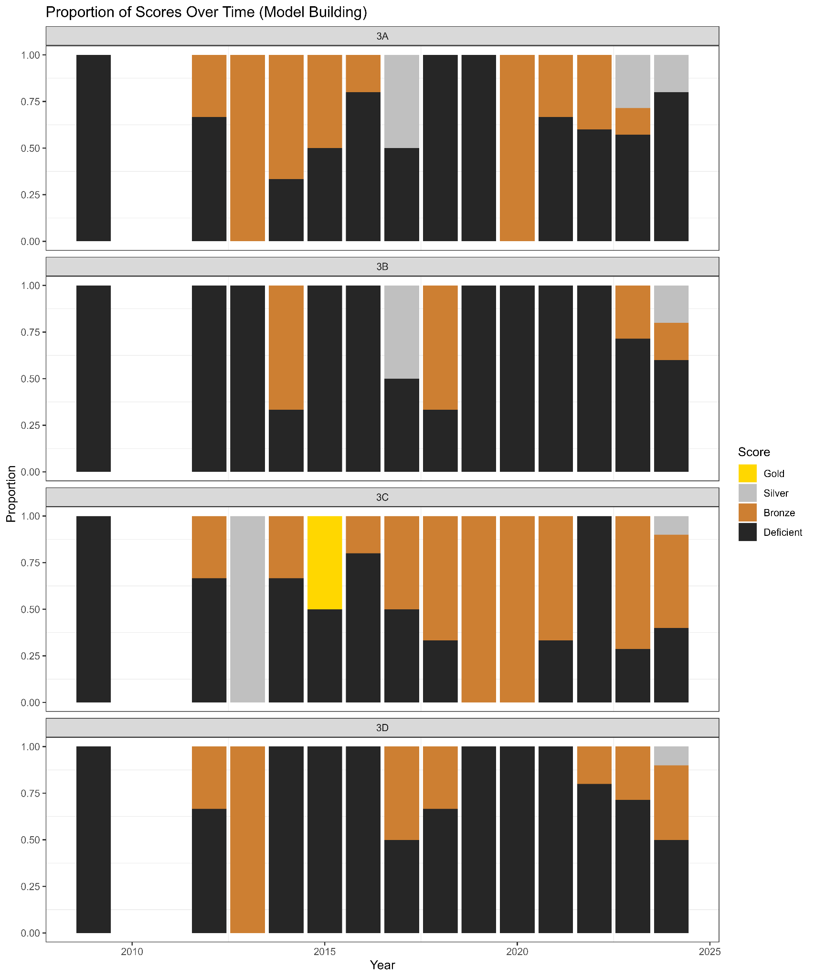

**Fig. S4.** Change in the proportion of model building best quality adherence scores over time. Model issue abbreviations: 3A=Model complexity, 3B=Treatment of bias and noise in response variables, 3C=Treatment of collinearity, 3D=Dealing with model and parameter uncertainty. The x-axis is binned by year; the y-axis is the proportion of scores for all studies within a year.

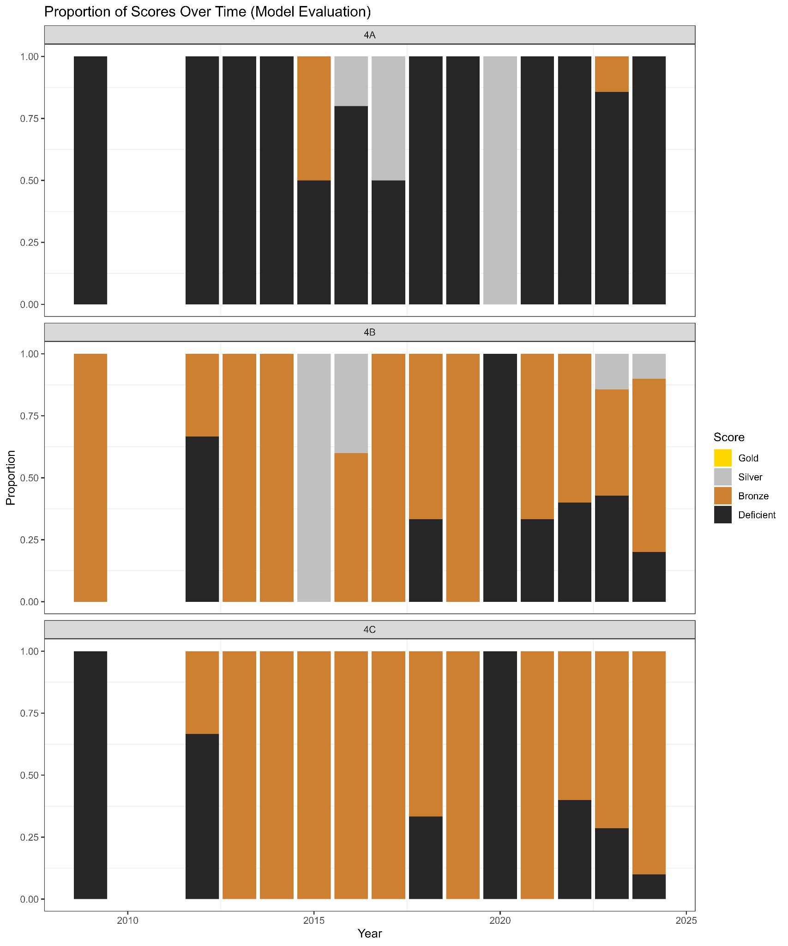

**Fig. S5.** Change in the proportion of model evaluation best quality adherence scores over time. Model issue abbreviations: 4A=Evaluation of model assumptions, 4B=Evaluation of model outputs, 4C=Measures of model performance. The x-axis is binned by year; the y-axis is the proportion of scores for all studies within a year.

**Table S1.** Genera included in the literature search terms. Taxonomic identification based on those presented in the World Registry of Marine Species (WoRMS) global taxonomic standard. The “Genus” column represents the genus name and describer, while the “WoRMS AphiaID” column represents the unique identifier for the respective genus in the WoRMS database.

|  |  |
| --- | --- |
| **Genus** | **WoRMS AphiaID** |
| *Bulinus* (O.F. Müller, 1781) | 224352 |
| *Biomphalaria* (Preston, 1910) | 718742 |
| *Oncomelania* (Gredler, 1881) | 740258 |
| *Lymnaea* (Lamarck, 1799) | 160345 |
| *Parafossarulus* (Annandale, 1924) | 758823 |
| *Bithynia* (Leach, 1818) | 182698 |
| *Melanoides* (Olivier, 1804) | 224571 |
| *Neotricula* (G.M. Davis, 1986) | 1057312 |
| *Galba* (Schrank, 1803) | 716335 |
| *Fossaria* (Westerlund, 1885) | 593326 |
| *Pseudosuccinea* (F.C. Baker, 1908) | 724459 |
| *Radix* (Montfort, 1810) | 248262 |
| *Segmentina* (J. Fleming, 1818) | 716354 |
| *Hippeutis* (Charpentier, 1837) | 716352 |
| *Cerithidia* (Swainson, 1840) | 204619 |
| *Pirenella* (J.E. Gray, 1847) | 206423 |
| *Thiara* (Röding, 1798) | 206444 |
| *Melania* (Lamarck, 1799) | 205560 |
| *Stenomelania* (P. Fischer, 1885) | 818571 |
| *Bradybaena* (H. Beck, 1837) | 818138 |

**Table S2.** Species list of snails modeled in the reviewed studies. Columns represent the species names presented in the screened studies, the current globally accepted name for the presented species according to the World Registry of Marine Species (WoRMS) taxonomy, and the WoRMS taxonomic ID for the accepted species, respectively.

|  |  |  |
| --- | --- | --- |
| **Species name in paper** | **Accepted species name** | **Accepted AphiaID** |
| *Ampullaceana balthica (*Linneaus, 1758) | *Ampullaceana balthica* (Linneaus, 1758) | 1288085 |
| *Burnupia* (B. Walker, 1912) | *Burnupia* (B. Walker, 1912) | 933171 |
| *Biomphalaria alexandrina* (Ehrenberg, 1831) | *Biomphalaria alexandrina* (Ehrenberg, 1831) | 1060864 |
| *Biomphalaria angulosa* (Mandahl-Barth, 1957) | *Biomphalaria angulosa* (Mandahl-Barth, 1957) | 1060934 |
| *Biomphalaria camerunensis* (C.R. Boettger, 1941) | *Biomphalaria camerunensis* (C.R. Boettger, 1941) | 1060866 |
| *Biomphalaria choanomphala* (E. von Martens, 1879) | *Biomphalaria choanomphala* (E. von Martens, 1879) | 1060869 |
| *Biomphalaria cousini* (Paraense, 1966) | *Biomphalaria cousini* (Paraense, 1966) | 1060946 |
| *Biomphalaria glabrata* (Say, 1818) | *Biomphalaria glabrata* (Say, 1818) | 848622 |
| *Biomphalaria kuhniana* (Clessin, 1883) | *Biomphalaria kuhniana* (Clessin, 1883) | 848626 |
| *Biomphalaria occidentalis* (Paraense, 1981) | *Biomphalaria occidentalis* (Paraense, 1981) | 1060634 |
| *Biomphalaria peregrina* (A. d'Orbigny, 1835) | *Biomphalaria peregrina* (A. d'Orbigny, 1835) | 1059938 |
| *Biomphalaria pfeifferi* (Krauss, 1848) | *Biomphalaria pfeifferi* (Krauss, 1848) | 1058681 |
| *Biomphalaria* (Preston, 1910) | *Biomphalaria* (Preston, 1910) | 718742 |
| *Biomphalaria stanleyi* (E.A. Smith, 1888) | *Biomphalaria stanleyi* (E.A. Smith, 1888) | 1060966 |
| *Biomphalaria straminea* (Dunker, 1848) | *Biomphalaria straminea* (Dunker, 1848) | 1060816 |
| *Biomphalaria sudanica* (E. von Martens, 1870) | *Biomphalaria sudanica* (E. von Martens, 1870) | 1060923 |
| *Biomphalaria tenagophila* (A. d'Orbigny, 1835) | *Biomphalaria tenagophila* (A. d'Orbigny, 1835) | 1001488 |
| *Bithynia siamense goniomphalos* (Morelet, 1866) | *Digoniostoma siamense goniomphalos* (Morelet, 1866) | 1793858 |
| *Bulinus africanus* (Krauss, 1848) | *Bulinus africanus* (Krauss, 1848) | 1058682 |
| *Bulinus camerunensis* (Mandahl-Barth, 1957) | *Bulinus camerunensis* (Mandahl-Barth, 1957) | 1339396 |
| *Bulinus forskalii* (Ehrenberg, 1831) | *Bulinus forskalii* (Ehrenberg, 1831) | 1058686 |
| *Bulinus globosus* (Morelet, 1866) | *Bulinus globosus* (Morelet, 1866) | 1058683 |
| *Bulinus jousseaumei* (Dautzenberg, 1890) | *Bulinus jousseaumei* (Dautzenberg, 1890) | 1062554 |
| *Bulinus senegalensis* (O.F. Müller, 1781) | *Bulinus senegalensis* (O.F. Müller, 1781) | 1338932 |
| *Bulinus truncatus* (Audouin, 1827) | *Bulinus truncatus* (Audouin, 1827) | 716338 |
| *Cipangopaludina chinensis* (J.E. Gray, 1833) | *Cipangopaludina chinensis* (J.E. Gray, 1833) | 594807 |
| *Drepanotrema cimex* (Moricand, 1838) | *Drepanotrema cimex* (Moricand, 1838) | 848733 |
| *Drepanotrema depressissimum* (Moricand, 1839) | *Drepanotrema depressissimum* (Moricand, 1839) | 848735 |
| *Drepanotrema lucidum* (L. Pfeiffer, 1839) | *Drepanotrema lucidum* (L. Pfeiffer, 1839) | 1060415 |
| *Drepanotrema schubarti* (Haas, 1938) | *Drepanotrema lucidum* (L. Pfeiffer, 1839) | 1060415 |
| *Ferrissia* (B. Walker, 1903) | *Ferrissia* (B. Walker, 1903) | 181578 |
| *Galba schirazensis* (Küster, 1863) | *Galba schirazensis* (Küster, 1863) | 716337 |
| *Lymnaea natalensis* (Krauss, 1848) | *Radix natalensis* (Krauss, 1848) | 843744 |
| *Lymnaea truncatula* (O.F. Müller, 1774) | *Galba truncatula* (O.F. Müller, 1774) | 829360 |
| *Melanoides tuberculata* (O.F. Müller, 1774) | *Melanoides tuberculata* (O.F. Müller, 1774) | 225694 |
| *Oncomelania hupensis* (Gredler, 1881) | *Oncomelania hupensis* (Gredler, 1881) | 740259 |
| *Physa* (Draparnaud, 1801) | *Physa* (Draparnaud, 1801) | 181551 |
| *Physella acuta* (Draparnaud, 1805) | *Physella acuta* (Draparnaud, 1805) | 234093 |
| *Pomacea canaliculata* (Lamarck, 1822) | *Pomacea canaliculata* (Lamarck, 1822) | 741113 |
| *Pseudosuccinea columella* (Say, 1817) | *Pseudosuccinea columella* (Say, 1817) | 724460 |
| *Radix auricularia* (Linneaus, 1758) | *Radix auricularia* (Linneaus, 1758) | 248263 |
| *Semisulcospira cancellata* | *Semisulcospira ningpoensis* (I. Lea, 1857) | 1392391 |
| *Semisulcospira libertina* (A. Gould, 1859) | *Semisulcospira libertina* (A. Gould, 1859) | 741121 |
| *Sinotaia limnophila* (Mabille, 1886) | *Sinotaia limnophila* (Mabille, 1886) | 835656 |
| *Sinotaia quadrata* (W.H. Benson, 1842) | *Sinotaia quadrata* (W.H. Benson, 1842) | 820921 |
| *Stenophysa marmorata* (Guilding, 1828) | *Stenophysa marmorata* (Guilding, 1828) | 1253849 |
| *Uncancylus concentricus* (A. d'Orbigny, 1835) | *Uncancylus concentricus* (A. d'Orbigny, 1835) | 827826 |