
3 4 5 6 7 8 9 10
0

1

2

3

4

5

6

7
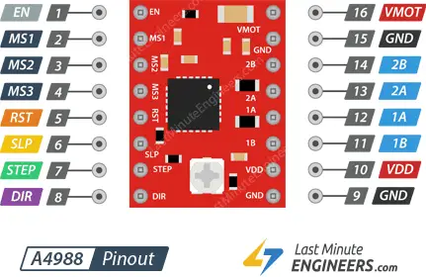
5V / 2: 5V Stromversorgung
GND / 39: GND
GPIO 16 / 36: M1 Direction
GPIO 20 / 38: M1 Step
GPIO 21 / 40: M1 Sleep
GPIO 5 / 29: M2 Direction
GPIO 6 / 31: M2 Step
GPIO 13 / 33: M2 Sleep
GPIO 26 / 37: Magnet
