PHENIKAA UNIVERSITY
PHENIKAA SCHOOL OF COMPUTING

SOFTWARE ARCHITECTURE
TOPIC: HUMAN RESOURCE MANAGEMENT SYSTEM

Instructor: Vũ Quang Dũng
Course: Software Architecture – Class N01
Team Members: Group 09
Nguyễn Phương Ngân - 23010450
Đỗ Nguyên Anh Vũ - 23010334

February 2026
MỤC LỤC
I. Executive Summary 4
1. Project Objectives 5
2. Architectural Solution 5
3. Key Outcomes 5
II. Project Requirements & Goals 6
2.1. Core Functional Requirements (FRs) 6
2.2. Key Quality Attributes (Non-functional Requirements) 6
2.3 Propose Model of ASR (Attribute Scenario Requirement) 8
2.4 Actors và Use Cases 9
2.4.1 Actors Table 10
2.4.2 List of 44 Use Cases 10
III. Architectural Design & Implementation 35
3.1. Architectural Pattern: Microservices Architecture 35
3.2. Technical Stack and Data Model 38
3.2.1 Technical Stack 38
3.2.2 Data Model 39
3.3 Server-side Implementation (Node.js/Express) 40
3.3.1 Service Execution Logic & Inter-service Communication 40
3.3.2 Implementation Case Study: Payroll Service 41
3.3.3 Detailed Component Design (C4 Level 3) 41
3.3.4 Source Code Structure & File Organization (C4 Level 4). 52
3.4 Client-side Implementation (React) 54
3.4.1 API Consumption with Axios 54
3.4.2 State Management & UI Update Flow 55
IV. Testing and Verification 55
4.1. Integration Testing: Inter-service Flows 55
4.2.1 Functional Verification Matrix 56
4.2.2. Technical Verification Steps 56
4.3. Resilience & Failure Handling Verification 57
4.4. Quality Attribute Verification (NFR Testing) 58
4.5. Final Product Interface Demonstration 58
VI. Conclusion & Reflection 74
6.1. Lessons Learned 75
6.2. Future Improvements 75

BẢNG PHÂN CHIA CÔNG VIỆC

Họ và tên | Mã sinh viên | Công việc | Đánh giá
Đỗ Nguyên Anh Vũ | 23010334 | Thiết kế hệ thống, lập trình chức năng chính, tổng hợp kết quả. | 50%
Nguyễn Phương Ngân | 23010450 | Hỗ trợ thiết kế, góp ý lập trình, kiểm thử và hoàn thiện báo cáo. | 50%

I. Executive Summary

1. Project Objectives
This project focuses on the design and implementation of a centralized Human Resource Management System (HRM App) aimed at digitizing all human resource governance activities within an enterprise. The primary objective is to replace disparate manual processes with a modern technological platform, automating workflows ranging from employee record management, timekeeping, and payroll to recruitment and KPI evaluation. The system strives to provide a transparent working environment, enhance the operational efficiency of the HR department, and support executive leadership in data-driven decision-making.

2. Architectural Solution
To address the requirements for high scalability and the inherent complexity of HR business logic, the project adopts a Microservices Architecture. This solution is characterized by the following technical pillars:
- Decoupled Independent Services: The system is decomposed into specialized services, including Identity Service (Authentication), Employee Service (Personnel Management), Payroll Service (Salary processing), and Attendance Service (Timekeeping). Each service maintains its own dedicated database and execution logic, effectively eliminating inter-service dependencies.
- API Gateway Integration: All client requests are orchestrated through a centralized API Gateway. This component enhances system security by abstracting the internal microservices structure and simplifying the interaction between the Client-side and the backend infrastructure.
- Elastic Scalability: This architecture empowers the development team to independently scale or upgrade specific modules. For instance, the Attendance Service can be scaled to handle high-frequency traffic during peak check-in hours without necessitating a resource increase for the entire system or causing operational downtime.

3. Key Outcomes
The application of Microservices to the HRM domain has yielded several critical practical results:
- High Availability and Resilience: The system maintains high stability; a localized failure within a specific service does not paralyze the entire organizational workflow.
- Process Optimization: The successful automation of end-to-end Use Case chains—from timekeeping to payroll—minimizes human-induced errors and significantly reduces data processing time.
- Future-Ready Foundation: With a standardized RESTful API structure, the system is engineered for seamless integration with emerging technologies, such as AI-driven performance analytics, or for interconnectivity with international ERP ecosystems.

II. Project Requirements & Goals

2.1. Core Functional Requirements (FRs)
The functional requirements are categorized into independent service modules to ensure the decoupling and scalability of the HRM system.
ID | Description
FR-01 | The system must provide secure authentication (JWT) and Role-Based Access Control (RBAC) to manage permissions for all actors.
FR-02 | The application must feature a centralized dashboard with HR metric statistics and an internal notification system.
FR-03 | The system must manage the complete employee lifecycle and organizational structures, including departments and job titles.
FR-04 | The application must record real-time attendance (check-in/out) and digitize the leave request approval workflow.
FR-05 | The server must automate monthly payroll calculations based on integrated attendance data and manage salary records.
FR-06 | The system must handle recruitment pipelines, professional training courses, and candidate profile management.
FR-07 | The application must support KPI metric establishment and employee performance evaluation tracking.
FR-08 | The system must allow users to manage personal profiles and provide the Admin with access to system audit logs

To ensure system integrity and data consistency, the following business rules are strictly enforced across all modules:
- Data Uniqueness: Employee email addresses , department names , and job titles must be unique within the system to prevent data duplication.
- Referential Integrity: A department or job title cannot be deleted if there are active employees currently assigned to them.
- Approval Workflow: Leave requests can only be approved or rejected by the HR department or the employee's direct Manager.
- Payroll Constraints: To maintain financial accuracy, each employee is restricted to a single salary record for any given month and year.
- Data Privacy & Security: Employees are strictly limited to viewing only their own personal profiles and individual attendance history.

2.2. Key Quality Attributes (Non-functional Requirements)
These attributes define the architectural drivers that justify the selection of a Microservices model for the HRM App
Attribute Type | Quality Metric | Detailed Technical Requirement
Performance | Response Time | UI operations (e.g., Check-in, Profile view) must complete within a sub-2-second threshold.
Scalability | Module Expansion | The architecture must allow independent scaling of services (e.g., Attendance) and the seamless addition of new modules like KPI.
Security | RBAC & Encryption | Passwords must be hashed; strict Role-Based Access Control (RBAC) must prevent unauthorized access to payroll and personnel data.
Maintainability | Code Modularity | The codebase must be highly modular and well-documented to support independent service updates and maintenance.
Reliability | Fault Tolerance | The system must implement robust error handling and logging to prevent data loss and ensure service resilience.
Integrity | REST API | The backend must provide standardized REST APIs to facilitate future integration with external ERP or Accounting systems.

Architectural Drivers and Strategic Impact
The quality attributes listed above serve as the primary Architectural Drivers for adopting a Microservices Architecture over a traditional monolithic structure:
- Resource Isolation: By decoupling high-frequency services like Attendance from resource-intensive services like Payroll, the system ensures that heavy computational loads during end-of-month processing do not degrade daily user performance.
- Elastic Scalability: The architecture empowers the team to scale specific modules independently. For instance, the Attendance Service can be scaled to handle 10,000 concurrent active users during peak hours without requiring a resource increase for the entire system.
- Fault Isolation: Microservices ensure high availability by isolating failures. A localized failure in a non-core module (e.g., Recruitment) will not paralyze the entire organizational workflow, allowing essential services like Identity and Attendance to remain operational.
- Future-Ready Foundation: Utilizing a standardized RESTful API structure ensures the system is engineered for seamless integration with emerging technologies, such as AI-driven analytics, or interconnectivity with international ERP ecosystems.

Impact on Design Decisions
Based on these non-functional requirements, several critical design decisions were implemented in Chapter III:
- Database per Service: Each domain manages its own independent MongoDB instance to ensure total data ownership and prevent cross-service coupling.
- API Gateway Orchestration: A centralized gateway manages traffic through rate-limiting and request timeouts, protecting downstream services from exhaustion.
- Observability & Monitoring: The integration of Prometheus and Grafana allows for real-time tracking of response times and system health metrics to meet defined quality thresholds.

2.3 Propose Model of ASR (Attribute Scenario Requirement)
In software architecture, an ASR is a requirement that has a significant impact on the system's design and structural decisions. For the HRM App, the following scenario is defined to justify the implementation of a Microservices Architecture over a traditional monolith.
Scenario: High Scalability under Peak Load
- Source of Stimulus: A large volume of concurrent users, specifically 10,000 active sessions during peak HR events.
- Stimulus: A surge in concurrent requests for daily timekeeping (UC-11.2) and resource-intensive monthly payroll processing (UC-7.5).
- Environment: The system operates in a production environment during the final business day of the month.
- Artifacts Affected: API Gateway, Attendance Service, and Payroll Service.
- Architectural Response:
  - Distributed Architecture: The system adopts a Microservices model to ensure that services are decoupled and can scale independently.
  - Stateless Processing: Key services (such as Identity and Attendance) are designed to be stateless to facilitate effective load balancing across multiple instances.
  - Orchestration via API Gateway: A centralized API Gateway manages all 10,000 concurrent requests, abstracting the internal microservices structure while maintaining high security.
- Response Measures:
  - Latency: Core UI operations (e.g., Check-in/out) must maintain a response time of under 2 seconds.
  - Throughput: The system must successfully process all concurrent requests without performance degradation or service failure.
Architectural Significance
This ASR is the primary driver for the following architectural decisions:
- Microservices Selection: To prevent a single point of failure and allow for Elastic Scalability during peak hours.
- Resource Isolation: By decoupling the Payroll Service from the Attendance Service, the heavy computational load of salary calculation does not impact the responsiveness of the timekeeping module.
- Future-Ready Foundation: This modular approach ensures the system can integrate with external ERP ecosystems or AI-driven analytics without requiring a full system redesign.
2.4 Actors và Use Cases
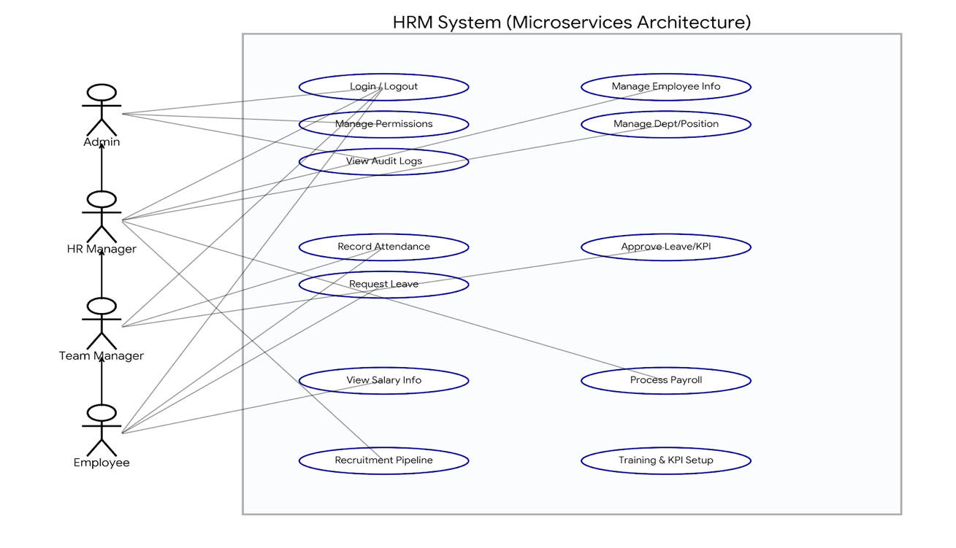

2.4.1 Actors Table
Actor | Role Description
Admin | System administrator with full access to management functions, permissions, and audit logs.
HR | Responsible for employee records, recruitment, training, payroll processing, and timekeeping data.
Manager | Approves leave requests, monitors department KPI progress, and sends internal notifications.
Employee | Records daily attendance, submits leave requests, updates KPI results, and manages personal profiles.

2.4.2 List of 44 Use Cases
Function Group | UC ID | Use Case Name | Primary Actor
System | UC-1.1 | Login | All Roles
 | UC-1.2 | Logout | All Roles
Dashboard | UC-2.1 | View Dashboard Overview | Admin, HR, Manager
Employee Management | UC-3.1 | Add New Employee | Admin, HR
 | UC-3.2 | Edit Employee Information | Admin, HR
 | UC-3.3 | Delete Employee | Admin, HR
 | UC-3.4 | View Employee List | Admin, HR
Department Management | UC-4.1 | View Department List | Admin, HR
 | UC-4.2 | Add Department | Admin, HR
 | UC-4.3 | Edit Department | Admin, HR
 | UC-4.4 | Delete Department | Admin, HR
Job Title Management | UC-5.1 | View Job Title List | Admin, HR
 | UC-5.2 | Add New Job Title | Admin, HR
 | UC-5.3 | Edit Job Title | Admin, HR
 | UC-5.4 | Delete Job Title | Admin, HR
Leave Management | UC-6.1 | Create Leave Request | Employee
 | UC-6.2 | Approve/Reject Request | Admin, HR, Manager
 | UC-6.3 | View Leave Request List | All Roles
Payroll Management | UC-7.1 | View Payroll List | Admin, HR
 | UC-7.2 | Add Salary Record | Admin, HR
 | UC-7.3 | Edit Salary Record | Admin, HR
 | UC-7.4 | Delete Salary Record | Admin, HR
 | UC-7.5 | Process Monthly Payroll | Admin, HR
Recruitment | UC-8.1 | View Recruitment List | Admin, HR
 | UC-8.2 | Add Candidate Profile | Admin, HR
 | UC-8.3 | Edit Candidate Profile | Admin, HR
 | UC-8.4 | Delete Candidate Profile | Admin, HR
Training | UC-9.1 | View Training Course List | All Roles
 | UC-9.2 | Create New Training Course | Admin, HR
 | UC-9.3 | Update Course Information | Admin, HR
KPI Management | UC-10.1 | View KPI List | All Roles
 | UC-10.2 | Assign KPI to Employee | Admin, HR, Manager
 | UC-10.3 | Update KPI Results | All Roles
Timekeeping | UC-11.1 | View Attendance History | All Roles
 | UC-11.2 | Record Attendance | Admin, HR, Employee
 | UC-11.3 | Edit Timekeeping Data | Admin, HR
 | UC-11.4 | Delete Timekeeping Data | Admin, HR
Notifications | UC-12.1 | View Notification List | All Roles
 | UC-12.2 | Create New Notification | Admin, HR, Manager
 | UC-12.3 | Edit Notification | Admin, HR, Manager
 | UC-12.4 | Delete Notification | Admin, HR, Manager
Personal Profile | UC-13.1 | View Personal Profile | All Roles
 | UC-13.2 | Update Personal Profile | All Roles
Administration | UC-14.1 | View Audit Logs | Admin

ID & Name: | UC-1.1: Login
Created by: | Ngân Team Date: 04/02/2026
Primary Actor: | Admin/HR/Manager/Employee
Description: | Users enter their email and password to access the system.
Trigger: | The user clicks "Log in".
Pre-condition: | PRE-1: User has a valid account in the system.
Post-condition: | POST-1: User logs in successfully and is redirected to the Dashboard.
Main Flow: | 1. User enters email and password.  2. System validates login credentials.  3. System generates a token and saves the session.  4. Redirects to the Dashboard page.
Alternative Flow: | A1: User selects a demo account → System auto-fills email/password..
Exception: | E1: Incorrect email/password → Display error.  E2: Backend not responding → Display connection error.
Priority: | High
Business Rules: | BR-1: Account must exist.  BR-2: BR-2: Tokens have an expiration time.
Other Info:

ID & Name: | UC-1.2: Logout
Created by: | Ngân Team Date: 04/02/2026
Primary Actor: | Admin/HR/Manager/Employee
Description: | User exits the system.
Trigger: | Click "Logout".
Pre-condition: | PRE-1: Currently logged in.
Post-condition: | POST-1: Token is deleted, return to login page.
Main Flow: | 1. User clicks Logout.  2. System deletes token.  3. Redirect to login.
Alternative Flow:
Exception:
Priority: | Medium
Business Rules: | BR-1: Always delete token
Other Info:

ID & Name: | UC-2.1: Dashboard - Overview
Created by: | Ngân Team Date: 04/02/2026
Primary Actor: | Admin/HR/Manager
Description: | View general statistics
Trigger: | Enter Dashboard.
Pre-condition: | PRE-1: Successfully logged in
Post-condition: | POST-1: Display summary data.
Main Flow: | 1. System loads data (employee, payroll, leave...).  2. Display statistics cards.
Alternative Flow:
Exception: | E1: Failed to load data → Display 0.
Priority: | High
Business Rules: | BR-1: Statistics based on permissions.
Other Info:

ID & Name: | UC-3.1: Employee - Add Employee
Created by: | Ngân Team Date: 04/02/2026
Primary Actor: | Admin/HR
Description: | Allows the Admin or HR to create a new employee record in the system.
Trigger: | User clicks the "Add Employee" (Thêm nhân viên) button.
Pre-condition: | PRE-1: User must be logged in with Admin or HR privileges.
Post-condition: | POST-1: A new employee profile is successfully generated and saved.
Main Flow: | 1. Enter employee information.  2. Click Save.  3. System saves data.
Alternative Flow: | A1: Cancel operation.
Exception: | E1: Missing mandatory fields.
Priority: | High
Business Rules: | BR-1: Email must be unique.
Other Info:

ID & Name: | UC-3.2: Employee - Edit Employee
Created by: | Ngân Team Date: 04/02/2026
Primary Actor: | Admin/HR
Description: | Allows Admin or HR to update existing employee information
Trigger: | User clicks the "Edit" (Sửa) button on a specific employee record.
Pre-condition: | PRE-1: User must be logged in with Admin or HR privileges.
Post-condition: | POST-1: Employee information is updated successfully in the system.
Main Flow: | 1. Select employee.  2. Edit information.  3. Save changes.
Alternative Flow: | A1: Cancel changes.
Exception: | E1: Invalid data.
Priority: | High
Business Rules: | BR-1: Email must be unique
Other Info:

ID & Name: | UC-3.3: Employee - Delete Employee
Created by: | Ngân Team Date: 04/02/2026
Primary Actor: | Admin/HR.
Description: | Allows Admin or HR to permanently remove an employee record from the system.
Trigger: | User clicks the "Delete" (Xóa) button on a specific employee's record.
Pre-condition: | PRE-1: User must be logged in with Admin or HR privileges.  PRE-2: The employee record to be deleted must exist in the system.
Post-condition: | POST-1: The employee record is successfully removed from the database.  POST-2: The employee list is refreshed to reflect the change
Main Flow: | 1. User navigates to the Employee List page.  2. User identifies the employee to be removed.  3. User clicks the "Delete" icon/button associated with that employee.  4. The system deletes the record from the database and displays a success notification.
Alternative Flow: | A1: Cancel Deletion: At step 5, the user clicks "Cancel". The system closes the pop-up, and no data is deleted.
Exception: | E1: Employee Not Found: If the record was deleted by another user simultaneously, the system displays an error message: "Employee record no longer exists."  E2: Database Constraint: If the employee is linked to critical historical data (e.g., finalized payroll), the system prevents deletion and suggests deactivating the account instead.
Priority: | Medium
Business Rules: | BR-1: Only accounts with Admin or HR roles have the permission to execute this action.  BR-2: Deletion is permanent and cannot be undone via the UI.
Other Info:

ID & Name: | UC-3.4: Employee - View List
Created by: | Ngân Team Date: 04/02/2026
Primary Actor: | Admin/HR.
Description: | Allows the user to view the complete list of employees within the system
Trigger: | User selects the "Employee" (Nhân viên) menu item.
Pre-condition: | PRE-1: User must be logged in with Admin or HR privileges.
Post-condition: | POST-1: The employee list is displayed correctly with all necessary columns.
Main Flow: | 1. User opens the "Employee" page  2. The system sends a request to fetch the employee database  3. The system displays the main columns of the employee list
Alternative Flow: | A1: Filter/Search: User uses keywords or filters to find specific employees in the list.
Exception: | E1: No data: If no employees exist, the system displays an empty list or "No data available".
Priority: | High
Business Rules: | BR-1: Only Admin and HR roles have the permission to view this list.
Other Info:

ID & Name: | UC-4.1: Department - View List
Created by: | Ngân Team Date: 04/02/2026
Primary Actor: | Admin/HR.
Description: | View the list of departments within the company.
Trigger: | User selects the "Department" (Phòng ban) menu item.
Pre-condition: | PRE-1: User must be logged in with Admin or HR privileges.
Post-condition: | POST-1: The department list is displayed correctly.
Main Flow: | 1. User opens the department page  2. System displays the department data.
Alternative Flow: | A1: Search/Filter: User filters or searches for a specific department.
Exception: | E1: No data: System displays a message if no departments exist.
Priority: | Medium
Business Rules: | BR-1: Only Admin and HR roles have the permission to view this list.
Other Info:

ID & Name: | UC-4.2: Department - Add Department
Created by: | Ngân Team Date: 04/02/2026
Primary Actor: | Admin/HR.
Description: | Create a new department record.
Trigger: | User selects the "Add Department" (Thêm phòng ban) button.
Pre-condition: | PRE-1: User must be logged in with Admin or HR privileges.
Post-condition: | POST-1: A new department is successfully created.
Main Flow: | 1. User enters the department information.  2. User clicks the "Save" (Lưu) button.
Alternative Flow: | A1: Cancel: User cancels the operation.
Exception: | E1: Duplicate Name: Error occurs if the department name already exists.
Priority: | High
Business Rules: | BR-1: Admin and HR roles have the right to add departments.
Other Info:

ID & Name: | UC-4.3: Department - Edit Department
Created by: | Ngân Team Date: 04/02/2026
Primary Actor: | Admin/HR.
Description: | Update existing department information
Trigger: | User clicks the "Edit" (Sửa) button
Pre-condition: | PRE-1: User must be logged in with Admin or HR privileges.
Post-condition: | POST-1: The department is updated successfully.
Main Flow: | 1. User selects the "Edit" function.  2. User chooses the department to modify.  3. User modifies the data and clicks "Save" (Lưu).
Alternative Flow: | A1: Cancel: User cancels the edit.
Exception: | E1: Name Conflict: Error occurs if the new name is already taken.
Priority: | Medium
Business Rules: | BR-1: Department names must remain unique.
Other Info:

ID & Name: | UC-4.4: Department - Delete Department
Created by: | Ngân Team Date: 04/02/2026
Primary Actor: | Admin/HR.
Description: | Remove a department from the system
Trigger: | User selects the "Delete" (Xóa) button.
Pre-condition: | PRE-1: User must be logged in with Admin or HR privileges.
Post-condition: | POST-1: The department is deleted successfully.
Main Flow: | 1. User selects the department to delete.  2. User clicks the "Confirm" (Xác nhận) button.  3. System completes the deletion.
Alternative Flow: | A1: Cancel: User cancels the deletion.
Exception: | E1: Linked Employees: Error occurs if employees are still assigned to the department.
Priority: | Low
Business Rules: | BR-1: A department cannot be deleted if it still contains active employees.
Other Info:

ID & Name: | UC-5.1: Job Title - View List
Created by: | Ngân Team Date: 04/02/2026
Primary Actor: | Admin/HR.
Description: | Access the Job Title module to view all existing job positions.
Trigger: | User selects the "Job Title" (Chức vụ) menu item.
Pre-condition: | PRE-1: User is logged in as Admin or HR.
Post-condition: | POST-1: System displays the complete list of job titles.
Main Flow: | 1. User selects the "Job Title" menu.  2. System queries the job title data from the database..  3. System loads and displays the list in a table format  4. User views title details (Name, description, creation date).
Alternative Flow: | A1: Search: User enters keywords to search for a specific title.
Exception: | E1: No data: System shows an empty table and notification.
Priority: | Medium
Business Rules: | BR-1: Admin and HR roles have viewing permissions.
Other Info:

ID & Name: | UC-5.2: Job Title - Add Job Title
Created by: | Ngân Team Date: 04/02/2026
Primary Actor: | Admin/HR.
Description: | Allows Admin or HR to create a new job title to assign to employees
Trigger: | User clicks the "Add Job Title" (Thêm chức vụ) button.
Pre-condition: | PRE-1: User is logged in as Admin/HR and is on the Job Title list page.
Post-condition: | POST-1: New job title is saved and displayed in the list.
Main Flow: | - User clicks "Add Job Title".  - System displays the input form (Name, description)....).  - User enters required information.  - User clicks "Save" (Lưu).  - System validates and saves to database.  - System notifies "Added successfully" and redirects to the list.
Alternative Flow: | A1: Cancel: User clicks "Cancel" (Hủy) or "Close"; the form closes without saving.
Exception: | E1: Duplicate Name: System notifies that the title already exists.  E2: Missing Information: System warns about empty mandatory fields.
Priority: | Medium
Business Rules: | BR-1: Job title must be unique.  BR-2: Creator must have Admin/HR write permissions
Other Info:

ID & Name: | UC-5.3: Job Title - Edit Job Title
Created by: | Ngân Team Date: 04/02/2026
Primary Actor: | Admin/HR.
Description: | Modify information for an existing job title
Trigger: | User clicks the "Edit" (Sửa) button next to the job title.
Pre-condition: | PRE-1: User has Admin or HR privileges.
Post-condition: | POST-1: Job title information is updated successfully.
Main Flow: | 1. User selects the job title to edit.  2. User modifies the information.  3. User clicks "Save" (Lưu).
Alternative Flow: | A1: Cancel: User discards the changes.
Exception: | E1: Duplicate Name: New name conflicts with another existing title.
Priority: | Medium
Business Rules: | BR-1: Job title must remain unique after editing.
Other Info:

ID & Name: | UC-5.4: Job Title - Delete Job Title
Created by: | Ngân Team Date: 04/02/2026
Primary Actor: | Admin/HR.
Description: | Remove a job title from the system.
Trigger: | User clicks the "Delete" (Xóa) button.
Pre-condition: | PRE-1: User has Admin or HR privileges
Post-condition: | POST-1: Job title is removed from the list.
Main Flow: | 1. User selects the job title to delete.  2. System executes the data removal.
Alternative Flow: | A1: Cancel: User declines the confirmation.
Exception: | E1: Assigned Employees: Cannot delete if employees are currently holding this title.
Priority: | Low
Business Rules: | BR-1: Cannot delete a job title that is actively assigned to employees.
Other Info:

ID & Name: | UC-6.1: Leave - Create Request
Created by: | Ngân Team Date: 04/02/2026
Primary Actor: | Employee
Description: | Employee creates a leave application on the system
Trigger: | User clicks the "Create Leave Request" (Tạo đơn nghỉ) button.
Pre-condition: | PRE-1: User is logged into the system.
Post-condition: | POST-1: Leave request is created with "Pending" status.
Main Flow: | 1. System displays the leave request form.  2. User enters necessary info (Type, duration, reason).  3. User clicks "Submit" (Gửi).  4. System validates data and saves to database.
Alternative Flow: | A1: Hủy: Người dùng chọn hủy bỏ thao tác tạo đơn, hệ thống không lưu dữ liệu.
Exception: | E1: Invalid Date: Error if start/end dates violate rules.
Priority: | Medium
Business Rules: | BR-1: Every leave request must include a specific reason.
Other Info:

ID & Name: | UC-6.2: Leave - Approve/Reject
Created by: | Ngân Team Date: 04/02/2026
Primary Actor: | Admin/HR/Manager
Description: | Managers approve or reject employee leave requests.
Trigger: | Select request from list -> Click "Approve" or "Reject".
Pre-condition: | PRE-1: Account has approval permissions.
Post-condition: | POST-1: Leave request status is successfully updated.
Main Flow: | 1. Manager selects the leave request to process.  2. System displays the request details.  3. Manager chooses "Approve" or "Reject".  4. Manager clicks "Save" (Lưu) to confirm.
Alternative Flow: | A1: Cancel: Manager closes details without changing status.
Exception: | E1: Already Processed: Error if request was already approved/rejected.
Priority: | High
Business Rules: | BR-1: Only HR or the direct Manager has approval rights.
Other Info:

ID & Name: | UC-6.3: Leave - View List
Created by: | Ngân Team Date: 04/02/2026
Primary Actor: | Admin/HR/Manager/Employee
Description: | View the list of leave requests in the system.
Trigger: | User selects the "Leave" (Nghỉ phép) menu.
Pre-condition: | PRE-1: User is successfully logged in.
Post-condition: | POST-1: List of leave requests is displayed according to permissions.
Main Flow: | 1. User opens the Leave page.  2. System loads leave data relevant to the user.  3. System displays the list on the screen.
Alternative Flow: | A1: Filter by Status: Filter by Pending, Approved, or Rejected.
Exception: | E1: No Data: System displays "No data found."
Priority: | Medium
Business Rules: | BR-1: Employees view only their own; HR/Manager views subordinates.
Other Info:

ID & Name: | UC-7.1: Payroll - View List
Created by: | Ngân Team Date: 04/02/2026
Primary Actor: | Admin/HR.
Description: | Allows the user to view the list of all salary records in the system.
Trigger: | User selects the “Payroll” menu.
Pre-condition: | PRE-1: User is logged in as Admin or HR.
Post-condition: | POST-1: The payroll list is displayed on the screen.
Main Flow: | 1. User opens the Payroll page.  2. The system fetches salary data from the database.  3. The system displays the records.
Alternative Flow: | A1: Filter by time: User filters the list by specific Month/Year.
Exception: | E1: No data: The system displays a "No data found" message.
Priority: | High
Business Rules: | BR-1: Admin/HR has full permission to view all payroll records.
Other Info:

ID & Name: | UC-7.2: Payroll - Add Record
Created by: | Ngân Team Date: 04/02/2026
Primary Actor: | Admin/HR.
Description: | Create a new salary record for an employee.
Trigger: | User clicks “Add Record”.
Pre-condition: | PRE-1: User has Admin/HR privileges.
Post-condition: | POST-1: The salary record is successfully created.
Main Flow: | 1. User enters payroll information (Employee, base salary, bonuses...).  2. User clicks the "Save" button.  3. The system validates and stores the data.
Alternative Flow: | A1: Cancel: User cancels the operation; no data is saved.
Exception: | E1: Duplicate: System alerts if a record for the same employee/month/year already exists.
Priority: | High
Business Rules: | BR-1: Each employee can only have one record per month.
Other Info:

ID & Name: | UC-7.3: Payroll - Edit Record
Created by: | Ngân Team Date: 04/02/2026
Primary Actor: | Admin/HR.
Description: | Update or adjust an existing salary record.
Trigger: | User clicks the “Edit” button.
Pre-condition: | PRE-1: User has Admin/HR privileges.
Post-condition: | POST-1: Payroll information is updated successfully.
Main Flow: | 1. User selects a record from the list.  2. User modifies the salary parameters.  3. User clicks "Save" to commit changes.
Alternative Flow: | A1: Cancel: User discards the changes.
Exception: | E1: Invalid data: System displays an error if the input format is incorrect.
Priority: | Medium
Business Rules: | BR-1: The final net salary must be calculated based on the official company formula.
Other Info:

ID & Name: | UC-7.4: Payroll - Delete Record
Created by: | Ngân Team Date: 04/02/2026
Primary Actor: | Admin/HR.
Description: | Remove a salary record from the system.
Trigger: | User clicks “Delete”.
Pre-condition: | PRE-1: User has Admin/HR privileges.
Post-condition: | POST-1: The record is successfully removed.
Main Flow: | 1. User selects a record.  2. User confirms the deletion.  3. System removes the data.
Alternative Flow: | A1: Cancel: User clicks cancel; data remains unchanged.
Exception: | E1: Not found: System cannot locate the record.
Priority: | Low
Business Rules: | BR-1: Admin/HR has full authority over record deletion.
Other Info:

ID & Name: | UC-7.5: Payroll - Process Monthly Payroll
Created by: | Ngân Team Date: 04/02/2026
Primary Actor: | Admin/HR.
Description: | Execute the monthly payroll processing for the entire company.
Trigger: | User clicks “Process Payroll”.
Pre-condition: | PRE-1: User has Admin/HR privileges.
Post-condition: | POST-1: Processing notification is displayed.
Main Flow: | 1. User selects the month/year for processing.  2. User confirms the action.  3. The system processes the calculations.
Alternative Flow: | A1: Cancel: User halts the process
Exception: | E1: Already processed: System alerts if payroll for this period was already run.
Priority: | Medium
Business Rules: | BR-1: Payroll can only be processed once per month.
Other Info:

ID & Name: | UC-8.1: Recruitment - View List
Created by: | Ngân Team Date: 04/02/2026
Primary Actor: | Admin/HR.
Description: | View recruitment list.
Trigger: | Menu “Recruitment”.
Pre-condition: | PRE-1: Admin/HR.
Post-condition: | POST-1: List displayed
Main Flow: | 1. Open page.  2. Display.
Alternative Flow: | A1: Filter by status.
Exception: | E1: No data.
Priority: | Medium.
Business Rules: | BR-1: Admin/HR can view.
Other Info:

ID & Name: | UC-8.2: Recruitment - Add Profile
Created by: | Ngân Team Date: 04/02/2026
Primary Actor: | Admin/HR.
Description: | Create new recruitment profile.
Trigger: | User selects the “Add Profile”.
Pre-condition: | PRE-1: Admin/HR.
Post-condition: | POST-1: Profile created.
Main Flow: | 1. Input.  2. Save.
Alternative Flow: | A1: Cancel.
Exception: | E1: Missing information.
Priority: | Medium.
Business Rules: | BR-1: Candidate information is mandatory.
Other Info:

ID & Name: | UC-8.3: Recruitment - Edit Profile
Created by: | Ngân Team Date: 04/02/2026
Primary Actor: | Admin/HR.
Description: | Allows the user to view the list of all salary records in the system.
Trigger: | “Edit”.
Pre-condition: | PRE-1: Admin/HR
Post-condition: | POST-1: Update successful
Main Flow: | 1. Select.  2. Edit.  3. Save.
Alternative Flow: | A1: Cancel.
Exception: | E1: Profile not found.
Priority: | Medium.
Business Rules: | BR-1: Admin/HR has full authority
Other Info:

ID & Name: | UC-8.4: Recruitment - Delete Profile
Created by: | Ngân Team Date: 04/02/2026
Primary Actor: | Admin/HR.
Description: | Delete recruitment profile.
Trigger: | “Delete”
Pre-condition: | PRE-1: Admin/HR.
Post-condition: | POST-1: Profile deleted.
Main Flow: | 1. Select.  2. Confirm.  3. Delete.
Alternative Flow: | A1: Cancel.
Exception: | E1: Not found.
Priority: | Low.
Business Rules: | BR-1: Admin/HR has full authority
Other Info:

ID & Name: | UC-9.1: Training - View List
Created by: | Ngân Team Date: 04/02/2026
Primary Actor: | Admin/HR/Manager/Employee
Description: | Allows users to view the list of available training courses or programs.
Trigger: | User selects the “Assessment & KPI” menu (Training section)
Pre-condition: | PRE-1: User is successfully authenticated in the system.
Post-condition: | POST-1: The training course list is visible to the user.
Main Flow: | 1. User navigates to the "Assessment & KPI" menu.  2. System identifies the user's role and retrieves relevant course data.  3. System displays the list including course names, schedules, and status.
Alternative Flow: | A1: Filter by course: User searches or filters courses by keywords or categories.
Exception: | E1: No data available: System displays a message stating "No training courses found."
Priority: | Medium
Business Rules: | BR-1: Visibility of courses is restricted based on the user's specific permissions.
Other Info:

ID & Name: | UC-9.2: Training - Create Course
Created by: | Ngân Team Date: 04/02/2026
Primary Actor: | Admin/HR.
Description: | Setup and initialize a new training course for employees.
Trigger: | User clicks “Add Training”.
Pre-condition: | PRE-1: User is logged in with Admin or HR authority.
Post-condition: | POST-1: The training course is successfully established
Main Flow: | 1. 1. User clicks "Add Training".  2. System displays the course creation form.  3. User inputs course title, trainer, date, and description.  4. User clicks "Save".  5. System verifies the data and records the new course.
Alternative Flow: | A1: Cancel: User halts the creation process; no information is saved to the database.
Exception: | E1: Missing data: System alerts the user if essential course details are absent.
Priority: | Medium
Business Rules: | BR-1: Admin/HR has full permission to view all payroll records.
Other Info:

ID & Name: | UC-9.3: Training - Update Course
Created by: | Ngân Team Date: 04/02/2026
Primary Actor: | Admin/HR.
Description: | Allows the Admin or HR to modify and update existing training course details.
Trigger: | User clicks the “Edit” button on a specific course.
Pre-condition: | PRE-1: User is logged in as Admin or HR.
Post-condition: | POST-1: The course information is updated successfully in the system.
Main Flow: | 1. User identifies and selects the course to be modified from the list.  2. User clicks the "Edit" button.  3. System displays the current course information in an editable form.  4. User modifies the necessary fields (e.g., Title, Schedule, Description).  5. User clicks the "Save" button.  6. System validates the changes and updates the database.
Alternative Flow: | A1: Cancel: User clicks the "Cancel" button; system discards all modifications and returns to the course list.
Exception: | E1: Course not found: System displays an error if the selected course record no longer exists or cannot be retrieved.
Priority: | Medium
Business Rules: | BR-1: Admin and HR have full authority to update course information.
Other Info:

ID & Name: | UC-10.1: KPI - View List
Created by: | Ngân Team Date: 04/02/2026
Primary Actor: | Admin/HR/Manager/Employee
Description: | View Key Performance Indicators (KPIs) within the system.
Trigger: | User selects the “KPI” menu.
Pre-condition: | PRE-1: User is successfully logged into the system.
Post-condition: | POST-1: The KPI list is displayed on the screen.
Main Flow: | 1. User clicks on the "KPI" menu item.  2. The system retrieves KPI data from the database.  3. The system displays the KPIs in a list format showing metrics and progress
Alternative Flow: | A1: Filter by period: User filters the KPI list by a specific evaluation period (e.g., Month, Quarter).
Exception: | E1: No data available: System displays a notification that no KPI records exist.
Priority: | Medium
Business Rules: | BR-1: Data visibility and access are determined by the user's role and permissions.
Other Info:

ID & Name: | UC-10.2: KPI - Assign KPI
Created by: | Ngân Team Date: 04/02/2026
Primary Actor: | Admin/HR/Manager
Description: | Assign specific performance targets (KPIs) to an employee
Trigger: | User clicks the “Assign KPI” button.
Pre-condition: | PRE-1: User has the authorization to assign performance targets
Post-condition: | POST-1: The KPI is successfully assigned to the selected employee
Main Flow: | 1. User selects the target employee from the list.  2. User inputs KPI metrics, weights, and targets.  3. User clicks the "Save" button to finalize the assignment.  4. System records the data and notifies the employee.
Alternative Flow: | A1: Cancel: User chooses to cancel the process; the system discards all entered data.
Exception: | E1: Missing data: System alerts the user if any required fields are empty
Priority: | Medium
Business Rules: | BR-1: Only HR or the designated Manager has the authority to assign KPIs.
Other Info:

ID & Name: | UC-10.3: KPI - Update Results
Created by: | Ngân Team Date: 04/02/2026
Primary Actor: | Admin/HR/Manager/Employee
Description: | Update the actual results or progress of a specific KPI.
Trigger: | User selects “Update KPI”
Pre-condition: | PRE-1: An existing KPI has been assigned to the user/employee
Post-condition: | POST-1: The KPI record is updated with the new result.
Main Flow: | 1. User selects the KPI record to be updated from the list.  2. User enters the current achieved result/value.  3. User clicks the "Save" button.  4. System recalculates performance scores based on the input.
Alternative Flow: | A1: Cancel: User discards the update; data remains at previous values.
Exception: | E1: KPI not found: System displays an error if the selected KPI record cannot be retrieved.
Priority: | Medium
Business Rules: | BR-1: Access to update specific results is restricted based on the user's role and permissions.
Other Info:

ID & Name: | UC-11.1: Timekeeping - View List
Created by: | Ngân Team Date: 04/02/2026
Primary Actor: | Admin / HR / Manager / Employee
Description: | Allows users to view the attendance and timekeeping data recorded in the system
Trigger: | User selects the “Timekeeping” menu item.
Pre-condition: | PRE-1: User must be successfully logged into the system.
Post-condition: | POST-1: The timekeeping data list is successfully displayed on the screen
Main Flow: | 1. User navigates to the Timekeeping section via the main menu  2. The system sends a request to the server to fetch attendance logs for the current user or department.  3. The system loads the data and displays it in a table format (including date, check-in, check-out times).
Alternative Flow: | A1: Filter by month: The user selects a specific month/year from the filter dropdown to view historical data.
Exception: | E1: No data available: If no records exist for the selected period, the system displays a "No data available" message.
Priority: | Medium
Business Rules: | BR-1: Data visibility is restricted based on the user's assigned role and permissions (e.g., Employees see only their own, Managers see their team).
Other Info:

ID & Name: | UC-11.2: Timekeeping - Record Attendance
Created by: | Ngân Team Date: 04/02/2026
Primary Actor: | Admin / HR / Employee
Description: | Facilitates the recording of a new attendance entry for an individual.
Trigger: | User clicks the “Add Attendance” button
Pre-condition: | PRE-1: The user has the specific permission required to record or submit attendance data.
Post-condition: | POST-1: A new attendance record is successfully created and stored.
Main Flow: | 1. User clicks the "Add Attendance" button  2. The system displays a form to input timekeeping details (Date, Start Time, End Time).  3. User enters the required information and clicks "Save"  4. The system validates the input and records the data into the database
Alternative Flow: | A1: Cancel: User clicks the "Cancel" (Hủy) button; the system discards the input and returns to the previous view.
Exception: | E1: Invalid data: The system displays an error message if the time format is incorrect or mandatory fields are missing.
Priority: | Medium
Business Rules: | BR-1: Duplicate records for the same day are not permitted to prevent redundant entries.
Other Info:

ID & Name: | UC-11.3: Timekeeping - Edit
Created by: | Ngân Team Date: 04/02/2026
Primary Actor: | Admin/HR
Description: | Update or adjust an existing attendance/timekeeping record
Trigger: | User clicks the “Edit” (Sửa) button
Pre-condition: | PRE-1: User must have Admin or HR privileges.
Post-condition: | POST-1: The timekeeping record is successfully updated in the system
Main Flow: | 1. User selects the specific attendance record to be modified  2. User performs the edits on the attendance information.  3. User clicks the "Save" (Lưu) button.  4. The system validates and updates the database.
Alternative Flow: | A1: Cancel (Hủy): User cancels the operation; the system discards changes and returns to the list view.
Exception: | E1: Not found: System displays an error if the selected record cannot be located.
Priority: | Medium
Business Rules: | BR-1: Admin and HR have full authority to modify timekeeping data
Other Info:

ID & Name: | UC-11.4: Timekeeping - Delete
Created by: | Ngân Team Date: 04/02/2026
Primary Actor: | Admin/HR
Description: | Remove a specific timekeeping record from the system.
Trigger: | User clicks the “Delete” (Xóa) button
Pre-condition: | PRE-1: User must have Admin or HR privileges
Post-condition: | POST-1: The record is successfully deleted from the database
Main Flow: | 1. User selects the attendance record to be removed.  2. User confirms the deletion through a confirmation prompt  3. The system executes the deletion of the data
Alternative Flow: | A1: Cancel (Hủy): User cancels the deletion at the confirmation step.
Exception: | E1: Not found: System displays an error if the record is missing or already removed.
Priority: | Low
Business Rules: | BR-1: Admin and HR have full authority over the deletion of attendance records.
Other Info:

ID & Name: | UC-12.1: Notifications - View List
Created by: | Ngân Team Date: 04/02/2026
Primary Actor: | Admin/HR/Manager/Employee
Description: | Allows users to view the list of internal notifications sent through the system.
Trigger: | User selects the "Notifications" (Thông báo) menu item
Pre-condition: | PRE-1: User is successfully logged into the system.
Post-condition: | POST-1: The notification list is displayed on the screen.
Main Flow: | 1. User clicks on the "Notifications" menu  2. The system retrieves all relevant notification records from the database.  3. The system displays the list of notifications, including titles and timestamps.
Alternative Flow: | A1: Search: User enters keywords into the search bar to find specific notifications.
Exception: | E1: No data: If no notifications exist, the system displays a "No data" message.
Priority: | Medium
Business Rules: | BR-1: Notifications are displayed based on user permissions and roles
Other Info:

ID & Name: | UC-12.2: Notifications - Create
Created by: | Ngân Team Date: 04/02/2026
Primary Actor: | Admin/HR/Manager
Description: | Allows authorized users to create and send a new notification.
Trigger: | User clicks the "Create Notification" (Tạo thông báo) button.
Pre-condition: | PRE-1: User has the necessary permissions to create notifications.
Post-condition: | POST-1: The notification is successfully created and sent.
Main Flow: | 1. User clicks the "Create Notification" button.  2. System displays a form to input notification details (Title, Content).  3. User enters the data and clicks the "Save" (Lưu) button.  4. System validates the information and stores the new notification in the database.
Alternative Flow: | A1: Cancel: User clicks the "Cancel" (Hủy) button; the system discards the input and returns to the list view.
Exception: | E1: Missing data: The system displays an error if required fields (Title or Content) are empty.
Priority: | Medium
Business Rules: | BR-1: Only HR/Manager roles are authorized to create new notifications
Other Info:

ID & Name: | UC-12.3: Notifications - Edit
Created by: | Ngân Team Date: 04/02/2026
Primary Actor: | Admin/HR/Manager
Description: | Allows users to update the content of an existing notification.
Trigger: | User clicks the "Edit" (Sửa) button.
Pre-condition: | PRE-1: User has the necessary permissions to modify notifications.
Post-condition: | POST-1: The notification is successfully updated.
Main Flow: | 1. User selects a notification from the list and clicks "Edit".  2. System displays the current details in an editable form.  3. User modifies the information and clicks "Save"  4. System updates the record and displays a success message
Alternative Flow: | A1: Cancel: User clicks the "Cancel" (Hủy) button; the changes are discarded
Exception: | E1: Not found: The system displays an error if the notification no longer exists.
Priority: | Medium
Business Rules: | BR-1: HR and Managers have full authority to edit notifications.
Other Info:

ID & Name: | UC-12.4: Notifications - Delete
Created by: | Ngân Team Date: 04/02/2026
Primary Actor: | Admin/HR/Manager
Description: | Permanently removes a notification from the system.
Trigger: | User clicks the "Delete" (Xóa) button.
Pre-condition: | PRE-1: User has the necessary permissions to delete notifications.
Post-condition: | POST-1: The notification is successfully removed from the database.
Main Flow: | 1. User selects the notification(s) to be deleted.  2. System asks for confirmation via a pop-up.  3. User confirms the deletion.  4. System deletes the record and refreshes the list
Alternative Flow: | A1: Cancel: User cancels the deletion at the confirmation step
Exception: | E1: Not found: The system displays an error if the record cannot be located.
Priority: | Low
Business Rules: | BR-1: HR and Managers have full authority to delete notifications
Other Info:

ID & Name: | UC-13.1: Profile - View Profile
Created by: | Ngân Team Date: 04/02/2026
Primary Actor: | Admin/HR/Manager/Employee
Description: | Allows users to view their own personal information in the system.
Trigger: | User selects the "Profile" (Hồ sơ) menu item.
Pre-condition: | PRE-1: User is successfully logged into the system.
Post-condition: | POST-1: Personal profile details are displayed on the screen.
Main Flow: | 1. User clicks on the "Profile" menu.  2. The system retrieves the personal data of the currently logged-in user.  3. The system displays the information (Name, Role, Department, etc.).
Alternative Flow: | A1: None (No search or filter available for personal profile).
Exception: | E1: Not found: The system displays an error if the profile data cannot be retrieved.
Priority: | Medium
Business Rules: | BR-1: Users are strictly restricted to viewing only their own profile data.
Other Info:

ID & Name: | UC-13.2: Profile - Update Profile
Created by: | Ngân Team Date: 04/02/2026
Primary Actor: | Admin/HR/Manager/Employee
Description: | Allows users to update their personal profile information.
Trigger: | User clicks the "Update" (Cập nhật) button within their profile.
Pre-condition: | PRE-1: User is successfully logged into the system.
Post-condition: | POST-1: Personal profile information is updated successfully.
Main Flow: | 1. User selects the update function within the profile page.  2. User modifies their personal details in the editable fields.  3. User clicks the "Save" (Lưu) button.  4. The system validates the new data and updates the database.
Alternative Flow: | A1: Cancel: User clicks "Cancel" (Hủy); the system discards changes and keeps old data.
Exception: | E1: Invalid data: The system displays an error message if the input format is incorrect.
Priority: | Medium
Business Rules: | BR-1: Users are not allowed to change their own assigned roles or permissions.
Other Info:

ID & Name: | UC-14.1: Audit Log - View Logs
Created by: | Ngân Team Date: 04/02/2026
Primary Actor: | Admin
Description: | Allows the System Administrator to view the history of all user operations and actions.
Trigger: | User selects the "Audit Log" menu item.
Pre-condition: | PRE-1: User is logged in with Admin privileges.
Post-condition: | POST-1: The list of operation logs is displayed on the screen.
Main Flow: | 1. Admin navigates to the Audit Log section.  2. The system fetches the latest operation logs from the audit database.  3. The system displays logs including User ID, Action, Module, and Timestamp.
Alternative Flow: | A1: Filter: Admin filters logs by a specific module (e.g., Payroll, Recruitment).
Exception: | E1: No data: The system displays a "No logs available" message if the record is empty.
Priority: | Low
Business Rules: | BR-1: Access is strictly limited to users with the Admin role.
Other Info:

III. Architectural Design & Implementation

3.1. Architectural Pattern: Microservices Architecture
The HRM system is engineered using the Microservices Architecture pattern, a software development approach that structures the application as a collection of small, autonomous services modeled around specific business domains. Instead of adopting a monolithic structure, the system decomposes business logic into specialized functional units to optimize management and operational efficiency.
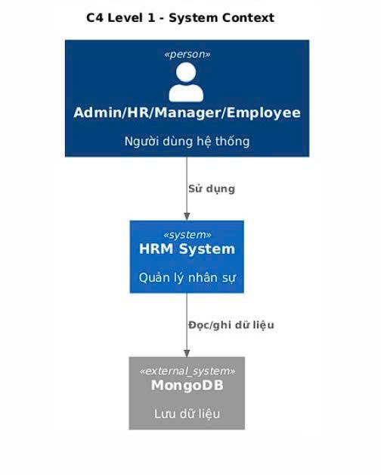
Picture 1: C4 level 1 – System Context
This diagram establishes the boundaries between the HRM System and its external environment.
- Central Focus: The HRM System acts as the core entity managing all human resource administrative activities.
- User Interactions: Four primary actor groups (Admin, HR, Manager, and Employee) interact directly with the system to perform business operations such as timekeeping, leave approval, and payroll processing.
- Data Storage: The system connects to a MongoDB cluster to ensure that personnel data is stored centrally and securely.
- Significance: This high-level view defines the project scope, focusing on the value provided to end-users rather than technical implementation details.
Core Architectural Characteristics:
- Decoupling and Independence: The system is composed of distinct services, including but not limited to Identity, Employee, Payroll, Attendance, Recruitment, and Leave services. Each service maintains its own dedicated database and execution logic, effectively eliminating inter-service dependencies.
- API Gateway Integration: A centralized API Gateway serves as the single entry point for all client requests. This component orchestrates traffic, abstracts the internal microservices structure, and enhances overall system security.
- Elastic Scalability: The architecture empowers independent scaling or upgrading of specific modules. For instance, the Attendance Service can be scaled to handle a surge of 10,000 concurrent active users during peak hours without necessitating a resource increase for the entire system or causing operational downtime.
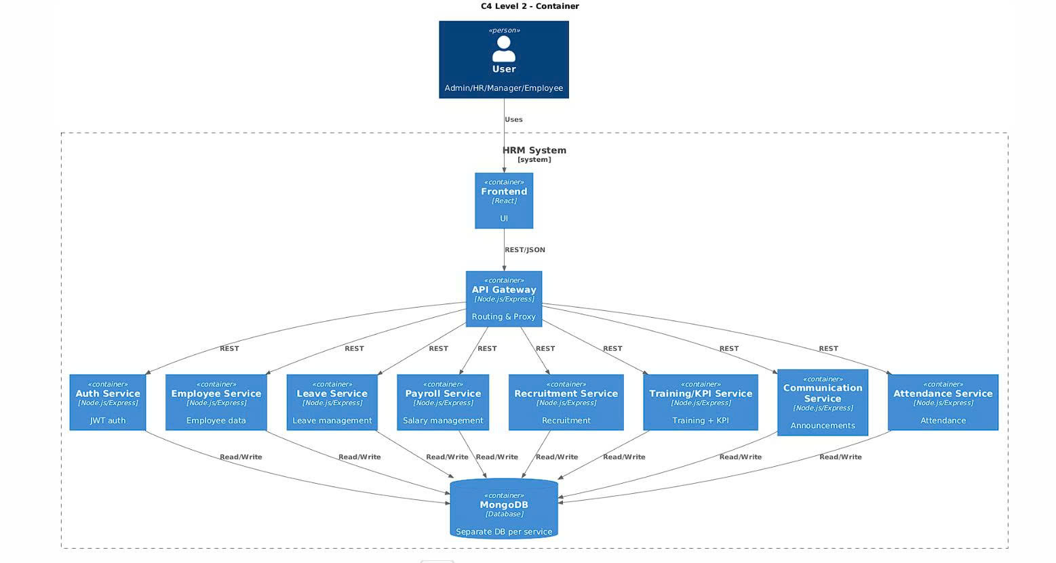
Picture 2: C4 level 2 – Container
This diagram illustrates how the system is decomposed into self-contained technical units.
- Frontend Layer: Built with React.js, providing a responsive and dynamic web/mobile interface for a seamless user experience.
- API Gateway: Acting as the "Single Entry Point," it is responsible for request routing, centralized security, and protecting downstream services from exhaustion through rate limiting.
- Business Microservices: The system is partitioned into 8 specialized services (Identity, Employee, Payroll, Attendance, etc.). This ensures Fault Isolation—if one service (e.g., Payroll) fails, other core modules like Attendance remain operational.
- Data Strategy: Each service owns its independent MongoDB instance (Database per Service), eliminating cross-service data coupling and ensuring high maintainability.
Architectural Justification:
- Fault Isolation: The Microservices architecture ensures high availability through the isolation of failures. A localized failure within a specific service (e.g., a crash in the Payroll module) will not paralyze the entire organizational workflow, allowing core services like Identity and Attendance to remain operational.
- Process Optimization: The automation of end-to-end functional chains—from timekeeping to payroll—minimizes human-induced errors and significantly reduces data processing time.
- Future-Ready Foundation: Utilizing a standardized RESTful API structure ensures the system is engineered for seamless integration with emerging technologies, such as AI-driven performance analytics, or for interconnectivity with international ERP ecosystems.

3.2. Technical Stack and Data Model

3.2.1 Technical Stack
The HRM system utilizes a modern, production-ready technology stack designed to support the Microservices architectural pattern, ensuring high performance, type safety, and efficient containerization.
- Frontend: React.js + Vite:
  - React.js: Employed to build a dynamic, role-based User Interface for Admin, HR, Manager, and Employee roles. It efficiently handles complex states such as large data tables, reporting dashboards, and intricate forms.
  - Vite: Acts as the next-generation frontend tool to provide significantly faster build times and a superior development experience compared to traditional bundlers.
  - Axios: Utilized for handling asynchronous HTTP requests from the client to the API Gateway.
- Backend: Node.js + Express (TypeScript):
  - Node.js: Provides a high-performance, non-blocking I/O environment suitable for handling multiple concurrent requests across distributed services.
  - Express: Used as the primary web framework for each microservice (Auth, Employee, Leave, Payroll, etc.) to handle RESTful routing.
  - TypeScript: Implemented to enforce strict typing, which minimizes logic errors, improves code readability, and facilitates long-term maintenance in a multi-service environment.
- API Gateway: Express + http-proxy-middleware:
  - Routing: Serves as the single entry point for all /api/* requests, routing traffic to the correct downstream microservice.
  - Traffic Management: Implements rate-limit to prevent service exhaustion and manages request timeouts.
  - Centralized Logging: Injects a unique request-id into every incoming request to ensure full traceability across the distributed system.
- Database: MongoDB (Database per Service):
  - A NoSQL database chosen for its flexibility and scalability.
  - Adheres to the microservices principle where each domain manages its own independent database instance to ensure total data ownership and prevent cross-service data coupling.
- Observability & Monitoring: Prometheus + Grafana:
  - Prometheus: Scrapes performance metrics via the /metrics endpoint of individual services.
  - Grafana: Provides visual dashboards to monitor real-time system health and performance metrics.
- Deployment: Docker + Docker Compose:
  - Docker: Each service is encapsulated in its own Dockerfile, ensuring environment consistency from development to production.
  - Docker Compose: Orchestrates the entire stack, including the API Gateway, all microservices, MongoDB instances, and the monitoring suite, allowing the whole system to be deployed with a single command.

3.2.2 Data Model
In alignment with the microservices principle of Loose Coupling, the HRM system implements a decentralized data model. Each microservice maintains its own MongoDB collection, ensuring that data schemas are optimized for their specific business domain and that no cross-service database dependencies exist.

Service-Specific Data Entities
The following table defines the primary data entities managed within each service's isolated database instance:

Service | Primary Entities (Collections) | Functional Purpose
Auth | User, AuditLog | Manages authentication credentials, Role-Based Access Control (RBAC), and security audit trails.
Employee | Employee, Department, Position, Contract, WorkShift | Acts as the "Master Data" hub for personal information, organizational structure, and contractual terms.
Leave | Leave, Holiday, AuditLog | Tracks employee absence requests, vacation balances, and official holiday schedules.
Payroll | Salary, AuditLog | Stores payroll structures, historical pay stubs, and financial audit logs.
Recruitment | Recruitment | Manages the talent acquisition pipeline, from job postings to candidate tracking.
Training/KPI | Training, KPI, AuditLog | Monitors professional development progress and performance metrics.
Communication | Announcement, SystemSettings | Handles global system announcements and real-time configuration settings.
Attendance | Attendance | Records high-frequency time-tracking data (check-in/check-out events).

Data Isolation and Enrichment Strategy
To fulfill business logic that spans multiple domains (e.g., displaying employee names on a payroll sheet), the system utilizes an API-driven enrichment strategy instead of database joins:
- Strict Ownership: A service can only perform Create, Read, Update, and Delete (CRUD) operations on its local MongoDB instance.
- Cross-Service Fetching: When additional context is required, the initiating service (e.g., Payroll Service) performs a server-side REST request to the provider service (e.g., Employee Service).
- Data Integrity: AuditLog entities are embedded in most services to track sensitive data changes, ensuring accountability across the distributed environment.

3.3 Server-side Implementation (Node.js/Express)
The backend is developed using Node.js and Express, focusing on RESTful API principles and internal service coordination. Each microservice operates independently, handling its own domain logic while interacting with others through the API Gateway.

3.3.1 Service Execution Logic & Inter-service Communication
Each service is designed to be self-contained but remains capable of "data enrichment" by requesting information from other domains when necessary.
- Authentication & Authorization: Every request entering a service must first pass through the Auth Middleware to verify the JWT token issued by the Auth Service.
- Request Routing: The API Gateway utilizes http-proxy-middleware to intercept requests (e.g., /api/salaries) and proxy them directly to the appropriate downstream service (e.g., Payroll Service).
- Inter-service Data Fetching: Since databases are isolated (Database per Service), a service may need to call another service’s API to complete a data set without violating data ownership rules.

3.3.2 Implementation Case Study: Payroll Service
The following flow illustrates how the Payroll Service retrieves salary data and enriches it with employee details:
- Local Query: The service queries its local MongoDB for salary records.
- External API Call: It utilizes the fetchEmployeesByIds method to request employee names and departments from the Employee Service via an internal REST call.
- Data Merger: The results are combined and returned as a unified JSON response.
Code Implementation Example (Payroll Controller):
const salaries = await Salary.find(query);
const employeeIds = salaries.map(s => s.employeeId);
const employees = await fetchEmployeesByIds(employeeIds, req.header('Authorization'));
const salariesWithEmployee = salaries.map(salary => ({ ...salary.toObject(),
employee: employees.find(e => e._id === salary.employeeId)
}));
res.json({ success: true, data: salariesWithEmployee });

3.3.3 Detailed Component Design (C4 Level 3)

* API Gateway Components

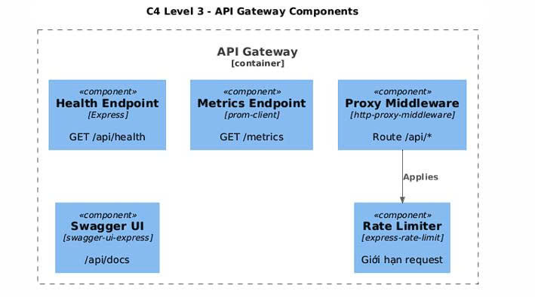

Picture 3: C4 Level 3 API Gateway – Component Diagram

This diagram provides a deep dive into the internal logical structure of the API Gateway.
- Traffic Control: The Rate Limiter component restricts the number of incoming requests to protect the system against DoS attacks or resource depletion.
- Request Orchestration: The Proxy Middleware inspects request paths (e.g., /api/salaries) and forwards them precisely to the corresponding target microservice.
- Observability & Documentation: Features dedicated endpoints for Health Checks (status monitoring), Metrics (performance data for Prometheus), and Swagger UI to provide automated API documentation for developers.

* Authentication & Administrative Services

.
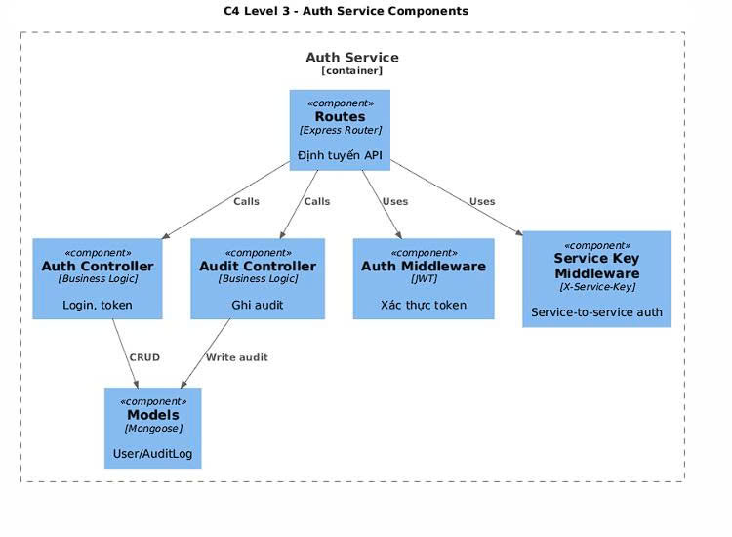
Picture 4: C4 Level 3 Auth Service – Component Diagram
This diagram illustrates the security backbone of the HRM system, responsible for identity management.
- Authentication Logic: the Auth Controller handles login requests by validating credentials against the User model and issuing JWT tokens.
- Service-to-Service Security: the Service Key Middleware ensures that internal requests between microservices are authenticated using a secure X-Service-Key.
- Accountability: every authentication event is captured by the Audit Controller and stored in the AuditLog for security tracking.
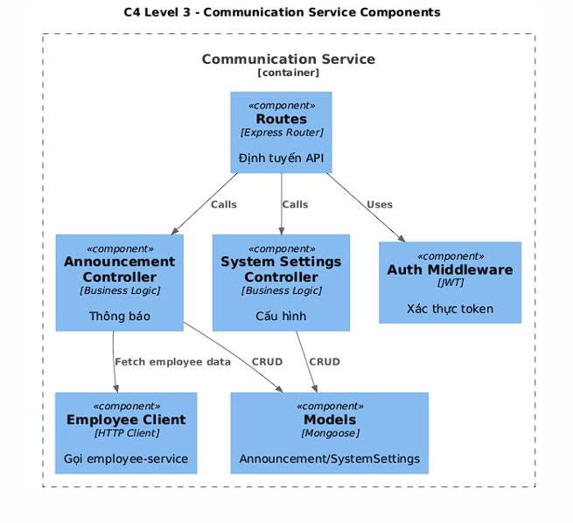
Picture 5: C4 Level 3 Communication Service – Component Diagram

This service manages internal messaging and global system configurations.
- Announcement Management: the Announcement Controller handles the creation and distribution of company-wide notices.
- Data Integration: similar to other modules, it uses an Employee Client to fetch recipient data from the Employee Service for targeted notifications.
- System Settings: the System Settings Controller manages global variables and application configurations stored in MongoDB

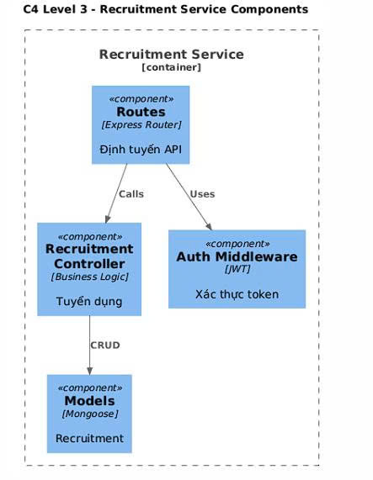
Picture 6: C4 Level 3 Recruitment Service – Component Diagram

This module is dedicated to managing the end-to-end talent acquisition pipeline, from job postings to candidate tracking.
- Pipeline Orchestration: The Recruitment Controller manages the complete lifecycle of recruitment profiles, allowing HR staff to add, edit, or delete candidate information.
- Access Control: The Auth Middleware strictly enforces security policies, ensuring that only authorized HR or Admin roles can modify sensitive recruitment data.
- Data Sovereignty: In line with the microservices principle, the service interacts with its own isolated Recruitment collection in MongoDB, ensuring that hiring data is decoupled from other organizational modules.
- Simplified Integration: The service provides a standardized set of RESTful Routes (API endpoints) for the frontend to consume recruitment-related data via the API Gateway.

* Core HR & Operational Services

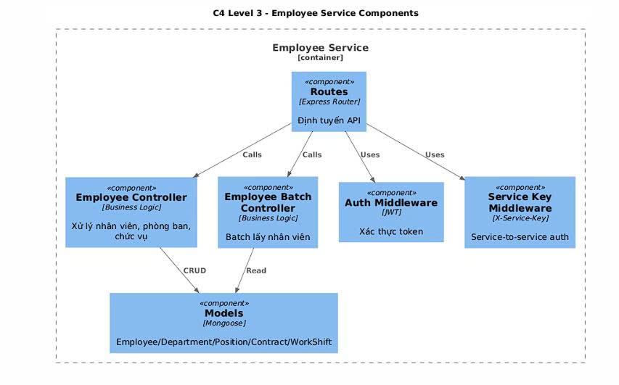
Picture 7: C4 Level 3 Employee Service – Component Diagram

This diagram illustrates the internal components of the Employee Service, which acts as the "Master Data" hub and the foundational pillar of the entire HRM system.
- Organizational Logic (Employee Controller): The Employee Controller is the primary component responsible for managing complex human resource entities, including personal employee profiles, departmental structures, job positions, labor contracts, and work shifts.
- High-Volume Data Retrieval (Employee Batch Controller): To support the distributed nature of the system, the Employee Batch Controller is specifically designed to handle bulk data requests from other microservices. This allows services like Payroll or Attendance to retrieve multiple employee records in a single optimized call.
- Security & Access Control (Auth Middleware): Every incoming request is intercepted by the Auth Middleware to verify JWT tokens, ensuring that sensitive personnel information is only accessible to users with authorized roles, such as HR or Admin.
- Service-to-Service Authentication: The Service Key Middleware provides an additional layer of security for internal communications, validating that requests coming from other microservices are legitimate and secure.
- Data Persistence (Models): The service interacts with its isolated MongoDB instance through a comprehensive set of Mongoose models (Employee, Department, Position, Contract, and WorkShift). This ensures that the core organizational data is decoupled from other functional modules, enhancing system maintainability.

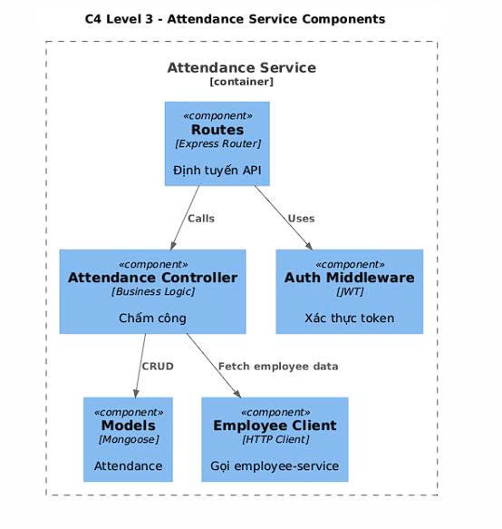
Picture 8: C4 Level 3 Attendance Service – Component Diagram

This diagram illustrates the internal components of the Attendance Service, which is engineered to handle high-frequency data recording and real-time monitoring of employee presence.
- Attendance Management (Attendance Controller): The Attendance Controller is the core component responsible for validating and recording "check-in" and "check-out" events. It ensures that each entry is accurately timestamped and linked to the correct workday.
- Data Verification (Employee Client): To maintain the "Database per Service" architecture, the service utilizes an Employee Client to perform internal REST calls to the Employee Service. This interaction is critical to verify that the individual recording attendance is a valid and active employee within the organization.
- Security & Access Control (Auth Middleware): Every request to the Attendance Service is intercepted by the Auth Middleware. It validates the user's JWT token to ensure that employees can only record their own attendance, while managers or HR can view team-wide logs.
- Data Persistence (Models): The service interacts with its dedicated MongoDB instance through the Attendance Model. This isolated database stores high-frequency time-tracking data, ensuring that the heavy load of daily check-ins does not impact the performance of other administrative modules.
- Business Rule Enforcement: The controller implements strict logic to prevent duplicate records for the same day, ensuring data integrity for subsequent payroll calculations.

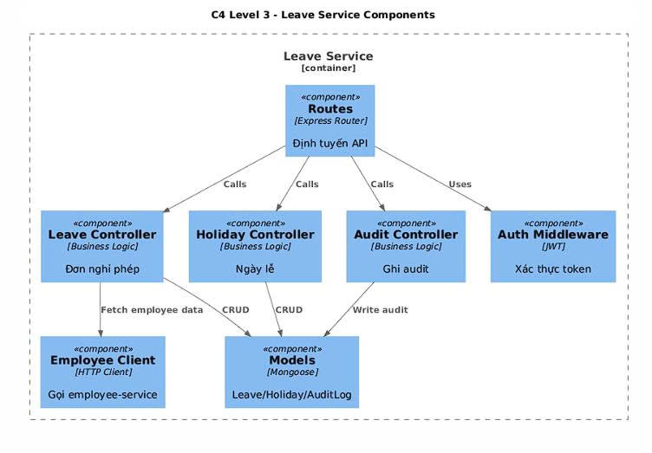
Picture 9: C4 Level 3 Leave Service – Component Diagram

This diagram illustrates the internal architecture of the Leave Service, which is responsible for managing employee absence requests and maintaining the official company holiday calendar.
- Workflow Management (Leave Controller): The Leave Controller manages the entire lifecycle of a leave application, handling operations from initial submission by an employee to the final "Approved" or "Rejected" status.
- Holiday Administration (Holiday Controller): The Holiday Controller manages the organization's official holiday schedule, ensuring that leave duration and vacation balances are calculated accurately.
- Data Enrichment (Employee Client): To adhere to the "Database per Service" principle, the service utilizes an Employee Client to perform internal REST calls to the Employee Service. This is essential for verifying employee identities and identifying direct managers for the approval chain.
- Security & Authorization: The Auth Middleware intercepts all incoming requests to validate JWT tokens, ensuring that employees can only create their own requests while managers can only process requests from their subordinates.
- Accountability (Audit Controller): Any change in leave status or modification of holiday data is captured by the Audit Controller and recorded in the AuditLog to maintain a transparent history of administrative actions.
- Data Persistence (Models): The service manages its own isolated MongoDB instance with dedicated collections for Leave, Holiday, and AuditLog, preventing any direct database coupling with other services.
* Financial & Performance Services

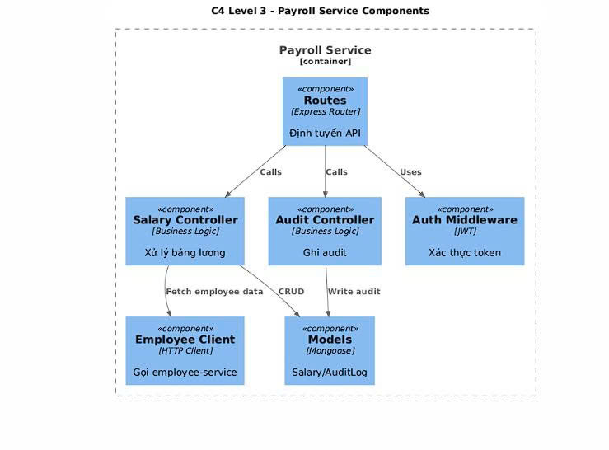
Picture 10: C4 Level 3 Payroll Service – Component Diagram

This diagram provides a granular view of the internal components and logic flow within the Payroll Service, which is responsible for the system's most complex financial calculations.
- Core Logic (Salary Controller): The Salary Controller serves as the central orchestration point, executing the business logic required to calculate net salaries based on base pay, bonuses, and deductions.
- Data Enrichment (Employee Client): Since the Payroll Service adheres to the "Database per Service" principle and does not store personal employee details, it utilizes the Employee Client to perform internal RESTful API calls to the Employee Service. This allows the controller to "enrich" local salary records with names and department information before returning the final result.
- Security & Authorization: All incoming requests to the service's routes are intercepted by the Auth Middleware, which validates the user's JWT (JSON Web Token) and ensures the requester has the appropriate permissions (Admin or HR) to access financial data.
- Auditability: To ensure transparency and compliance, any sensitive data operations (such as monthly payroll processing) are captured by the Audit Controller. These events are stored in a dedicated AuditLog collection within the service's MongoDB instance.
- Data Persistence (Models): The service interacts with its isolated MongoDB database through Mongoose models (Salary and AuditLog), ensuring complete data sovereignty and preventing cross-service database coupling

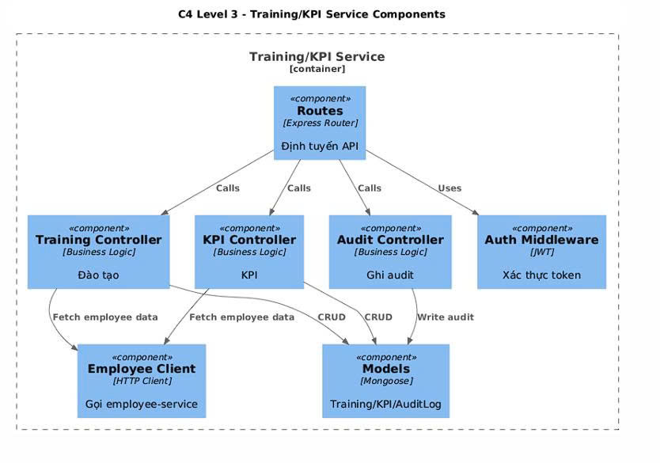
Picture 11: C4 Level 3 Training/KPI Service – Component Diagram

This diagram illustrates the internal architecture of the Training/KPI Service, which is dedicated to monitoring professional development and evaluating employee performance.
- Performance Monitoring (KPI Controller): The KPI Controller manages the lifecycle of Key Performance Indicators, including defining metrics, assigning targets to specific employees, and calculating achievement scores based on updated results.
- Professional Development (Training Controller): The Training Controller handles the administration of training programs, from creating course schedules to tracking employee participation and completion status.
- Data Enrichment (Employee Client): To maintain the "Database per Service" principle, this service uses the Employee Client to perform internal REST calls to the Employee Service. This ensures that KPI and training records are accurately linked to the correct employee profiles without direct database coupling.
- Security & Authorization: The Auth Middleware intercepts all incoming requests to verify JWT tokens, ensuring that only authorized roles (such as Managers or HR) can assign KPIs or create new training courses.
- System Traceability: An Audit Controller is integrated to record significant actions, such as KPI assignments or result updates, into the AuditLog for transparency and compliance.
- Data Persistence: The service manages its own isolated MongoDB instance, storing data related to Training courses, KPI metrics, and Audit logs.

3.3.4 Source Code Structure & File Organization (C4 Level 4).

* System Infrastructure

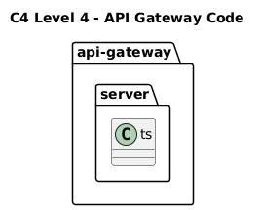

Picture 12: C4 Level 4 - API Gateway Code

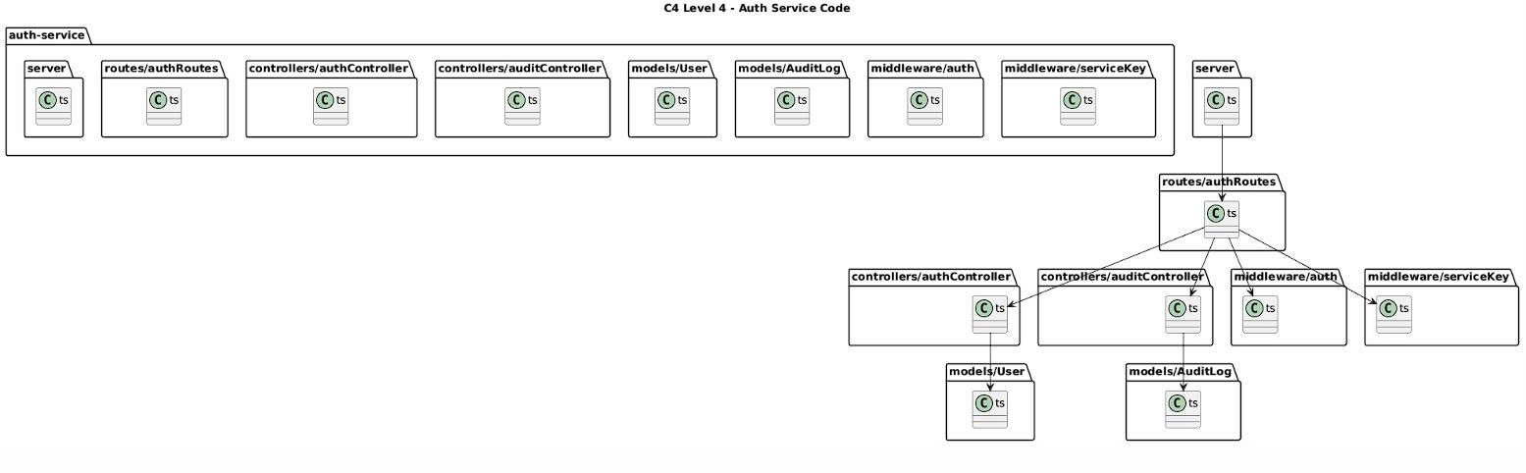
Picture 13: C4 Level 4 – Auth Service Code

* Business Services

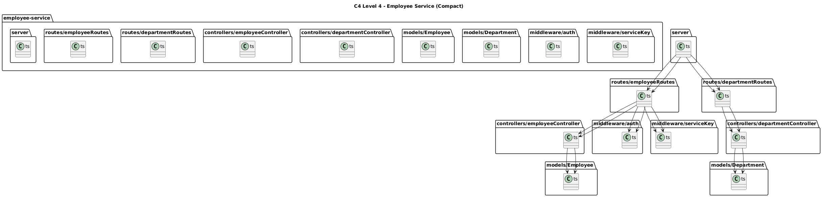

Picture 14: C4 Level 4 – Employee Service (Compact)

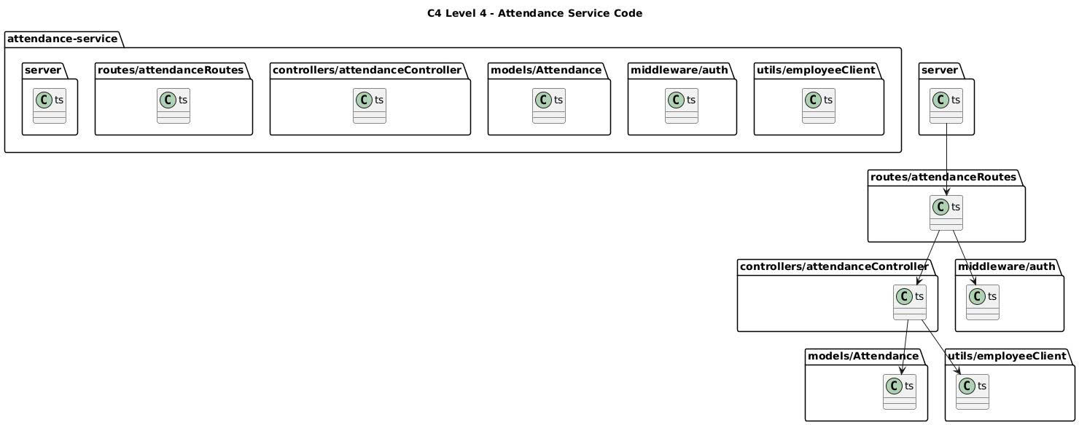
Picture 15: C4 Level 4 – Attendance Service Code

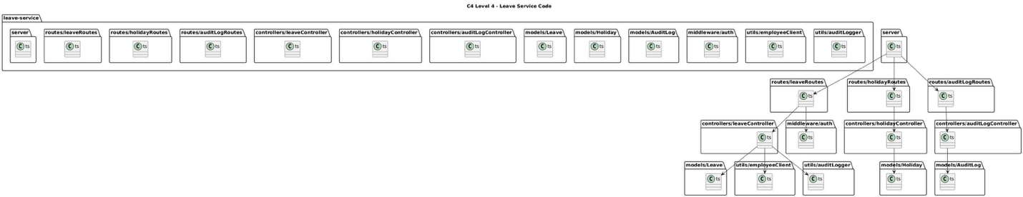

Picture 16: C4 Level 4 – Leave Service Code

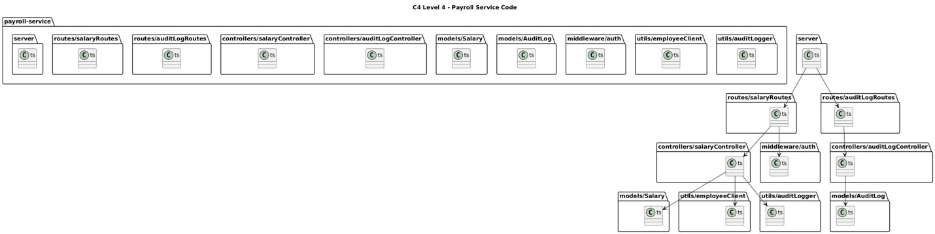

Picture 17: C4 Level 4 – Payroll Service Code

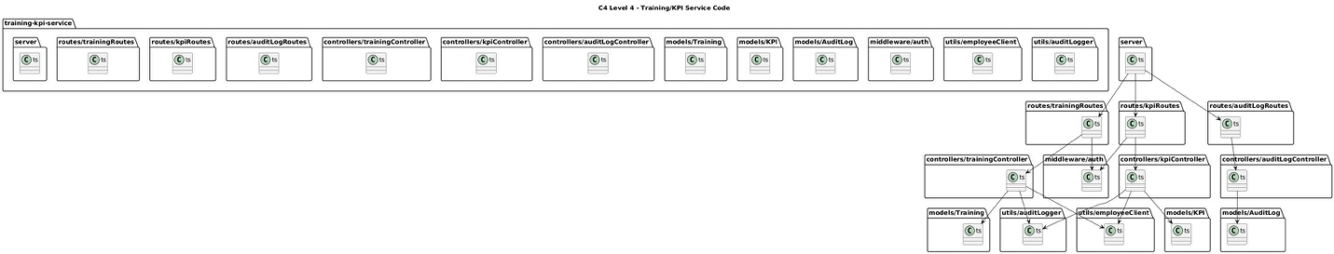

Picture 18: C4 Level 4 – Training/KPI Service Code

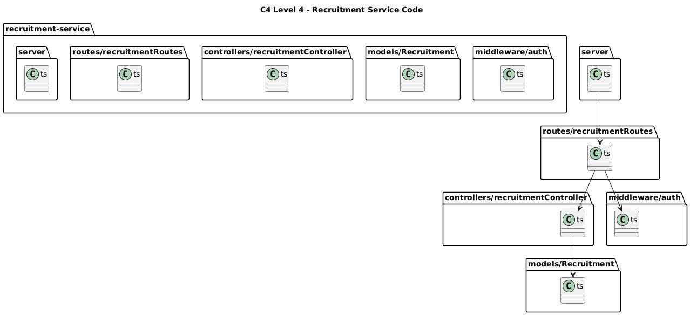

Picture 19: C4 Level 4 – Recruitment Service Code

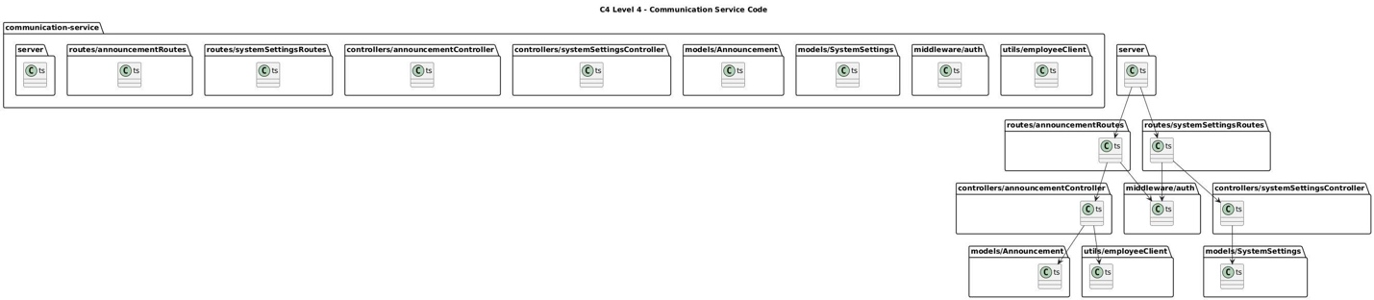

Picture 20: C4 Level 4 – Communication Service Code

3.4 Client-side Implementation (React)
The frontend is built using React.js with Vite, providing a highly responsive Interface that communicates exclusively through the API Gateway.

3.4.1 API Consumption with Axios
The client-side application utilizes Axios to handle HTTP requests. This ensures that the frontend remains decoupled from the internal microservice network, as it only knows the public URL of the API Gateway.
- Centralized Requests: All requests are sent to a base URL (e.g., https://api.hrm-system.com/api/*), hiding the complexity of the backend services.
- Authorization Header: Each request automatically includes the Authorization: Bearer <token> header, allowing the Gateway and target services to verify the user's role and identity.

3.4.2 State Management & UI Update Flow
The frontend follows a reactive pattern to ensure the UI stays in sync with backend data:
- Component Mounting: When a user navigates to a page (e.g., the Salaries dashboard), an effect hook triggers an API call.
- Data Fetching: The request passes through the Gateway to the backend for processing.
- State Update: Once the JSON response is received, the React state is updated, triggering a re-render to display the data immediately.
Code Implementation Example (Salaries Page):
// React (Salaries Page)
const fetchSalaries = async () => {
const response = await api.get('/salaries'); // Request via API Gateway
setSalaries(response.data.data || []); // Dynamic UI update
};

IV. Testing and Verification
This section verifies the HRM system's integrity by validating the seamless coordination of microservices and their adherence to defined quality attributes. The focus is on tracing data flows from the API Gateway through Node.js/Express services to their respective MongoDB databases, ensuring the system operates reliably as a unified distributed ecosystem.

4.1. Integration Testing: Inter-service Flows
We verified the API communication between autonomous services to ensure that data "loops" correctly across the network as designed in our Node.js environment.
- Authentication Loop Verification: Tested the request lifecycle where the API Gateway uses http-proxy-middleware to route requests to the Auth Service. The service utilizes Bcrypt and JWT for credential validation and token issuance before granting access.
- Data Dependency Loop Verification: Confirmed the Payroll Service successfully utilizes its Employee Client to perform internal REST calls to the Employee Service. This verifies that even with isolated MongoDB instances, data consistency is maintained via service-to-service communication.

4.2.1 Functional Verification Matrix
The following matrix maps the designed technical components against the key Use Cases to ensure end-to-end functionality and technical traceability.
ID | Test Scenario | Technical Traceability (Component Flow) | Status
TC-01 | User Login | Client $⟶$API Gateway (Proxy) $⟶$Auth Service (Auth Controller $⟶$Bcrypt $⟶$JWT) $⟶$MongoDB. | Pass
TC-02 | Real-time Attendance | Mobile App $⟶$API Gateway (Rate Limiter) $⟶$ Attendance Service (Auth Middleware $⟶$Attendance Controller) $⟶$MongoDB. | Pass
TC-03 | Payroll Calculation | HR $⟶$ Payroll Service (Salary Controller $⟶$ Employee Client) $⟶${API} Employee Service $⟶$Audit Controller. | Pass
TC-04 | Rate Limiting | External Request $⟶$API Gateway (Express-rate-limit) $⟶$ Block/Allow logic based on IP threshold. | Pass
TC-05 | Leave/Profile Management | Employee $⟶$Leave Service (Leave Controller) $⟶\{$API} Employee Service (Check Manager/Profile) $⟶$Notification Service. | Pass

4.2.2. Technical Verification Steps
To ensure each component operates strictly according to the architectural design, every test scenario is validated through a rigorous three-stage technical verification process:
1. Gateway-Level Verification:
- Proxy Routing: We verify that the Proxy Middleware correctly inspects the request path and routes the traffic to the designated microservice (e.g., routing /api/salaries to Payroll).
- Traffic Control: We confirm that the Rate Limiter successfully intercepts requests exceeding the defined threshold to protect system resources from exhaustion.
2. Service-Middleware Verification:
- Authentication & RBAC: We validate that the Auth Middleware within the target service accurately extracts claims from the JWT and enforces Role-Based Access Control (RBAC).
- Security Rejection: We ensure that all requests lacking a valid token or proper permissions are immediately blocked with standard 401/403 error codes.
3. Inter-service Communication Verification (The "Loop"):
- Internal API Integration: In scenarios like TC-03 and TC-05, we verify that the Employee Client (HTTP Client) successfully executes an internal call to another service.
- Data Processing Integrity: We confirm that the returned dataset from the remote service is correctly processed by the local Controller to generate the final result.
- Auditability: We verify that all sensitive data modifications are intercepted and recorded by the Audit Controller for compliance and traceability.

4.3. Resilience & Failure Handling Verification
To reflect real-world operational conditions, we simulated failure scenarios that typically occur when data loops across multiple APIs.
- Timeout & Retry Handling:
  - Scenario: The Employee Service experiences high latency while the Payroll Service is retrieving data.
  - Execution: The Employee Client implements a Retry mechanism (3 attempts) before returning a 504 error and logging the event via the Audit Controller.
  - Result: The system avoids infinite hanging, ensuring the availability of the payroll service under stress.
- Circuit Breaker Simulation:
  - Scenario: The Communication Service encounters persistent 500-errors.
  - Execution: The API Gateway detects the failure via the Health Endpoint and temporarily severs the connection to this service to protect the overall ecosystem.
  - Result: The Gateway provides a Fallback response, preventing cascading failures from affecting core services like Auth or Attendance.
- Fault Isolation:
  - Scenario: Simulating a total shutdown of the Recruitment Service.
  - Result: The Identity, Attendance, and Payroll services remain 100% operational due to the Separate DB per Service strategy, proving no single point of failure.

4.4. Quality Attribute Verification (NFR Testing)
Stress testing was conducted to confirm the system meets the performance commitments for 10,000 concurrent users.
- Performance: Load testing confirmed that average API response times through the Gateway ranged from 1.2s to 1.8s, comfortably below the defined 2s threshold.
- Scalability: Verified that the Attendance Service can scale its instances independently behind the Gateway to handle the surge of check-in requests during peak hours

4.5. Final Product Interface Demonstration

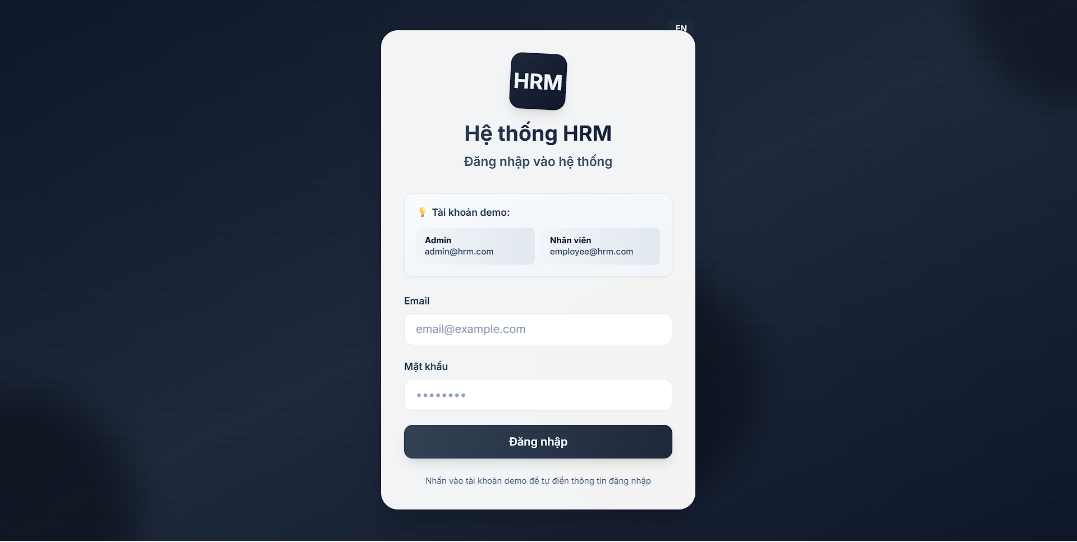

Picture 21: HRM Application Login Screen

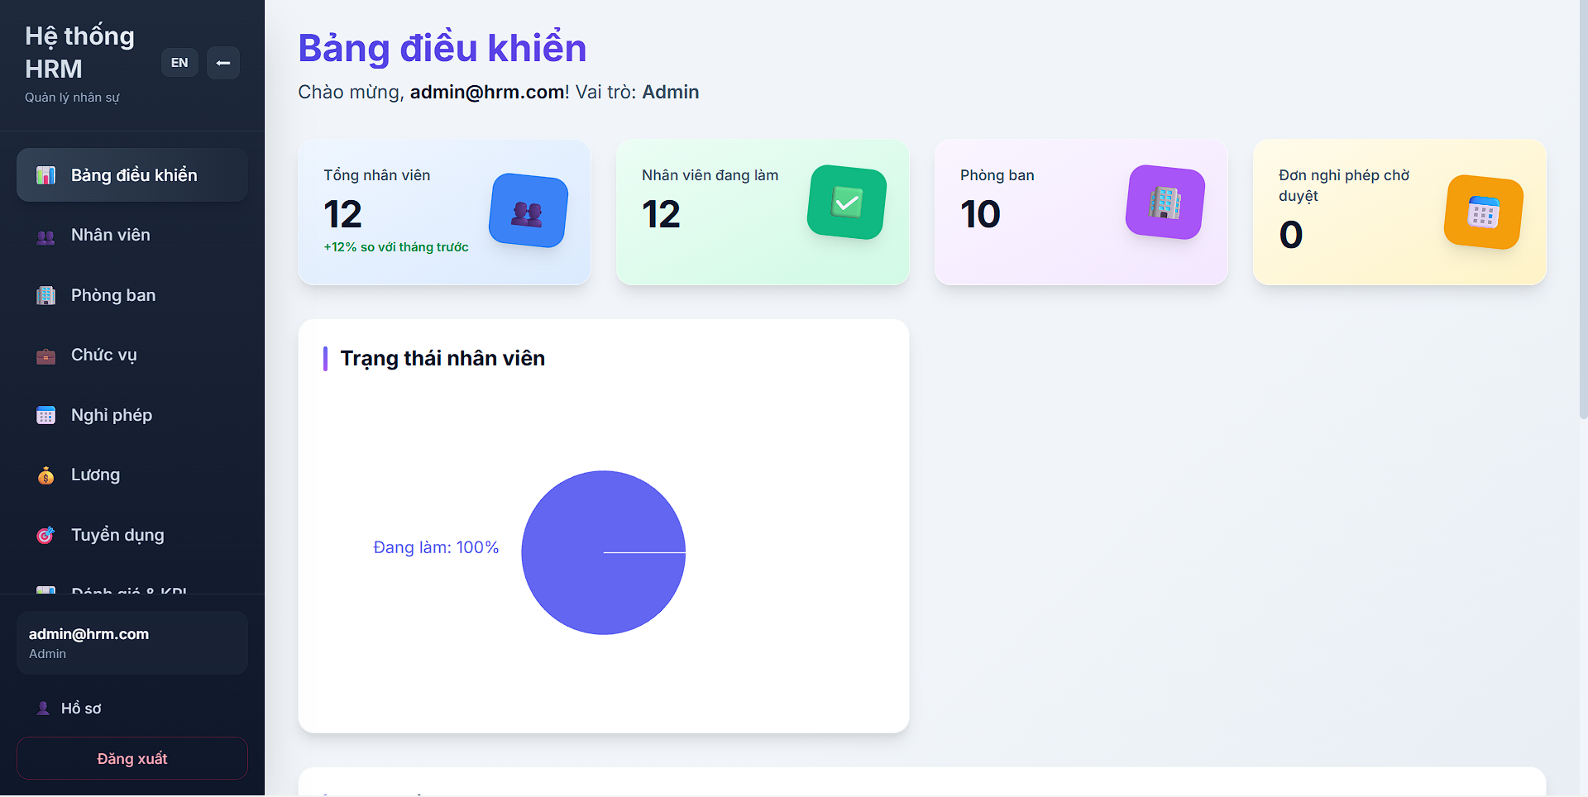
Picture 22: Main Dashboard Interface

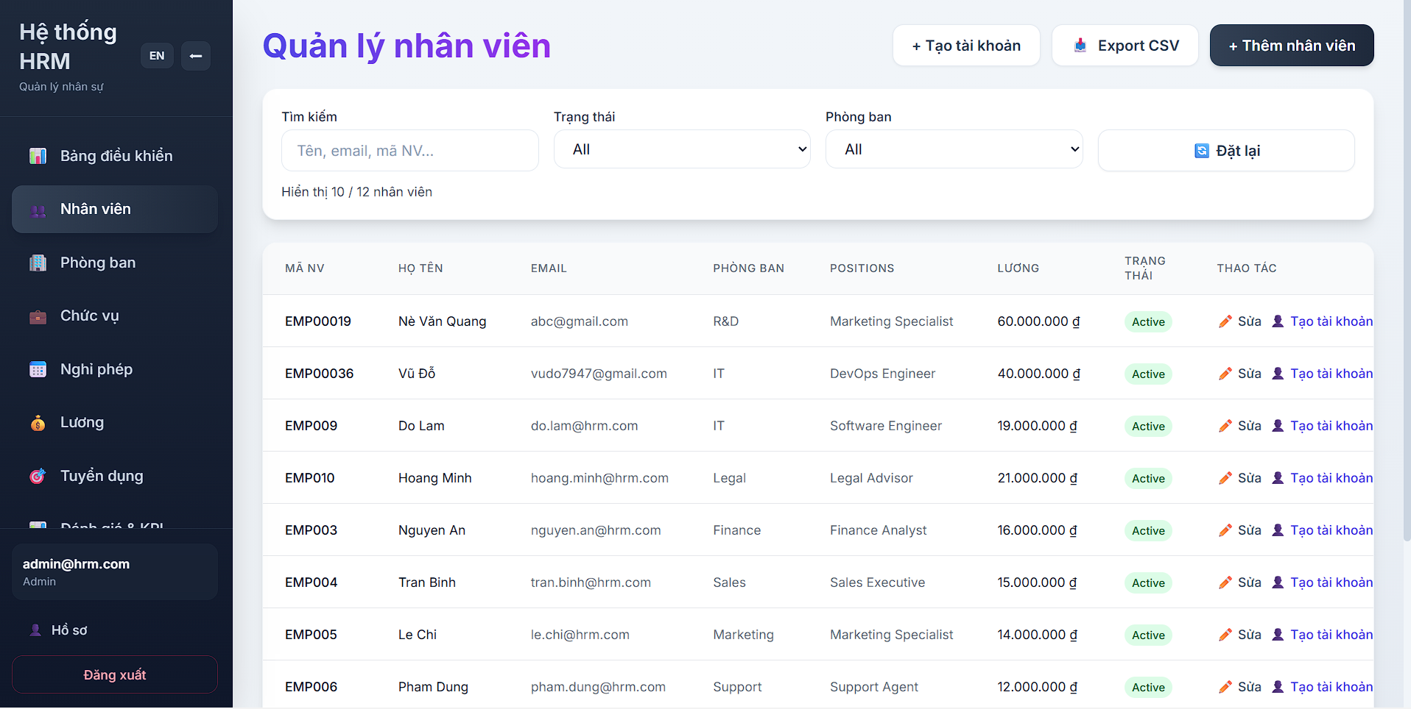
Picture 23: Employee Management Main Screen

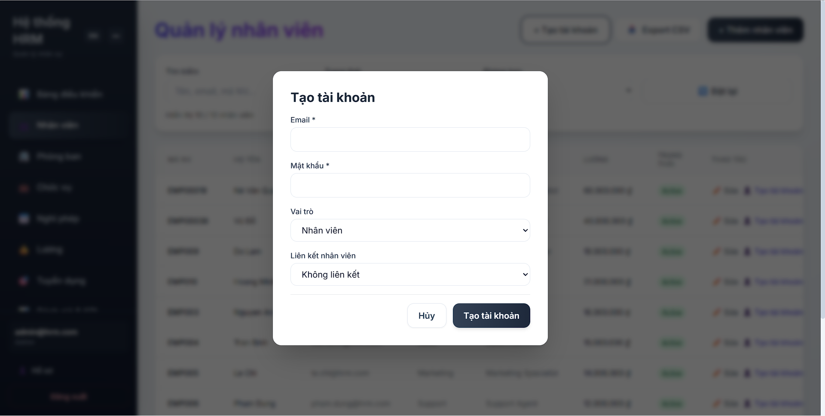
Picture 24: Create Employee Account Interface

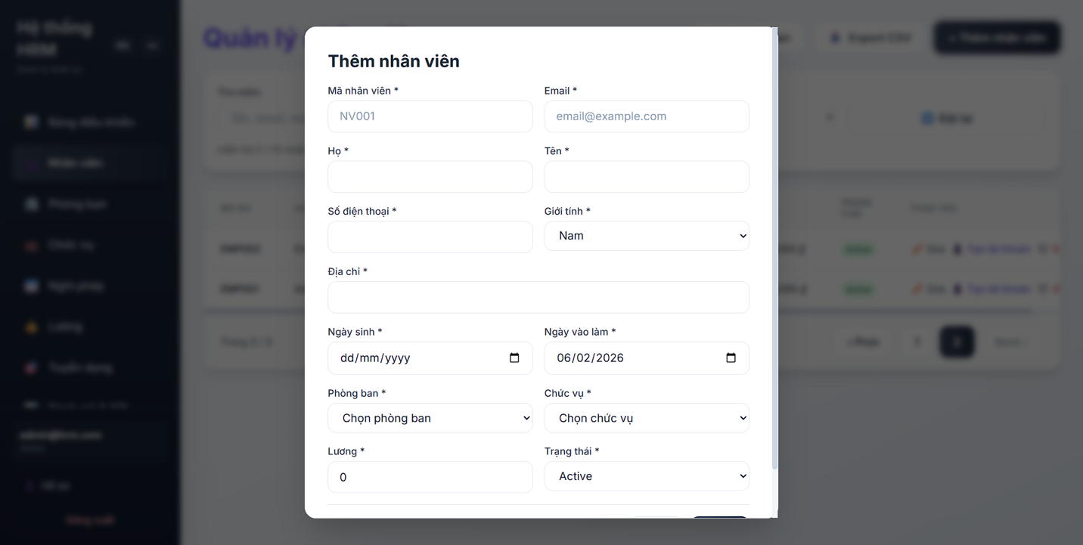
Picture 25: Display Add Employee Form

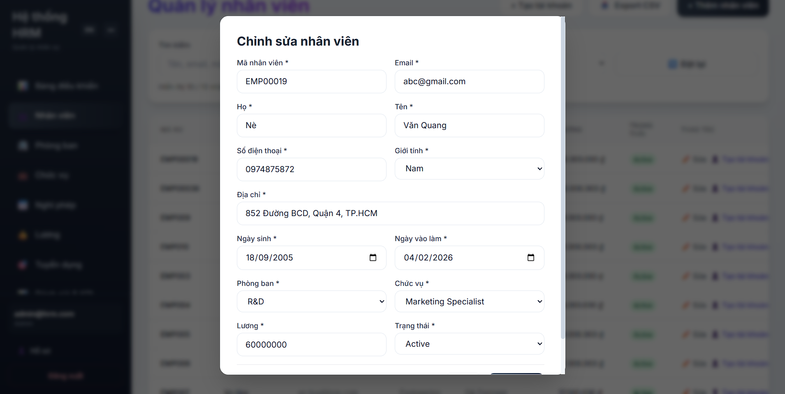
Picture 26: Display Edit Employee Information Form

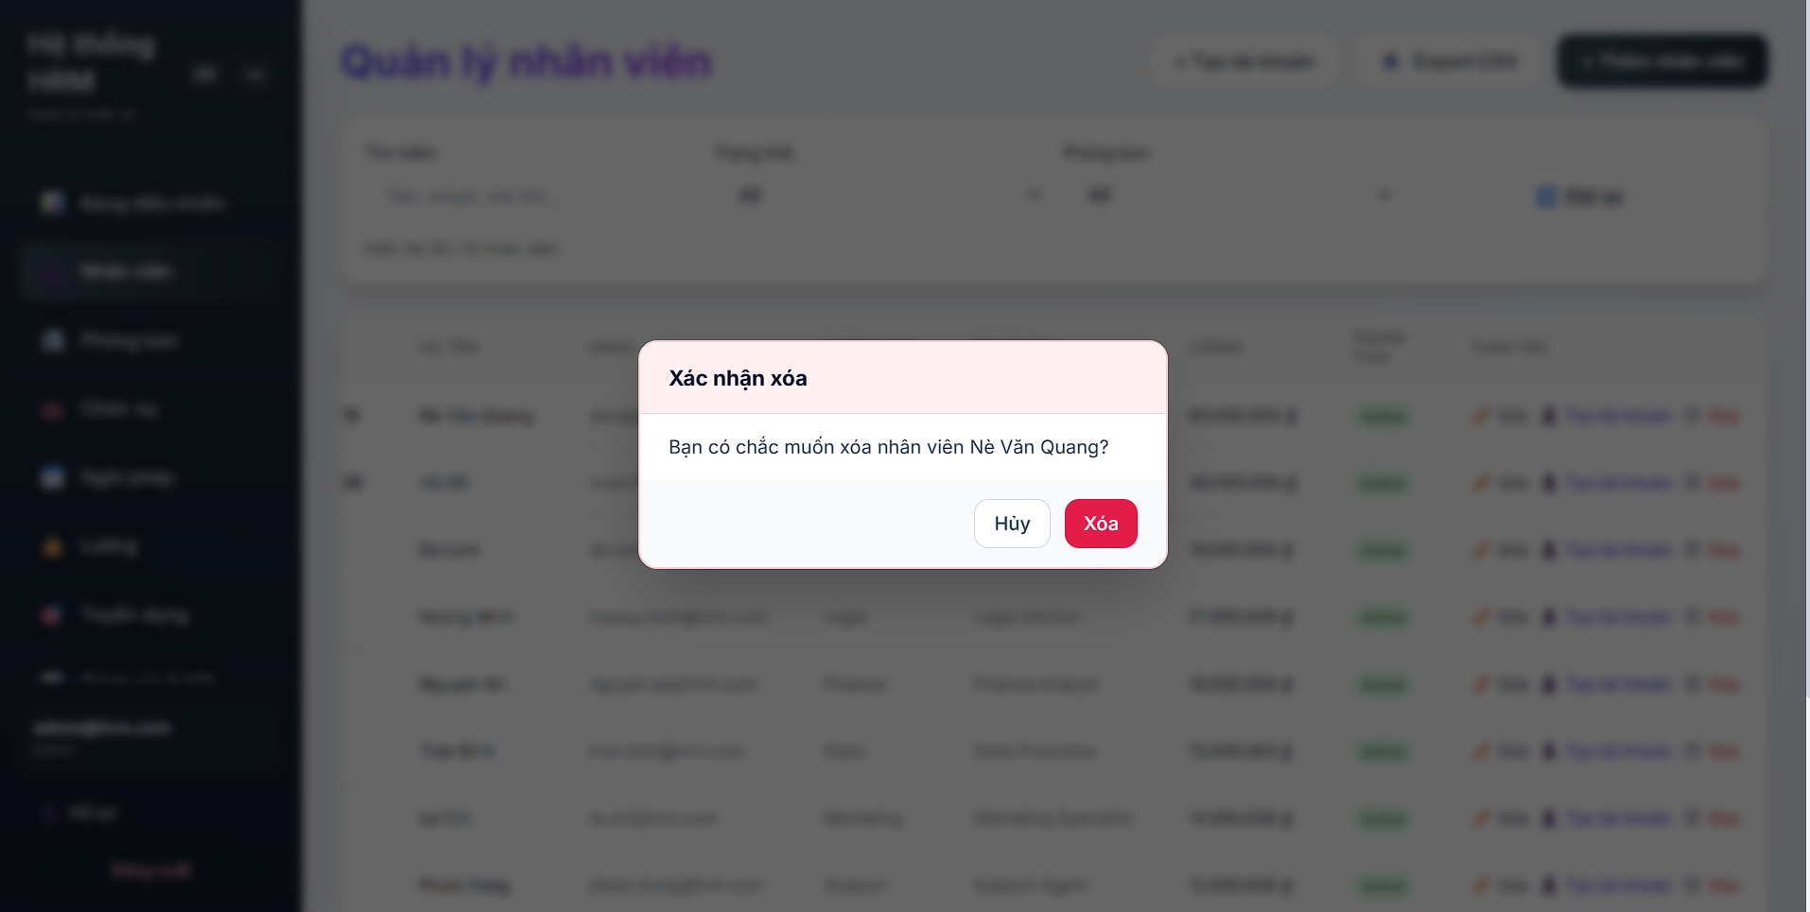

Picture 27: Display Delete Employee Option
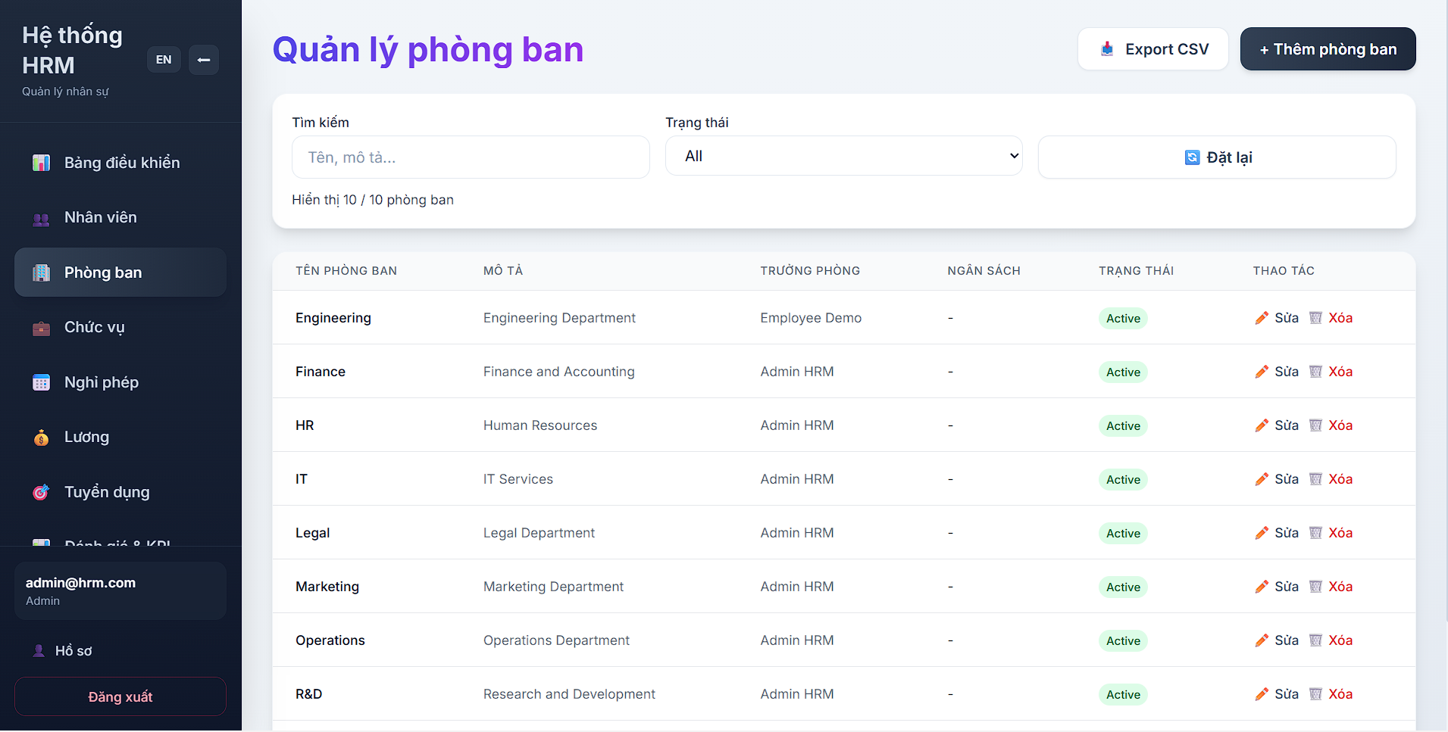
Picture 28: Department Management Main Screen

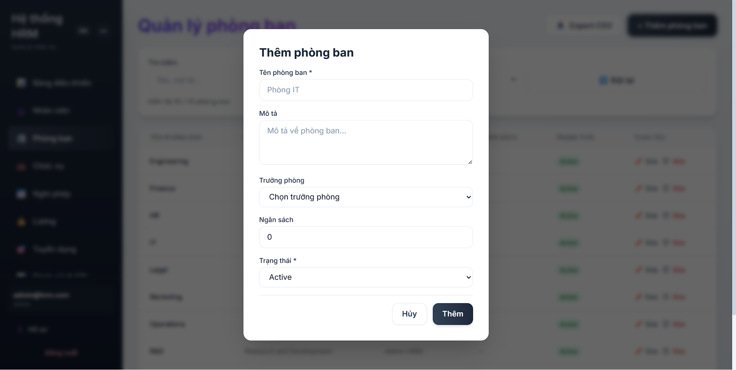
Picture 29: Display Add Department Form
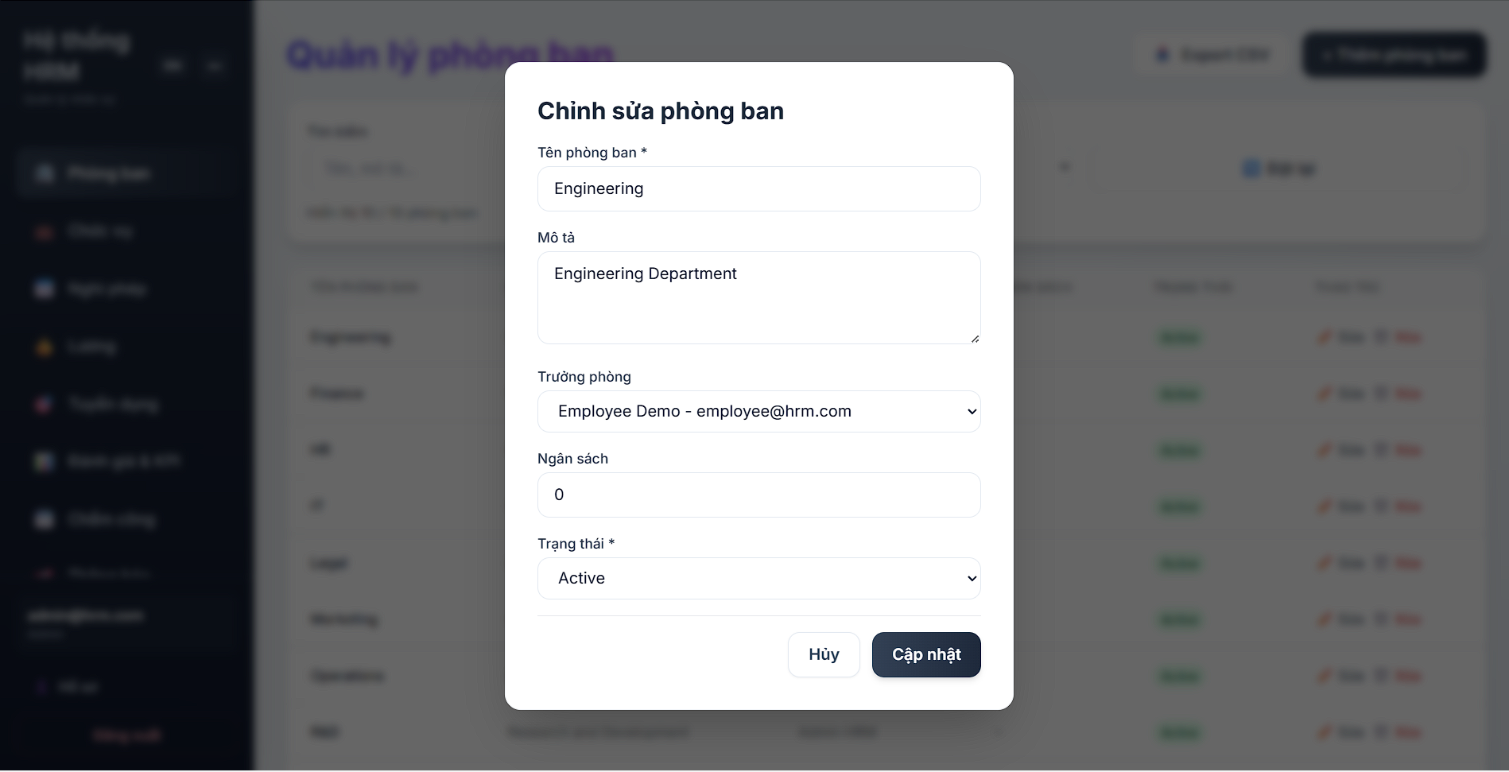
Picture 30: Display Edit Department Information Form

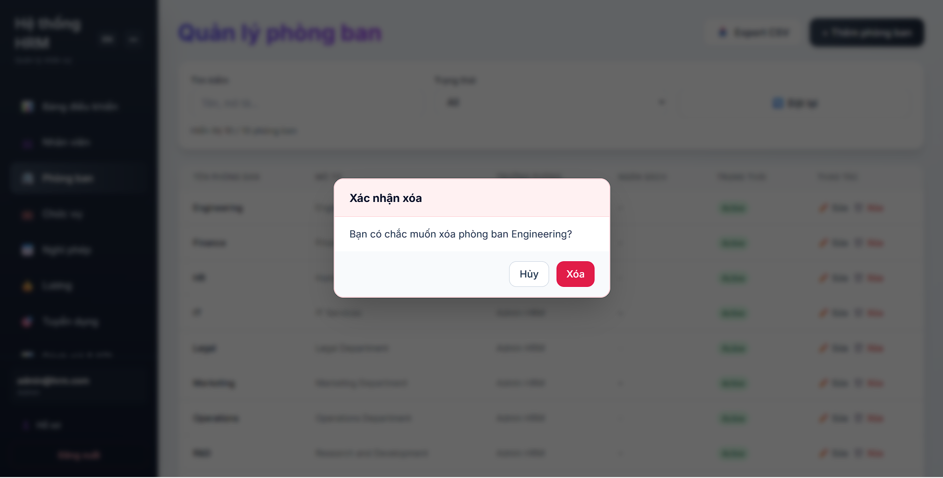
Picture 31: Display Delete Department Option

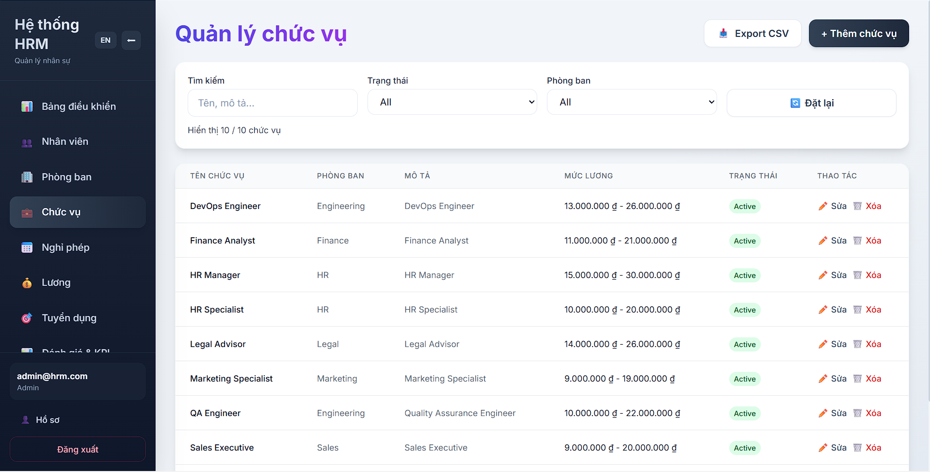
Picture 32: Position Management Main Screen Interface

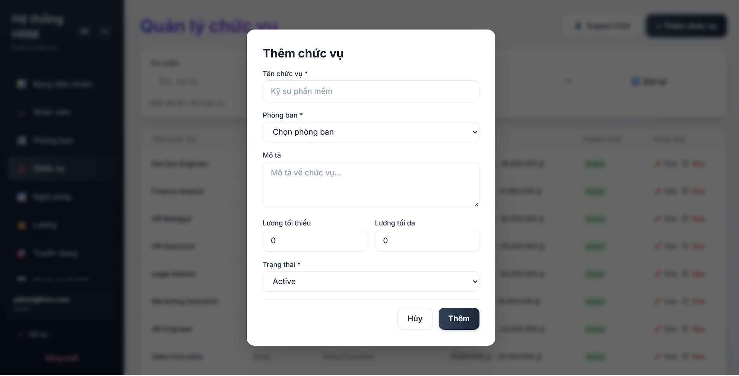
Picture 33: Display Add Position Form
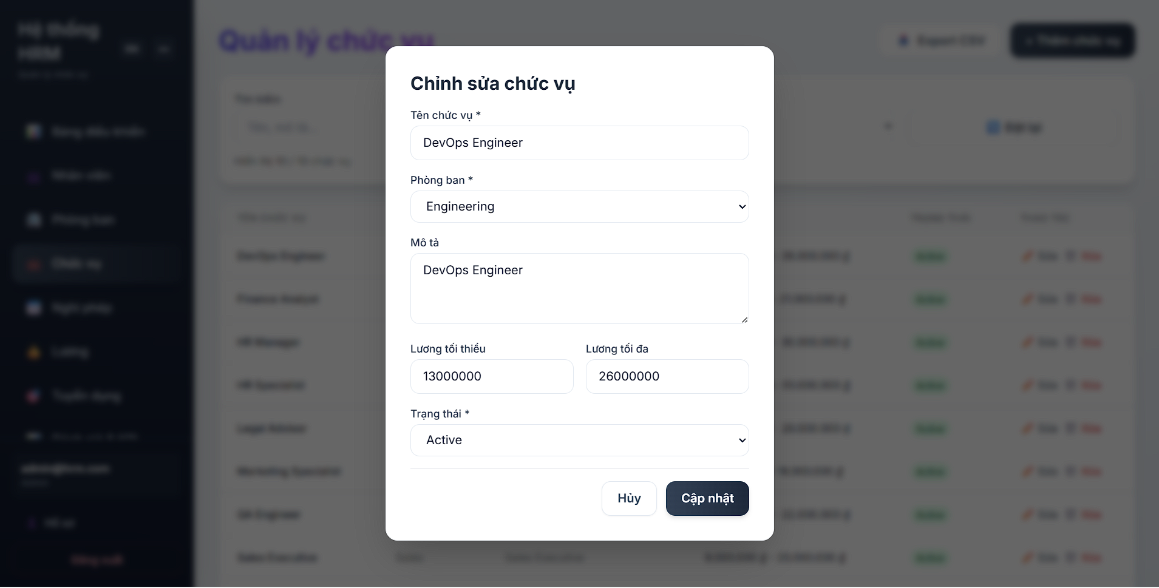
Picture 34: Display Edit Position Information Form

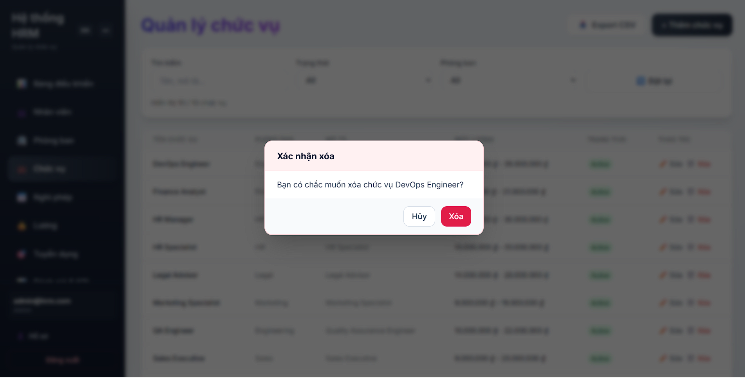
Picture 35: Hiển thị mục Xoá chức vụ

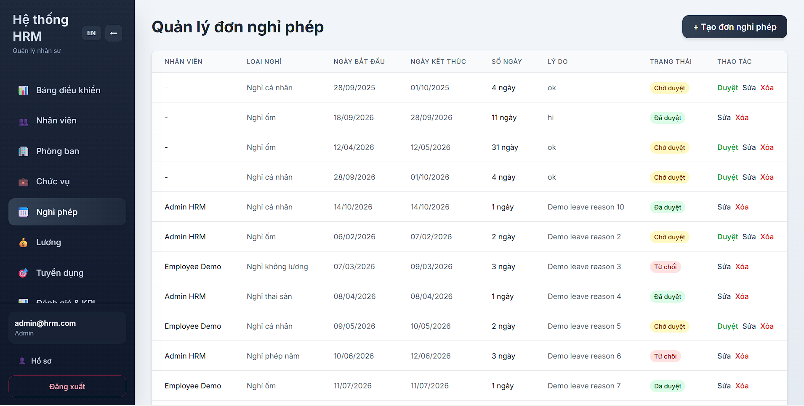
Picture 36: Leave Request Management Main Screen

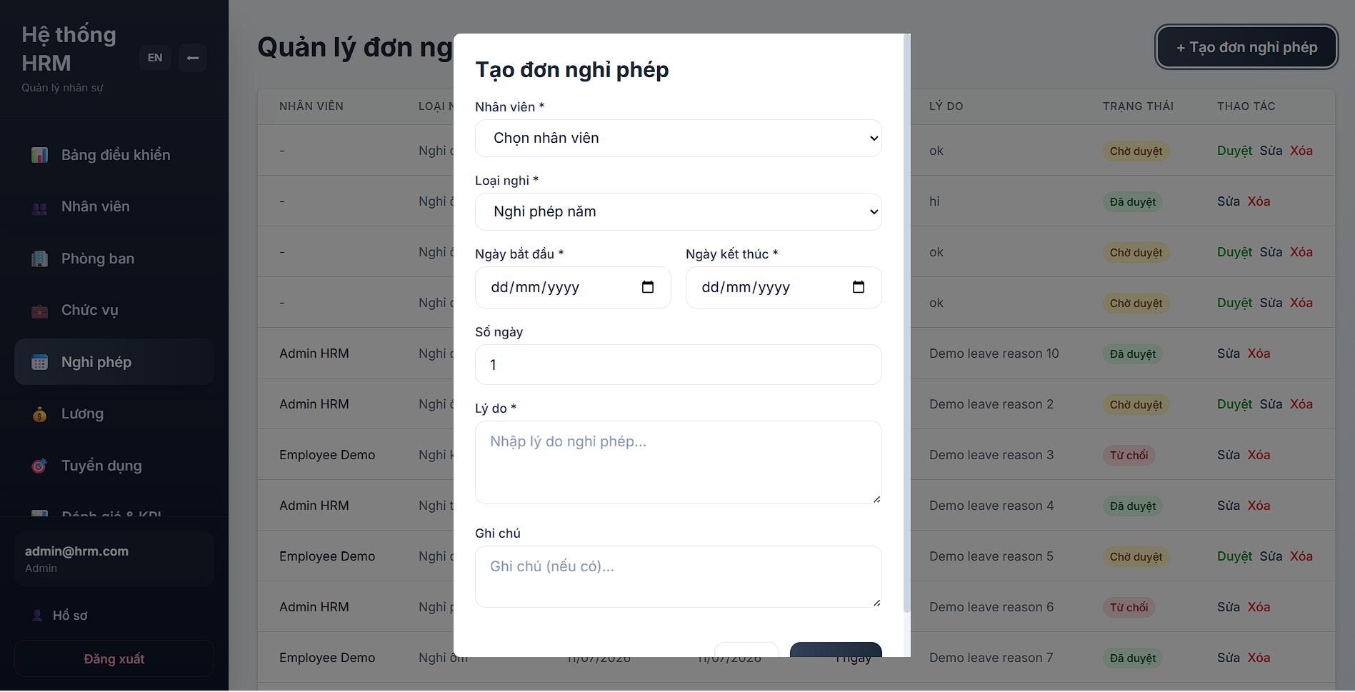
Picture 37: Display Create Leave Request Form

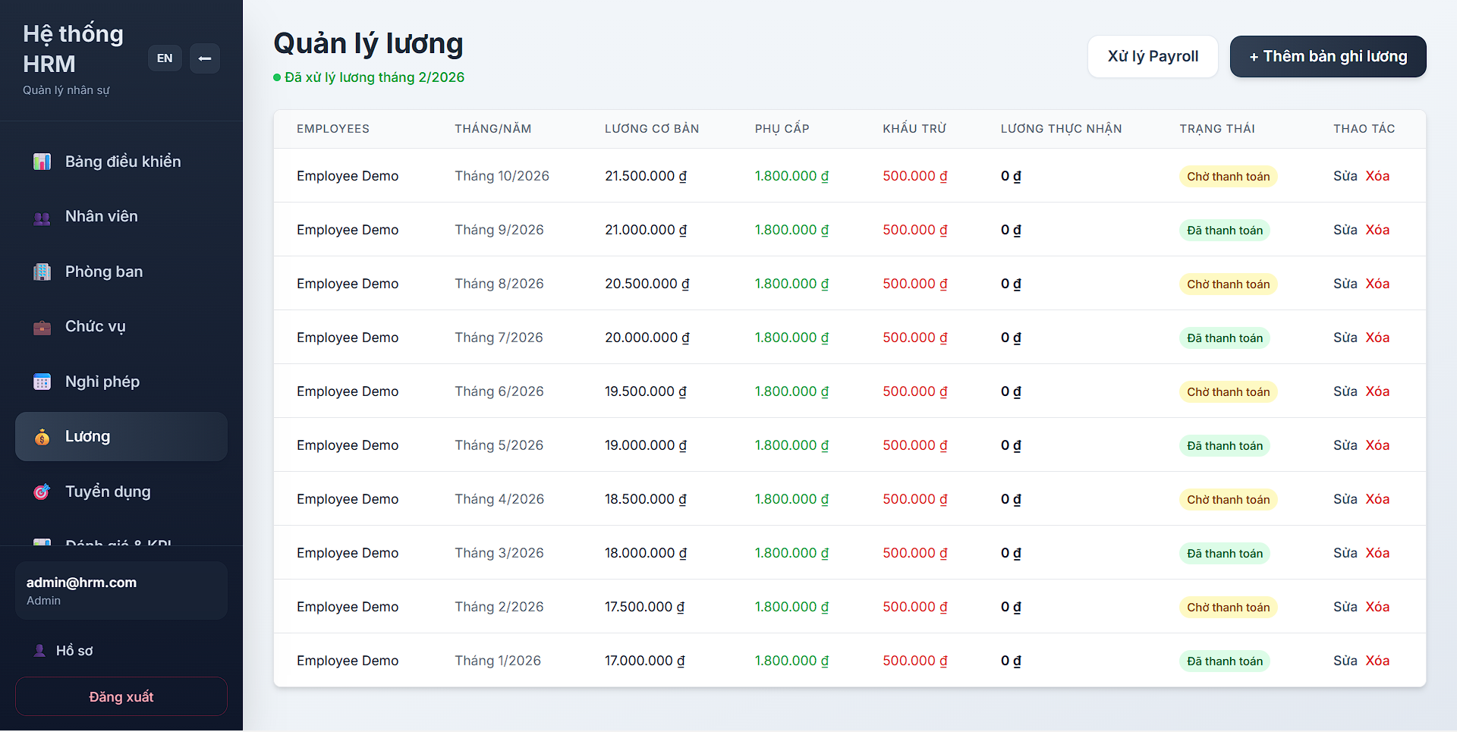
Picture 38: Payroll Management Main Screen

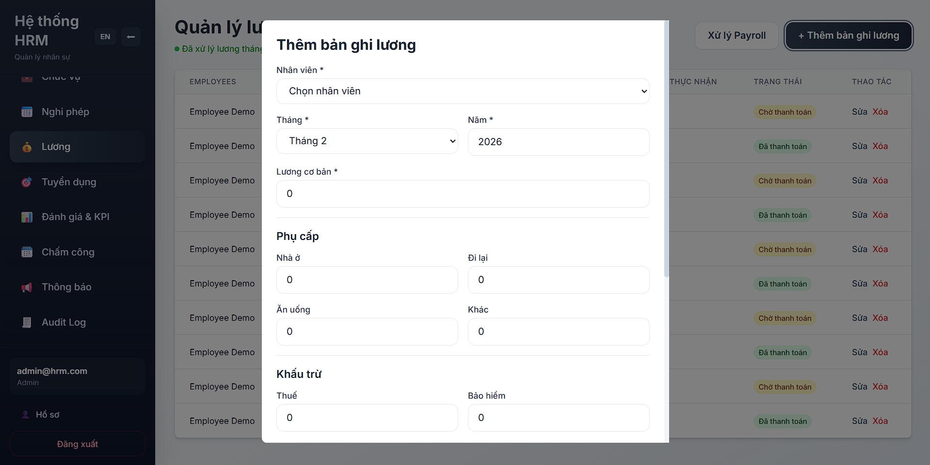
Picture 39: Display Add Payroll Record Form

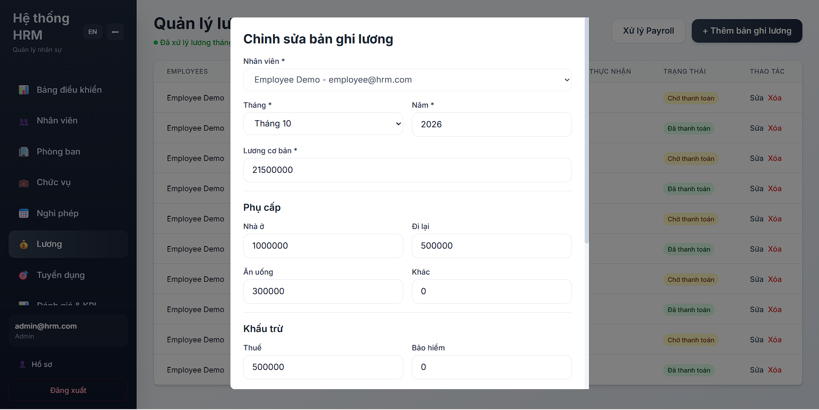
Picture 40: Display Edit Payroll Record Form

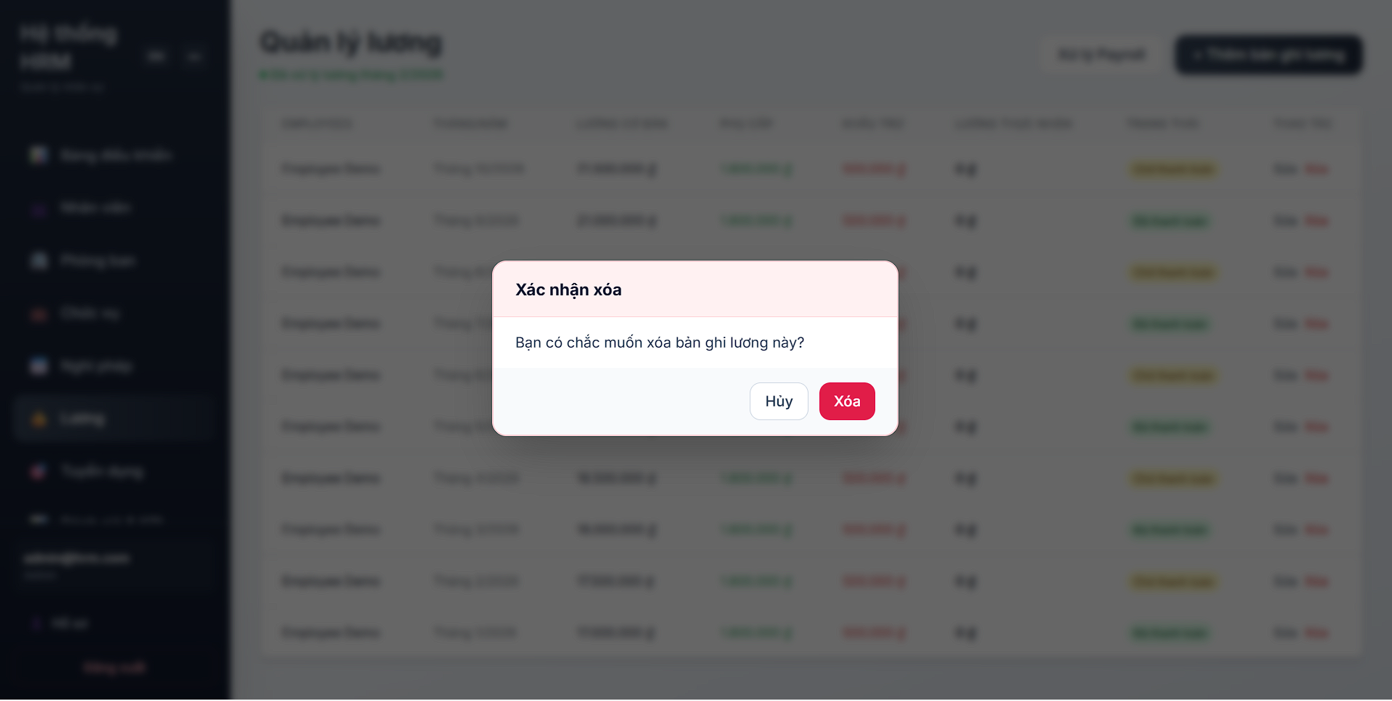
Picture 41: Display Delete Payroll Record Option

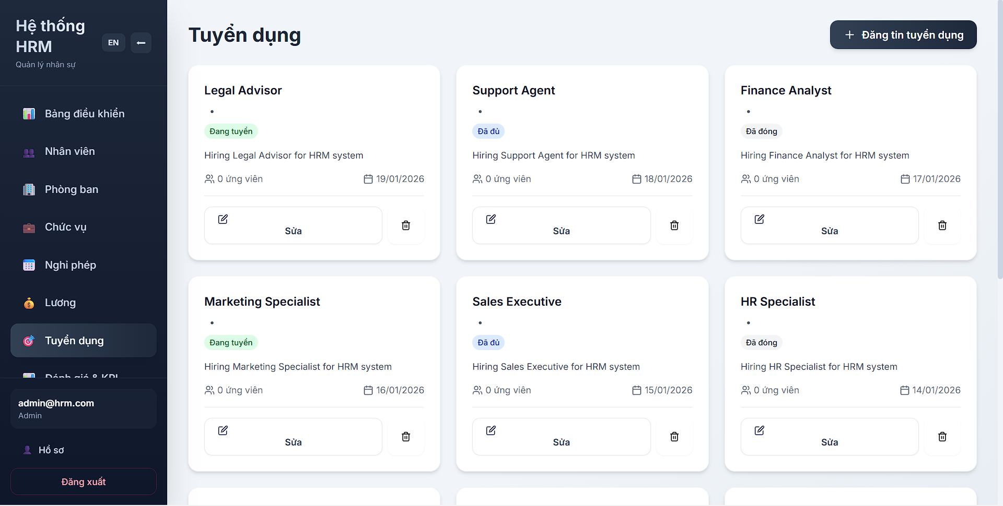
Picture 42: Recruitment Management Main Screen

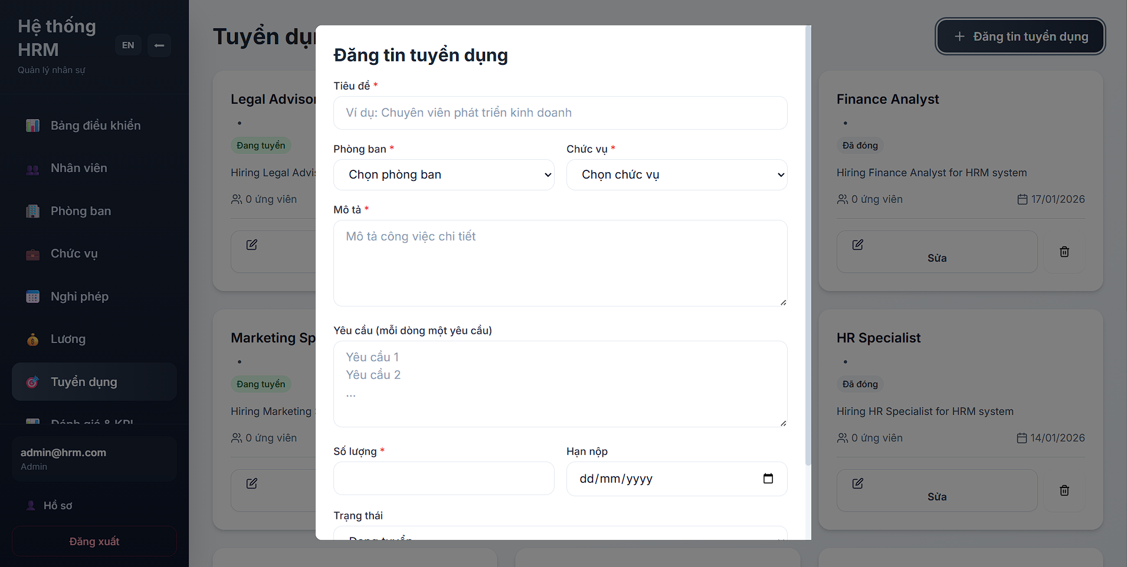
Picture 43: Display Add Recruitment Information Form

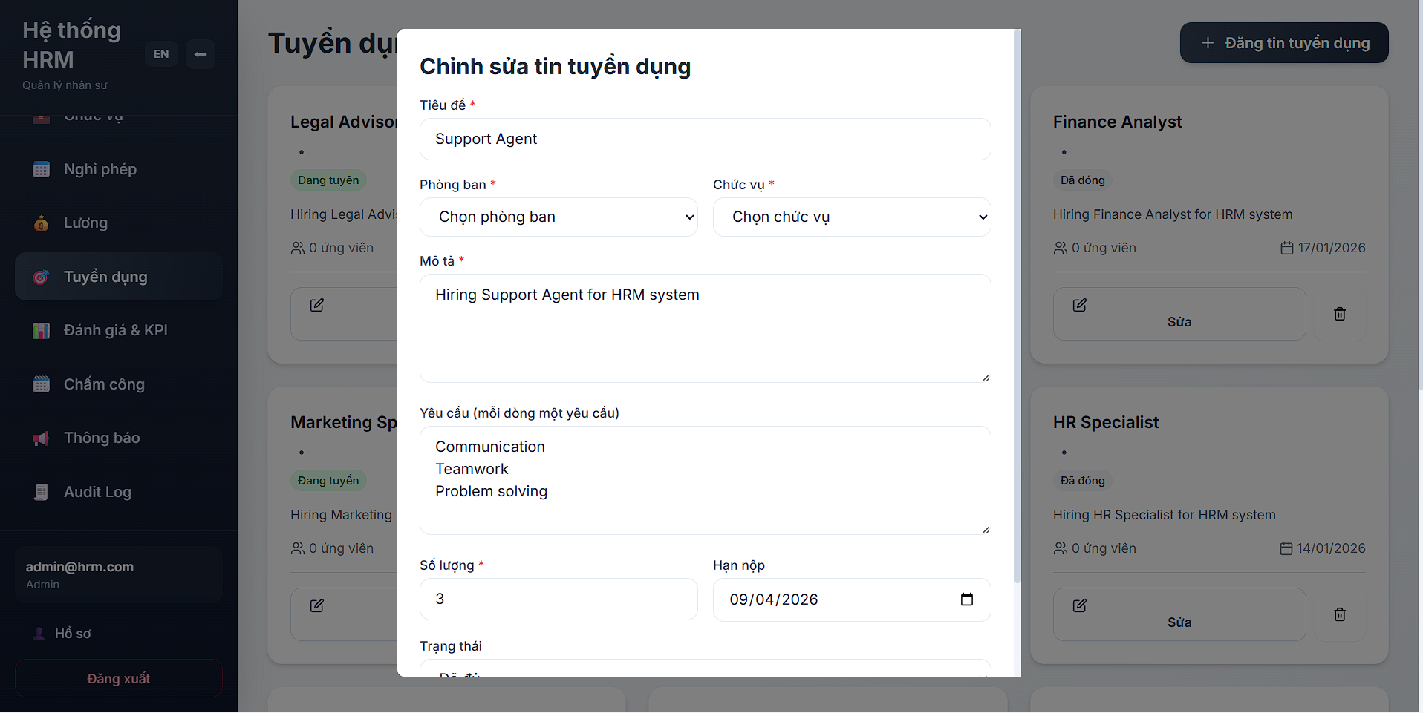
Picture 44: Display Edit Recruitment Information Form

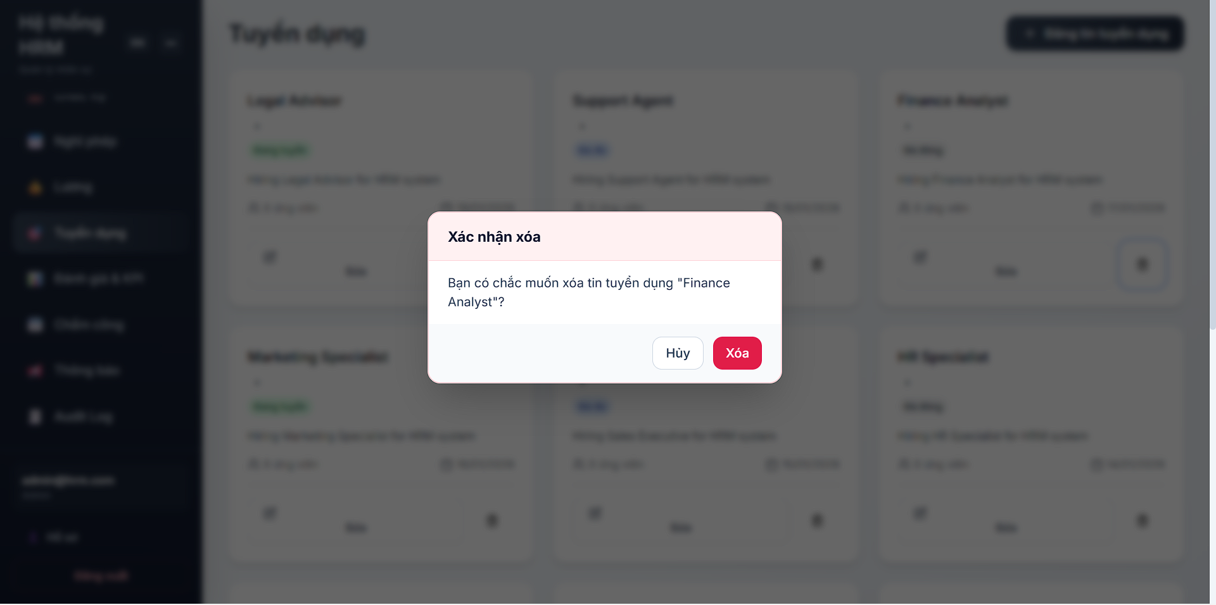
Picture 45: Display Delete Recruitment Post Option

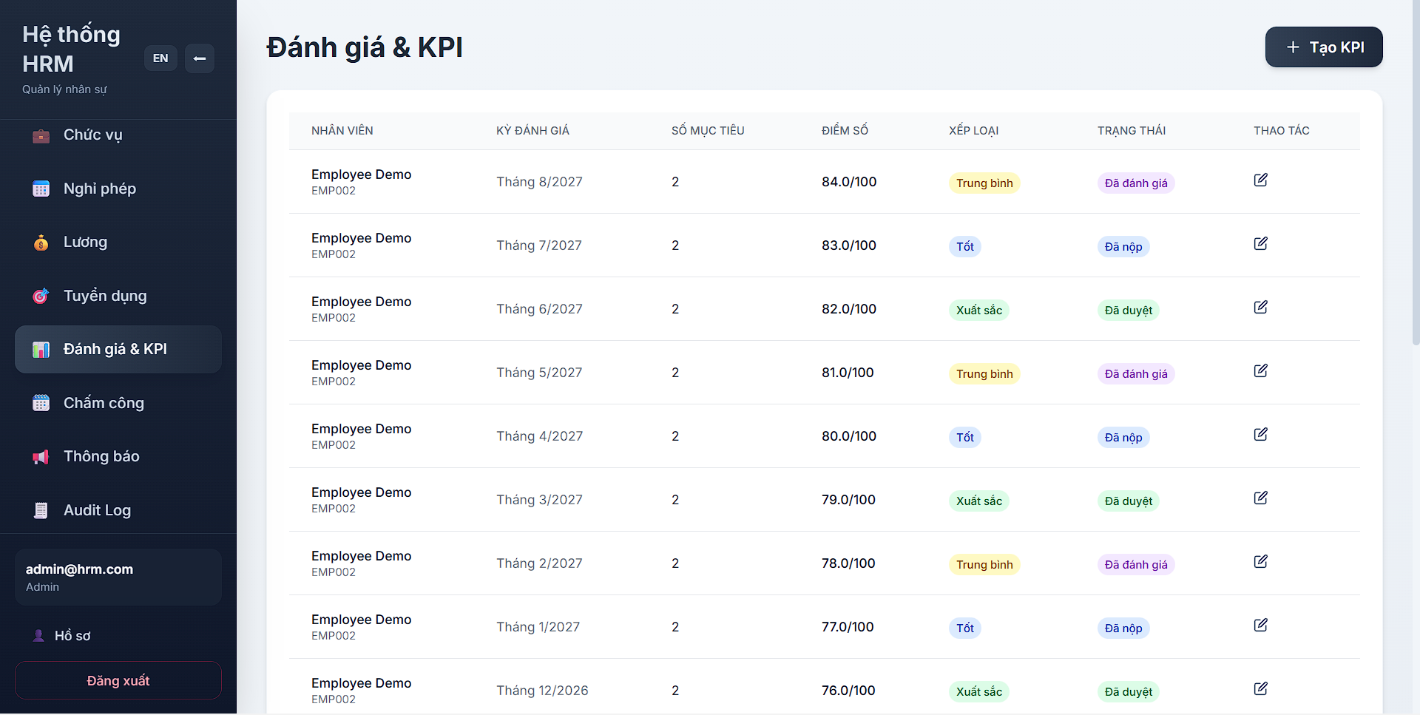
Picture 46: Performance Evaluation & KPI Main Screen

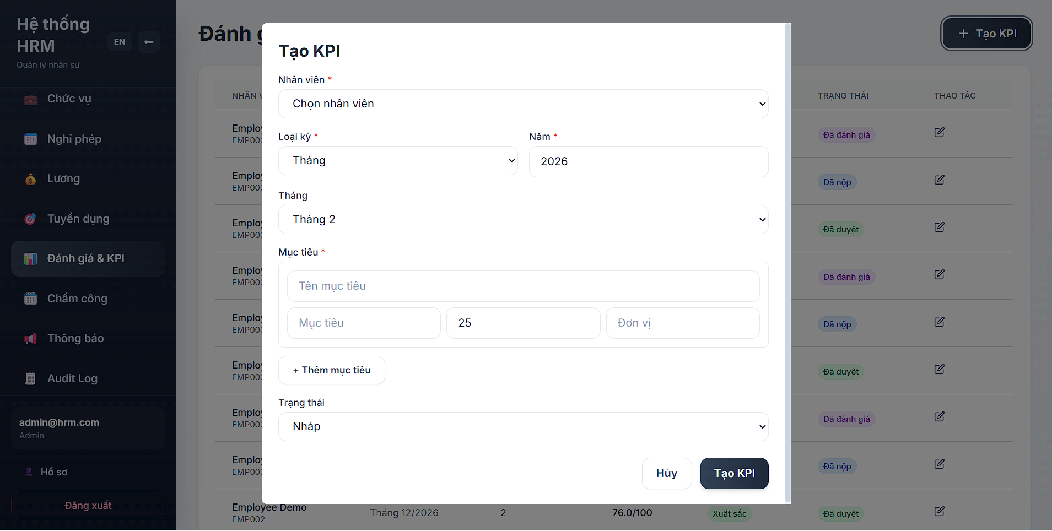
Picture 47: Display Create KPI Form

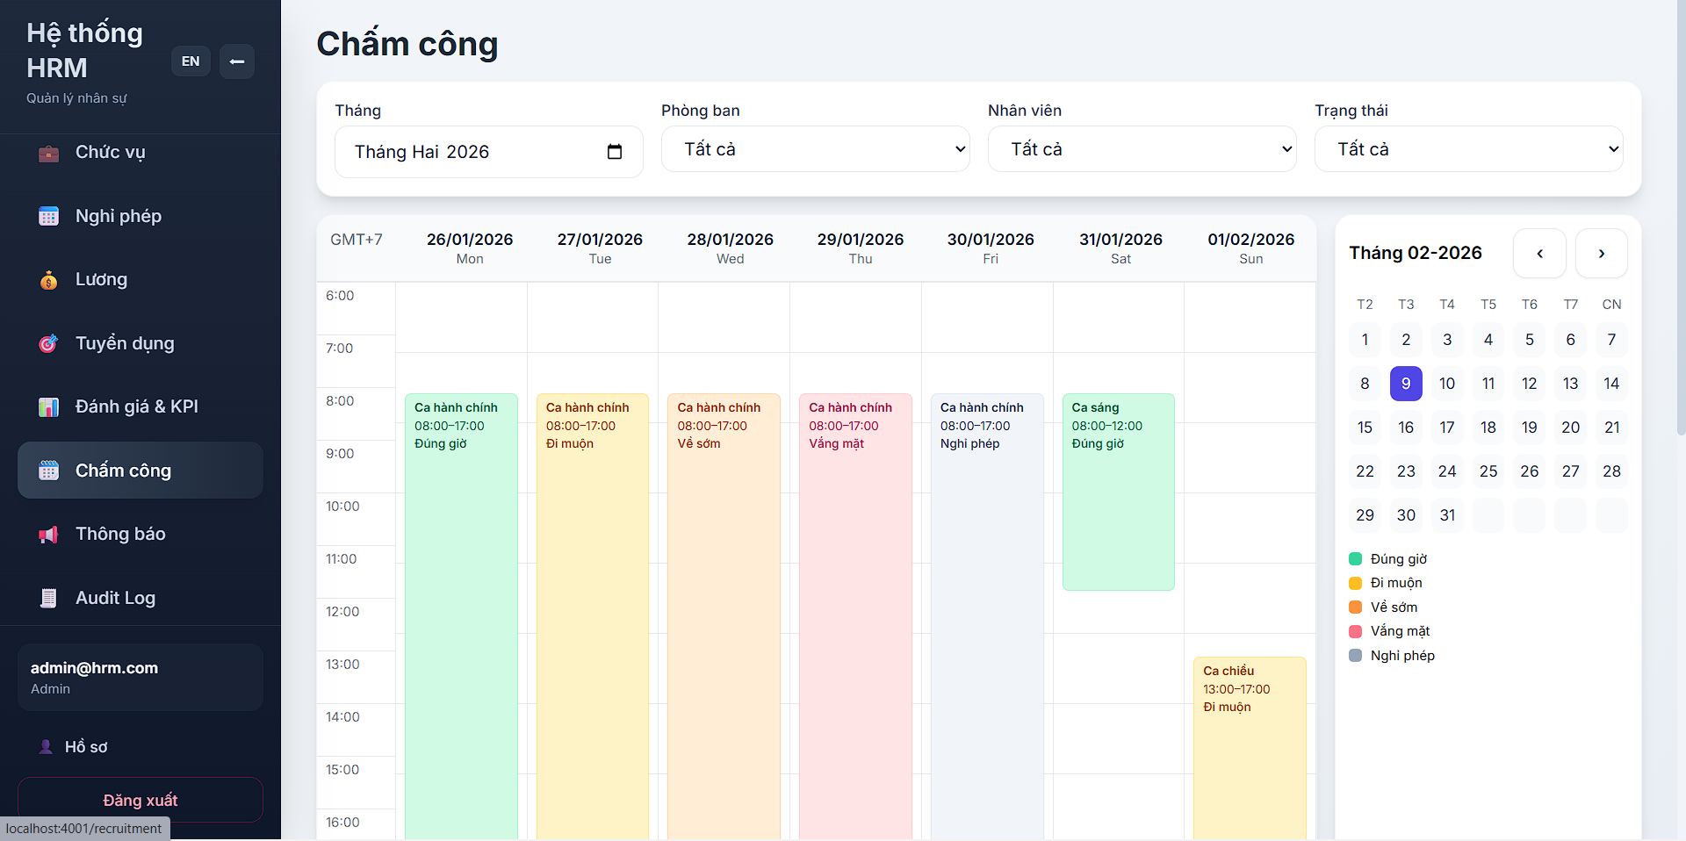
Picture 48: Attendance/Timekeeping Main Screen

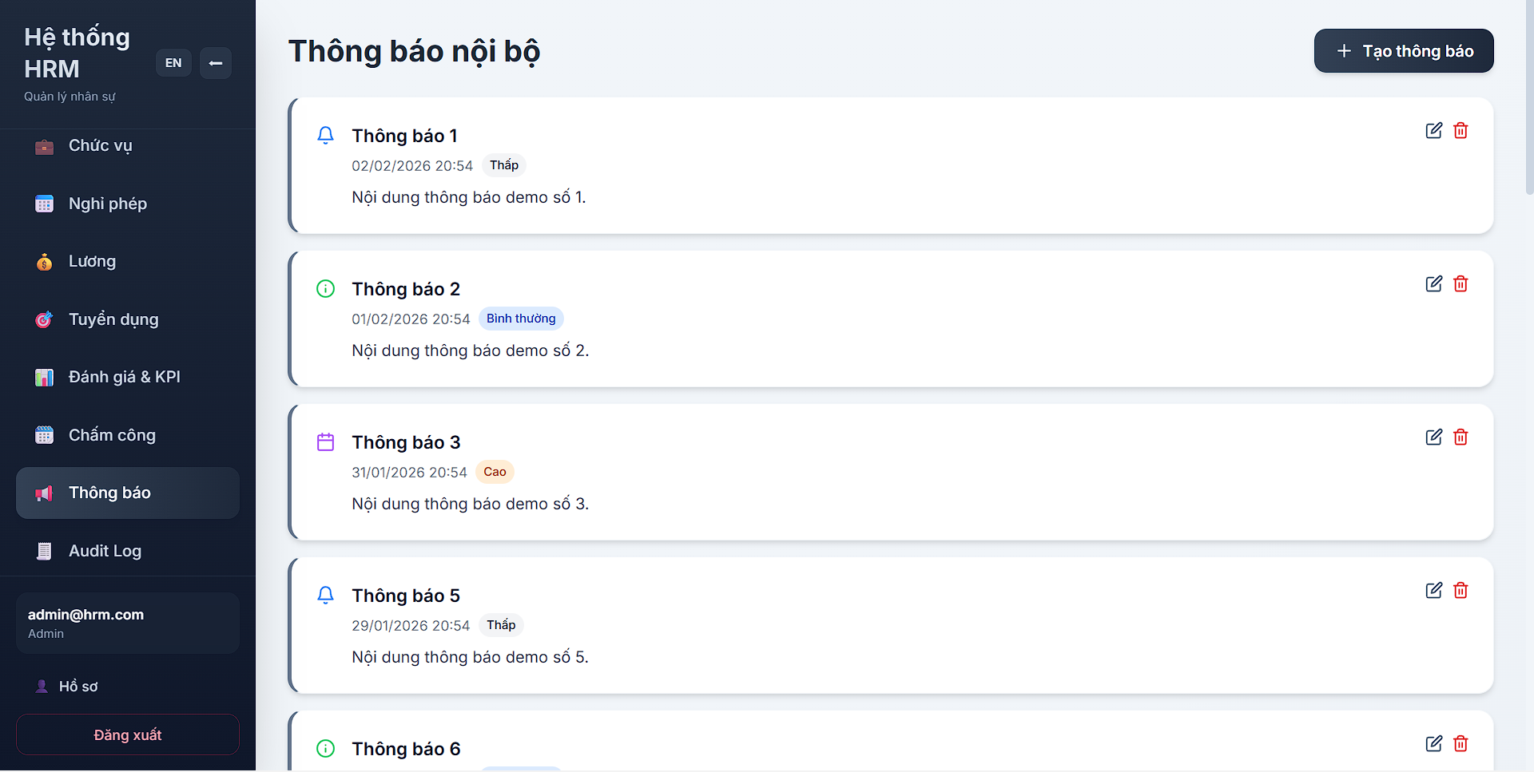
Picture 49: Internal Announcement Main Screen
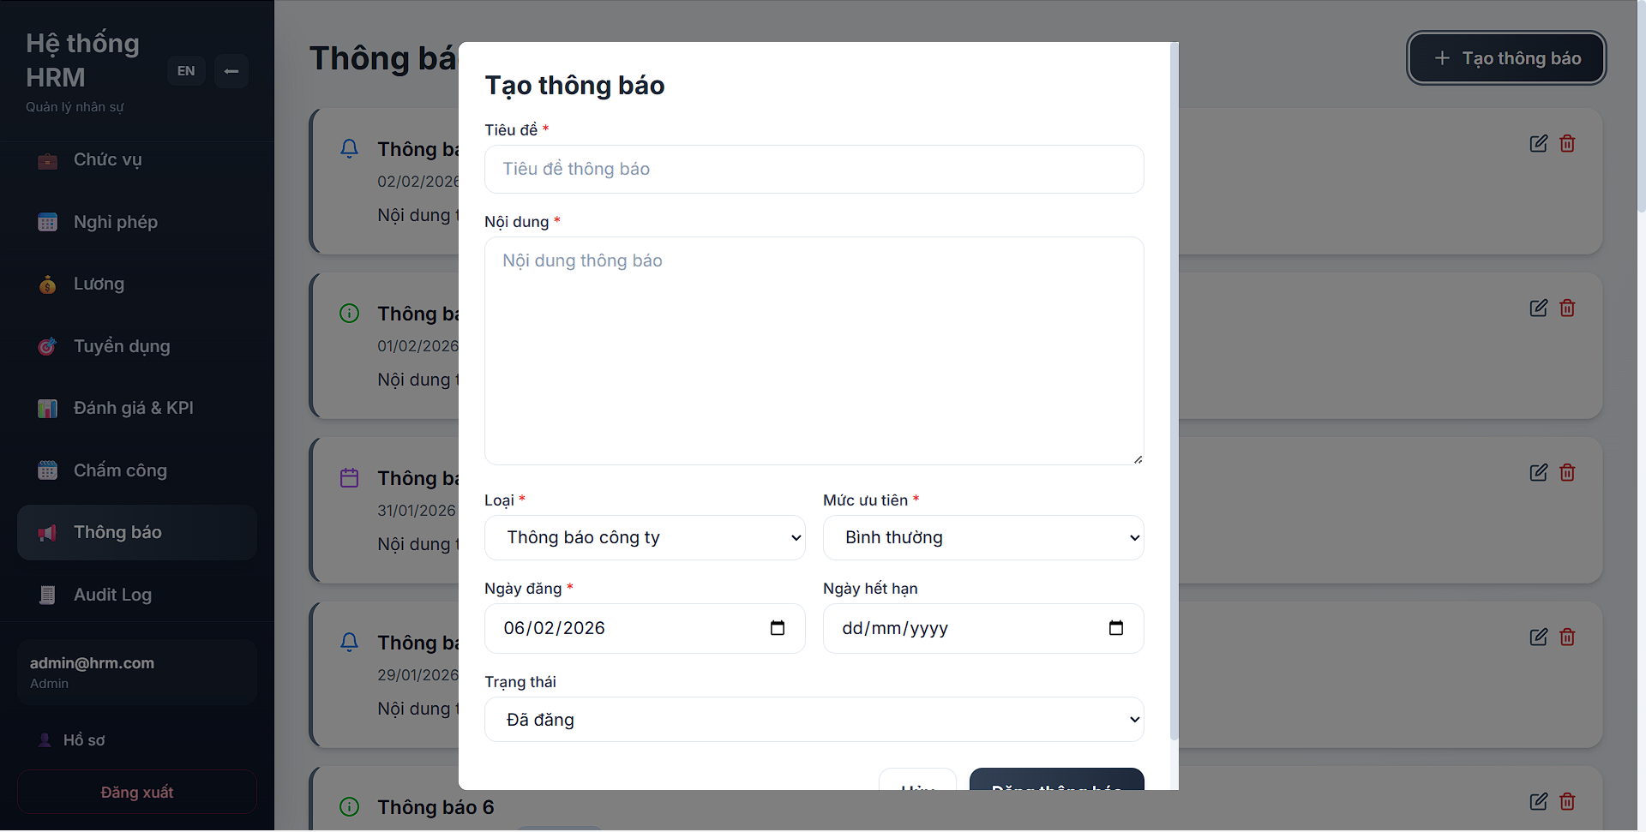
Picture 50: Display Create Announcement Form

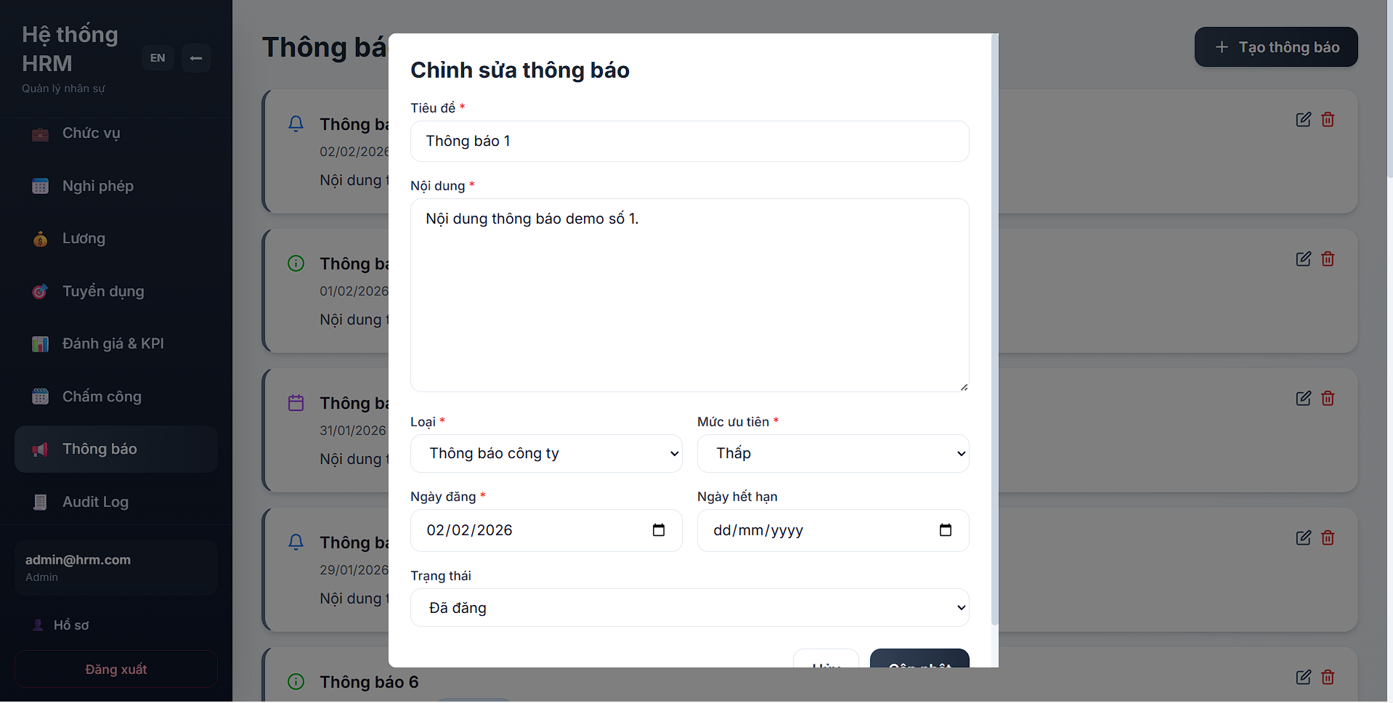
Picture 51: Display Edit Announcement Form

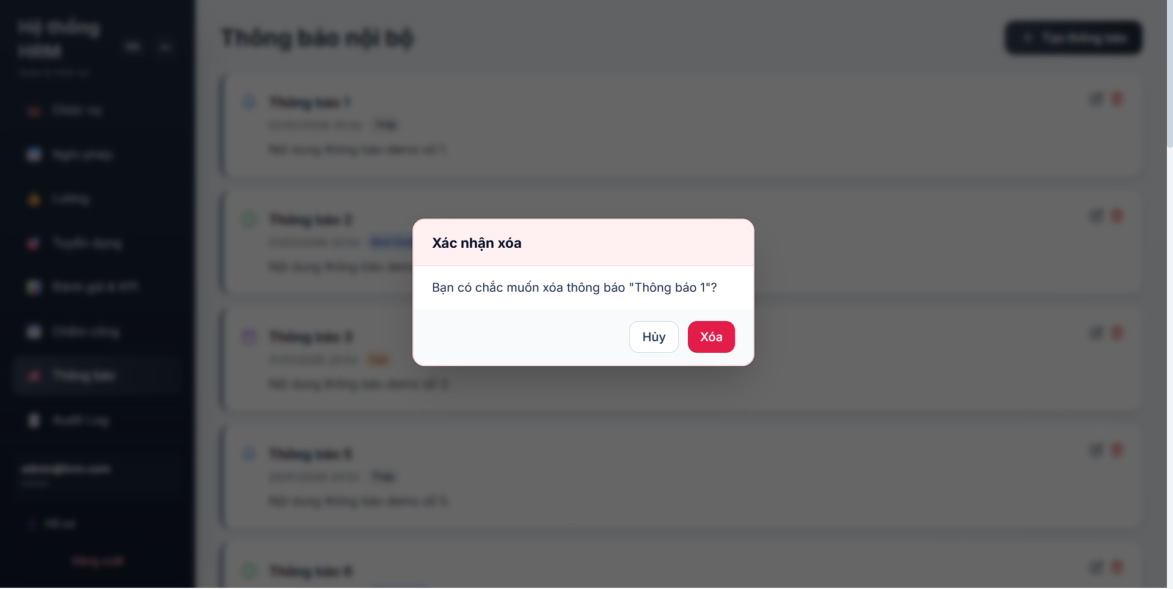
Picture 52: Display Delete Announcement Option

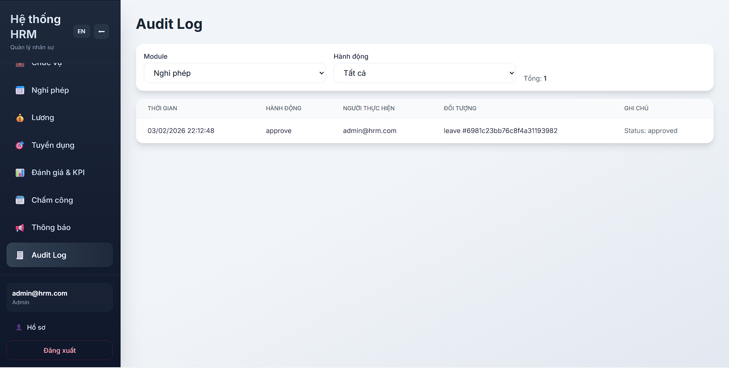
Picture 53: Audit Log Main Screen Interface

VI. Conclusion & Reflection
This project has successfully culminated in the design and implementation of a robust Human Resource Management (HRM) system, leveraging a Microservices Architecture powered by Node.js, Express, and Docker . By decomposing complex HR business logic into autonomous services, the system effectively meets the primary architectural drivers of high scalability, fault isolation, and real-time performance required for modern enterprise governance

6.1. Lessons Learned
- Architectural Efficiency and Domain Decomposition:The transition from a monolithic mindset to a Microservices model proved far more effective for the HRM domain. We learned that defining clear Bounded Contexts for each service-such as isolating the Attendance Service from the Payroll Service-is essential . This separation ensures that high-frequency check-in events during peak hours do not create bottlenecks for resource-intensive salary calculations, maintaining a sub-2-second response time across the platform.
- Data Sovereignty and Distributed Consistency: Adopting a Database per Service strategy with MongoDB successfully eliminated data coupling and enhanced system security . The project highlighted the importance of an API-driven enrichment strategy. By utilizing internal REST calls via the Employee Client instead of traditional database joins, the system achieves data synthesis while strictly adhering to service autonomy and data privacy standards .
- Operational Resilience through Gateway Orchestration: The API Gateway emerged as the critical "nervous system" of the architecture . Beyond simple request routing, we learned the value of centralized traffic management . Implementing Rate Limiting and Circuit Breaker mechanisms proved vital for resilience; these tools ensure that localized failures are contained, preventing cascading effects and allowing the core ecosystem to remain operational during service outages .
- Standardized Security and Traceability:Integrating JWT-based authentication and Bcrypt hashing established a rigorous security baseline for handling sensitive personnel data . Furthermore, the injection of a unique request-id at the Gateway level provided full end-to-end traceability, which is indispensable for debugging and auditing actions within a distributed environment.

6.2. Future Improvements
To further enhance the system's capabilities, the following strategic improvements are proposed:
- Cloud-Native Orchestration with Kubernetes (K8s): While Docker Compose provided an excellent baseline, migrating to Kubernetes will enable Horizontal Pod Autoscaling (HPA) . This ensures the system can dynamically manage the surge of 10,000 concurrent users by scaling replicas during peak shifts and reducing them during idle hours to optimize costs.
- Transition to Asynchronous Event-Driven Architecture (EDA): Integrating a message broker like RabbitMQ or Apache Kafka will facilitate asynchronous communication. This transition will improve system throughput by allowing services to emit events (e.g., "Payroll Processed") that are consumed by other modules (e.g., Notifications) without blocking the primary execution flow .
- Implementation of Advanced AI-Driven Analytics: Leveraging the standardized RESTful API structure, an AI module will be integrated for predictive modeling. This will transform raw attendance and KPI data into actionable insights, such as forecasting employee performance trends or identifying potential retention risks before they occur .
- Zero-Trust Security and Service Mesh: Future iterations will aim for a Zero-Trust architecture by implementing a Service Mesh (like Istio). This will provide mutual TLS (mTLS) for all internal service-to-service communication, ensuring that every data "loop" within the system is encrypted and verified

