PHENIKAA UNIVERSITY
PHENIKAA SCHOOL OF COMPUTING

SOFTWARE ARCHITECTURE
LAB 1: REQUIREMENTS ELICITATION $ MODELING

Instructor: Vũ Quang Dũng
Course: Software Architecture – Class N01
Team Members: Group 09
Nguyễn Phương Ngân - 23010450
Đỗ Nguyên Anh Vũ - 23010334

Tháng 12 năm 2025

1. Abstract/Summary

Abstract/Summary The HRM App (Human Resource Management) project aims to develop a centralized personnel management platform, helping to digitize personnel records and automate administrative processes in enterprises. This practice lab focuses on the first and most important step of the software architecture process: Requirements Elicitation and Modeling
In this report, we have performed:
- Detailed documentation of Functional Requirements (FRs) based on the needs of 4 actor groups: Admin, HR Staff, Manager, and Employee.
- Defined quality standards through Non-Functional Requirements (NFRs).
- Analyzed and selected Architecturally Significant Requirements (ASRs).
- Built the system behavior model through UML Use Case Diagrams.

2. Actors
Identifying Actors Based on the system context, the main entities interacting with the software include:

Actor | Role Description
Admin (System Administrator) | Is a mandatory actor, with full power to manage the system. Responsible for managing user accounts, creating departments, assigning permissions, and system configuration (salary, policies).
HR Staff (Human Resources) | Is the central actor using the system the most. Responsible for managing employee records, managing contracts, processing attendance/leave, and processing payroll.
Manager (Department Head) | The creator of approval workflows, playing a very important role. Performs viewing employee lists, approving leave requests, approving overtime, and evaluating employees.
Employee | Accounts for the largest number of users. Uses the application to view/update personal profiles, send leave requests, view attendance history, and view payslips.

3.1 Functional Requirements - FRs
The table below lists the core functions detailed by each actor:

3.1.1 Functions for Admin
ID | Use Case Name (Function) | Behavioral Details & Relationships in HR App
FR-01 | User Management | Admin creates new accounts for new employees, reissues passwords, or locks accounts when employees resign.
FR-02 | Permissions & Departments | Admin establishes organizational structure, creates new departments, and assigns access rights corresponding to each role.
FR-03 | System Configuration | Admin sets global parameters such as: working hour regulations, salary formulas, holidays.

3.1.2 Functions for HR Staff

ID | Use Case Name (Function) | Behavioral Details & Relationships in HR App
FR-04 | Contract Management | HR Staff creates new, renews, or terminates labor contracts. The system stores and alerts about contracts about to expire.
FR-05 | Attendance Processing | HR Staff aggregates data from timekeepers, checks for abnormal cases (late arrival, early departure) to finalize monthly attendance.
FR-06 | Payroll Calculation | HR Staff performs monthly salary calculations based on pre-configured formulas (base salary + allowances - deductions).

3.1.3 Functions for Manager

ID | Use Case Name (Function) | Behavioral Details & Relationships in HR App
FR-07 | Approve Leave Requests | Department head receives notification, views the employee's reason for leave, and performs "Approve" or "Reject" actions.
FR-08 | Approve Overtime | Department head reviews overtime (OT) requests from employees to confirm the extra hours calculated.
FR-09 | Employee Evaluation | Periodically, the department head accesses the system to evaluate work productivity or KPIs for employees under their management.
FR-10 | View Employee List | Department head has the right to view the list and work profiles (excluding detailed salary) of all employees in the department.

3.1.4 Functions for Employee

ID | Use Case Name (Function) | Behavioral Details & Relationships in HR App
FR-11 | Manage Personal Profile | Employees access the system to view their information and update allowed data (address, phone number).
FR-12 | Register Leave | Employees create leave requests. The system records the type of leave, time, reason, and automatically forwards it to the Manager for approval.
FR-13 | Track Attendance | Employees review daily check-in/check-out history or monthly history to cross-check actual working days.
FR-14 | View Payslip | During the pay period, employees access to view detailed payslips (income, deductions) and download if needed.

3.2 Non-Functional Requirements – NFRs
The quality attributes of the system:

ID | Criteria Group | Specific Criteria & Technical Constraints
NFR-01 | Performance | 1. Response Time: Frequent user operations (Check-in/Check-out, download payslip) must respond under 1.0 second on stable 4G/WiFi. Payroll process for the entire company must complete within < 5 minutes.  2. Concurrency: System must support at least 2,000 employees performing attendance check-in simultaneously during peak hours (08:00 - 08:30 AM) without network congestion or crashing.
NFR-02 | Reliability (Availability & Reliability) | 1. Uptime: Commit to 99.9% system uptime during business hours to ensure attendance is not interrupted.  2. Error Recovery & Backup: Attendance and payroll data must be automatically backed up daily at 00:00. Zero Data Loss mechanism: App must be capable of saving attendance data offline (when network is lost) and automatically sync when connection returns.
NFR-03 | Security | 1. Sensitive Data Security: Data fields such as: Salary, Bank Account Number, ID Number must be encrypted in the Database (e.g., AES-256).  2. Access Control (RBAC): Apply strict permission model. E.g., Manager can view employee profiles but cannot view the "Salary" field. Only authorized HR Staff and the Employee themselves can view salary.

3.3 Architecturally Significant Requirements – ASRs
This is the most important part of the course, identifying requirements that directly affect system design decisions.

ID | Requirement Group | Architectural Constraint Details
ASR-01 | Deployment Platform | 1. Mobile App: Mandatory for Employee actors to perform attendance via GPS/Wifi and receive instant notifications (Push Notification). Support iOS and Android.  2. Web Portal: For Admin and HR Staff to perform complex operations on large screens.
ASR-02 | Legal Compliance | Dynamic Business Logic: Modules for payroll, social insurance, and personal income tax must be designed as Configurable Formulas to be easily updated when Vietnamese Labor Law changes without needing to edit code (Hard-code).
ASR-03 | Scalability | Modular/Microservices Architecture: System needs to separate modules (Attendance separate, Payroll separate) to be able to scale independently when company size increases from 100 to 10,000 employees.

4. UC Modeling
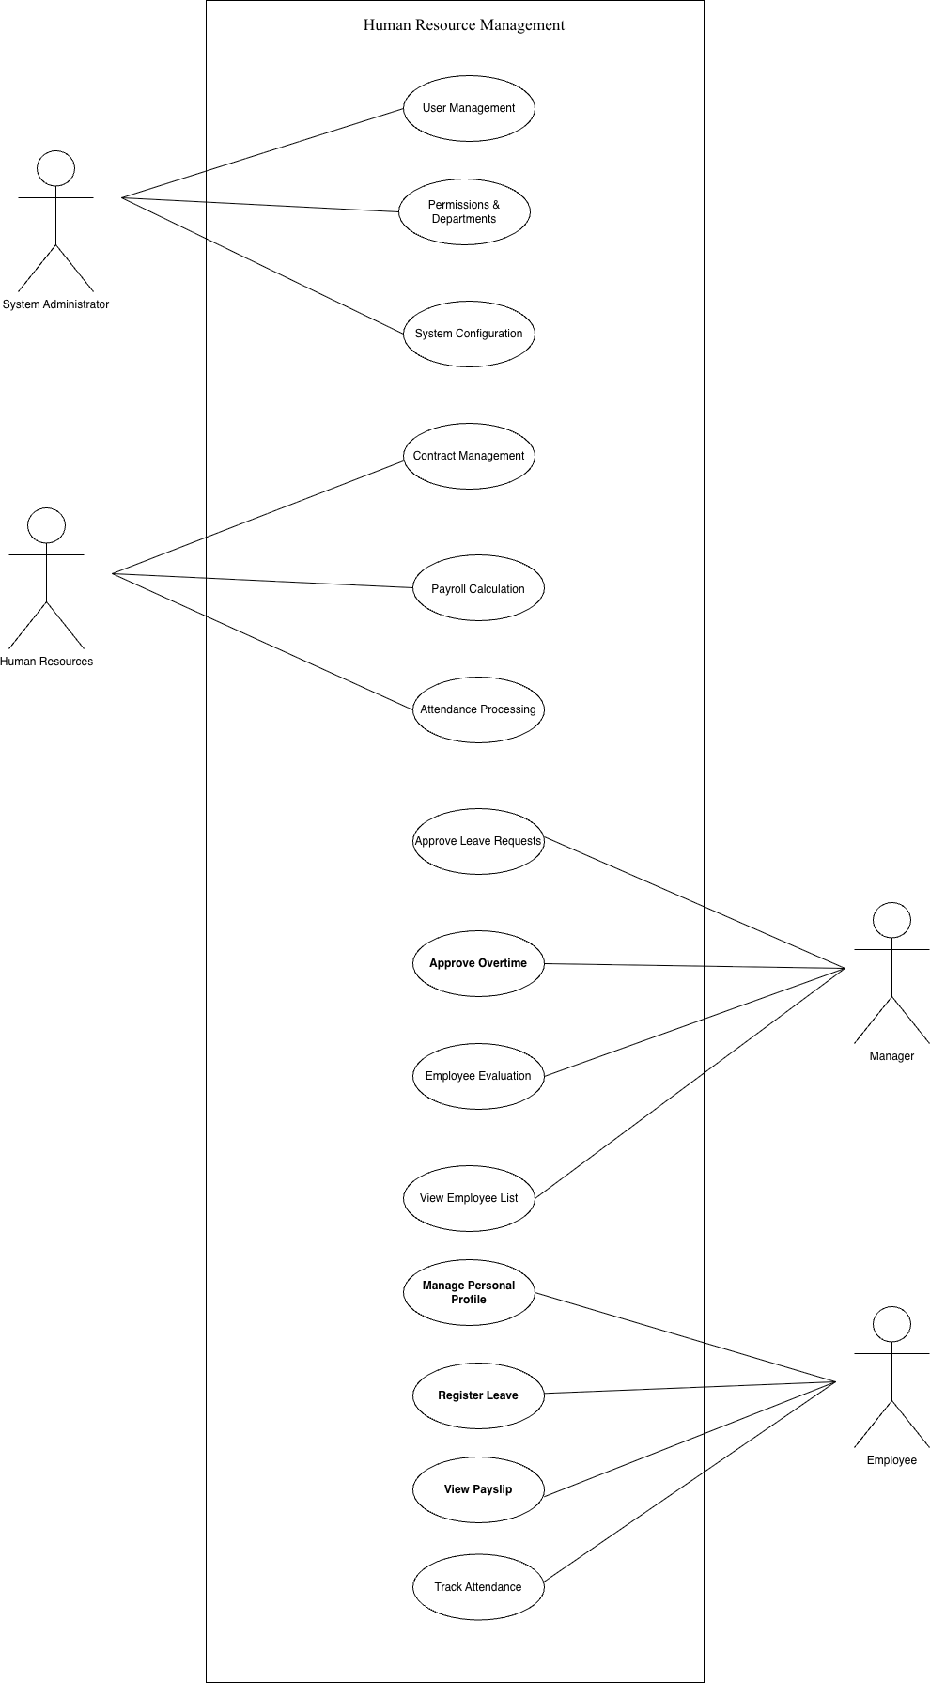

5. Structural design
Structural Design Based on the requirements elicitation results of Lab 1, we determined the direction for Lab 2: Layered Architecture Design.
5.1. Problem statement
Problem Statement The problem posed is to design a human resource management system that ensures both sensitive salary data security (ASR-Security) and easy maintenance when there are changes in Labor Law or tax formulas (ASR-Compliance). The Layered Architecture pattern is selected as the structural solution.
5.2. Impact of ASRs on Layered Design
- Impact of ASRs on Layered Design ASR-Compliance (Compliance/Modifiability) → Dependency Rule: To ensure that changing salary/insurance formulas does not affect the user interface, the architecture will be divided into 4 layers: Presentation, Business, Persistence, Database. The rule is that the upper layer only calls down to the lower layer; the lower layer does not know about the upper layer. Payroll logic will be completely isolated at the Business Layer.
- ASR-Security (Security) → Logic at Business Layer: Permission check logic (RBAC) – for example: Manager cannot view employee salary – will be placed strictly at the Business layer. This ensures that even if hackers bypass the interface (Presentation), they cannot call directly into the Database to get the payroll table without the rights of HR Staff or the valid account owner.

6. Conclusion
Conclusion The Lab 1 practice has completed defining the scope of the HRM App project through a detailed SRS document set and Use Case models with 4 main actors (Admin, HR Staff, Manager, Employee). Early identification of ASRs regarding Security (salary data) and Scalability (when employee numbers increase) is a key preparatory step, affirming the necessity of applying Layered Architecture in the next design phase.

