PHENIKAA UNIVERSITY
PHENIKAA SCHOOL OF COMPUTING

SOFTWARE ARCHITECTURE
LAB 4: MICROSERVICES DECOMPOSITION & COMMUNICATION

Instructor: Vũ Quang Dũng
Course: Software Architecture – Class N01
Team Members: Group 09
Nguyễn Phương Ngân - 23010450
Đỗ Nguyên Anh Vũ - 23010334

1. Objectives
- The primary objective of this laboratory session is to transition the HRM App project from the Monolithic Layered Architecture (designed in Lab 2 and implemented in Lab 3) to a Microservices Architecture.
- This architectural change is driven by the ASR-03 (Scalability) requirement identified in Lab 1, which states: "The system needs to separate modules (Attendance separate, Payroll separate) to be able to scale independently when company size increases to 10,000 employees.".

2. Technology & Tool Installation
The following tools are used to perform the architectural design and documentation tasks for this lab:
Tool | Purpose & Usage Details
draw.io (Diagrams.net) | Used to design the System Context Diagram (C4 Level 1) and Communication Strategy maps. We specifically utilize the web-based version with the C4 standard shape extension to visualize the boundaries between the HRM System, its Users (Actors), and External Systems (Email, GPS).
Documentation Tools (Word/Markdown) | Used to draft the Service Contracts (API Specifications) and the final report. As this lab focuses on architectural design rather than implementation ("No Coding Required"), we use these tools to formally define the HTTP Methods and JSON Data schemas for key services (like Payroll) before actual coding begins.

3. Activity Practice 1: Decomposition by Business Capability
Goal: Identify clear, independent microservices based on the business functions of the HRM App.
3.1. Microservice Decomposition Table

Based on the Functional Requirements (FRs) defined in Lab 1, Group 09 has decomposed the system into 5 core services:

Business Capability | Proposed Microservice | Data Owned (Entities) | Rationale (Mapping from Lab 1 FRs)
Identity & Access Management | Identity Service | User Accounts, Roles, Permissions, Tokens | Handles FR-01 (User Management) and FR-02 (Permissions). Manages authentication and RBAC.
Employee Management | Employee Service | Employee Profiles, Contracts, Departments | Handles FR-04 (Contract Management) and FR-11 (Manage Profile). The central source of truth for staff data.
Attendance Tracking | Attendance Service | Time Logs (Check-in/out), Overtime Requests | Handles FR-05 (Attendance Processing) and FR-13 (Track Attendance). Must handle high concurrency during peak hours (8:00 AM).
Payroll Management | Payroll Service | Payslips, Salary Formulas, Tax Config | Handles FR-06 (Payroll Calculation) and FR-14 (View Payslip). Contains complex logic and sensitive data.
Leave Management | Leave Service | Leave Requests, Leave Balances | Handles FR-07 (Approve Leave) and FR-12 (Register Leave). Manages the workflow for time-off requests.

3.2. External Dependencies
The HRM Microservices system must interact with the following external systems, as identified in the ASRs and NFRs of Lab 1:
- Email/Notification Service: Required to send asynchronous notifications for payslips and leave approvals (ASR-01).
- GPS/Location Service: Required for the Mobile App to validate employee location during check-in (ASR-01).

4. Activity Practice 2: Defining Service Contracts
Goal: Establish public interfaces (API Endpoints). We have selected the Payroll Service for detailed documentation, as it contains the core business logic implemented in Lab 3.
4.1. Payroll Service API Specification
Based on the SalaryController logic from Lab 3 , adapted for a Microservice REST interface:

Endpoint | HTTP Method | Description | Data Returned
/api/salaries | GET | Retrieve a list of payslips. Supports filtering by month, year, and employeeId. | JSON List of Salary objects (Summary view).
/api/salaries/{id} | GET | Retrieve full details of a specific payslip by ID. | Single Salary object (includes Base Salary, Allowances, Deductions, Net Salary).
/api/salaries/calculate | POST | Trigger the monthly payroll calculation process for all employees. | JSON Status: { "jobId": "PAY-101", "status": "PROCESSING" }
/api/config/formulas | PUT | Update salary/tax formulas dynamically (Compliance ASR). | JSON: { "success": true, "updatedAt": "timestamp" }

4.2. Inter-Service Communication Rule
Scenario: When the Payroll Service calculates salary (FR-06), it requires attendance data (e.g., total working days, overtime hours).
Constraint: The Payroll Service cannot access the Attendance Database directly.
Solution: It must call the Attendance Service via an internal API:
GET http://attendance-service/api/summary?employeeId=...&month=...

5. Activity Practice 3: Communication Strategy
Goal: Determine when to use Synchronous vs. Asynchronous communication to satisfy the Performance (NFR-01) and Reliability (NFR-02) requirements from Lab 1.

Interaction | Service Flow | Communication Type | Rationale (Based on Lab 1 NFRs)
Employee Login | App $\rightarrow$ Identity Service | Synchronous (HTTP) | UX Requirement: Users need immediate feedback to access the system.
View Payslip (FR-14) | App $\rightarrow$ Payroll Service | Synchronous (HTTP) | NFR-01 (Performance): Response time must be under 1.0 second. Employees expect to see their salary immediately upon request.
Send Approval Email | Leave Service $\rightarrow$ Email Service | Asynchronous (Message Queue) | Non-blocking: Sending an email (SMTP) is slow. Using a queue (e.g., RabbitMQ) ensures the Manager's "Approve" button responds instantly, while the email is sent in the background.
Bulk Payroll Calculation | HR Portal $\rightarrow$ Payroll Service | Asynchronous (Message Queue) | Long-running Task: Calculating salary for 10,000 employees takes time (< 5 mins per NFR-01). Async processing prevents HTTP timeouts and system blocking.

6. Activity Practice 4: C4 Model (Level 1: System Context)
Goal: Visualizing the HRM System boundaries and its interactions with Users and External Systems.

6.1. Diagram Elements
- System: HRM Microservices System.
- Actors: Employee, Manager, HR Staff, Admin.
- External Systems: Email Service, GPS Service.
6.2. System Context Diagram

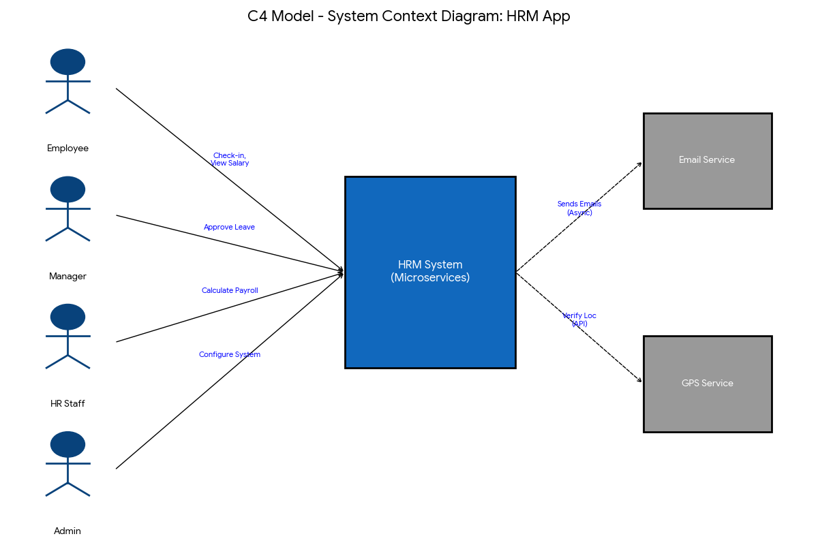

Diagram Description:

- User Group (Actors):
- Employee: Sends requests to Check-in and View Payslips (FR-13, FR-14).
- Manager: Sends requests to Approve Leave applications (FR-07).
- HR Staff: Sends requests to trigger the Monthly Payroll Calculation (FR-06).
- Admin (System Administrator): Accesses the system to configure critical parameters (such as salary formulas, holidays) and manage user permissions (User/Role Management).
- HRM System (System of Interest): Receives requests from Actors via the API Gateway, processes business logic across microservices, and invokes external systems when necessary.
- External Systems:
- Email Service: Receives commands from the HRM System to send notification emails (Asynchronous/SMTP).
- GPS Service: Provides location verification data to the HRM System during employee check-in (Synchronous/API).

7. Conclusion
This report presents a comprehensive architectural framework for the migration of the HRM Application to a Microservices architecture. By decoupling critical components—specifically the Payroll and Attendance Services—and establishing rigorous API contracts, the design effectively mitigates the Scalability (ASR-03) and Security (NFR-03) constraints identified in the initial requirements analysis. This architectural specification serves as a robust foundation for the subsequent implementation phase.

