PHENIKAA UNIVERSITY
PHENIKAA SCHOOL OF COMPUTING

SOFTWARE ARCHITECTURE
LAB 5: IMPLEMENTING THE MICROSERVICE

Instructor: Vũ Quang Dũng
Course: Software Architecture – Class N01
Team Members: Group 09
Nguyễn Phương Ngân - 23010450
Đỗ Nguyên Anh Vũ - 23010334

1. OBJECTIVES
Lab 5 focuses on the practical implementation of one of the core services: Employee Service – a microservice responsible for managing employee information in the HRM system. This service is fully independent, owns its own data, and exposes a RESTful API, following the principles of Microservices Architecture.
Specific objectives:
- Set up a standalone Flask application dedicated to employee management.
- Implement the Employee Service logic and persistence layer (simulated using a database).
- Expose the defined Service Contract (REST API) for retrieving and searching employee information.
- Test the service in an isolated environment.

2. TECHNOLOGIES AND TOOLS USED

Technology | Purpose | Version
Python 3.x | Main programming language | 3.x
Flask | Lightweight web framework for API development | 3.0.0
Flask-SQLAlchemy | ORM and Flask integration for database | 3.1.1
SQLite | Database for storing employee data | Built-in
Postman/cURL | API testing tools | -

3. IMPLEMENTATION
3.1. Activity Practice 1: Project Setup and Data Modeling
3.1.1. Project Structure
A standalone employee_service directory was created with the following structure:

employee_service/
├── app.py # Main Flask application
├── init_db.py # Script khởi tạo database
├── requirements.txt # Python dependencies
├── setup.bat # Script setup tự động (Windows)
├── run.bat # Script chạy service (Windows)
└── .gitignore # Git ignore file
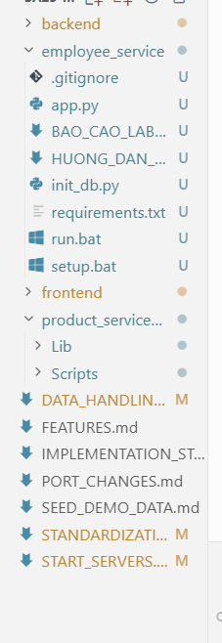

3.1.2. Flask and SQLAlchemy Configuration
File: app.py
from flask import Flask, request, jsonify
from flask_sqlalchemy import SQLAlchemy
from datetime import datetime
app = Flask(__name__)

# Configure SQLite database dedicated only to this service
app.config['SQLALCHEMY_DATABASE_URI'] = 'sqlite:///employees.db'
app.config['SQLALCHEMY_TRACK_MODIFICATIONS'] = False
db = SQLAlchemy(app)

3.1.3. Employee Model Definition
File: app.py - Employee Model
class Employee(db.Model):
"""Employee model representing the Employee entity in the database"""
# The primary key for the Employee Service's database
id = db.Column(db.Integer, primary_key=True)
employee_id = db.Column(db.String(20), unique=True, nullable=False)
first_name = db.Column(db.String(50), nullable=False)
last_name = db.Column(db.String(50), nullable=False)
email = db.Column(db.String(100), unique=True, nullable=False)
phone = db.Column(db.String(20), nullable=False)
date_of_birth = db.Column(db.Date, nullable=False)
gender = db.Column(db.String(10), nullable=False)
address = db.Column(db.String(200), nullable=False)
department = db.Column(db.String(100), nullable=False)
position = db.Column(db.String(100), nullable=False)
salary = db.Column(db.Float, nullable=False)
hire_date = db.Column(db.Date, nullable=False)
status = db.Column(db.String(20), default='active')
is_active = db.Column(db.Boolean, default=True)

def to_dict(self):
"""Converts the database object to a dictionary for API response"""
return {
'id': self.id,
'employee_id': self.employee_id,
'first_name': self.first_name,
'last_name': self.last_name,
'full_name': f"{self.first_name} {self.last_name}",
'email': self.email,
'phone': self.phone,
'date_of_birth': self.date_of_birth.isoformat() if self.date_of_birth else None,
'gender': self.gender,
'address': self.address,
'department': self.department,
'position': self.position,
'salary': self.salary,
'hire_date': self.hire_date.isoformat() if self.hire_date else None,
'status': self.status,
'is_active': self.is_active
}

Description of key fields:

Field | Data Type | Description
employee_id | String(20) | Unique employee code
full_name | String | Concatenation of first_name and last_name
salary | Float | Base salary
status | String | Working status (active / inactive)

3.1.4. Database Initialization and Sample Data
File: init_db.py
from app import app, db, Employee
from datetime import date

def init_database():
"""Initialize database tables and insert sample data"""
with app.app_context():
# Create all database tables
db.create_all()
print("Database tables created successfully.")

# Check if data already exists
existing_employees = Employee.query.count()
if existing_employees > 0:
print(f"Database already contains {existing_employees} employees.")
return

# Insert initial sample data
employees = [
Employee(
employee_id='EMP001',
first_name='Nguyễn',
last_name='Văn An',
email='nguyenvanan@company.com',
phone='0912345678',
date_of_birth=date(1990, 5, 15),
gender='male',
address='123 Đường ABC, Quận 1, TP.HCM',
department='Phòng Kỹ Thuật',
position='Lập trình viên',
salary=15000000.00,
hire_date=date(2020, 1, 10),
status='active'
),
Employee(
employee_id='EMP002',
first_name='Trần',
last_name='Thị Bình',
email='tranthibinh@company.com',
phone='0987654321',
date_of_birth=date(1992, 8, 20),
gender='female',
address='456 Đường XYZ, Quận 3, TP.HCM',
department='Phòng Nhân Sự',
position='Chuyên viên Nhân sự',
salary=12000000.00,
hire_date=date(2021, 3, 15),
status='active'
)
]

for employee in employees:
db.session.add(employee)

db.session.commit()
print("Database initialized with sample data.")
print(f"Inserted {len(employees)} employees.")

if __name__ == '__main__':
init_database()

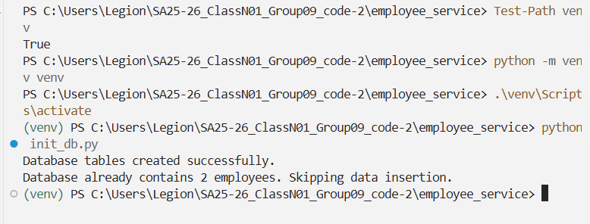
3.2. Activity Practice 2: Implementing the Service API
3.2.1. GET /api/employees - List/Search Employees
Endpoint: GET /api/employees
Functionality:
- Retrieve all active employees (is_active=True, status='active')
- Support search by first name, last name, or employee ID using query parameter q
- Case-insensitive search
Code Implementation:
@app.route('/api/employees', methods=['GET'])
def list_employees():
"""Get all active employees or search by name"""
# Get optional search query from request arguments
query = request.args.get('q')

# Start with all active employees
employees = Employee.query.filter_by(is_active=True, status='active')

if query:
# Add search filtering (case-insensitive name search)
employees = employees.filter(
(Employee.first_name.like(f'%{query}%')) |
(Employee.last_name.like(f'%{query}%')) |
(Employee.employee_id.like(f'%{query}%'))
)

# Execute query and convert results to a list of dictionaries
return jsonify([e.to_dict() for e in employees.all()]), 200

3.2.2. GET /api/employees/<employee_id> - Employee Details
Endpoint: GET /api/employees/<employee_id>
Code Implementation:
@app.route('/api/employees/<int:employee_id>', methods=['GET'])
def get_employee_details(employee_id):
"""Get a single employee by ID"""
# Query the database for the specific employee ID
employee = Employee.query.get(employee_id)

if employee and employee.is_active and employee.status == 'active':
return jsonify(employee.to_dict()), 200
else:
# Handle the case where the resource is not found
return jsonify({'message': 'Employee not found or is inactive'}), 404

3.2.3. Port Configuration
File: app.py - Run Block
if __name__ == '__main__':
# Run the microservice on a dedicated port
app.run(port=5001, debug=True)

3.3. Activity Practice 3: Isolation Testing
3.3.1. Test Case 1: Employee Listing
- Command: curl -X GET http://127.0.0.1:5001/api/employees
- Expected Result: HTTP 200 OK, JSON list of employees.

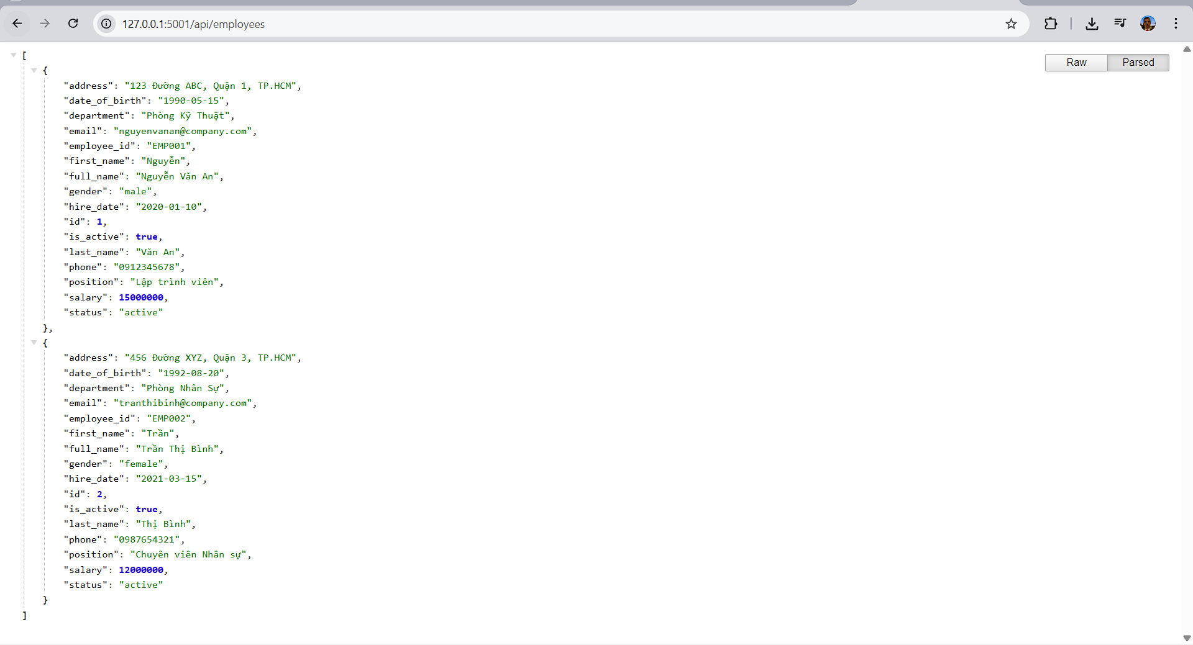
3.3.2. Test Case 2: Employee Details Lookup
- Command: curl -X GET http://127.0.0.1:5001/api/employees/1
- Expected Result: HTTP 200 OK, employee details.

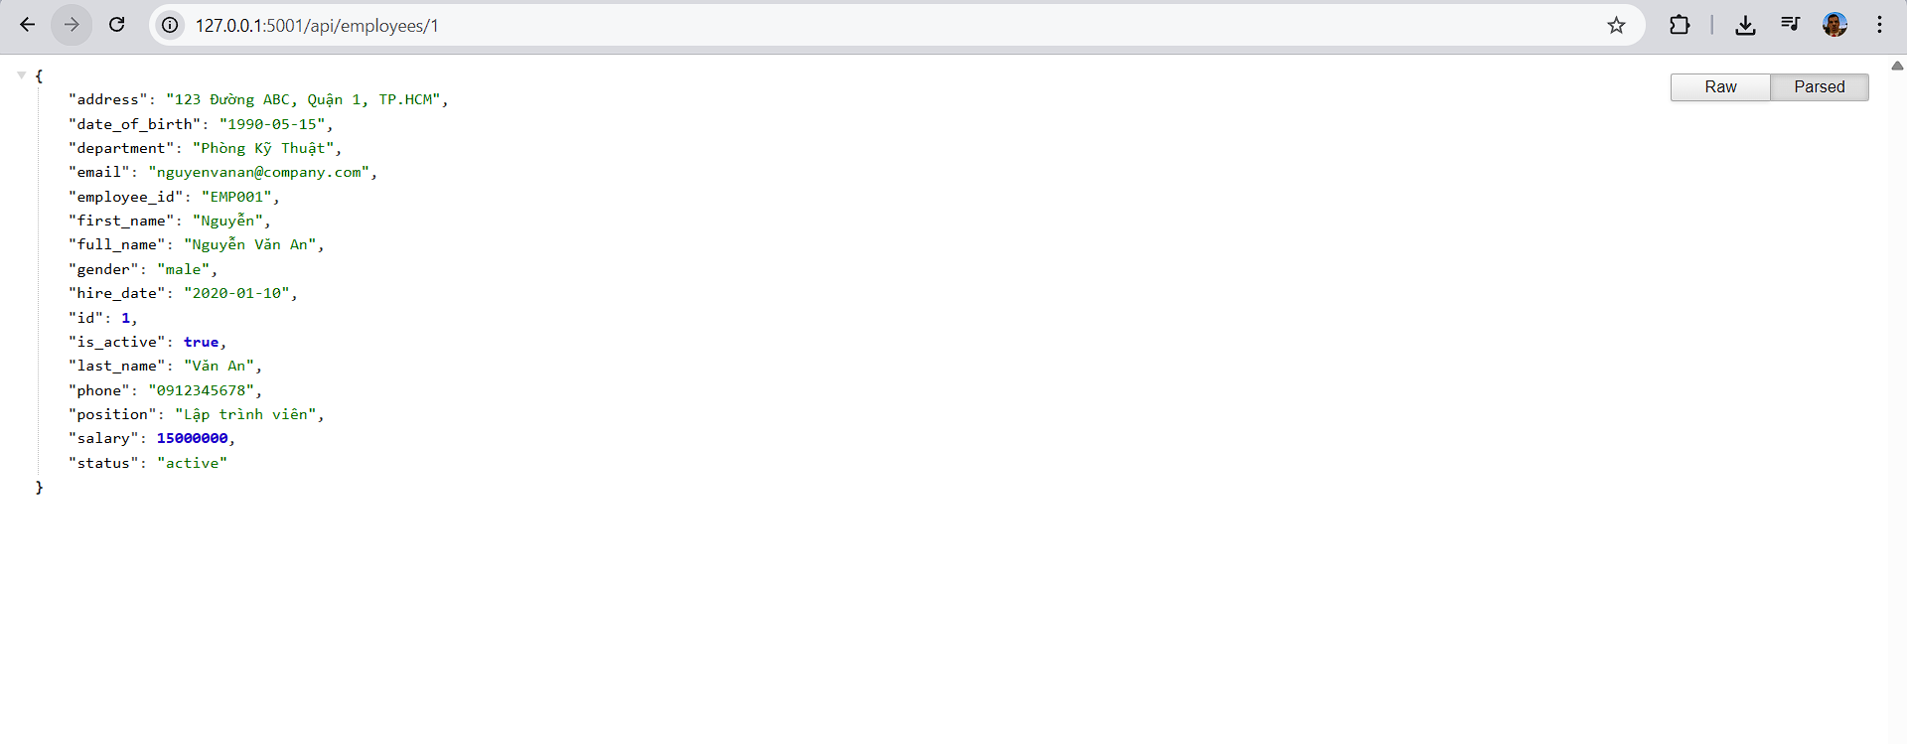
3.3.3. Test Case 3: Error Handling
- Command:curl -X GET http://127.0.0.1:5001/api/employees/99
- Expected Result: HTTP 404 Not Found.
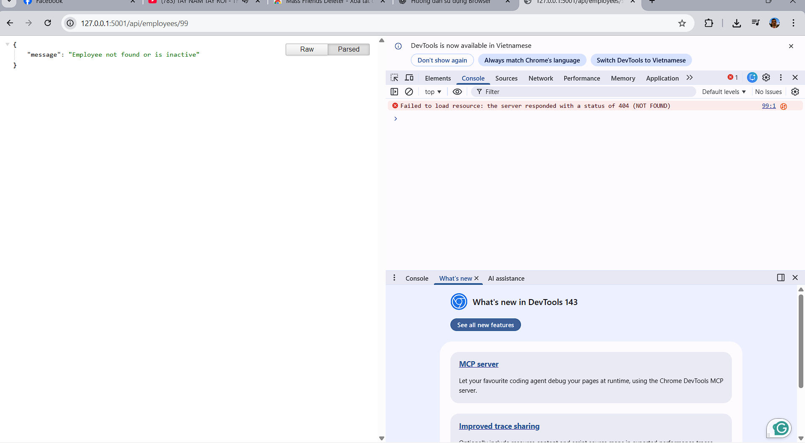

3.3.4. Test Case 4: Search Functionality
- Command: curl -X GET "http://127.0.0.1:5001/api/employees?q=Nguyen"
- Expected Result: HTTP 200 OK, filtered result.

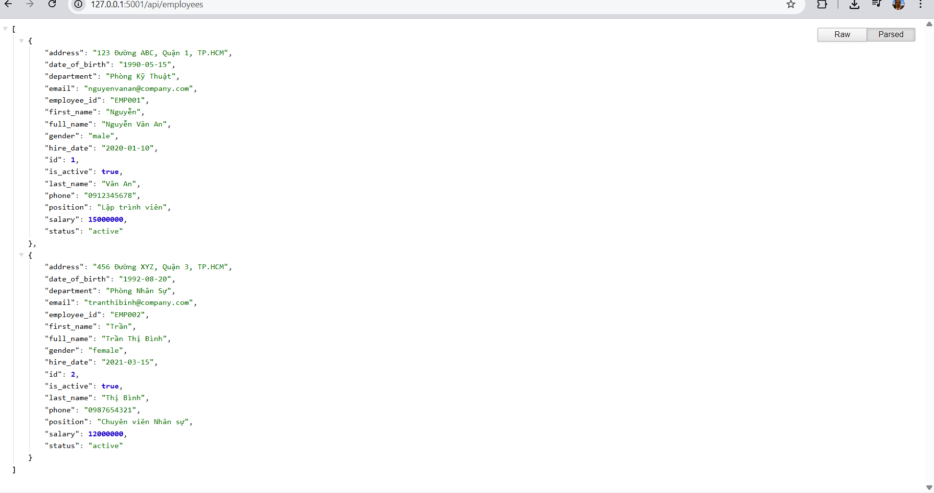

4. RESULTS
4.1. Checklist Implementation
- Standalone Flask application
- SQLAlchemy ORM with SQLite
- Employee model with all required fields
- REST API endpoints
- Search functionality
- Error handling (404)
- Database initialization with sample data
- Service running on port 5001
4.2. Microservice Characteristics
Full independence: Dedicated database (SQLite – employees.db)
- RESTful API: Standard REST, JSON responses
- Data ownership: Employee data managed solely by the service
- Isolation: Independent testing and deployment
- Integration-ready: Sample data aligned with HRM system context

5. CONCLUSION
Lab 5 successfully implemented a complete Employee Microservice, adhering to Microservices Architecture principles and fitting well within the HRM system:
- Independent service with its own database
- Fully functional RESTful API for reading and searching employee data
- Proper error handling
- Ready for integration with the API Gateway in Lab 6
Separating the Employee Service from the main HRM backend improves system flexibility, scalability, and maintainability.

