PE_PRN211_SP23_TrialTest
SUMMER 2023
Subject: PRN211
Duration: 90 minutes

INSTRUCTIONS
Please read the instructions carefully before doing the questions.
- You are NOT allowed to use any other materials. You are NOT allowed to use any device to share data with others.
- You must use IDE as Visual Studio 2019 or later, MSSQL Server 2016 or later database for your development tools.
IMPORTANT – Before you start doing your solution, MUST do the following steps:
- To do your program, you must use Windows Forms, apply 3-Layer architecture. Note that you are not allowed to connect direct to database from WindowsForms, every database connection must be used with Repository and Data Access Objects. The database connection string must get from appsettings.json file. In the case your program connects directly to database from WindowsForms or you hardcode connection string, you will get 0 mark.
- If there are syntax errors or compilation errors in your PE program, you will not pass the PE requirements, the mark will be 0.
- Create Solution in Visual Studio 2019/2022 named PE_PRN211_SP23_TrialTest_StudentName. Inside the Solution, Project Windows Forms named: PetStore_StudentName.
- Create your MS SQL database named PetStore2023DB by running code in script PetStore2023DB.sql.
- Set the default user interface for your project as Login form.

Create an application using Windows Forms with .NET5/.NET6, C#, and ADO.NET (or Entity Framework Core). A MS SQL Server database will be created to persist the data and it will be used for reading and managing data.
The below Figure is a part of PetStore2023DB database.
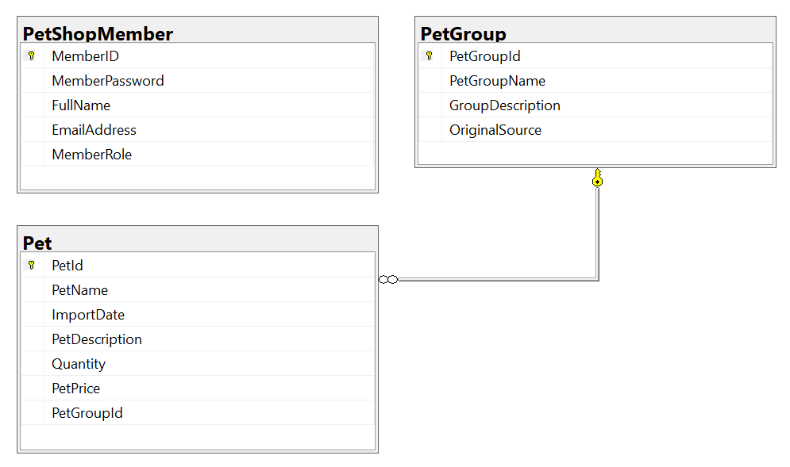
Note that: Account role: Administrator = 1; Staff = 2; Member = 3. A group will have many pets, one pet will belong to only one group.

Task 1. Design graphic user interface and project organize with 3-Layer architecture.
- (0.25 mark) Design Login form includes UI controls for login function.
- (0.25 mark) Design PetStore Management form, this form includes UI controls for CRUD actions with pet information. Note: The PetGroupId/PetGroupName will come from the PetGroup table. Design a form which allows you to view the list of records, create a new item, update the existing item, and delete a specific item.
Task 2. Implement CRUD actions with GUI.
- (1.0 mark) Authentication function
If user with a Staff role logs in successfully (using email address for login process), save this information to a temporary parameter. All CRUD actions are required authentication with Staff role. In the case login unsuccessfully, display “You have no permission to access this function!”.
- (2.0 marks) Check if login successfully with Staff role, list all pets in Pet table (the information includes PetId, PetName, ImportDate, PetDescription, Quantity, PetPrice and PetGroupName – group name).
- (1.0 mark) Check if login successfully with Staff role, search pet information by Quantity or PetPrice (using relative search).
- (1.0 mark) Check if login successfully with Staff role, delete the selected item with the confirmation then update the list of pets.
- (2.5 marks) Check if login successfully with Staff role, add new item with the requirements:
- The PetGroupId/ PetGroupName (group Id, pet group name) will come from the PetGroup table (you can use ComboBox UI control in this case)
- All fields are required.
- Value for PetPrice and Quantity is greater than or equal to 0.
- Value for PetName (the name of the pet) is in the range of 5 – 20 characters. Each word of the PetName must begin with the capital letter. PetName is not alowed with special characters.
- (2.0 marks) Check if login successfully with Staff role, update an existing item.
- You can use your different form or use the data grid view for this update function (update by PetId). With update function, the same validation requirements with Add function.

