1.Waterfall methodology : This is a sequential, linear approach to software development . It involves a strict sequence of phases where each phase must be completed before moving to the next . This approach is suitable for projects with well-defined requirements and stable technology.

2.Context mode:

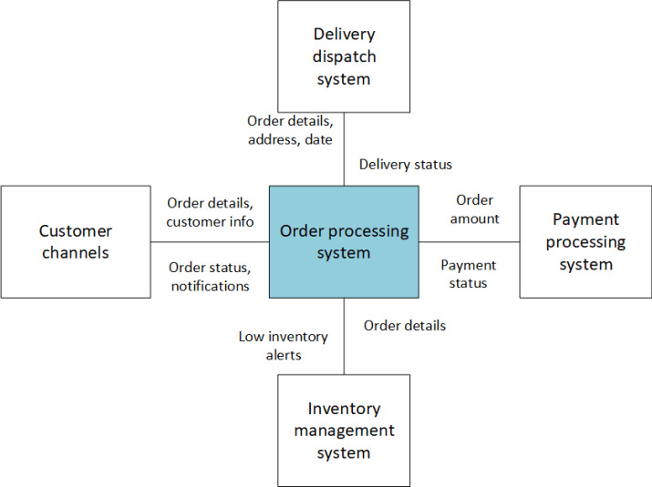

3.Interaction model:

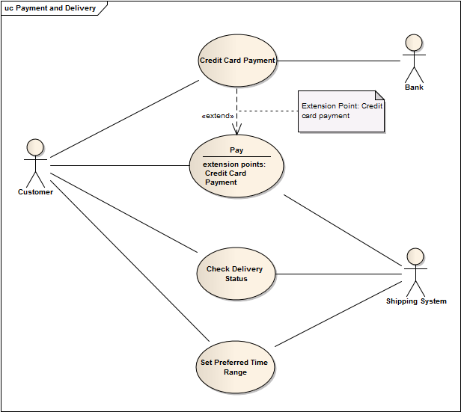

4 Structural model:

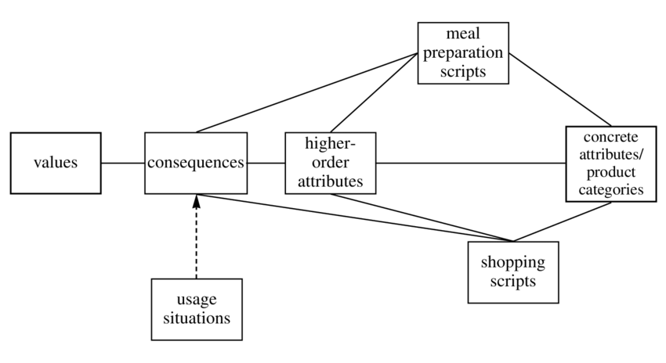

5.Behavioral model:

