# Weather Detection Classifier

Thunder Cloudy

# Sunny Snow Rainy Haze

Weather detection for blind people

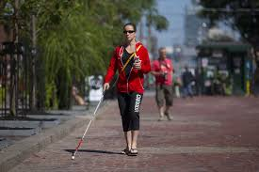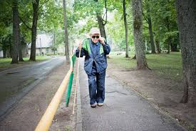

# Problems:

* The problem which is generally faced by blind person to detect the weather from where they are present. So that they take a crucial step regarding the weather present in that locality.
* Limited dataset for training resulting into less accuracy
* Limited resource availability.

## Solution:

* The problem is been solved using machine learning firstly we have used CNN(Convolutionary Neural Network) to train and predict over the data.
* PCA (Principal Component Analysis) is used for dimensionality reduction and then this dataset is passed through SVM (Support Vector Machine) where the feature of the image is extracted using MPEG7 software.
* Our model can predict over the single image input

## Innovation we bring in:

* Locality specific weather detection using a single click of image
* Providing weather detection feature in a very low cost.
* The classifier and technique used can be made to run over an average smartphone.

## Future Aspects:

* Till now we detect the weather of a city but not in a specific locality . We are bringing a weather detection model which can detect weather in a specific location using machine learning which results in helping blind person to detect the weather with just one click of an image from their smartphone.
* Innovating our model we can make changes into it to detect more objects around the physically disabled persons using machine learning.

Link to our blueprint:

https://docs.google.com/document/d/1UQ5DESq22o8Q2BUk4rdmpl-dXukBLba4MTQUd5-i7Cg/edit?usp=sharing