sinhvienModel.php
<?php
function getAllSinhVien($pdo){
$sql="select * from sinhvien";
$stmt=$pdo->query($sql);
return $stmt->fetchAll(PDO::FETCH_ASSOC);
}
function addSinhVien($pdo, $ten, $email){
$sql="insert into sinhvien(hoten, email) values (?,?)";
$stmt=$pdo->prepare($sql);
$stmt->execute([$ten, $email]);
}
?>
Sinhvien_view.php
<!DOCTYPE html>
<html lang="vi">
<head>
<meta charset="UTF-8">
<title>PHT Chương 6 - MVC</title>
<style>
table { width: 100%; border-collapse: collapse; }
th, td { border: 1px solid #ddd; padding: 8px; }
th { background-color: #f2f2f2; }
</style>
</head>
<body>
<h2>Thêm Sinh Viên Mới (Kiến trúc MVC)</h2>
<form action="index.php" method="POST">
<label for="hoten">Ho ten: </label>
<input type="text" required name="hoten" id="hoten">
<label for="email">Email: </label>
<input type="email" required name="email" id="email">
<button type="submit" >Submit</button>
</form>

<h2>Danh Sách Sinh Viên (Kiến trúc MVC)</h2>
<table>
<tr>
<th>ID</th>
<th>Tên Sinh Viên</th>
<th>Email</th>
<th>Ngày Tạo</th>
</tr>
<?php foreach($danh_sach_sv as $i=>$sv):?>
<tr>
<td><?= htmlspecialchars($sv['id']) ?></td>
<td><?= htmlspecialchars($sv['hoten']) ?></td>
<td><?= htmlspecialchars($sv['email']) ?></td>
<td><?= htmlspecialchars($sv['ngay_tao']) ?></td>
</tr>
<?php endforeach; ?>
</table>
</body>
</html>

Index.php
<?php
require_once "models/sinhvien_model.php";

$host='localhost';
$dbname="qlsv";
$username="root";
$pass='';

$dsn="mysql:host=$host;dbname=$dbname;charset=utf8mb4";
try{
$pdo= new PDO($dsn, $username, $pass);
$pdo->setAttribute(PDO::ATTR_ERRMODE,PDO::ERRMODE_EXCEPTION);
}catch(PDOException $e){
die("Failed to connect " .$e->getMessage());
}

if (isset($_POST['hoten'])){
$ten=$_POST['hoten'];
$email=$_POST['email'];
addSinhVien($pdo, $ten, $email);
header("Location: index.php");
exit;
}
$danh_sach_sv=getAllSinhVien($pdo);
include "views/sinhvien_view.php";
?>

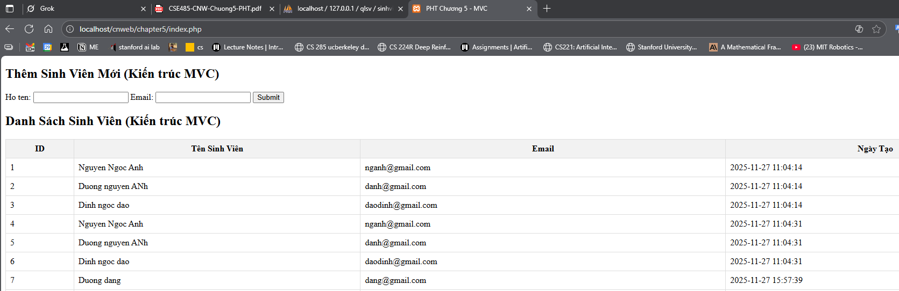
Câu hỏi: Việc nhúng query SQL thẳng vào Controller có vi phạm MVC không, giải thích

