<?php
$host='localhost';
$dbname='qlsv';
$username='root';
$pass='';
$dsn="mysql:host=$host;dbname=$dbname;charset=utf8mb4";
try{
$pdo = new PDO($dsn, $username, $pass);
$pdo->setAttribute(PDO::ATTR_ERRMODE, PDO::ERRMODE_EXCEPTION);
echo 'ket noi thanh cong';
}catch (PDOException $e){
die("Ket noi that bai: ".$e->getMessage());
}

$stmt_select = null;

if(isset($_POST['hoten'])){
$hoten=$_POST['hoten'];
$email=$_POST['email'];
$sql="insert into sinhvien (hoten, email) values (?, ?)";
$stmt=$pdo->prepare($sql);
$stmt->execute([$hoten, $email]);

header("Location: ". $_SERVER['PHP_SELF']);
exit;
}

$sql_select= "select * from sinhvien order by ngay_tao desc";
$stmt_select=$pdo->query($sql_select);
?>

<!doctype html>
<html lang='vi'>
<head>
<meta charset="utf-8">
<title>PHT chuong 4 - website huong du lieu</title>
<style>
table { width: 100%; border-collapse: collapse; }
th, td { border: 1px solid #ddd; padding: 8px; }
th { background-color: #f2f2f2; }
</style>
</head>
<body>
<h2> Them sinh vien moi</h2>
<form action="" method="POST">
Ho ten: <input type="text" name='hoten' required>
Email: <input type="email" name='email' required>
<button type='submit'>Them</button>
</form>
<h2>Danh sach sinh vien</h2>
<table>
<tr>
<th>ID</th>
<th>Ho ten</th>
<th>Email</th>
<th>Ngay tao</th>
</tr>
<?php if($stmt_select): while($row= $stmt_select->fetch(PDO::FETCH_ASSOC)): ?>
<tr>
<td><?= htmlspecialchars($row['id']) ?></td>
<td><?= htmlspecialchars($row['hoten']) ?></td>
<td><?= htmlspecialchars($row['email']) ?></td>
<td><?= htmlspecialchars($row['ngay_tao']) ?></td>
</tr>
<?php endwhile; endif ?>
</table>
</body>
</html>

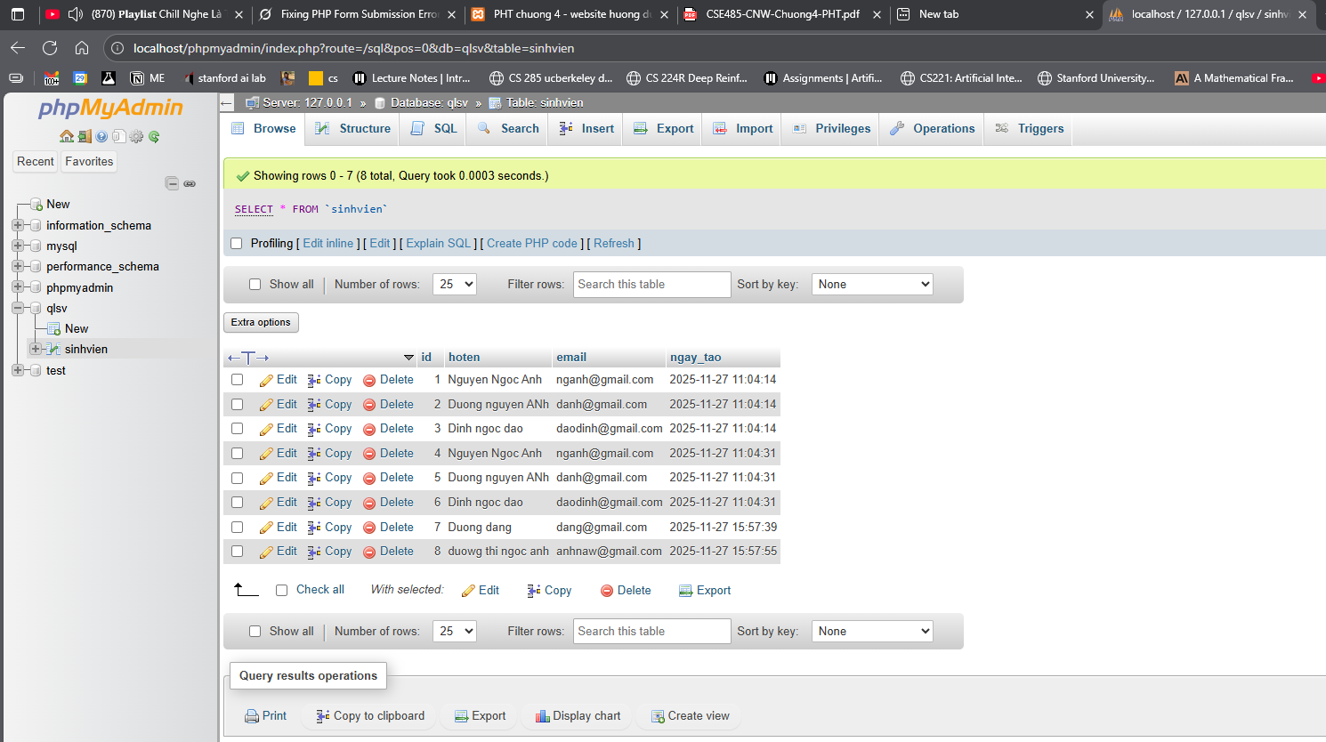
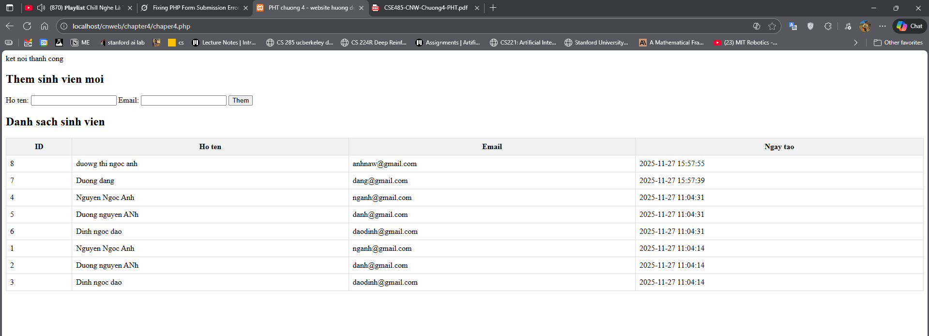
Câu hỏi của tôi là: Tại sao nên tạo file config.php riêng để lưu các thông số kết nối database ($host, $dbname, $username, $pass) thay vì viết trực tiếp trong chapter4.php?

