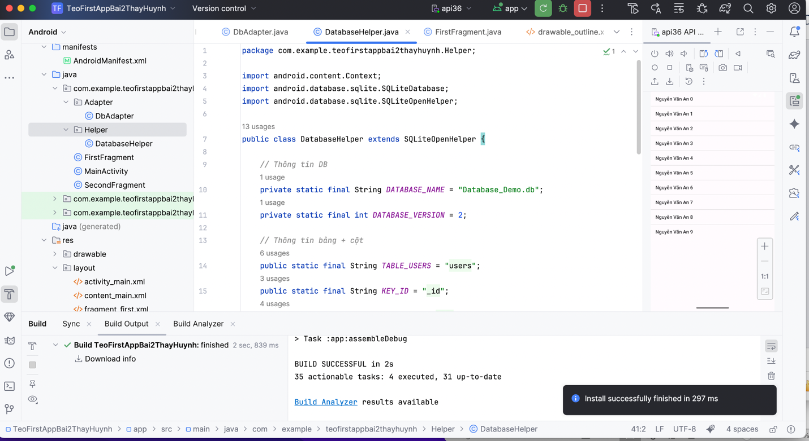

Maiactivity

package com.example.teofirstappbai2thayhuynh;  
  
import android.database.Cursor;  
import android.os.Bundle;  
import android.widget.ArrayAdapter;  
import android.widget.ListView;  
  
import androidx.appcompat.app.AppCompatActivity;  
  
import com.example.teofirstappbai2thayhuynh.Adapter.DbAdapter;  
import com.example.teofirstappbai2thayhuynh.Helper.DatabaseHelper;  
  
import java.util.ArrayList;  
import java.util.List;  
  
public class MainActivity extends AppCompatActivity {  
 private DbAdapter dbAdapter;  
 private List<String> users;  
  
 @Override  
 protected void onCreate(Bundle savedInstanceState) {  
 super.onCreate(savedInstanceState);  
 setContentView(R.layout.*activity_main*);  
  
 dbAdapter = new DbAdapter(this);  
 dbAdapter.open();  
 dbAdapter.deleteAllUsers();  
  
 *// Thêm dữ liệu mẫu* for (int i = 0; i < 10; i++) {  
 dbAdapter.createUser("Nguyễn Văn An " + i);  
 }  
  
 users = getData();  
 showData();  
 }  
  
 private List<String> getData() {  
 List<String> data = new ArrayList<>();  
  
 try (Cursor cursor = dbAdapter.getAllUsers()) {  
 *// Lấy index của cột name, dùng getColumnIndexOrThrow để chắc chắn không bị -1* int columnIndex = cursor.getColumnIndexOrThrow(DatabaseHelper.*KEY_NAME*);  
  
 while (cursor.moveToNext()) {  
 data.add(cursor.getString(columnIndex));  
 }  
 }  
  
 return data;  
 }  
  
 private void showData() {  
 ListView lvUser = findViewById(R.id.*lv_user*);  
  
 ArrayAdapter<String> userAdapter = new ArrayAdapter<>(  
 this,  
 android.R.layout.*simple_list_item_1*, *// layout mặc định* users  
 );  
  
 lvUser.setAdapter(userAdapter);  
 }  
  
 @Override  
 protected void onDestroy() {  
 super.onDestroy();  
 if (dbAdapter != null) {  
 dbAdapter.close();  
 }  
 }  
}

dbadapter

package com.example.teofirstappbai2thayhuynh.Adapter;  
  
import android.content.ContentValues;  
import android.content.Context;  
import android.database.Cursor;  
import android.database.sqlite.SQLiteDatabase;  
  
import com.example.teofirstappbai2thayhuynh.Helper.DatabaseHelper;  
  
public class DbAdapter {  
  
 private DatabaseHelper dbHelper;  
 private SQLiteDatabase sqLiteDatabase;  
 private final Context context;  
  
 public DbAdapter(Context ctx) {  
 this.context = ctx;  
 }  
  
 public DbAdapter open() {  
 dbHelper = new DatabaseHelper(context);  
 sqLiteDatabase = dbHelper.getWritableDatabase();  
 return this;  
 }  
  
 public void close() {  
 if (dbHelper != null) {  
 dbHelper.close();  
 }  
 }  
  
 *// Thêm user* public long createUser(String name) {  
 ContentValues inititalValues = new ContentValues();  
 inititalValues.put(DatabaseHelper.*KEY_NAME*, name);  
 return sqLiteDatabase.insert(DatabaseHelper.*TABLE_USERS*, null, inititalValues);  
 }  
  
 *// Xóa user theo ID* public boolean deleteUser(long rowId) {  
 return sqLiteDatabase.delete(  
 DatabaseHelper.*TABLE_USERS*,  
 DatabaseHelper.*KEY_ID* + "=" + rowId,  
 null  
 ) > 0;  
 }  
  
 *// Xóa tất cả user* public boolean deleteAllUsers() {  
 return sqLiteDatabase.delete(DatabaseHelper.*TABLE_USERS*, null, null) > 0;  
 }  
  
 *// Lấy toàn bộ user* public Cursor getAllUsers() {  
 return sqLiteDatabase.query(  
 DatabaseHelper.*TABLE_USERS*,  
 new String[]{DatabaseHelper.*KEY_ID*, DatabaseHelper.*KEY_NAME*},  
 null, null, null, null, null  
 );  
 }  
}

DatabaseHelper

package com.example.teofirstappbai2thayhuynh.Helper;  
  
import android.content.Context;  
import android.database.sqlite.SQLiteDatabase;  
import android.database.sqlite.SQLiteOpenHelper;  
  
public class DatabaseHelper extends SQLiteOpenHelper {  
  
 *// Thông tin DB* private static final String *DATABASE_NAME* = "Database_Demo.db";  
 private static final int *DATABASE_VERSION* = 2;  
  
 *// Thông tin bảng + cột* public static final String *TABLE_USERS* = "users";  
 public static final String *KEY_ID* = "_id";  
 public static final String *KEY_NAME* = "name";  
  
 *// Câu lệnh tạo bảng* private static final String *DATABASE_CREATE* =  
 "CREATE TABLE " + *TABLE_USERS* + " (" +  
 *KEY_ID* + " INTEGER PRIMARY KEY AUTOINCREMENT, " +  
 *KEY_NAME* + " TEXT NOT NULL);";  
  
 public DatabaseHelper(Context context) {  
 super(context, *DATABASE_NAME*, null, *DATABASE_VERSION*);  
 }  
  
 @Override  
 public void onCreate(SQLiteDatabase db) {  
 *// Tạo bảng khi DB mới* db.execSQL(*DATABASE_CREATE*);  
 }  
  
 @Override  
 public void onUpgrade(SQLiteDatabase db, int oldVersion, int newVersion) {  
 *// Xoá bảng cũ nếu tồn tại* db.execSQL("DROP TABLE IF EXISTS " + *TABLE_USERS*);  
 *// Tạo lại bảng mới* onCreate(db);  
 }  
}