BÁO CÁO LAB 3
Luyện tập:
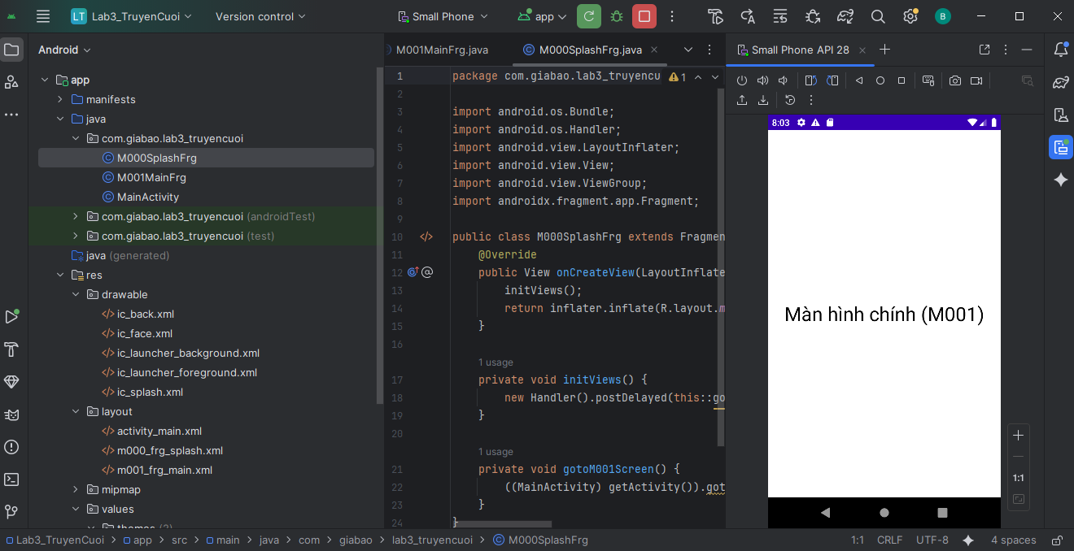

Code giao diện (m000_frg_splash.xml):
<?xml version="1.0" encoding="utf-8"?>
<FrameLayout xmlns:android="http://schemas.android.com/apk/res/android"
xmlns:tools="http://schemas.android.com/tools"
android:layout_width="match_parent"
android:layout_height="match_parent"
android:background="@color/greenMid">

<ImageView
android:layout_width="200dp"
android:layout_height="100dp"
android:layout_gravity="center"
android:src="@drawable/ic_splash"
tools:ignore="ContentDescription" />

</FrameLayout>

Code Logic (M000SplashFrg.java): (tự động chuyển màn hình sau 2 giây)
package com.giabao.lab3_truyencuoi;

import android.os.Bundle;
import android.os.Handler;
import android.view.LayoutInflater;
import android.view.View;
import android.view.ViewGroup;
import androidx.fragment.app.Fragment;

public class M000SplashFrg extends Fragment {
@Override
public View onCreateView(LayoutInflater inflater, ViewGroup container, Bundle savedInstanceState) {
initViews();
return inflater.inflate(R.layout.m000_frg_splash, container, false);
}

private void initViews() {
new Handler().postDelayed(this::gotoM001Screen, 2000);
}

private void gotoM001Screen() {
((MainActivity) getActivity()).gotoM001Screen();
}
}

Bài tập 1:
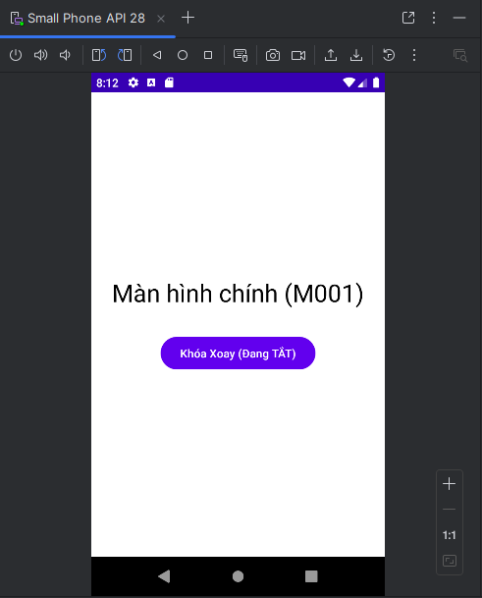
Code Giao diện (m001_frg_main.xml):
<?xml version="1.0" encoding="utf-8"?>
<LinearLayout xmlns:android="http://schemas.android.com/apk/res/android"
android:layout_width="match_parent"
android:layout_height="match_parent"
android:gravity="center"
android:orientation="vertical"
android:background="#FFFFFF">

<TextView
android:layout_width="wrap_content"
android:layout_height="wrap_content"
android:text="Màn hình chính (M001)"
android:textSize="30sp"
android:textColor="#000000"/>

<Button
android:id="@+id/btn_lock_rotation"
android:layout_width="wrap_content"
android:layout_height="wrap_content"
android:layout_marginTop="30dp"
android:text="Khóa Xoay (Đang TẮT)" />

</LinearLayout>

Code Logic (M001MainFrg.java): (Xử lý logic khi nhấn nút "Khóa Xoay")
package com.giabao.lab3_truyencuoi;

import android.content.pm.ActivityInfo;
import android.os.Bundle;
import android.view.LayoutInflater;
import android.view.View;
import android.view.ViewGroup;
import android.widget.Button;
import androidx.fragment.app.Fragment;

public class M001MainFrg extends Fragment {

private boolean isRotationLocked = false;
private Button btnLockRotation;

@Override
public View onCreateView(LayoutInflater inflater, ViewGroup container, Bundle savedInstanceState) {
View view = inflater.inflate(R.layout.m001_frg_main, container, false);

btnLockRotation = view.findViewById(R.id.btn_lock_rotation);

btnLockRotation.setOnClickListener(new View.OnClickListener() {
@Override
public void onClick(View v) {
toggleRotationLock();
}
});

return view;
}

private void toggleRotationLock() {
if (getActivity() == null) {
return;
}

if (isRotationLocked) {
getActivity().setRequestedOrientation(ActivityInfo.SCREEN_ORIENTATION_UNSPECIFIED);
btnLockRotation.setText("Khóa Xoay (Đang TẮT)");
} else {
getActivity().setRequestedOrientation(ActivityInfo.SCREEN_ORIENTATION_PORTRAIT);
btnLockRotation.setText("Khóa Xoay (Đang BẬT)");
}
isRotationLocked = !isRotationLocked;
}
}

Code (MainActivity.java):
package com.giabao.lab3_truyencuoi;

import android.os.Bundle;
import androidx.appcompat.app.AppCompatActivity;
import androidx.fragment.app.Fragment;

public class MainActivity extends AppCompatActivity {

@Override
protected void onCreate(Bundle savedInstanceState) {
super.onCreate(savedInstanceState);
setContentView(R.layout.activity_main);
showFrg(new M000SplashFrg());
}

private void showFrg(Fragment frg) {
getSupportFragmentManager().beginTransaction().replace(R.id.ln_main, frg,
null).commit();
}

public void gotoM001Screen() {
showFrg(new M001MainFrg());
}
}
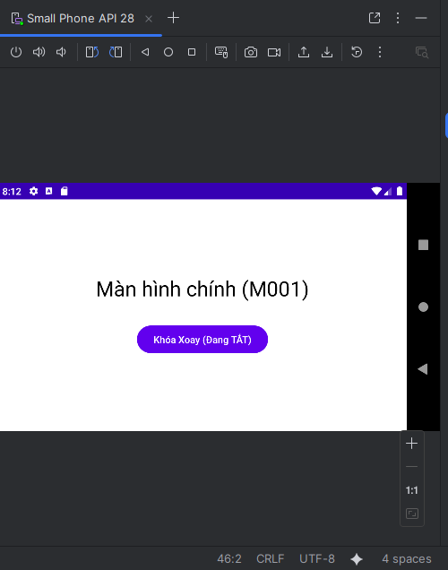

Bài 2:
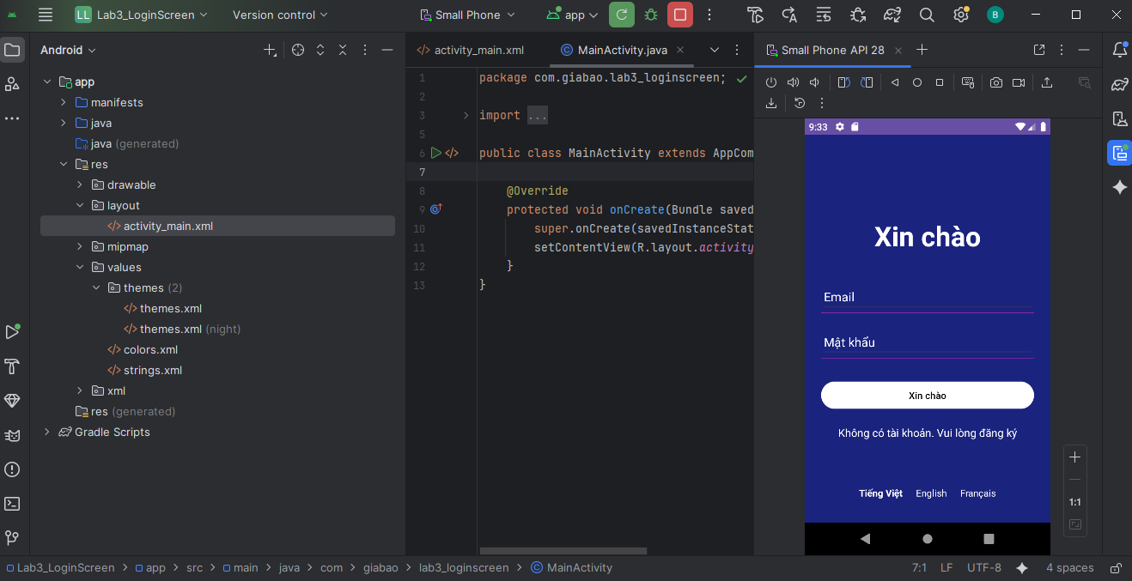

Code Giao diện (activity_main.xml):
<?xml version="1.0" encoding="utf-8"?>
<RelativeLayout xmlns:android="http://schemas.android.com/apk/res/android"
xmlns:tools="http://schemas.android.com/tools"
android:layout_width="match_parent"
android:layout_height="match_parent"
android:background="@color/colorPrimaryDark"
android:padding="24dp"
tools:context=".MainActivity">

<LinearLayout
android:layout_width="match_parent"
android:layout_height="wrap_content"
android:layout_centerInParent="true"
android:orientation="vertical">

<TextView
android:id="@+id/tv_welcome"
android:layout_width="wrap_content"
android:layout_height="wrap_content"
android:layout_gravity="center_horizontal"
android:text="@string/txt_welcome"
android:textColor="@color/white"
android:textSize="40sp"
android:textStyle="bold" />

<EditText
android:id="@+id/et_email"
android:layout_width="match_parent"
android:layout_height="wrap_content"
android:layout_marginTop="40dp"
android:hint="@string/txt_email"
android:inputType="textEmailAddress"
android:textColor="@color/white"
android:textColorHint="@color/white"
android:theme="@style/Theme.Lab3_LoginScreen" />

<View
android:layout_width="match_parent"
android:layout_height="1dp"
android:background="@color/purple_line" />

<EditText
android:id="@+id/et_password"
android:layout_width="match_parent"
android:layout_height="wrap_content"
android:layout_marginTop="20dp"
android:hint="@string/txt_password"
android:inputType="textPassword"
android:textColor="@color/white"
android:textColorHint="@color/white"
android:theme="@style/Theme.Lab3_LoginScreen" />

<View
android:layout_width="match_parent"
android:layout_height="1dp"
android:background="@color/purple_line" />

<Button
android:id="@+id/btn_login"
android:layout_width="match_parent"
android:layout_height="wrap_content"
android:layout_marginTop="30dp"
android:backgroundTint="@color/white"
android:text="@string/txt_welcome"
android:textColor="@color/black" />

<TextView
android:id="@+id/tv_no_account"
android:layout_width="wrap_content"
android:layout_height="wrap_content"
android:layout_gravity="center_horizontal"
android:layout_marginTop="20dp"
android:text="@string/txt_no_account"
android:textColor="@color/white"
android:textSize="16sp" />

</LinearLayout>

<LinearLayout
android:layout_width="match_parent"
android:layout_height="wrap_content"
android:layout_alignParentBottom="true"
android:gravity="center"
android:orientation="horizontal">

<TextView
android:id="@+id/tv_lang_vi"
android:layout_width="wrap_content"
android:layout_height="wrap_content"
android:padding="10dp"
android:text="@string/txt_lang_vi"
android:textColor="@color/white"
android:textStyle="bold" />

<TextView
android:id="@+id/tv_lang_en"
android:layout_width="wrap_content"
android:layout_height="wrap_content"
android:padding="10dp"
android:text="@string/txt_lang_en"
android:textColor="@color/white" />

<TextView
android:id="@+id/tv_lang_fr"
android:layout_width="wrap_content"
android:layout_height="wrap_content"
android:padding="10dp"
android:text="@string/txt_lang_fr"
android:textColor="@color/white" />
</LinearLayout>

</RelativeLayout>

Code Logic (MainActivity.java):
package com.giabao.lab3_loginscreen;

import android.content.res.Configuration;
import android.content.res.Resources;
import android.os.Bundle;
import android.util.DisplayMetrics;
import android.view.View;
import android.widget.TextView;
import androidx.appcompat.app.AppCompatActivity;
import java.util.Locale;

public class MainActivity extends AppCompatActivity {

@Override
protected void onCreate(Bundle savedInstanceState) {
super.onCreate(savedInstanceState);
setContentView(R.layout.activity_main);

// Tìm 3 nút ngôn ngữ
TextView tvVi = findViewById(R.id.tv_lang_vi);
TextView tvEn = findViewById(R.id.tv_lang_en);
TextView tvFr = findViewById(R.id.tv_lang_fr);

// Thêm sự kiện click cho từng nút
tvVi.setOnClickListener(new View.OnClickListener() {
@Override
public void onClick(View v) {
setLocale("vi");
}
});

tvEn.setOnClickListener(new View.OnClickListener() {
@Override
public void onClick(View v) {
setLocale("en");
}
});

tvFr.setOnClickListener(new View.OnClickListener() {
@Override
public void onClick(View v) {
setLocale("fr");
}
});
}

// Hàm thay đổi ngôn ngữ
private void setLocale(String langCode) {
Locale locale = new Locale(langCode);
Resources resources = getResources();
DisplayMetrics dm = resources.getDisplayMetrics();
Configuration config = resources.getConfiguration();
config.setLocale(locale);
resources.updateConfiguration(config, dm);

// Tải lại activity để áp dụng ngôn ngữ mới
recreate();
}
}

File (strings.xml) - Tiếng Việt:
<resources>
<string name="app_name">Lab3_LoginScreen</string>
<string name="txt_welcome">Xin chào</string>
<string name="txt_email">Email</string>
<string name="txt_password">Mật khẩu</string>
<string name="txt_no_account">Không có tài khoản. Vui lòng đăng ký</string>
<string name="txt_lang_vi">Tiếng Việt</string>
<string name="txt_lang_en">English</string>
<string name="txt_lang_fr">Français</string>
</resources>

File (strings.xml) - Tiếng Anh:
<resources>
<string name="app_name">Lab3_LoginScreen</string>
<string name="txt_welcome">Welcome!</string>
<string name="txt_email">Email Address</string>
<string name="txt_password">Password</string>
<string name="txt_no_account">Don\'t have account? Sign Up</string>
<string name="txt_lang_vi">Tiếng Việt</string>
<string name="txt_lang_en">English</string>
<string name="txt_lang_fr">Français</string>
</resources>

File (strings.xml) - Tiếng Pháp:
<resources>
<string name="app_name">Lab3_LoginScreen</string>
<string name="txt_welcome">accueil</string>
<string name="txt_email">adresse e-mail</string>
<string name="txt_password">mot de passe</string>
<string name="txt_no_account">Ne pas avoir un compte? signer</string>
<string name="txt_lang_vi">Tiếng Việt</string>
<string name="txt_lang_en">English</string>
<string name="txt_lang_fr">Français</string>
</resources>

