Hình ban đầu:

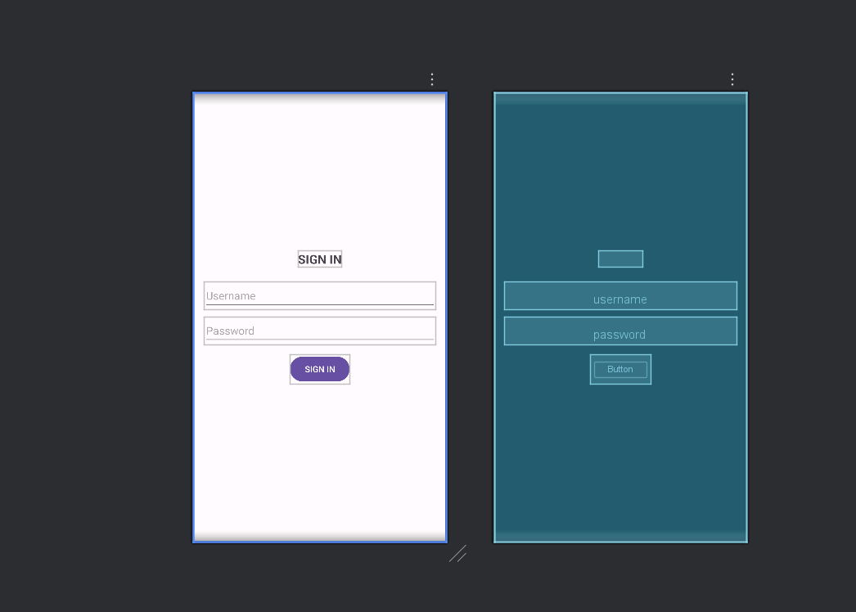

Sau khi chỉnh sửa code

<LinearLayout xmlns:android="http://schemas.android.com/apk/res/android"

android:layout_width="match_parent"

android:layout_height="match_parent"

android:orientation="vertical"

android:gravity="center"

android:padding="16dp">

<TextView

android:layout_width="wrap_content"

android:layout_height="wrap_content"

android:text="SIGN IN"

android:textSize="20sp"

android:textStyle="bold"

android:layout_marginBottom="24dp"/>

<EditText

android:id="@+id/username"

android:layout_width="match_parent"

android:layout_height="wrap_content"

android:hint="Username"

android:inputType="textEmailAddress"/>

<EditText

android:id="@+id/password"

android:layout_width="match_parent"

android:layout_height="wrap_content"

android:hint="Password"

android:inputType="textPassword"

android:layout_marginTop="12dp"/>

<Button

android:id="@+id/btnSignIn"

android:layout_width="wrap_content"

android:layout_height="wrap_content"

android:text="SIGN IN"

android:layout_marginTop="16dp"/>

<!-- Thêm 2 nút mới -->

<Button

android:id="@+id/btnSignInFacebook"

android:layout_width="match_parent"

android:layout_height="wrap_content"

android:text="SIGN IN VIA FACEBOOK"

android:layout_marginTop="20dp"/>

<Button

android:id="@+id/btnSignUp"

android:layout_width="match_parent"

android:layout_height="wrap_content"

android:text="SIGN UP"

android:layout_marginTop="10dp"/>

</LinearLayout>

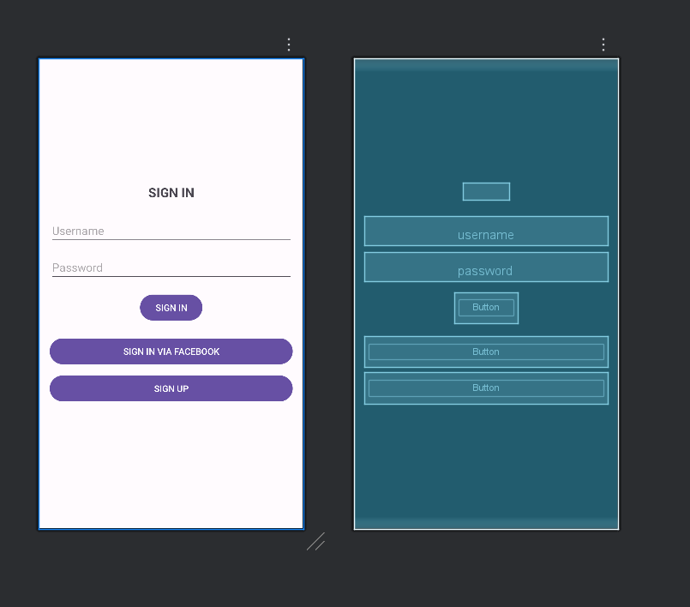

Chỉnh thêm ContraintsLayout

<androidx.constraintlayout.widget.ConstraintLayout xmlns:android="http://schemas.android.com/apk/res/android"

xmlns:app="http://schemas.android.com/apk/res-auto"

android:layout_width="match_parent"

android:layout_height="match_parent"

android:padding="16dp">

<!-- Tiêu đề -->

<TextView

android:id="@+id/tvTitle"

android:layout_width="wrap_content"

android:layout_height="wrap_content"

android:text="SIGN IN"

android:textSize="20sp"

android:textStyle="bold"

app:layout_constraintTop_toTopOf="parent"

app:layout_constraintStart_toStartOf="parent"

app:layout_constraintEnd_toEndOf="parent"

android:layout_marginTop="32dp"/>

<!-- Username -->

<EditText

android:id="@+id/username"

android:layout_width="0dp"

android:layout_height="wrap_content"

android:hint="Username"

android:inputType="textEmailAddress"

app:layout_constraintTop_toBottomOf="@id/tvTitle"

app:layout_constraintStart_toStartOf="parent"

app:layout_constraintEnd_toEndOf="parent"

android:layout_marginTop="24dp"/>

<!-- Password -->

<EditText

android:id="@+id/password"

android:layout_width="0dp"

android:layout_height="wrap_content"

android:hint="Password"

android:inputType="textPassword"

app:layout_constraintTop_toBottomOf="@id/username"

app:layout_constraintStart_toStartOf="parent"

app:layout_constraintEnd_toEndOf="parent"

android:layout_marginTop="12dp"/>

<!-- Nút SIGN IN -->

<Button

android:id="@+id/btnSignIn"

android:layout_width="wrap_content"

android:layout_height="wrap_content"

android:text="SIGN IN"

app:layout_constraintTop_toBottomOf="@id/password"

app:layout_constraintStart_toStartOf="parent"

app:layout_constraintEnd_toEndOf="parent"

android:layout_marginTop="16dp"/>

<!-- Nút SIGN IN VIA FACEBOOK -->

<Button

android:id="@+id/btnSignInFacebook"

android:layout_width="0dp"

android:layout_height="wrap_content"

android:text="SIGN IN VIA FACEBOOK"

app:layout_constraintTop_toBottomOf="@id/btnSignIn"

app:layout_constraintStart_toStartOf="parent"

app:layout_constraintEnd_toEndOf="parent"

android:layout_marginTop="20dp"/>

<!-- Nút SIGN UP -->

<Button

android:id="@+id/btnSignUp"

android:layout_width="0dp"

android:layout_height="wrap_content"

android:text="SIGN UP"

app:layout_constraintTop_toBottomOf="@id/btnSignInFacebook"

app:layout_constraintStart_toStartOf="parent"

app:layout_constraintEnd_toEndOf="parent"

android:layout_marginTop="10dp"/>

</androidx.constraintlayout.widget.ConstraintLayout>