**CAO ĐẲNG FPT POLYTECHNIC TÂY NGUYÊN**

-----🙞🙜🕮🙞🙜-----

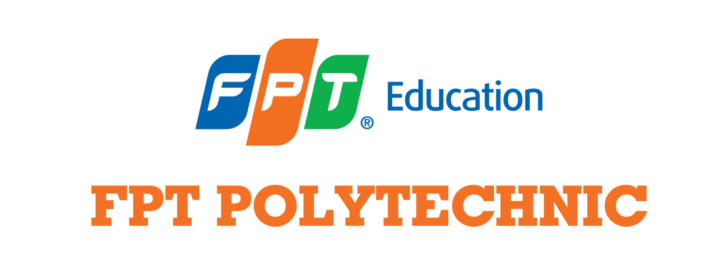

**ASSIGNMENT TIẾNG ANH 2.2**

Họ và tên:Lộc Thị Thùy Ngân

MSSV: PK02925

Lớp: ENT2226.05

**Topic 1: Talk about a hotel you have stayed in**

Hi everyone, I'd like to write about a hotel I have stayed in.

The name of the hotel is "Muong Thanh Hotel". The hotel is in Da Lat city, 42 Phan Boi Chau Street, Ward 2. The location is good because it is near in the city center. I can go to the market easily. My father took me there by car. I stayed there last year when I was traveling. I stayed in a double room because I was traveling with my family. Room price is quite expensive. About 1,000,000 VND. There were a large TV and a twin bed. There are a lot of drinks and fast food. The hotel had laundry service and spa so I can relax after travelling a lot. I use a laundry service because I'm quite busy and have a lot of dirty laundry. I did not request housekeeping service. I especially like the balcony here because it has a very nice view.I can see the whole city while on the balcony. This hotel is very good and I have nothing to complain however I have little dislike for the toothpaste here because it tastes so bad.

I am very satisfied and happy with my stay**.** I see a lot of good things so I will recommend to my friends.

**Topic 2: Talk about good and bad driving habits**

Hello everyone, I'd like to write about good and bad driving habits.

I don't know how to drive a car. Maybe, next 2 years, I will study how to drive a car. Driving a car is dangerous so I always pay attention. I hope I'll be a good driver. There are many good driving habits that people already know. Many people wear helmet, turn with signal, stop according to regulations and observe the speed limit when driving. I think the most dangerous driving behavior is driving with high speed, exceeding control limits. You maybe die when there is a collision with a big van and other cars. I see some people don't turn off lights signal, don't stop at red lights and talk on the phone. I think the most dangerous driving behavior is driving with high speed, exceeding control limits. I always wear a helmet when riding a motorbike and never talk on the phone while driving and stop at red lights. In the past, I had an accident. I hit the motorbike when it turned left but had a "turn right" light. I fell on the road, luckily I wasn't injured much. The accident happened on Amakhe Street and Nguyen Tat Thanh Street. I was driving my car when I had the accident. The accident was about 5 months ago. My car was slightly damaged. They turned left but there was a "turn right" light. There was no body hurt in the accident. There was no much damage.

Through that, I think I need to pay more attention when walking on the road and turn on the turn signal in the right direction.

**Topic 3: Talk about how you take care of your appearance**

Hi everyone, I'd like to write about take care of my appearance.

I am happy with my appearance. I think appearance is important because some people feel more confident in themselves or when meet someone and you look good, that's a way to show respect to the person you meet.

I often take care of my teeth by brushing teeth twice a day. I often use P/S toothpaste for my teeth. I also often go to the salon. The salon is near my house. I often go there with my mother. I often receive hair washing and skin care services when I go to the salon. I had to pay about 200,000 VND.

In my opinion outer beauty is necessary but inner beauty is more important. You will impress and attractive other people by inner beauty, your behaviors.

I think cosmetic surgery is good. It helps everyone change outner and be more good-looking. Cosmetic surgery can change your outer beauty and you can have good appearance then, but it is very expensive and can have risks. If I had money, I don't think I'll have plastic surgery, because I don't think it is necessary for me.

In short, I do focus on taking care of my appearance

**Topic 4: Your eating habit**

Hi everyone, I want to write about my eating habits

I am a healthy eater because I do not choose processed and fried foods every day. The most unhealthy food I can think of is fast food and junk food. I'm now focusing on eating healthy foods. Some different types of diets I have heard about are Keto, Vegan I eat small portions of food each day. I think Vietnamese people usually eat healthy food because our cuisine is rich in fresh vegetables and seafood. I am content with my current eating habits but always strive to maintain healthy choices.

In my opinion, think organic food is much more expensive due to Eco-friendly farming, labor, certifications, high demand and limited supply.

Traditional dishes in my country are rice dishes, bread, pho or banh chung. All are healthy foods. I think a person's eating habits do affect how long they will live because a balanced and healthy diet can reduce the risk of chronic diseases and contribute to overall well-being.

In short, my eating habits are very healthy and good for my health