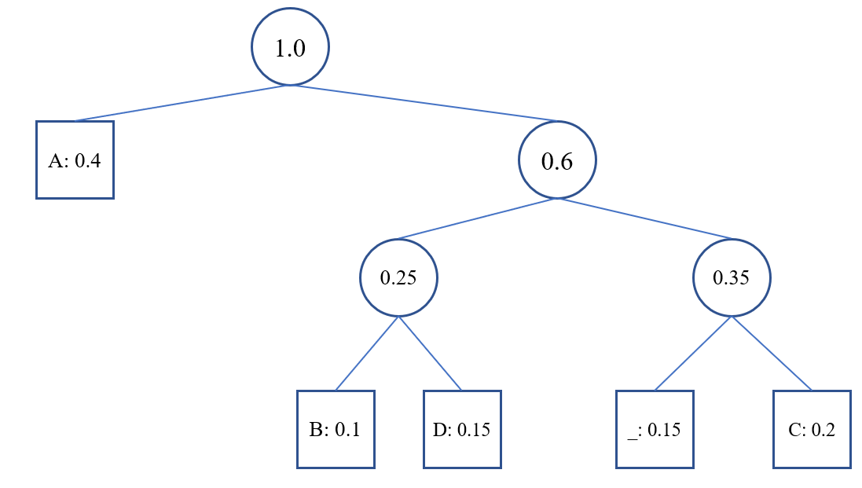

a/

|  |  |  |  |  |  |
| --- | --- | --- | --- | --- | --- |
| Symbol | A | B | C | D | - |
| Frequency | 0.4 | 0.1 | 0.2 | 0.15 | 0.15 |
| Codeword | 0 | 100 | 111 | 101 | 110 |

b/ ABACABAD: 0100011101000101

c/ 100010111001010: BAD_ADA