Nguyen Phan Yen Ngan – 14597

Chapter 3: Sending and Receiving Data – TCP/IP SOCKETS in JAVA

3.1 Encoding Information

3.1.1 Primitive Integers

- We can encode the values of other (larger) primitive integer types. However, the sender and receiver have to agree on several things first. One is the size (in bytes) of each integer to be transmitted.

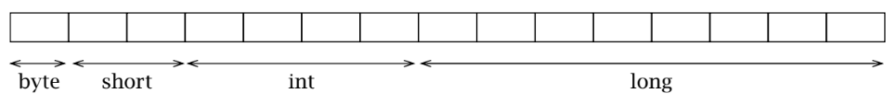

* For types that require more than one byte, we have to answer the question of which order to send the bytes in. There are two obvious choices: start at the right end of the integer, with the least significant byte—so-called little-endian order—or at the left end, with the most significant byte— big-endian order.

3.1.2 Strings and Text

- A mapping between a set of symbols and a set of integers is called a coded character set. For example, ASCII.

- Sender and receiver have to agree on a mapping from symbols to integers in order to communicate using text messages.

3.1.3 Bit-Diddling: Encoding Booleans

- Bitmaps are a very compact way to encode boolean information, which is often used in protocols.

- The idea of a bitmap is that each of the bits of an integer type can encode one boolean value—typically with 0 representing false, and 1 representing true.

- To be able to manipulate bitmaps, you need to know how to set and clear individual bits using Java’s “bit-diddling” operations. A mask is an integer value that has one or more specific bits set to 1, and all others cleared

3.2 Composing I/O Streams

- Java’s stream classes can be composed to provide powerful capabilities.

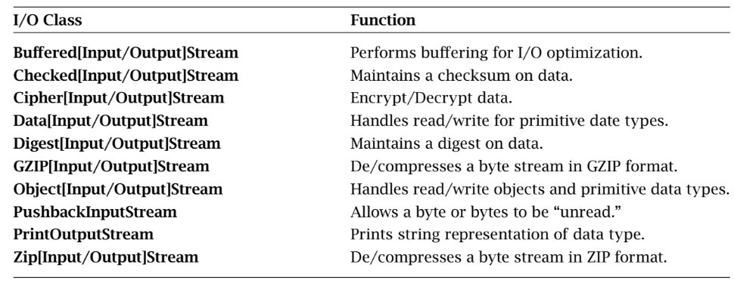

3.3 Framing and Parsing

- Framing refers to the problem of enabling the receiver to locate the beginning and end of a message.

- Whether information is encoded as text, as multibyte binary numbers, or as some combination of the two, the application protocol must specify how the receiver of a message can determine when it has received all of the message.

- If a receiver tries to receive more bytes from the socket than were in the message, one of two things can happen. If no other message is in the channel, the receiver will block and be prevented from processing the message; if the sender is also blocked waiting for a reply, the result will be deadlock. On the other hand, if another message is in the channel, the receiver may read some or all of it as part of the first message, leading to protocol errors. Therefore framing is an important consideration when using TCP sockets.

- Two general techniques enable a receiver to unambiguously find the end of the message:

+ Delimiter-based: The end of the message is indicated by a unique marker, an explicit byte sequence that the sender transmits immediately following the data. The marker must be known not to occur in the data.

+ Explicit length: The variable-length field or message is preceded by a (fixed-size) length field that tells how many bytes it contains.

3.4 Java-Specific Encodings

- When you use sockets, generally either you are building the programs on both ends of the communication channel—in which case you also have complete control over the protocol—or you are communicating using a given protocol, which you have to implement.

Chapter 4: Beyond the Basics – TCP/IP in JAVA

4.1 Multitasking

- Iterative server: If a client connects while another is already being serviced, the server will not echo the new client’s data until it has finished with the current client, although the new client will be able to send data as soon as it connects.

- We need some way for each connection to proceed independently, without interfering with other connections.

4.1.1 Java Threads

- It allows servers to handle many clients simultaneously. Using threads, a single application can work on several tasks concurrently.

- Java provides two approaches for performing a task in a new thread: 1) defining a subclass of the thread class with a run() method that performs the task, and instantiating it; or 2) defining a class that implements the Runnable interface with a run() method that performs the task, and passing an instance of that class to the thread constructor.

- When the start() method of an instance of thread is invoked, the JVM causes the instance’s run() method to be executed in a new thread, concurrently with all others. Meanwhile, the original thread returns from its call to start() and continues its execution independently.

4.1.4 Thread Pool

- Every new thread consumes system resources: spawning a thread takes CPU cycles and each thread has its own data structures (e.g., stacks) that consume system memory. In addition, when one thread blocks, the JVM saves its state, selects another thread to run, and restores the state of the chosen thread in what is called a context switch.

- As the number of threads increases, more and more system resources are consumed by thread overhead.

- We can avoid this problem by limiting the total number of threads and reusing threads. Instead of spawning a new thread for each connection, the server creates a thread pool on start-up by spawning a fixed number of threads. When the thread finishes with the client, it returns to the pool, ready to handle another request.

- Since each thread in the pool loops forever, processing connections one by one, a thread-pool server is really like a set of iterative servers.

4.2 Blocking and Timeouts

- Socket I/O calls may block for several reasons. Data input methods read() and receive() block if data is not available. A write() on a TCP socket may block if there is not sufficient space to buffer the transmitted data. The accept() method of ServerSocket() and the socket constructor both block until a connection has been established.

- A program that has other tasks to perform while waiting for call completion may have no time to wait on a blocked method call. What about lost UDP datagrams? If we block waiting to receive a datagram and it is lost, we could block indefinitely.

4.2.1 accept(), read(), write()

- For these methods, we can set a bound on the maximum time (in milliseconds) to block, using the setSoTimeout() method of Socket, ServerSocket, and DatagramSocket. If the specified time elapses before the method returns, an InterruptedIOException is thrown. For Socket instances, we can also use the available() method of the socket’s inputStream to check for available data before calling read()

4.2.2 Connecting and Writing

- A write() call blocks until the last byte written is copied into the TCP implementation’s local buffer; if the available buffer space is smaller than the size of the write, some data must be successfully transferred to the other end of the connection before the call to write() will return. Thus, the amount of time that a write() may block is ultimately controlled by the receiving application.

4.3 Mutiple Recipients

- So far all of our sockets have dealt with communication between exactly two entities, usually a server and a client. Such one-to-one communication is sometimes called unicast

- Networks provide a way to use bandwidth more efficiently. Instead of making the sender responsible for duplicating packets, we can give this job to the network. In our video server example, we send a single copy of the stream across the server’s connection to the network, which then duplicates the data only when appropriate. With this model of duplication, the server uses only 1Mbps across its connection to the network, irrespective of the number of clients.

4.3.1 Broadcast

- Broadcasting UDP datagrams is similar to unicasting datagrams, except that a broadcast address is used instead of a regular (unicast) IP address.

- There is no networkwide broadcast address that can be used to send a message to all hosts. Sending a single datagram would result in a very, very large number of packet duplications by the routers, and bandwidth would be consumed on each and every network. The consequences of misuse (malicious or accidental) are too great, so the designers of IP left such an Internetwide broadcast facility out on purpose

4.3.2 Multicast

- As with broadcast, one of the main differences between multicast and unicast is the form of the address. A multicast address identifies a set of receivers. The designers of IP allocated a range of the address space dedicated to multicast.

- The only significant differences between our unicast and multicast senders are that 1) we verify that the given address is multicast, and 2) we set the initial Time To Live (TTL) value for the multicast datagram. Every IP datagram contains a TTL, initialized to some default value and decremented (usually by one) by each router that forwards the packet. When the TTL reaches zero, the packet is discarded.

- UDP unicast, multicast, and broadcast are all implemented using an underlying UDP socket.

4.4 Controlling Default Behaviors

4.4.1 Keep Alive

- TCP provides a keep-alive mechanism where, after a certain time of inactivity, a probe message is sent to the other endpoint. If the endpoint is alive and well, it sends an acknowledgment. After a few retries without acknowledgment, the probe sender gives up and closes the socket, eliciting an exception on the next attempted I/O operation.

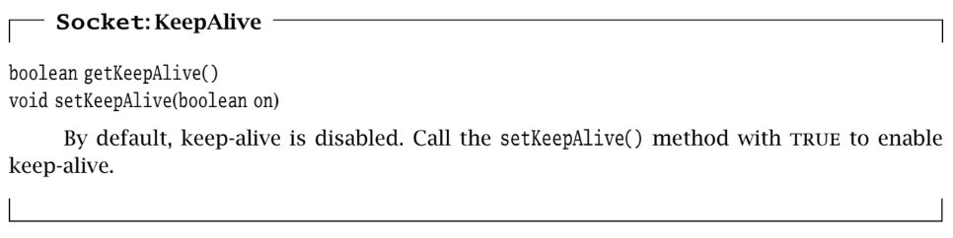

4.4.2 Send and Receive Buffer Size

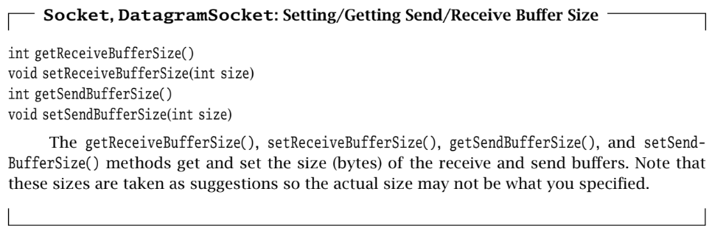

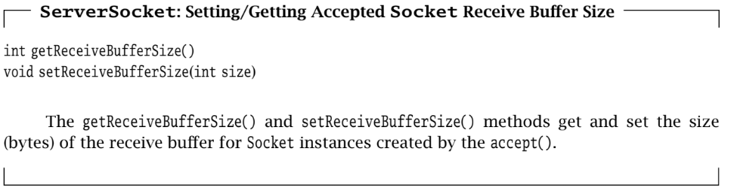

4.4.3 Timeout

- As we’ve already seen, many I/O operations will block if they cannot complete immediately

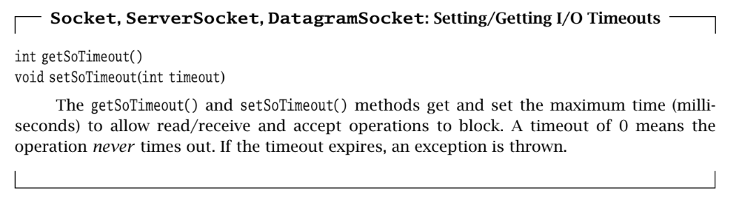

4.4.4 Address Reuse

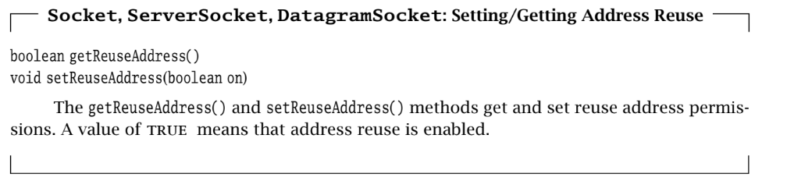

4.4.5 Eliminating Buffer Delay

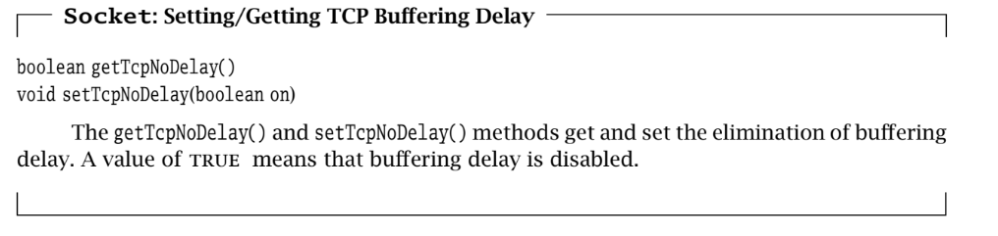

4.4.6 Urgent Data

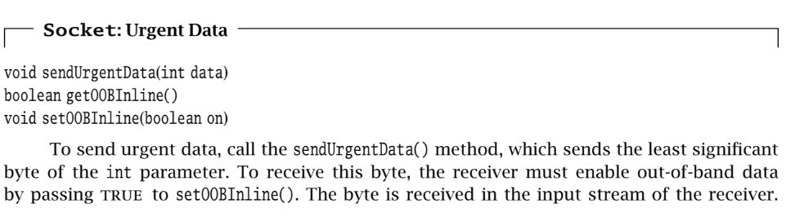

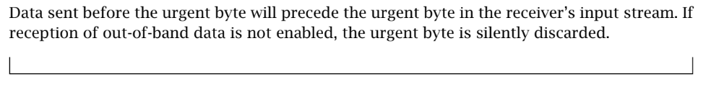

4.4.7 Lingering after close

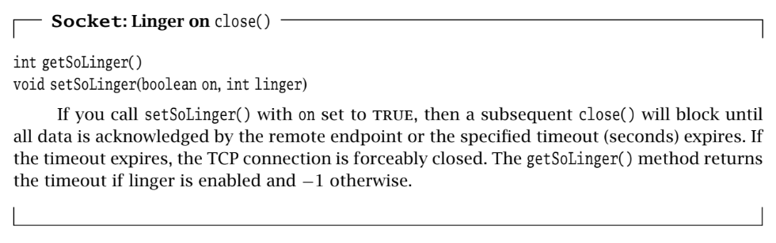

4.4.8 Broadcast Permission

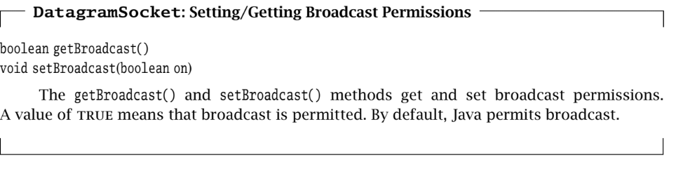

4.4.9 Traffic Class

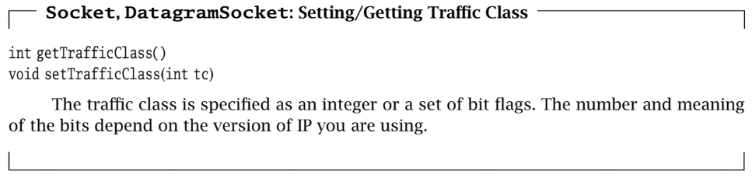

4.4.10 Performance-Based Protocol Selection

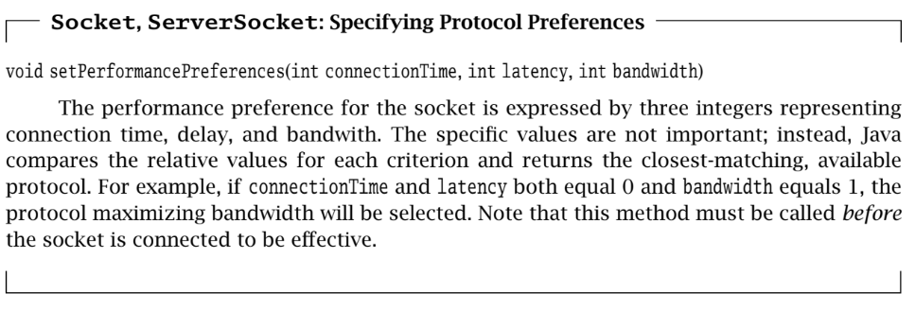

4.5 Closing Connections

- When the client is finished, it calls close(). After the server has received and echoed all of the data sent before the client’s call to close(), its read operation returns a−1, indicating that the client is finished. The server then calls close() on its socket.

- Calling close() on a Socket terminates both directions (input and output) of data flow. Once an endpoint (client or server) closes the socket, it can no longer send or receive data. This means that close() can only be used to signal the other end when the caller is completely finished communicating

4.6 Applets

- Applets can perform network communication using TCP/IP sockets, but there are severe restrictions on how and with whom they can converse. Without such restrictions, unsuspecting Web browsers might execute malicious applets that could, for example, send fake email, attempt to hack other systems while the browser user gets the blame, and so on.

- Typically, browsers only allow applets to communicate with the host that served the applet. This means that applets are usually restricted to communicating with applications executing on that host.