# Shop Inventory

A C# console application for managing a small shop's stock. Products are saved to a JSON file, so data is kept between runs.

## Features

- Add products (ID, name, quantity, price in KSh) with duplicate ID checks
- View all products, sorted by ID
- Search a product by ID
- Update a product's quantity and price
- Delete a product
- Total stock value calculation
- Low stock alert for items below a set limit (default: 5)
- Input validation: wrong input never crashes the app
- Automatic saving to `inventory.json`

## Screenshots

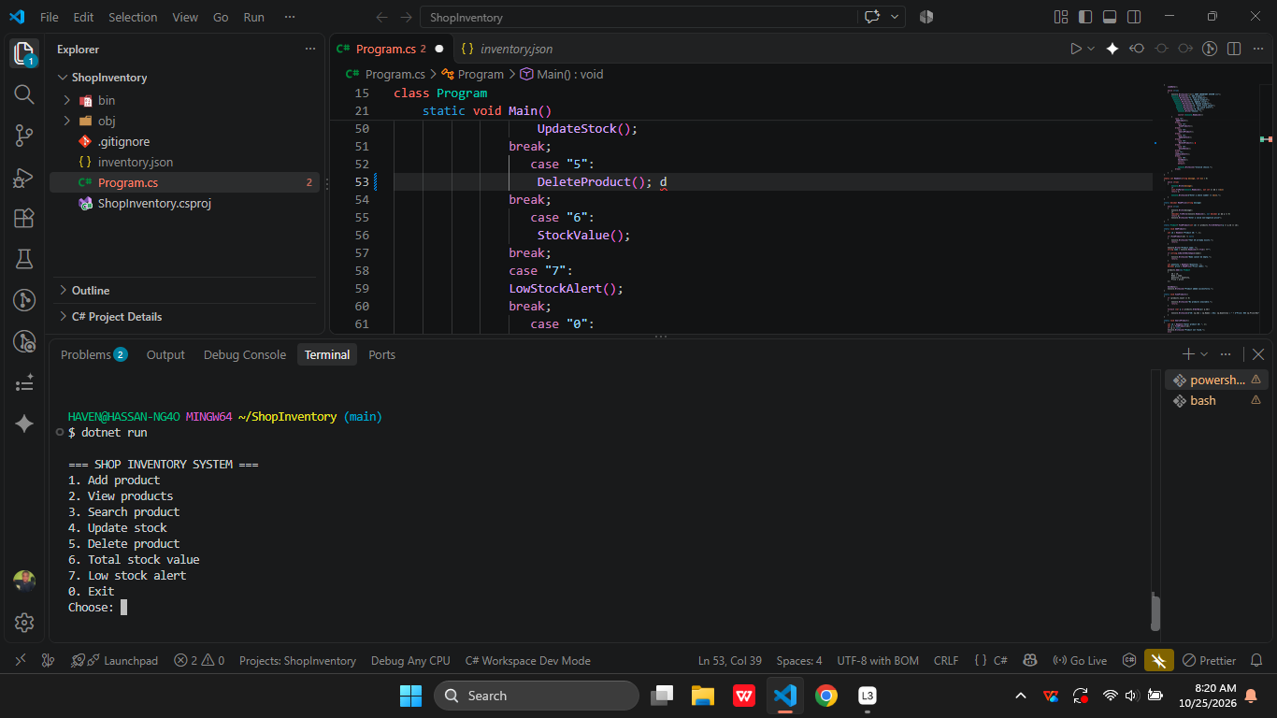

![Main menu]
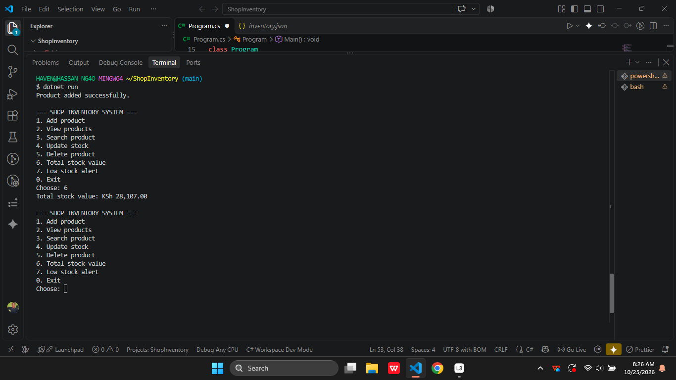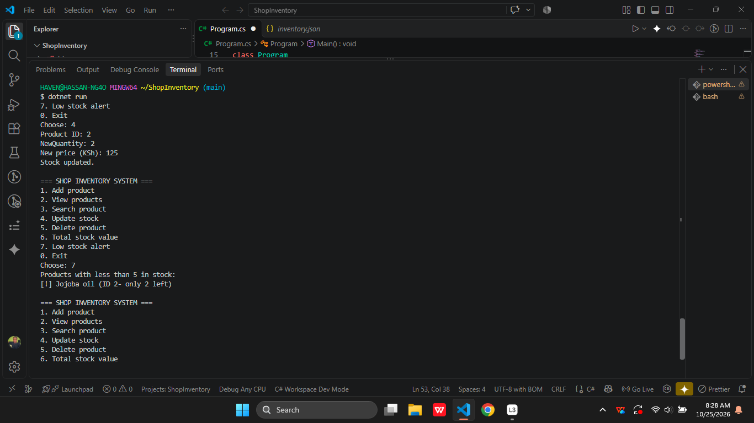

![Low stock alert]

## Tech used

- C# and .NET 10
- `System.Text.Json` for saving and loading data
- LINQ for sorting, filtering and totals

## How to run

1. Install the [.NET SDK](https://dotnet.microsoft.com/download)
2. Clone the repo and open the folder:
```
git clone https://github.com/ngaoleli18-jpg/Shop-Inventory.git
cd Shop-Inventory
```
3. Run the app:
```
dotnet run
```
4. Use option `0` to exit so your data is saved.

## Menu

| Option | Action |
|---|---|
| 1 | Add product |
| 2 | View products |
| 3 | Search product |
| 4 | Update stock |
| 5 | Delete product |
| 6 | Total stock value |
| 7 | Low stock alert |
| 0 | Exit |

## What I learned

- saving and loading data with JSON
- validating input with `TryParse`

## Possible improvements

- Product categories and suppliers
- Export to CSV
- Search by name
- A GUI or web version

## Author

Hassan Leli, IT student, Kenya

