2026 Spring - Software Engineering and Multiplatform App Development (MSCS-533-A01) - First Bi-term
Final Software Development Project: Build Multiplatform “Location Tracker" App with .NET MAUI
Assignment Task(s):
Using C Sharp (C#) and .NET MAUI, create a location tracking app that saves the location of the user and displays it as a heat map. This app will track the position of the user and save it to an SQLite database so that you can visualize the result in the form of a heat map. For the map, you will use the .NET MAUI Maps component and extend its functionality to build a heat map.

Output:
The following is the final layout of the App:
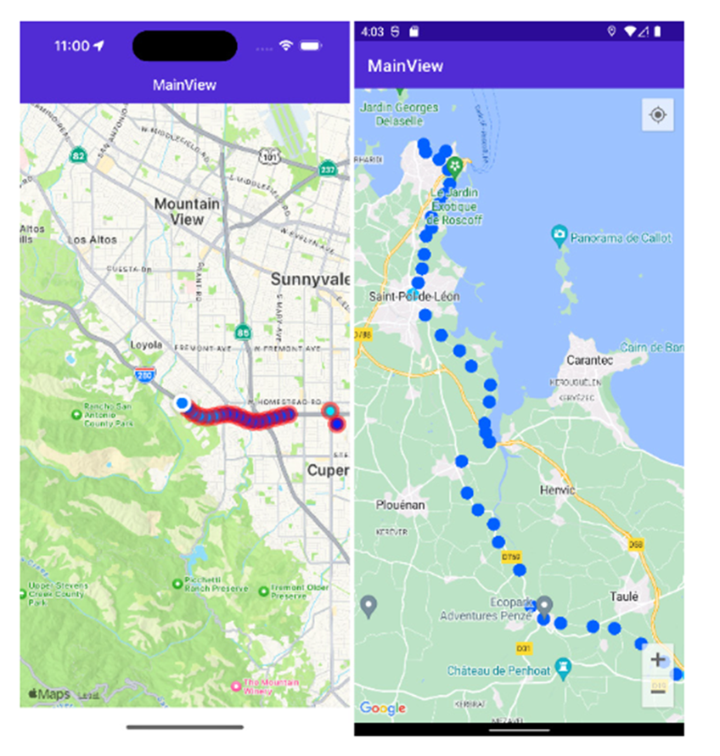

Deliverables:
C Sharp (C#) Source code, manifest file, and a screenshot of the application output in the Word document and use URL link from the GitHub repository to share code. Please ensure you are following coding best practices and provide comments.

Technical Requirements:
To be able to complete this project, you’ll need to have Visual Studio for Mac or Windows installed, as well as the .NET MAUI components.

Best Practices:
Refer to coding standards on the C#, JavaScript, and Dart languages coding conventions.
- Common C# code conventions
- JavaScript best practices
- Effective Dart

